Appendix

Figure S1. Annual publication production in our study. The formula fitted a non-linear relationship (formula = nls(y~a +exp (b* x))

Figure S2. Top 20 most cited countries in the study.
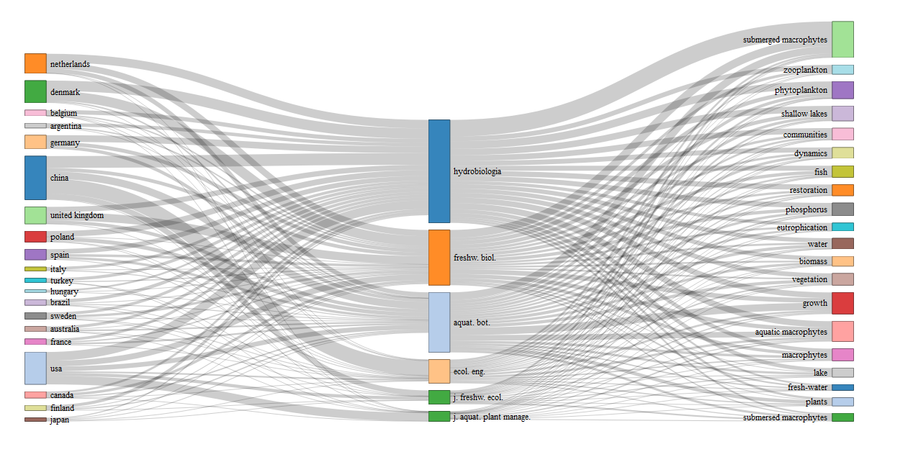
Figure S3. Plot of three fields (country, source and Keywords Plus) through a Sankey diagram

Figure S4. Word cloud of Top 100 most frequent words based on words extracted from the abstract retrieved in the study.
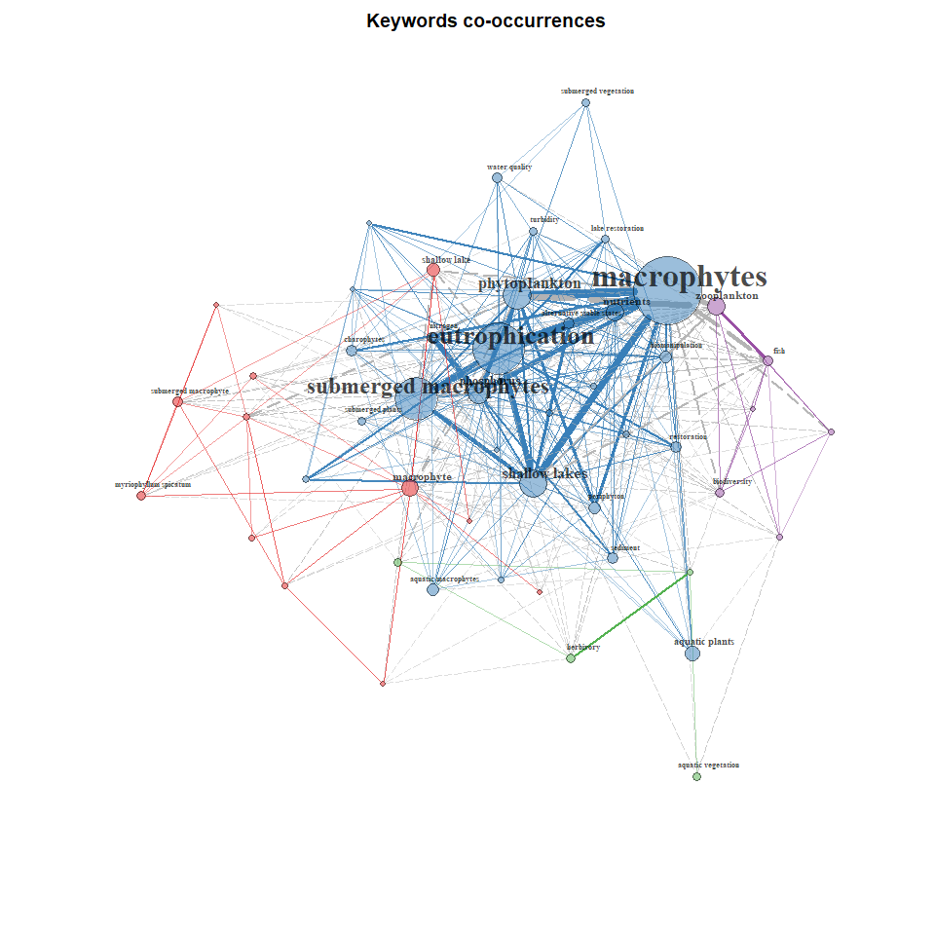
Figure S5. Keywords co-occurrence of retrieved articles in the study.

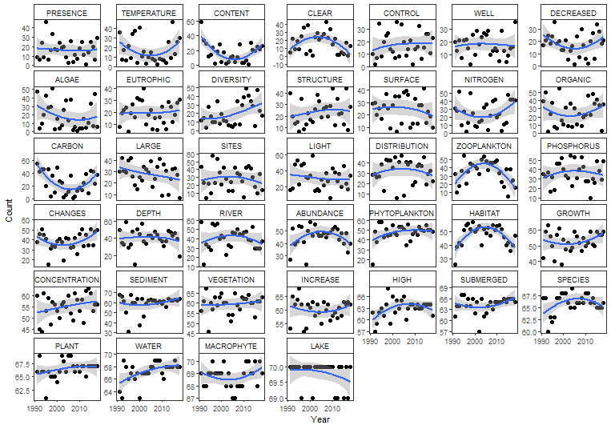
Figure S6. High-frequency words without significant monotonic trends in abstracts of retrieved articles in the study

Figure S7. K-fold cross validation of the optimum topic numbers based on perplexity. K was set as three in the study.

