Supporting Information

Do the joint effects of size, shape and ecocorona influence the attachment and physical eco(cyto)toxicity of nanoparticles to algae?
Fazel Abdolahpur Monikh,*† Daniel Arenas-Lago,† Petr Porcal,⊥ Renato Grillo, ‡ Peng Zhang,^{ɸ} Zhiling Guo,^{ɸ} Martina G. Vijver,† and Willie J.G.M. Peijnenburg,†#
†Institute of Environmental Sciences (CML), Leiden University, P.O. Box 9518, 2300 RA Leiden, Netherlands
⊥Biology Centre CAS, Institute of Hydrobiology and Soil & Water Research Infrastructure, Na Sádkách 7, České Budějovice, Czech Republic
‡São Paulo State University (UNESP), Department of Physics and Chemistry, School of Engineering, Ilha Solteira, SP, Brazil
^{ɸ}School of Geography, Earth and Environmental Science, University of Birmingham, Edgbaston, B15 2TT Birmingham, UK.
#National Institute of Public Health and the Environment (RIVM), Center for Safety of Substances and Products, Bilthoven, Netherlands
Email: f.a.monikh@cml.leidenuniv.nl
Address: Van Steenis Building, Einsteinweg 2, 2333 CC Leiden, Netherlands

Section S1. Algal cell growth
The Pseudokirchinella subcapitata algae cells were cultured according to the methodology recommended by the Organization for Economic Co-operation and Development (OECD testing guideline 201 (Table S1) in climatic chambers under a controlled temperature of 22 ºC. 200 mL Erlenmeyer flasks were cleaned and autoclaved. The culture medium (Woods Hole medium) were put in the autoclaved Erlenmeyer flasks. The algae were incubated under sterile conditions under a flow chamber.
Algal cell numbers were determined prior to the experiment using an Aquafluor Meter (TURNER DESIGNS, San Jose, CA, the USA) for 10 days to obtain the growth curve of the cells. This curve would assist to understand at which stage of the algae growth the exposure was carried out. The temperature and the light intensity were kept the same as in the algal incubator. We must mention that although we exposed algal cells to Au-ENPs after the exponential growth of the cells and reaching a stable state, there is a possibility of a slight increase in the density of cells during the tests (growth of population). The size of the algae was determined using a JEOL 7400F Scanning Electron Microscope (SEM) operated at 6 kV of high voltage after fixation of the cells with a standard solution containing 2.5% glutaraldehyde in 0.2 M phosphate buffer.

Table S1. Content of Woods Hole medium used to culture the algae
No. | Stock solution | Medium concentration (mg/L)
Macronutrient stock solutions
1 | CaCl.2H₂O | 3.676
2 | MgSO₄.4H₂O | 3.698
3 | NaHCO₃ | 1.26
4 | K₂HPO₄ | 0.872
5 | NaNO₃ | 8.502
Micronutrient stock solutions
6 | MnCl₂.4H₂O | 0.02
7 | ZnSO₄.7H₂O | 0.002
8 | NaMoO.2H₂O | 0.00012
9 | CoCl₂.6H₂O | 0.001
10 | CuSO₄.5H₂O | 0.001
11 | NaEDTA & FeCl₃.6H₂O = FeEDTA | 0.436 & 0.316

Section S2. Particle mass concentration measurement using ICP-MS
The concentration of Au in the samples was measured using inductively coupled plasma mass spectrometry (ICP-MS; Triple Quad 8800, Agilent Technologies) after acid digestion of the samples. The samples (except the algae pellets) were digested for 2 h with HNO₃ (65%) at 130 °C followed by 2 h of additional digestion with HClO₄ at 170 °C in an aluminum heating block. The isotope ¹⁹⁷Au was measured with a plasma flow of 15 L/min and a nebulizer gas flow of 1 L/min in He mode with an integration time of 0.17 s with 5 repetitions. The calculated limit of quantification was 10 ng/L.

Section S3. Characterization of the Au-ENPs. Stability testing of the Au-ENPs using single-particle inductively coupled plasma mass spectrometry (spICP-MS) and MADLS, respectively
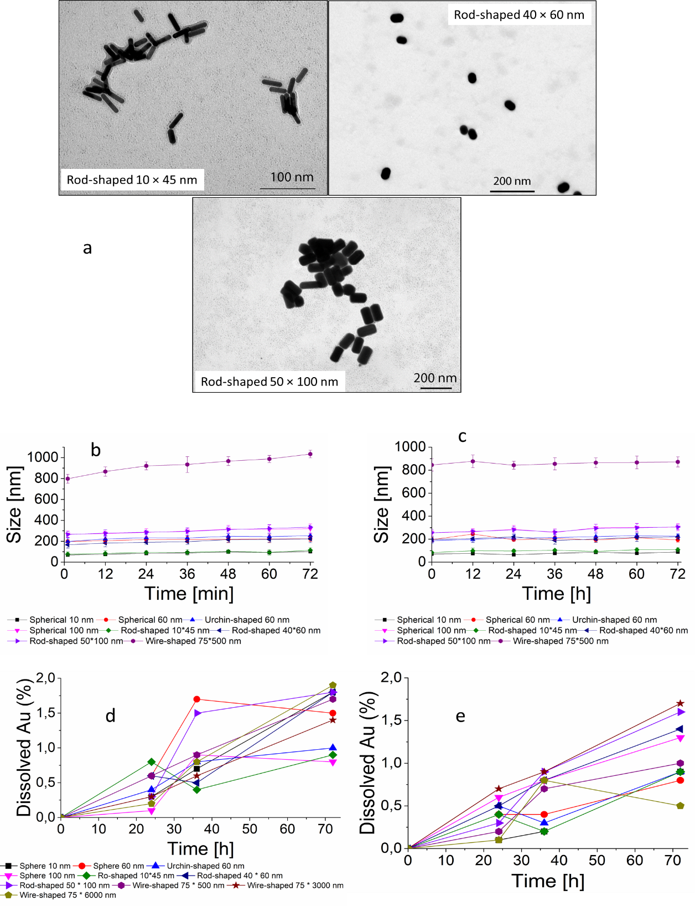
Figure S1. Dissolution and aggregation kinetics of the Au-ENPs in the culture media. a) The TEM images of the rod-shaped Au-ENPs in MQ water. b) Aggregation of the citrate-coated Au-ENPs. c) Aggregation of the NOM-coated Au-ENPs. d) Dissolution of the citrate-coated Au-ENPs. e) Dissolution of NOM-coated Au-ENPs.

Section S4. Algae size and growth inhibition test
Figure S2. (left) Scanning electron microscope picture of the algae. (right) The area under the peak of the absorbance at around 670 nm of the algal cells exposed to citrate-coated and NOM-coated Au-ENPs of different sizes and shapes as a function of exposure time at 10 mg/L. The graph shows that the area under the peaks obtained using UV-vis Spectrophotometry increased over time (incubation time). This indicated a normal growth of the algae.

Note that localized surface plasmon resonance, which is the collective oscillation of electrons in the conduction band of Au-ENPs in resonance with a specific wavelength of the incident light, results in a strong absorbance band in the region ≤ 600 nm (Haiss et al. 2007). We tested the absorbance of the citrate-coated Au-ENPs and Au-ENP-NOM without the algae cells using UV-Vis and the results showed that the absorbance occurs in the region ≤ 650 nm (Table S2). The plasmon resonance of Au-ENPs in the exposure media, thus, does not interfere with the light absorbance of the algae. To reduce the possibility of any interference resulted from the Au-ENPs, we washed the algae before the UV-Vis measurement. Accordingly, the algae were diluted with Phosphate Buffered Saline (PBS, pH 7.4) and centrifuged (Sorvall RC 5B plus centrifuge, Fiberlite F21-8) at 4000 rpm for 10 min at 4 ºC. This washing process was repeated twice.
Dispersion of the Au-ENPs (10 mg/L) in MQ water was prepared for UV-Vis measurement to assure that the absorbance of the Au-ENPs does not interfere with the absorbent of algae. Prior to the measurements, the baseline was established using the media of interest, ensuring that only the Au-ENPs (citrate-coated and NOM-coated) were detected. The results of UV-Vis measurements can be observed in Table S2. The data showed that the light absorbance of the Au-ENPs of different shape and size occurs at a wavelength lower than 650 nm.
Table S2. The light absorbance of the Au-ENPs dispersion measured using a UV-Vis Spectrophotometer
Au-ENPs | Absorbance (nm)
Spherical 10 nm | 540
Spherical 10 nm NOM | 540
Spherical 60 nm | 560
Spherical 60 nm NOM | 560
Spherical 100 nm | 580
Spherical 100 nm NOM | 580
Urchin-shaped 60 nm | 560
Urchin-shaped 60 nm NOM | 560
Rod-shaped 10*45 nm | 640
Rod-shaped 10*45 nm NOM | 640
Rod-shaped 40*60 nm | 640
Rod-shaped 40*60 nm NOM | 640
Rod-shaped 50*100 nm | 640
Rod-shaped 50*100 nm NOM | 640
Wire-shaped 75 * 500 | 640
Wire-shaped 75 * 500 NOM | 640
Wire-shaped 75 * 3000 | 640
Wire-shaped 75 * 3000 NOM | 640
Wire-shaped 75 * 6000 | 640
Wire-shaped 75 * 6000 NOM | 640

Section S5. Membrane integrity
The red fluorescence dots show the nuclear-specific staining due to PI uptake as a result of membrane damage. Figure S3a shows that in the control samples the cell membrane is healthy thus the PI could not penetrate the cell to provide red fluorescence after interaction with the nucleus. When the cells are exposed to spherical 10 nm Au-ENPs (Figure S3b) and rod-shaped 10 × 45 nm Au-ENPs (Figure S3c) the cell membrane become permeable to PI due to the damage resulted from the Au-ENPs. No membrane damage was observed for other citrate-coated Au-ENPs. The presence of NOM corona on the surface of the Au-ENPs prevents any membrane damage regardless of the shape and size of the particles.
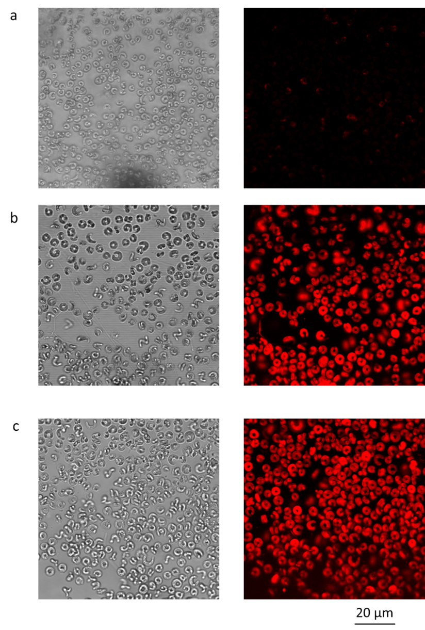

Figure S3. Confocal microscope pictures illustrating the influence of Au-ENPs of different sizes and shapes on the membrane of the algal cells after 72 h of exposure time. The red fluorescence dots show the nuclear-specific staining due to PI uptake as a result of membrane damage. a) Control, b) membrane damage caused after exposure to 10 nm spherical Au-ENPs and c) membrane damage to algae after exposure to rod-shaped 10 × 45 nm Au-ENPs.

Section S6. Recovery of the mass of the Au-ENPs
Calculating mass balance for ENPs is challenging, since the dispersion of ENPs must be considered as homogenous (similar to chemicals) which cannot be true for ENP dispersions. It was considerably reported that due to sample handling and attachment of the particles to tubing, ENPs are lost during exposure test. This can significantly influence the mass balance calculation and recovery measuring even between the replicates. Nevertheless, we calculated the mass recovery of the added Au-ENPs by combining the mass of Au resulted from different steps. The measured Au mass in the exposure media was higher than the mass adsorbed to the algae cells. This can be due to particle losses as expected during the exposure. Note that, particle losses for larger particles would results in a higher variances in the mass compared to particle losses in small particles.
Table S3. The recovery of the added Au-ENPs by combining the mass of Au resulted from different washing steps
Au-ENPs | Measured Au mass in the exposure media at 0 h (µg/L) | Measured Au mass in the exposure media after 72 h (µg/L) | Recovery %
Spherical 10 nm | 9350 | 9215 | 98
Spherical 10 nm NOM | 9347 | 9223 | 98
Spherical 60 nm | 9254 | 9173 | 99
Spherical 60 nm NOM | 9326 | 9167 | 98
Spherical 100 nm | 9353 | 9121 | 97
Spherical 100 nm NOM | 9312 | 9113 | 97
Urchin-shaped 60 nm | 9532 | 9402 | 98
Urchin-shaped 60 nm NOM | 9426 | 9232 | 97
Rod-shaped 10*45 nm | 9218 | 9185 | 99
Rod-shaped 10*45 nm NOM | 9164 | 9051 | 98
Rod-shaped 40*60 nm | 9743 | 9527 | 97
Rod-shaped 40*60 nm NOM | 9812 | 9584 | 97
Rod-shaped 50*100 nm | 9422 | 9156 | 97
Rod-shaped 50*100 nm NOM | 9736 | 9427 | 96
Wire-shaped 75 * 500 | 9287 | 8931 | 96
Wire-shaped 75 * 500 NOM | 9166 | 8964 | 97
Wire-shaped 75 * 3000 | 9456 | 8564 | 90
Wire-shaped 75 * 3000 NOM | 9615 | 8329 | 86
Wire-shaped 75 * 6000 | 9316 | 8431 | 90
Wire-shaped 75 * 6000 NOM | 9519 | 7783 | 81
References
Haiss, Wolfgang, Nguyen T. K. Thanh, Jenny Aveyard, and David G. Fernig. 2007. “Determination of Size and Concentration of Gold Nanoparticles from UV−Vis Spectra, Supporting Information.” Analytical Chemistry. doi:10.1021/ac0702084.

