Supporting information

Highly efficient green synthesis of the photochromic spironaphthoxazines using an eco-friendly choline hydroxide catalyst

Shailesh N. Vajekar^{b}, Ganapati S. Shankarling ^{a,}*

^{a,b}Department of Dyestuff Technology, Institute of Chemical Technology, N. P. Marg, Matunga, Mumbai-400019, Maharashtra, India.
ªE-mail: gsshankarling@gmail.com ªORCID ID : 0000-0002-1727-7941
^{b}E-mail: shaileshchem81@gmail.com ^{b}ORCID ID : 0000-0003-0321-3864

Content | Pages
Experimental section | 2-4
Characterization data for all the compounds | 4-6
¹H NMR spectra of the compounds | 7-11

- Experimental Section

Materials and methods
All the required chemicals were purchased from s d Fine-Chem Limited and utilized without additional purification. The advancement of all reactions was checked by aluminium TLC plate, silica gel coated with fluorescent indicator F254 (Merck) identifying the spots with the help of UV light as a visualizing agent. ¹H NMR spectra were obtained on a 500 MHz instrument (Agilent NMR spectrometer) and 400MHz (Bruker Ultrashield Plus NMR spectrometer) in CDCl₃ or DMSO-d₆ solvent at ambient temperature. We have mentioned the chemical shifts values on δ scale (ppm) relative to an internal standard tetramethylsilane [Si(CH₃)₄ = 0.00 ppm]. Infrared spectra were obtained with a JASCO-FT/IR 4100 LE ATR PRO450-S spectrometer. All the synthesized derivatives were analyzed by ¹H NMR spectra and melting points. Melting points were recorded on standard melting point instrument bought from Sunder Industrial Product, Mumbai and are uncorrected.

General method for the preparation of choline hydroxide (ChOH)
The Choline hydroxide was prepared as per the literature.^{[17]} The solution of choline chloride (10 mmol), KOH (10 mmol) and methyl alcohol (15 mL) was heated at 60 ⁰C for 12 h using continuous stirring. Solution was then cooled to rt and filtered later on to remove precipitated KCl. Eventually, the filtrate was concentrated by means of vacuum to get rid of methyl alcohol. The residue obtained was utilized without additional purification (Scheme 4).

General method for the synthesis of spironaphthoxazines
A mixture of indolium iodide 1 (1.0 mmol) and choline hydroxide (10 mol %) in water (3 mL) was stirred at 80 °C for 20 min. Then 1-nitroso-2-naphthol 2 (1.0 mmol) was added and the resulting mixture stirred at 80°C for another 40 min. Then reaction mass was cooled to rt. The solid product was then filtered and washed with water. The synthesized product was finally purified using column chromatography technique (silica gel 100-200 mesh size) with ethyl acetate:hexane (05:95) as an eluent to give the desired spironaphthoxazine (Scheme 2 & Table 1).

- Characterization Data of synthesized spironaphthoxazines

SNO-1: 1,1,3-trimethyl-1,3-dihydrospiro[benzo[e]indole-2,3'-naphtho[2,1-b][1,4]oxazine]

Yield: 89%; Colorless solid; mp 123-124 ºC. Reported mp 125 ºC(Lokshin, Samat, & Guglielmetti, 1997).
¹H NMR (500 MHz, DMSO-d₆) δ 8.499 (1H, d, J = 8.5 Hz, C10’-H), 7.968 (1H, s, C2’-H),
7.912 (1H, d, J = 8.6 Hz, C7’-H), 7.870-7.825 (3H, m, C6’-H, C8’-H, & C9’-H), 7.590 (1H, t, J = 8.3 Hz, C6-H), 7.418 (2H, m, C4 & C5’-H), 7.243 (1H, t, J = 8.0 Hz, C5-H), 7.075 (1H, d, J = 8.5 Hz, C7-H), 2.778 (3H, s, N-CH₃), 1.594 (3H, s, C1-CH₃), 1.472 (3H, s, C1-CH₃).

SNO-2: 1,3,3-trimethylspiro[indoline-2,3'-naphtho[2,1-b][1,4]oxazin]-9'-ol
Yield: 87%; light brown solid; mp 209-211 ⁰C. Reported mp 210-212 ºC(Fedorova et al., 2002).
¹H NMR (500 MHz, DMSO-d₆) δ 7.870 (1H, s, C2’-H), 7.783 (1H, s, C10’-H), 7.659 (1H, d, J = 8.5 Hz, C6’-H), 7.582 (1H, d, J = 8.3 Hz, C7’-H), 7.243 (1H, t, J = 7.9 Hz, C6-H), 7.168 (1H, d, J = 7.8 Hz, C4-H), 7.081 (1H, d, J = 8.5 Hz, C5’-H), 6.981 (1H, d, J = 8.3 Hz, C8’-H), 6.881 (1H, t, J = 7.6 Hz, C5-H), 6.623 (1H, d, J = 7.6 Hz, C7-H), 6.231 (1H, s, O-H), 2.796 (3H, s, N-CH₃), 1.381 (3H, s, C1-CH₃), 1.327 (3H, s, C1-CH₃).

SNO-3: 9'-methoxy-1,3,3-trimethylspiro[indoline-2,3'-naphtho[2,1-b][1,4]oxazine]
Yield: 83%; Yellow amorphous solid; mp 184 ºC. Reported mp 185-186 ºC(Lokshin et al., 1997).
¹H NMR (400 MHz, CDCl₃) δ 8.186 (1H, s, C2’-H), 7.787-7.748 (2H, m, C6’ & C7’-H), 7.381 (1H, s, C10’-H), 7.131-7.071 (2H, m, C4 & C6-H), 7.002-6.945 (2H, m, C5’ & 8’-H), 6.796 (1H, t, J = 8.0 Hz, C5-H), 6.613 (1H, d, J = 8.0 Hz, C7-H), 3.823 (3H, s, O-CH₃), 2.891 (3H, s, N-CH₃), 1.459 (3H, s, C1-CH₃), 1.362 (3H, s, C1-CH₃).

SNO-4: 1,3,3-trimethylspiro[indoline-2,3'-naphtho[2,1-b][1,4]oxazin]-5'-ol
Yield: 84%; Colorless solid; mp 105-107 ºC. Reported mp 103-107 ºC(Fedorova et al., 2002).
¹H NMR (500 MHz, DMSO-d₆) δ 8.236 (1H, s, C2’-H), 7.882 (1H, d, J = 8.0 Hz, C10’-H), 7.766 (1H, d, J = 8.4 Hz, C7’-H), 7.592-7.513 (2H, m, C9’ & C8’), 7.146 (1H, s, C6’-H), 7.061 (1H, d, J = 8.0 Hz, C4-H), 6.970-6.811 (2H, m, C6-H & C5-H), 6.573 (1H, d, J = 7.9 Hz, C7-H), 6.236 (1H, s, O-H), 2.765 (3H, s, N-CH₃), 1.580 (3H, s, C1-CH₃), 1.458 (3H, s, C1-CH₃).

SNO-5: 1,3,3-trimethyl-7'-nitrospiro[indoline-2,3'-naphtho[2,1-b][1,4]oxazine]
Yield: 91%; Yellow solid; mp 127-128 ⁰C. Reported mp 128-129 °C(Nedoshivin, V.Y., Lyubimov, A.V., Zaichenko, 1989)
¹H NMR (400 MHz, CDCl₃) δ 8.516 (1H, d, J = 8.4 Hz, C6’-H), 8.374 (1H, d, J = 8.2 Hz, C10’-H), 8.186 (1H, s, C2’-H), 8.003 (1H, d, J = 8.5 Hz, C8’-H), 7.562 (1H, t, J = 8.5 Hz, C9’-H), 7.292 (1H, d, J = 8.5 Hz, C5’-H), 7.061 (1H, d, J = 8.5 Hz, C4-H), 6.945 (1H, t, J = 8.6 Hz, C6-H), 6.796 (1H, t, J = 8.4 Hz, C5-H), 6.623 (1H, d, J = 8.5 Hz, C7-H), 2.797 (3H, s, N-CH₃), 1.481 (3H, s, C1-CH₃), 1.411 (3H, s, C1-CH₃).

SNO-6: 5-bromo-1,3,3-trimethylspiro[indoline-2,3'-naphtho[2,1-b][1,4]oxazine]
Yield: 88%; Light yellow solid; mp 183-184 ⁰C. Reported mp 182-183 ⁰C(Jin, Li, Ma, & Li, 2010)
¹H NMR (400 MHz, CDCl₃) δ 8.518 (1H, d, J = 8.0 Hz, C10’-H), 7.885 (1H, d, J = 8.5 Hz, C7’-H), 7.772 (1H, s, C2’-H), 7.674 (1H, d, J = 8.8 Hz, C6’-H), 7.588-7.562 (1H, m, C9’-H), 7.484-7.446 (1H, m, C8’-H), 7.349 (1H, d, J = 8.4 Hz, C6-H), 7.061 (1H, d, J = 8.5 Hz, C4-H), 6.934 (1H, d, J = 8.8 Hz, C5’-H), 6.479 (1H, d, J = 8.4 Hz, C7-H), 2.728 (3H, s, N-CH₃), 1.362 (3H, s, C1-CH₃), 1.316 (3H, s, C1-CH₃).

SNO-7: 1,1,3-trimethyl-1,3-dihydrospiro[benzo[e]indole-2,3'-naphtho[2,1-b][1,4]oxazine]
Yield: 87%; Colorless solid; mp 151-152 ºC. Reported mp 149-151 ºC(Nedoshivin, Zaichenko, Shienok, & Marevtsev, 1995)
¹H NMR (500 MHz, DMSO-d₆) δ 8.499 (1H, d, J = 8.5 Hz, C10’-H), 7.968 (1H, s, C2’-H),
7.912 (1H, d, J = 8.6 Hz, C9-H), 7.870-7.825 (3H, m, C7’-H, C6’-H & C5-H), 7.792 (1H, d, J = 7.9 Hz, C6-H), 7.590 (1H, t, J = 8.3 Hz, C9’-H), 7.418 (2H, m, C8 & C8’-H), 7.243 (1H, t, J = 7.9 Hz, C7-H), 7.152 (1H, d, J = 8.7 Hz, C4-H), 7.075 (1H, d, J = 8.9 Hz, C5’-H), 2.778 (3H, s, N-CH₃), 1.594 (3H, s, C1-CH₃), 1.472 (3H, s, C1-CH₃).

3. ¹H spectra of the Spironaphthoxazines
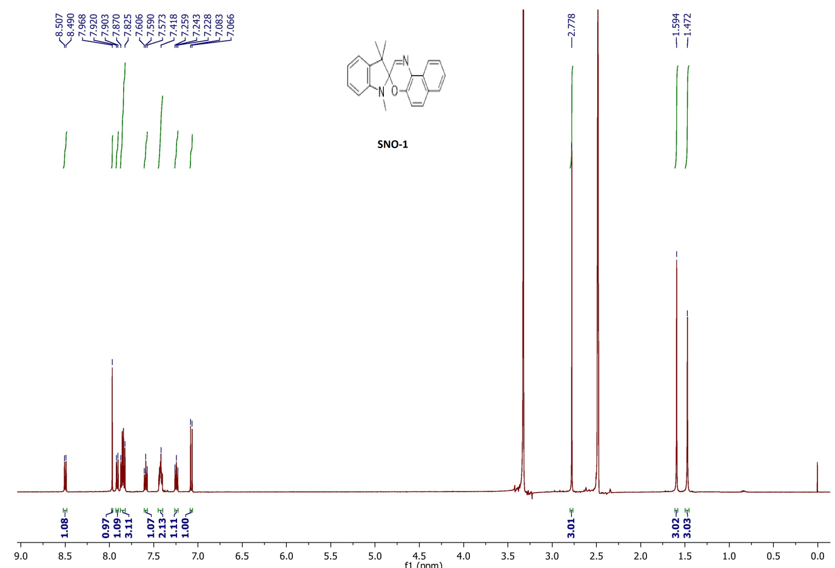
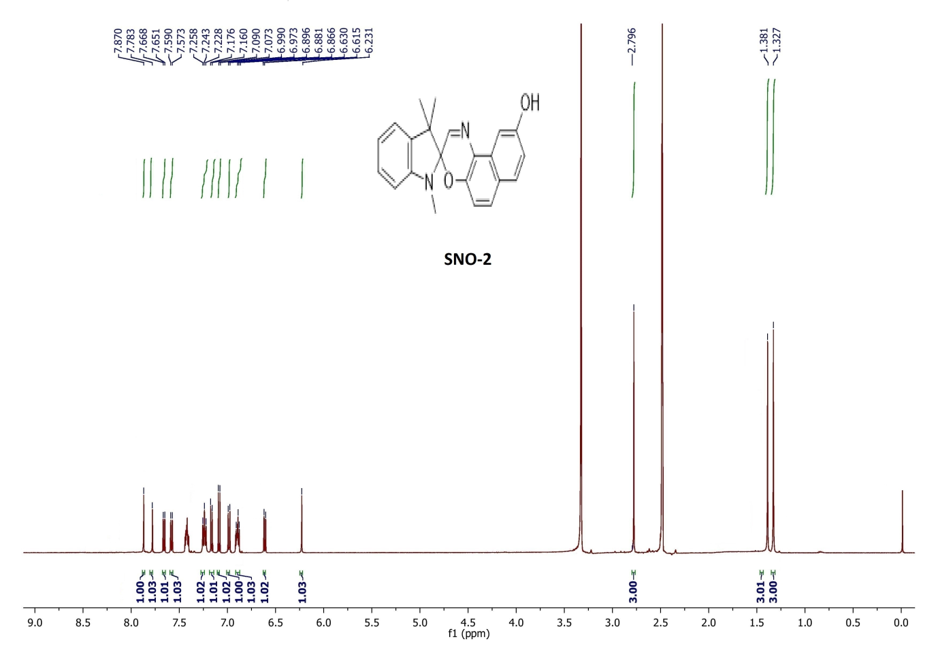

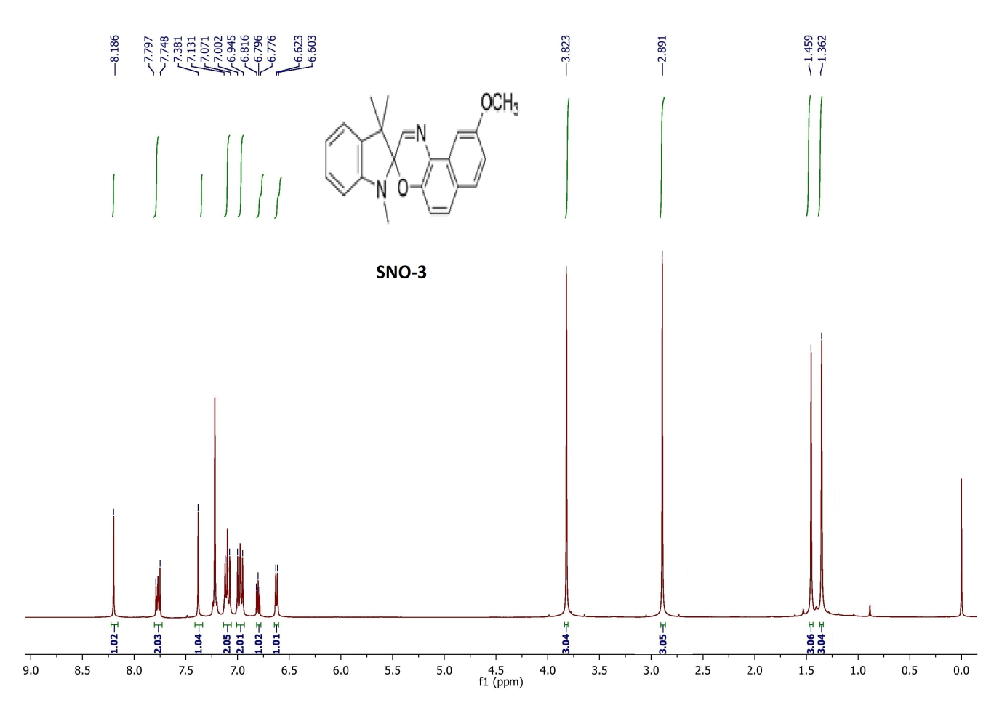

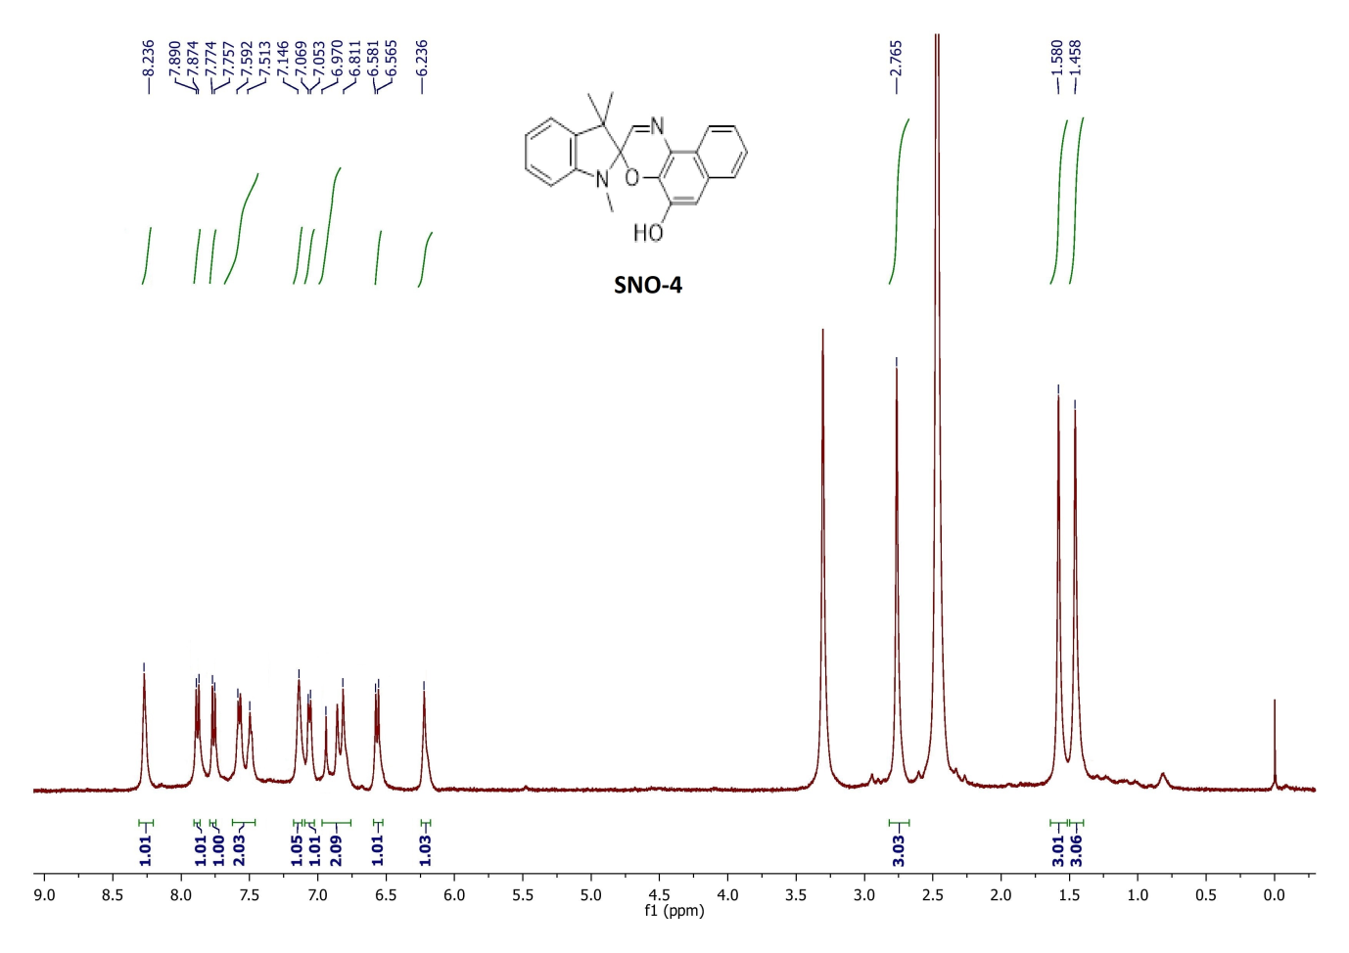
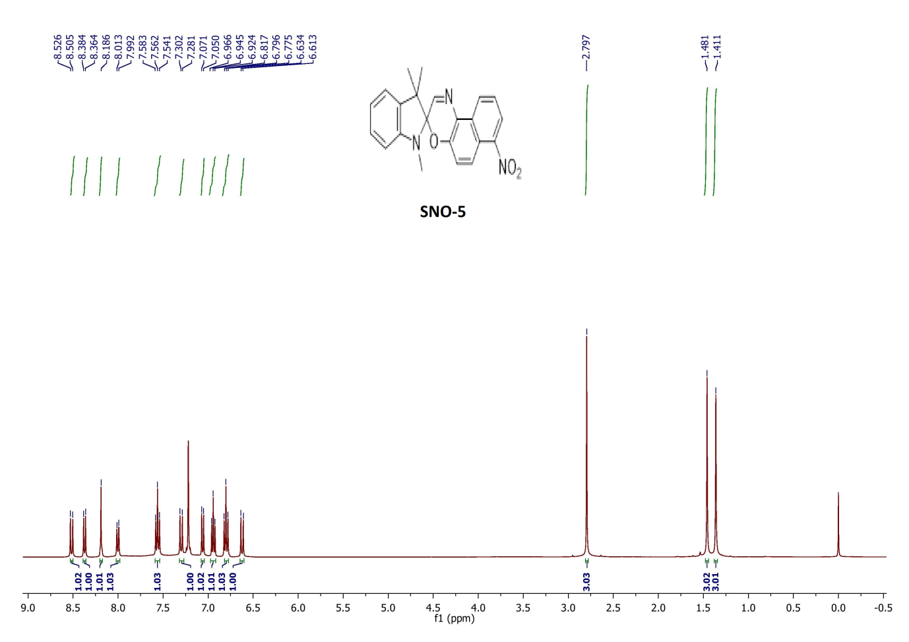
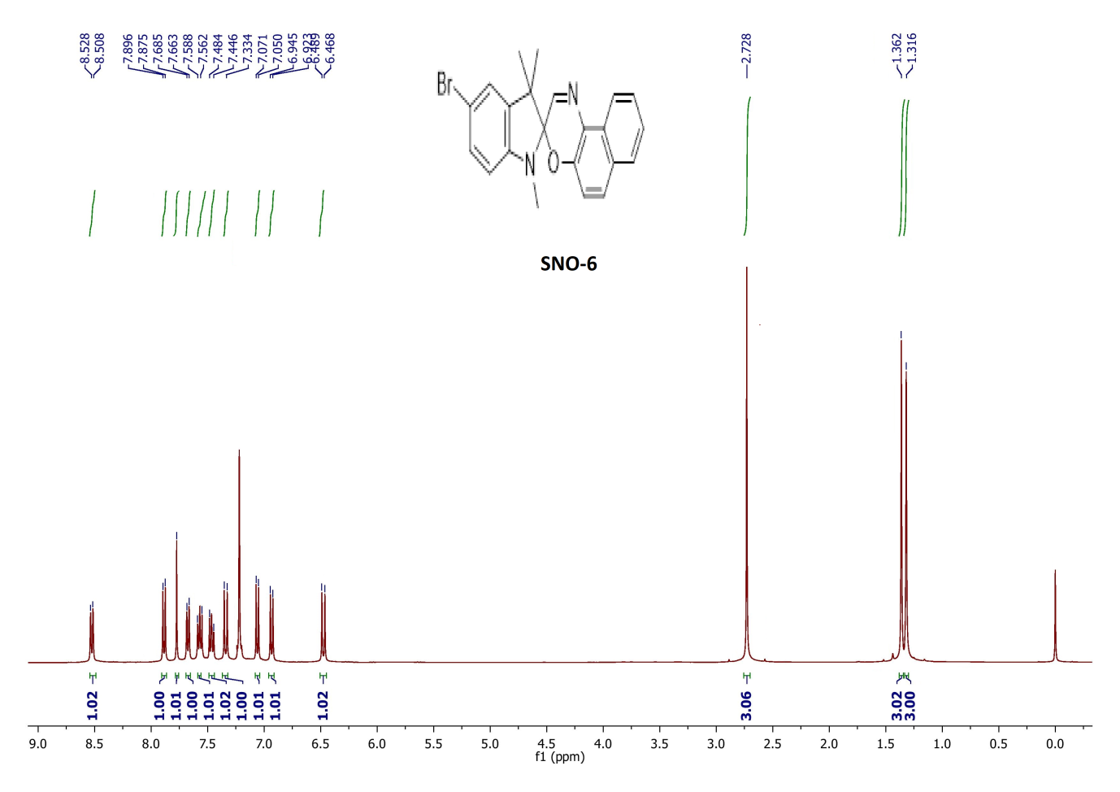
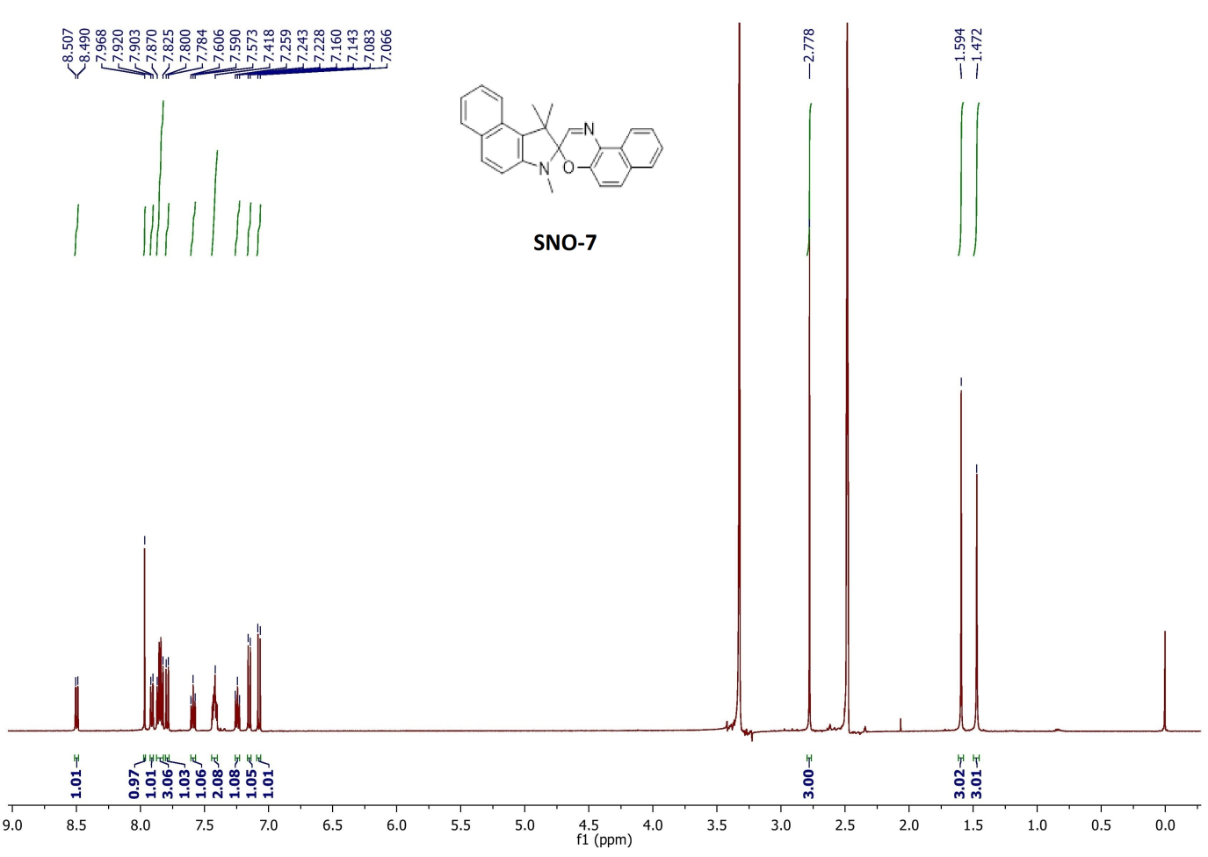

References

- Fedorova, O. A., Gromov, S. P., Pershina, Y. V., Sergeev, S. S., Strokach, Y. P., Barachevsky, V. A., Guglielmetti, R. Novel azacrown ether-containing spiro[indoline-2,3′-naphthoxazines]: design, synthesis and cation-dependent photochromism. J. Chem. Soc., Perkin Trans. 2002, 2, (3), 563–570. https://doi.org/10.1039/a905671h
- Jin, L.-M., Li, Y., Ma, J., & Li, Q. Synthesis of Novel Thermally Reversible Photochromic Axially Chiral Spirooxazines. Org. Lett. 2010, 12(15), 3552–3555. https://doi.org/10.1021/ol1014152
- Lokshin, V., Samat, A., & Guglielmetti, R. Synthesis of photochromic spirooxazines from 1-amino-2-naphthols. Tetrahedron. 1997, 53(28), 9669–9678. https://doi.org/10.1016/S0040-4020(97)00640-6
- Nedoshivin, V.Y., Lyubimov, A.V., Zaichenko, N. L. Synthesis and photochromic properties of nitro-substituted spironaphthooxazines. Bull. Acad. Sci. USSR, Div.Chem. Sci. 1989, 38(11), 2363–2366. https://doi.org/10.1007/BF01168090
- Nedoshivin, V. Y., Zaichenko, N. L., Shienok, A. I., & Marevtsev, V. S. Synthesis and photochromic properties of spiro (benzindoline-naphthoxazines). Russ. Chem. Bull. 1995. 44(4), 712–717. https://doi.org/10.1007/BF00698509

