Supporting Information

Synthesis, Characterization and Applications of New Schiff Base as Microbicidal Agent and Removal of Heavy Metals from Water
¹Nelofer Jamil, ^{2,*}Noureen Khan, ³Rukhsana Jabeen, ⁴Rashad Mehmood, ⁵Nadra Naheed
¹ Department of Environmental Sciences, Sardar Bahadur Khan Women’s University, Quetta, Pakistan
² Department of Chemistry, Sardar Bahadur Khan Women’s University, Quetta, Pakistan

³ Department of Botany, Sardar Bahadur Khan Women’s University, Quetta, Pakistan
⁴ Department of Chemistry, Devision of Science & Technology, University of Education, Lahore, Pakistan
⁵ International Center for Chemical Biological Sciences (ICCBS), H.E.J. Research Institute of Chemistry, University of Karachi, Karachi, Pakistan

*Corresponding author: Email: noureenhej@gmail.com , Tel. # +923313396610
Abstract
The new Schiff base ligand, N,N'-(3,3'-dimethyl-[1,1'-biphenyl]-4,4'-diyl)bis(1-(4-bromophenyl)methanimine (SBL), has been synthesized through condensation of 3,3'-dimethyl-[1,1'-biphenyl]-4,4'-diamine (1) with 4-bromobenzaldehyde in the presence of acetic acid as catalyst and characterized by spectroscopic data. The Schiff base ligand (SBL) was subjected to evaluate its potential to remove heavy metals copper, cobalt and zinc from polluted water under various pH, contact time, concentration of metal ions, concentration of SBL and temperature. The results showed that SBL has excellent potential to remove above metals at pH 8, 1.5 hour contact time, low concentration of metal ions, low concentration of SBL and at 25 ºC temperature, and the potential to remove metal ions is 93 % for Cu, 81 % for Co and 79 % for Zn.. The SBL was also evaluated for its antimicrobial potential against P. aureginosa, K. pneumonia, E. coli, S. dysentria, P. vulgaris and S. aureus bacteria and C. albican and A. niger yeast. The activities results showed that SBL was moderately to slightly active in comparison with the ciprofloxacin for bacteria and fluconazole for yeast. Toxicity of SBL was also measured with its various doses such as 0.1, 1, 10, 100, 500 and 1000 mg/Kg body weight of mice through daily oral administration. Sub-acute toxicity effects were studied for 15 days to observe the changes in behaviour and mortality. The highest dose of SBL did not cause any mortality or change in the overall behaviour of the treated mice, SBL has no toxicity and is safe for the oral administration. The biochemical and histopathological studies in liver and kidney were also estimated, the results showed variation in estimated parameters.
Keywords: Schiff base ligand, synthesis and characterization, Heavy metals removal from aqueous, antimicrobial potential, toxicity.

List of Supporting Information | Page
Figure S1. FAB-MS spectrum of N,N'-(3,3'-dimethyl-[1,1'-biphenyl]-4,4'-diyl)bis(1-(4-bromophenyl)methanimine (2) | 4
Figure S2. ¹H NMR Spectrum of N,N'-(3,3'-dimethyl-[1,1'-biphenyl]-4,4'-diyl)bis(1-(4-bromophenyl)methanimine (2) | 5

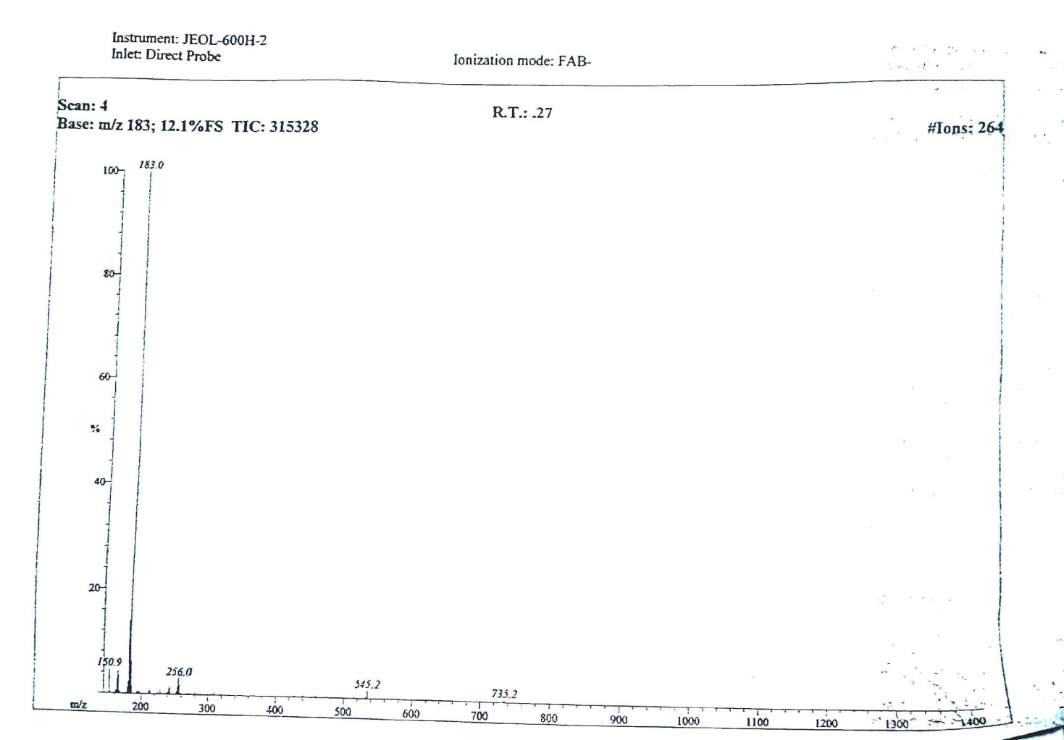

Figure S1. FAB-MS spectrum of N,N'-(3,3'-dimethyl-[1,1'-biphenyl]-4,4'-diyl)bis(1-(4-bromophenyl)methanimine (2)

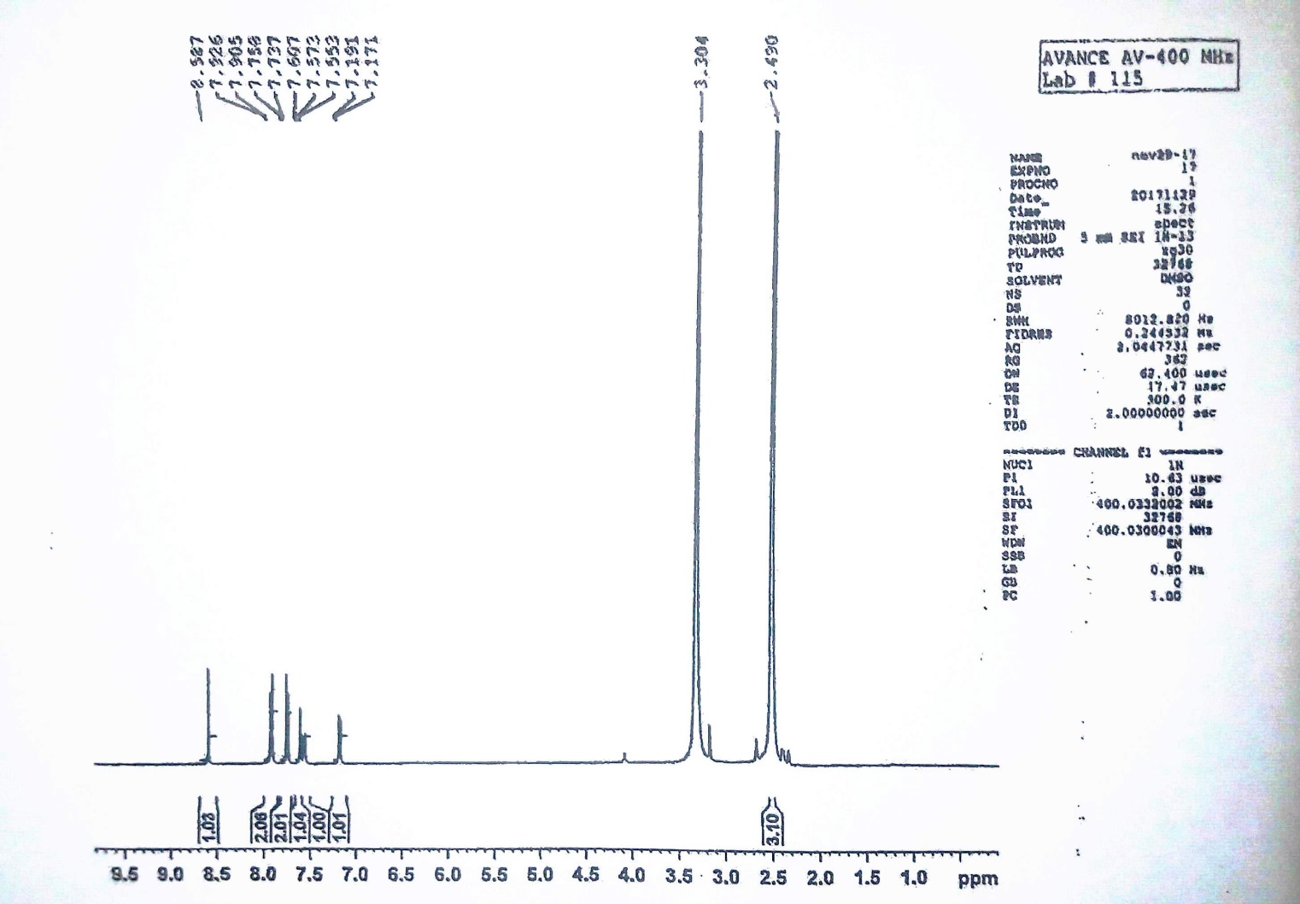

Figure S2. ¹H NMR Spectrum of N,N'-(3,3'-dimethyl-[1,1'-biphenyl]-4,4'-diyl)bis(1-(4-bromophenyl)methanimine (2)

