Supplementary materials
Synergistic effect of a spinel ferrite on the adsorption capacity of nano bio-silica for the removal of methylene blue
Sunday Joseph Olusegun¹*, Erico Tadeu Fraga Freitas², Luciano Roni Silva Lara¹, Nelcy Della Santina Mohallem¹**
¹Universidade Federal de Minas Gerais, Departamento de Química, Laboratório de Materiais Nanoestruturados,Belo Horizonte, Brazil
²Universidade Federal de Minas Gerais, Centro de Microscopia, 31.270-901, Belo Horizonte, Brazil
E-mail: *arewasegun@gmail.com, **nelcy@ufmg.br
Kinetic studies
Equations that define these models are listed below; pseudo-first order (S1), pseudo-second order (S2) and Elovich (S3).
$q_{t}=q_{e}\left[1-exp\left(-k_{1}t\right)\right]$ S1
$q_{t}= q_{e}- \frac{q_{e}}{\left[k_{2 }\left(q_{e}\right)t+1\right]}$ S2
$q_{t}=\frac{1}{β}(1+αβt)$ S3
where $α$ and $β$ are the initial adsorption rate (mg g⁻¹ min⁻¹) and extent of surface coverage (g mg⁻¹) respectively. And $q_{t}$ and $q_{e}$ are amount of MB adsorbed at time ‘t’ and at equilibrium time respectively, $k_{1}$ and $k_{2 }$ are the rate constant of pseudo-first order and second order kinetic models respectively.
Adsorption isotherm
Equation S4 (Langmuir) and equation S5 (Freundlich).
$q_{e}= \frac{q_{maxC_{eK_{L }}}}{(1+K_{LC_{e}})}$ S4
$q_{e}=K_{F}C_{e}^{1/n_{F}}$ S5
In these equations, $C_{e}$ stands for the equilibrium concentration in bulk solution (mg L⁻¹), $q_{e}$ is the amount of methylene blue that was adsorbed (mg g⁻¹), $q_{max}$ is the maximum adsorption capacity (mg g⁻¹) of the adsorbent, $K_{L}$ is equilibrium constant of Langmuir (L g⁻¹), $K_{F}$ is the Freundlich constant (mg g⁻¹ (mg L⁻¹)^{-1/nF} ), $n_{F}$ is the dimensionless exponent of Freundlich.
The nature of adsorption was determined by using the linear form of Dubinin–Radushkevich (D–R) isotherm in equations below.
$lnq_{e}=lnq_{DR}-k_{DR}ε^{2}$ S6
$ε^{2}=RTln(1+\frac{1}{C_{e}})$ S7
$E= \frac{1}{\sqrt{-2k_{DR}}}$ S8
The parameters in the equations are defined as follow: $q_{DR}$ is D-R adsorption capacity (mg g⁻¹), $k_{DR}$ is D-R constant (${mol}^{2}$ J⁻²), ε Polanyi potential, E is the mean energy of adsorption (kJ mol⁻¹), R is gas constant (J mol⁻¹ K⁻¹), T is temperature (K). Mean energy of adsorption was evaluated from the slope of the plot of $lnq_{e}$ versus $ε^{2}$ (Fig. S2).
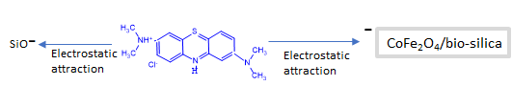
Fig. S1: Electrostatic attraction between MB and the adsorbents.
Fig. S2. D-R isotherm for the adsorption of MB on BSIL, SCOF100 and SCOF 700.

Fig. S3. Effect of ionic strength on the adsorption of MB on SIL and SCOF.

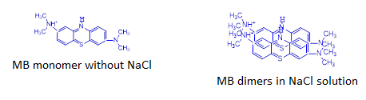
Fig. S4. Monomer and dimers molecules of MB.

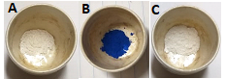
Fig. S5: Pictures of BSIL before adsorption (A), after adsorption (B) and after MB-loaded BSIL was calcined.

