**Supplementary Material: A spatio-temporal genetic assessment of juvenile smooth hammerhead sharks (*Sphyrna zygaena*) along the South African coastline**

Gibbs Kuguru1, Enrico Gennari234, Sabine Wintner56, Matt Dicken5,7, Clint Rhode1, and Aletta E. Bester-van der Merwe1

**Table S1** Pairwise FST values of *Sphyrna zygaena* populations sampled along the South African coastline (*indicates significance p < 0.05 after Bonferroni correction)

|  |  |  |  |
| --- | --- | --- | --- |
| Microsatellite FST and p-Values | | | |
|  | MB1 | AB | KZN |
| MB1 |  | 0.001* | 0.001* |
| AB | 0.081 |  | 0.437 |
| KZN | 0.077 | 0.000 |  |

**Figure S1** Search for the most likely number of clusters that best describes the spatial structure ofSphyrna zygaena populations (MB1, AB, KZN) sampled along the South African coastline following (A) the mean log probability for each value of K (Ln P(K)), (B) the second order rate of change of the likelihood function with respect to K (ΔK), and (C) ‘MedMedK’ (median of medians), MedMeaK’ (median of means), ‘MaxMeaK’ (maximum of means), ‘MaxMedK’ (maximum of medians).

**Table S2** Population pairwise ΦST values and associated p-values on the upper diagonal for four *Sphyrna zygaena* populations based on the mtDNA ND2 gene.

|  |  |  |  |  |
| --- | --- | --- | --- | --- |
|  | MB1 | MBO | AB | KZN |
| MB1 |  | 0.008* | 0.286 | 0.043* |
| MBO | 0.3428 |  | 0.021* | 0.266 |
| AB | 0.02924 | 0.18729 |  | 0.570 |
| KZN | 0.07218 | 0.02844 | -0.01766 |  |

*indicates significance p < 0.05

**Table S3.** Effective population size estimates using the linkage disequilibrium (LD) and heterozygote excess (HE) methods with associated 95% CIs.

|  |  |  |  |  |
| --- | --- | --- | --- | --- |
|  | **LD** | | **HE** | |
|  | **95% CI** | **Estimated Ne^** | **95% CI** | **Estimated Ne^** |
| **MB1** | 1354.3 - ∞ | ∞ | ∞ - ∞ | ∞ |
| **AB** | 61.3 - ∞ | ∞ | ∞ - ∞ | ∞ |
| **KZN** | 730.6 - ∞ | ∞ | ∞ - ∞ | ∞ |
| **Combined** | 1704 - ∞ | 6783.3 | ∞ - ∞ | ∞ |

**Fig. S2.** Gene flow estimates based on a Bayesian Inference of migration among *S. zygaena* clusters from each sampling site. The gene flow parameters have been estimated by the number of immigrants per generation, scaled by 4Nm, for diploid data. Each arrow represents the direction of gene flow and its value the magnitude.

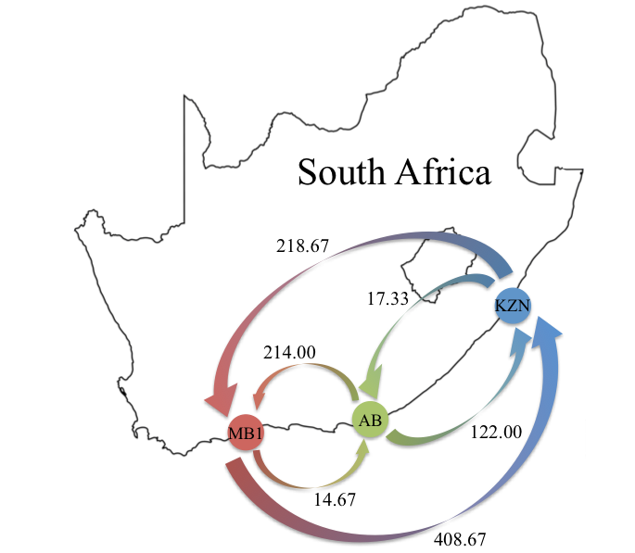

**Fig. S3.** Bayesian clustering assignment of two *S. zygaena* cohorts sampled across different sampling seasons (MB1, MB2). Each individual is represented by a single vertical column.

