Supporting Information

Targeting the MicroRNA Binding Domain of Argonaute 2: Rational Inhibitor Design and Study of Mutation Effects on Protein-Ligand Interaction

Shabnam Mahernia¹, Malihe Hassanzadeh², Sajad Sarvari³, Massoud Amanlou ^{1,2,4*}

¹ The Institute of Pharmaceutical Sciences (TIPS), Tehran University of Medical Sciences, Tehran, Iran.
² Department of Medicinal Chemistry, Faculty of Pharmacy, Tehran University of Medical Sciences, Tehran, Iran.
³ Institute of Biochemistry and Biophysics, University of Tehran, Tehran, Iran
⁴ Experimental Medicine Research Center, Tehran University of Medical Sciences, Tehran, Iran.

* Corresponding author: Massoud Amanlou.
Department of Medicinal Chemistry, Faculty of Pharmacy, Tehran University of Medical Sciences, Tehran, Iran., P.O. Box: 14155-6451, Tehran, Iran; Tel: +98-21-6695-9067; Fax: +98-21-6412-1111; E-mail: amanlou@tums.ac.ir.

* 5' uuaaugcuaaucgugauagggguu 3'

Fig. 1' The generated model of the human Ago2 in complex with miR155 based on the crystal structure of miR-20a (PDB ID: 4F3T). The N domain is shown in blue, the PAZ domain in purple, the mid domain in pink, the PIWI domain in red, linker1in cyan and linker2 in yellow.
* The sequence of the miR155 in the available crystal structure of Ago2.

Fig. 2' Representation of the last frame of MD simulation of the three complexes in which compound 1 binds to binding site of Ago2.
Fig. 3' DSSP analysis for the secondary structure fluctuations as a function of time from 0 to 200 ns for three complexes A, B and C.
Fig. 4' Hydrogen bond analysis from MD simulation study of interaction of compound 1 with Black: Complex A, Blue: Complex B, Pink: Complex C.
Table 1' 2D interaction diagram for the complex protein-ligand after docking interaction. violet: π-Sigma, pink: π-Alkyl, orange: π-Cation, light green: Van der Waals, green: Hydrogen bond, violet: π-π-stacked, cyan: Halogen.
No. | Number of active torsions | CLogP | Structure
1 | 4 | 5 | 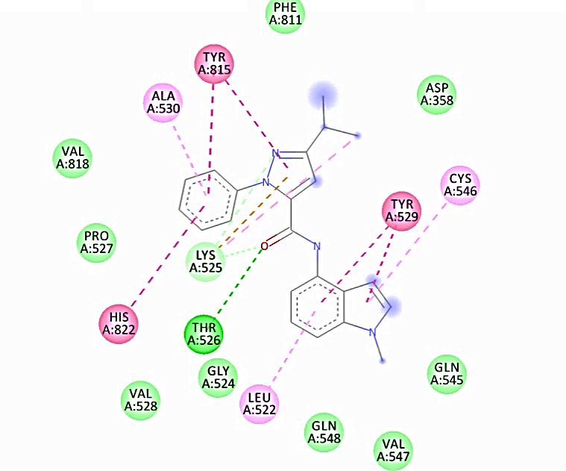
2 | 2 | 3.3 | 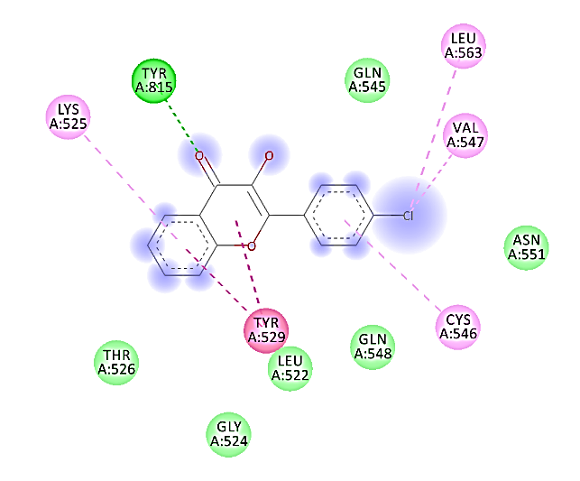
3 | 3 | 4.6 | 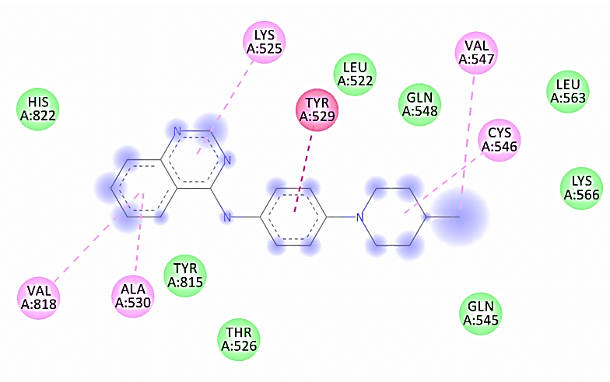
4 | 2 | 3.3 | 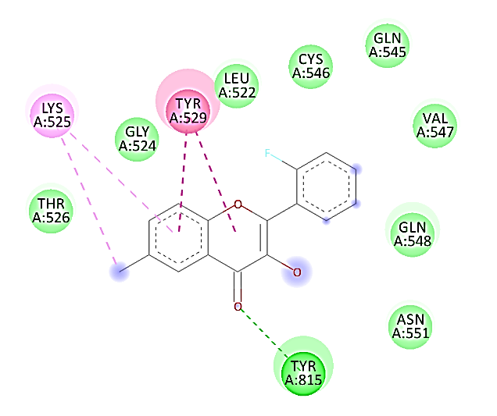
5 | 3 | 4.7 | 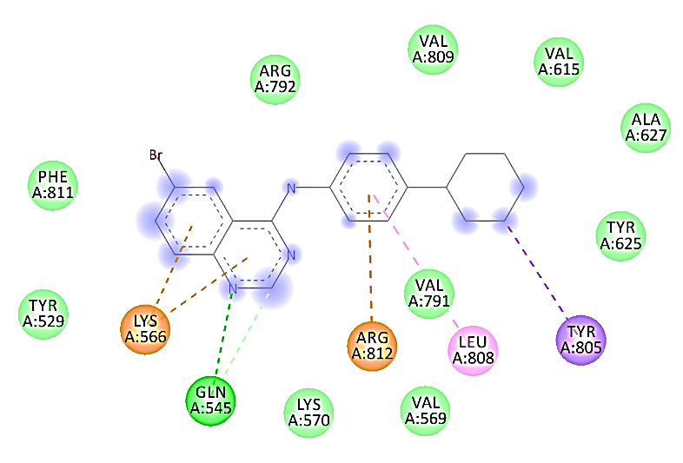
6 | 3 | 3.1 | 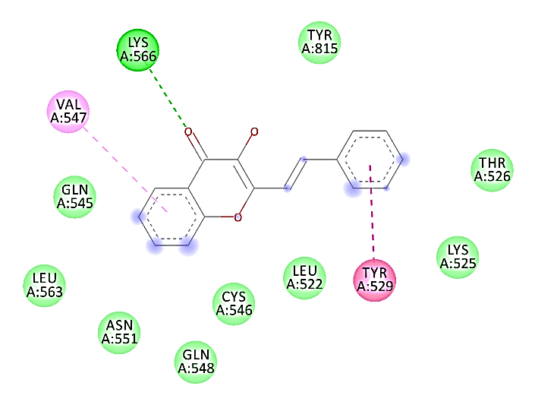
7 | 2 | 3.3 | 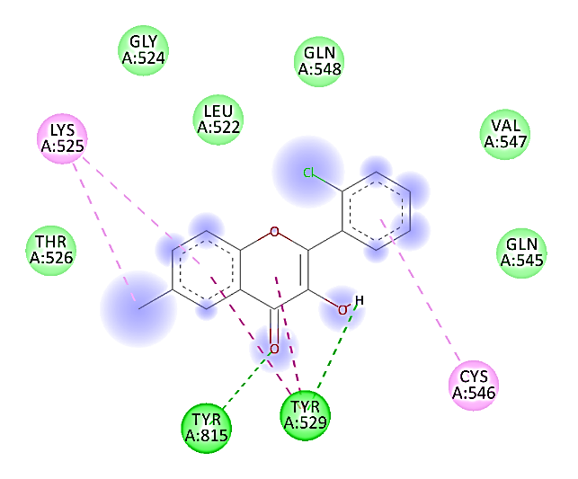
8 | 2 | 2.8 | 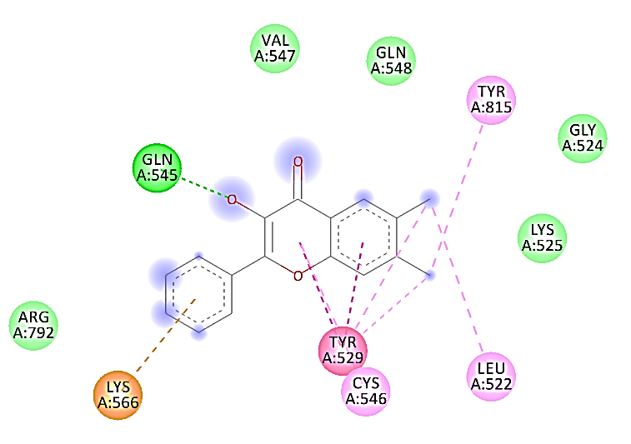
9 | 2 | 3.1 | 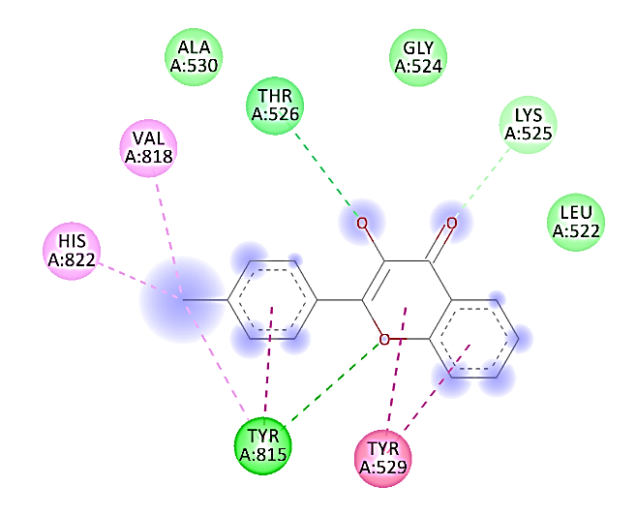
10 | 2 | 3.26 | 