Supporting Material

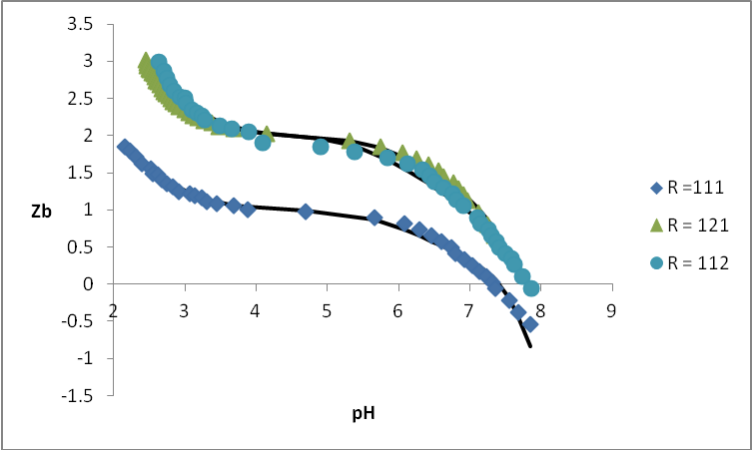
Figure 1 : Z_{B} versus pH data of the ternary nickel(II) - ligand L – α-alanine system

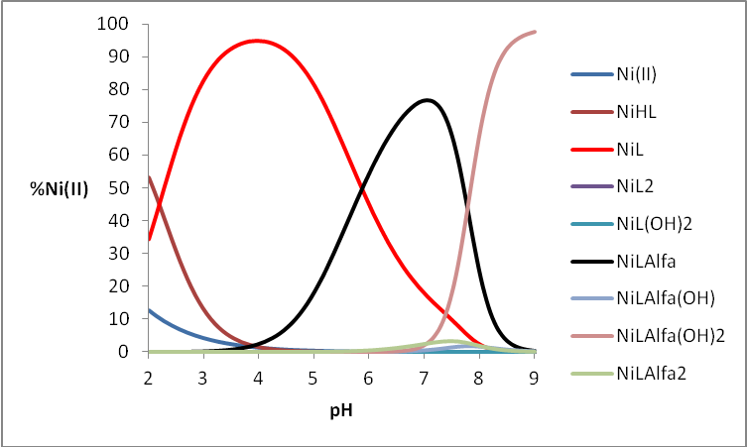
Figure 2 : Species distribution diagram as a function of pH for the A) nickel(II) – ligand L – α-alanine, in 1.0 mol.dm⁻³ NaCl at 25 °C considering the conditions M_{T} = 2 mmol.dm⁻³ and molar ratio R = 1:1:1.

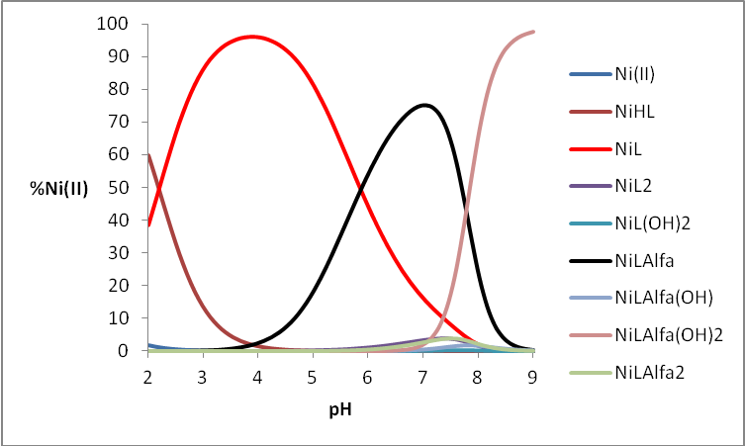
Figure 3: Species distribution diagram as a function of pH for the A) nickel(II) - ligand L – α-alanine, in 1.0 mol.dm⁻³ NaCl at 25 °C considering the conditions M_{T} = 2 mmol.dm⁻³ and molar ratio R = 1:2:1.

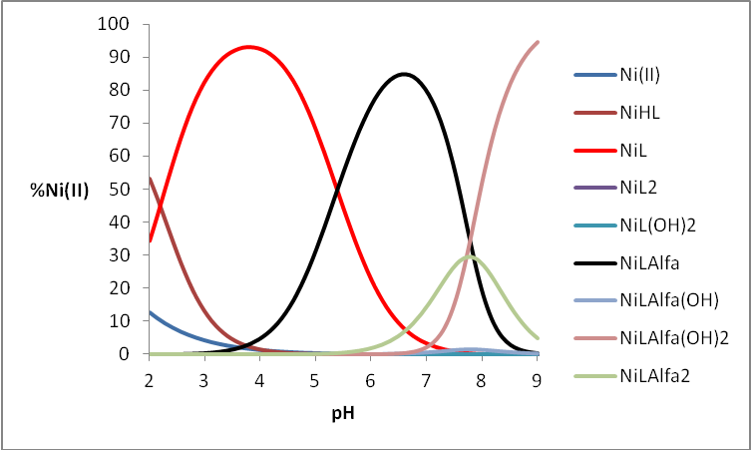
Figure 4 : Species distribution diagram as a function of pH for the A) nickel(II) - ligand L – α-alanine, in 1.0 mol.dm⁻³ NaCl at 25 °C considering the conditions M_{T} = 2 mmol.dm⁻³ and molar ratio R = 1:1:2.
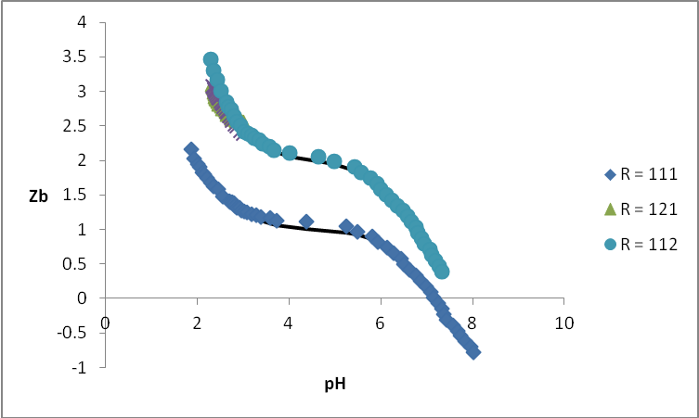
Figure 5 : Z_{B} versus pH data of the ternary nickel(II) - ligand L – glycine system

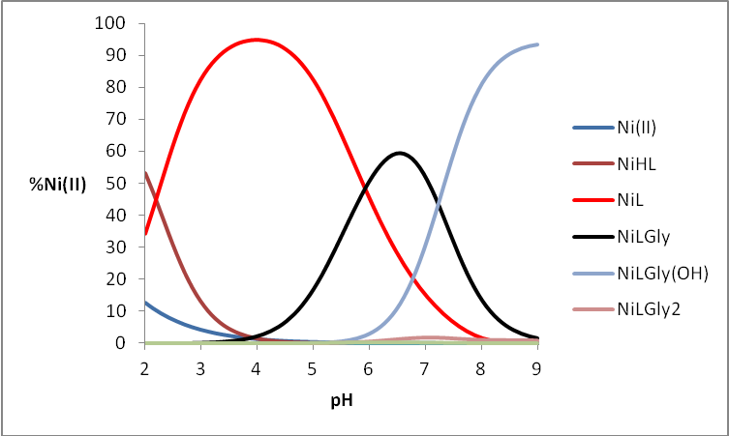
Figure 6 : Species distribution diagram as a function of pH for the A) nickel(II) - ligand L – glycine, in 1.0 mol.dm⁻³ NaCl at 25 °C considering the conditions M_{T} = 2 mmol.dm⁻³ and molar ratio R = 1:1:1.
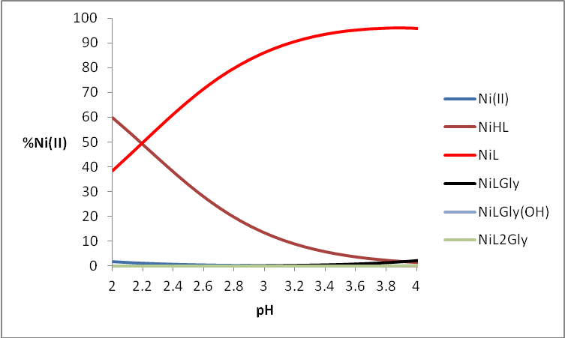
Figure 7 : Species distribution diagram as a function of pH for the A) nickel(II) - ligand L – glycine, in 1.0 mol.dm⁻³ NaCl at 25 °C considering the conditions M_{T} = 2 mmol.dm⁻³ and molar ratio R = 1:2:1.
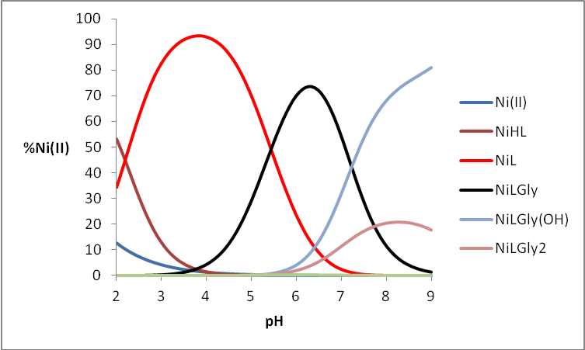
Figure 8 : Species distribution diagram as a function of pH for the A) nickel(II) - ligand L – glycine, in 1.0 mol.dm⁻³ NaCl at 25 °C considering the conditions M_{T} = 2 mmol.dm⁻³ and molar ratio R = 1:1:2.
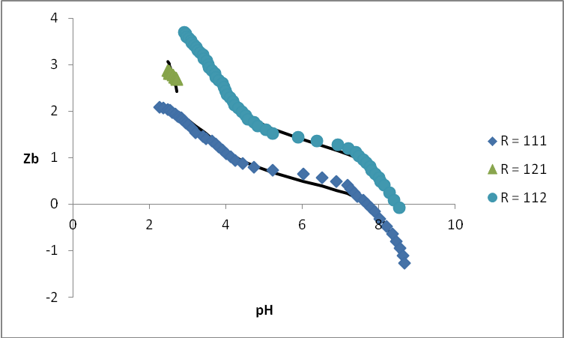
Figure 9 : Z_{B} versus pH data of the ternary nickel(II) - ligand L – β-alanine system
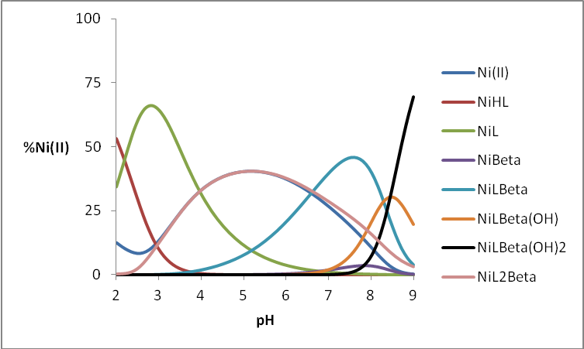
Figure 10 : Species distribution diagram as a function of pH for the A) nickel(II) - ligand L – β-alanine, in 1.0 mol.dm⁻³ NaCl at 25 °C considering the conditions M_{T} = 2 mmol.dm⁻³ and molar ratio R = 1:1:1.

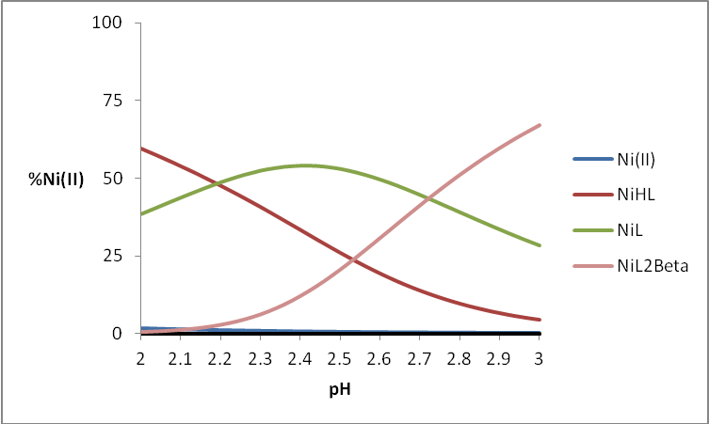
Figure 11: Species distribution diagram as a function of pH for the A) nickel(II) - ligand L – β-alanine, in 1.0 mol.dm⁻³ NaCl at 25 °C considering the conditions M_{T} = 2 mmol.dm⁻³ and molar ratio R = 1:2:1.

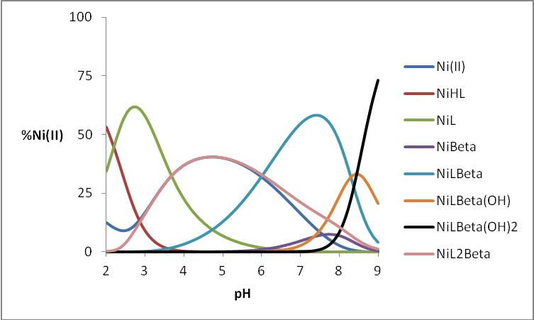
Figure 12 : Species distribution diagram as a function of pH for the A) nickel(II) - ligand L – β-alanine, in 1.0 mol.dm⁻³ NaCl at 25 °C considering the conditions M_{T} = 2 mmol.dm⁻³ and molar ratio R = 1:1:2.
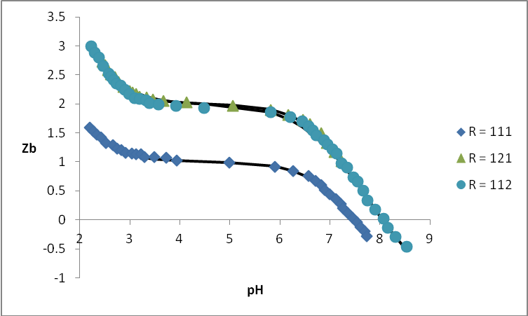
Figure 13 : Z_{B} versus pH data of the ternary nickel(II) - ligand L – proline system
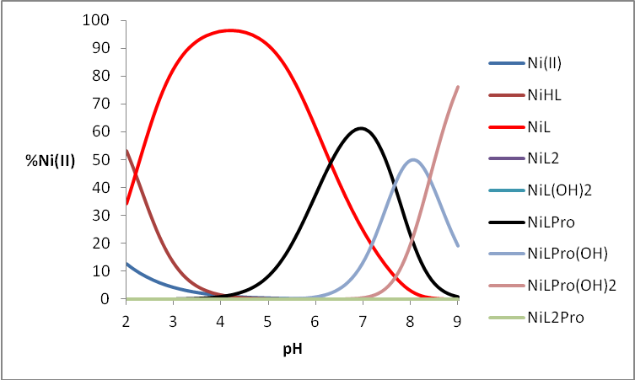
Figure 14 : Species distribution diagram as a function of pH for the A) nickel(II) - ligand L – proline, in 1.0 mol.dm⁻³ NaCl at 25 °C considering the conditions M_{T} = 2 mmol.dm⁻³ and molar ratio R = 1:1:1.

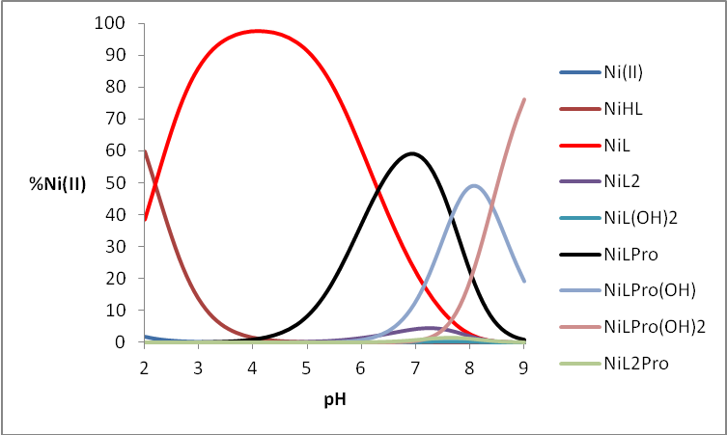
Figure 15: Species distribution diagram as a function of pH for the A) nickel(II) - ligand L – proline, in 1.0 mol.dm⁻³ NaCl at 25 °C considering the conditions M_{T} = 2 mmol.dm⁻³ and molar ratio R = 1:2:1.

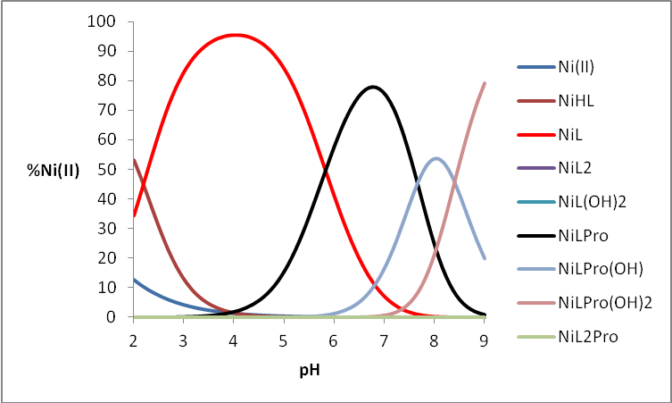
Figure 16 : Species distribution diagram as a function of pH for the A) nickel(II) - ligand L – proline, in 1.0 mol.dm⁻³ NaCl at 25 °C considering the conditions M_{T} = 2 mmol.dm⁻³ and molar ratio R = 1:1:2.

Figure 17 : Z_{B} versus pH data of the ternary nickel(II) - ligand L – serine system

Figure 18 : Species distribution diagram as a function of pH for the A) nickel(II) - ligand L – serine, in 1.0 mol.dm⁻³ NaCl at 25 °C considering the conditions M_{T} = 2 mmol.dm⁻³ and molar ratio R = 1:1:1.

Figure 19: Species distribution diagram as a function of pH for the A) nickel(II) - ligand L – serine, in 1.0 mol.dm⁻³ NaCl at 25 °C considering the conditions M_{T} = 2 mmol.dm⁻³ and molar ratio R = 1:2:1.

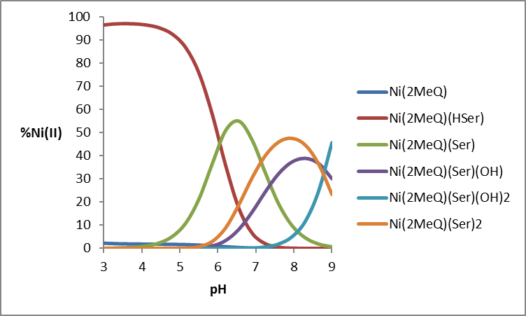
Figure 20: Species distribution diagram as a function of pH for the A) nickel(II) - ligand L – serine, in 1.0 mol.dm⁻³ NaCl at 25 °C considering the conditions M_{T} = 2 mmol.dm⁻³ and molar ratio R = 1:1:2.

Figure 21 : Z_{B} versus pH data of the ternary nickel(II) - ligand L – threonine system

Figure 22 : Species distribution diagram as a function of pH for the A) nickel(II) - ligand L – threonine, in 1.0 mol.dm⁻³ NaCl at 25 °C considering the conditions M_{T} = 2 mmol.dm⁻³ and molar ratio R = 1:1:1.

Figure 23: Species distribution diagram as a function of pH for the A) nickel(II) - ligand L – threonine, in 1.0 mol.dm⁻³ NaCl at 25 °C considering the conditions M_{T} = 2 mmol.dm⁻³ and molar ratio R = 1:2:1.

Figure 24: Species distribution diagram as a function of pH for the A) nickel(II) - ligand L – threonine, in 1.0 mol.dm⁻³ NaCl at 25 °C considering the conditions M_{T} = 2 mmol.dm⁻³ and molar ratio R = 1:1:2.

Figure 25 : Z_{B} versus pH data of the ternary nickel(II) - ligand L –methionine system

Figure 26 : Species distribution diagram as a function of pH for the A) nickel(II) - ligand L –methionine, in 1.0 mol.dm⁻³ NaCl at 25 °C considering the conditions M_{T} = 2 mmol.dm⁻³ and molar ratio R = 1:1:1.

Figure 27: Species distribution diagram as a function of pH for the A) nickel(II) - ligand L –methionine, in 1.0 mol.dm⁻³ NaCl at 25 °C considering the conditions M_{T} = 2 mmol.dm⁻³ and molar ratio R = 1:2:1.

Figure 28: Species distribution diagram as a function of pH for the A) nickel(II) - ligand L –methionine, in 1.0 mol.dm⁻³ NaCl at 25 °C considering the conditions M_{T} = 2 mmol.dm⁻³ and molar ratio R = 1:1:2.

Figure 29: Z_{B} versus pH data of the ternary nickel(II) - ligand L – phenylalanine system

Figure 30 : Species distribution diagram as a function of pH for the A) nickel(II) - ligand L – phenylalanine, in 1.0 mol.dm⁻³ NaCl at 25 °C considering the conditions M_{T} = 2 mmol.dm⁻³ and molar ratio R = 1:1:1.

Figure 31: Species distribution diagram as a function of pH for the A) nickel(II) - ligand L – phenylalanine, in 1.0 mol.dm⁻³ NaCl at 25 °C considering the conditions M_{T} = 2 mmol.dm⁻³ and molar ratio R = 1:2:1.

Figure 32: Species distribution diagram as a function of pH for the A) nickel(II) - ligand L – phenylalanine, in 1.0 mol.dm⁻³ NaCl at 25 °C considering the conditions M_{T} = 2 mmol.dm⁻³ and molar ratio R = 1:1:2.

Figure 33 : Z_{B} versus pH data of the ternary nickel(II) - ligand L – aspartic acid system

Figure 34 : Species distribution diagram as a function of pH for the A) nickel(II) - ligand L – aspartic acid, in 1.0 mol.dm⁻³ NaCl at 25 °C considering the conditions M_{T} = 2 mmol.dm⁻³ and molar ratio R = 1:1:1.

Figure 35: Species distribution diagram as a function of pH for the A) nickel(II) - ligand L – aspartic acid, in 1.0 mol.dm⁻³ NaCl at 25 °C considering the conditions M_{T} = 2 mmol.dm⁻³ and molar ratio R = 1:2:1.

Figure 36: Species distribution diagram as a function of pH for the A) nickel(II) - ligand L – aspartic acid, in 1.0 mol.dm⁻³ NaCl at 25 °C considering the conditions M_{T} = 2 mmol.dm⁻³ and molar ratio R = 1:1:2.

Figure 37: Z_{B} versus pH data of the ternary nickel(II) - ligand L – glutamic acid system

Figure 38: Species distribution diagram as a function of pH for the A) nickel(II) - ligand L – glutamic acid, in 1.0 mol.dm⁻³ NaCl at 25 °C considering the conditions M_{T} = 2 mmol.dm⁻³ and molar ratio R = 1:1:1.

Figure 39: Species distribution diagram as a function of pH for the A) nickel(II) - ligand L – glutamic acid, in 1.0 mol.dm⁻³ NaCl at 25 °C considering the conditions M_{T} = 2 mmol.dm⁻³ and molar ratio R = 1:2:1.

Figure 40: Species distribution diagram as a function of pH for the A) nickel(II) - ligand L – glutamic acid, in 1.0 mol.dm⁻³ NaCl at 25 °C considering the conditions M_{T} = 2 mmol.dm⁻³ and molar ratio R = 1:1:2.

Figure 41: Z_{B} versus pH data of the ternary nickel(II) - ligand L – cysteine system

Figure 42: Species distribution diagram as a function of pH for the A) nickel(II) - ligand L – cysteine, in 1.0 mol.dm⁻³ NaCl at 25 °C considering the conditions M_{T} = 2 mmol.dm⁻³ and molar ratio R = 1:1:1.

Figure 43: Species distribution diagram as a function of pH for the A) nickel(II) - ligand L – cysteine, in 1.0 mol.dm⁻³ NaCl at 25 °C considering the conditions M_{T} = 2 mmol.dm⁻³ and molar ratio R = 1:2:1.

Figure 44: Z_{B} versus pH data of the ternary nickel(II) - ligand L – histidine system

Figure 45: Species distribution diagram as a function of pH for the A) nickel(II) - ligand L – histidine, in 1.0 mol.dm⁻³ NaCl at 25 °C considering the conditions M_{T} = 2 mmol.dm⁻³ and molar ratio R = 1:1:1.

Figure 46: Species distribution diagram as a function of pH for the A) nickel(II) - ligand L – histidine, in 1.0 mol.dm⁻³ NaCl at 25 °C considering the conditions M_{T} = 2 mmol.dm⁻³ and molar ratio R = 1:2:1.

