Contrasting normality: Supplementary materials
Contents
Data and code 3
Power analyses 3
Expectations normality 3
Social norms normality 3
Past behavior normality 3
Overall Experiments 1-3 3
Experiment 4 4
Materials used in the experiments 5
Experiment 1 5
Conditions 5
Manipulation check 6
Dependent variables 6
Experiment 2 7
Conditions 7
Quiz comprehension questions 9
Manipulation checks 10
Dependent variables 10
Experiment 3 11
Conditions 11
Quiz comprehension questions 12
Dependent variables 12
Experiment 4 13
Pre-registration 13
Conditions 15
Quiz comprehension questions 18
Dependent variables 18
Results for perceived joy 20
Procedure and data disclosures 21
Data collection 21
Data exclusions 21
Conditions reporting 21
Variables reporting 21
Clarification about control condition 21
Additional findings, tables, and figures 22
Experiment 1 22
Post Hoc Tests 22
Figures 23
Experiment 1 after exclusions 25
Experiment 2 27
Post hoc comparisons 27
Figures 29
Experiment 3 30
Post hoc 30
Figures 31
Experiment 4 violin and estimation plots 32
Joy findings figures 34
Experiment 1 34
Experiment 3 34
Experiment 4 35
Gender differences 36
Experiment 1 36
Experiment 2 36
Experiment 3 37
Experiment 4 37
Discussion sections moved from main manuscript 38

Data and code
All datasets and code are available on the Open Science Framework (review version): https://osf.io/wmkpe/?view_only=4d181e034b974b59890650ed0f45d58b

Power analyses

Expectations normality
Used in Experiments 1 and 3.
Our experimental paradigm was based on the Zeelenberg et al. (2002) experiments. In Experiment 2 the reported statistics were:
- Inaction expectations (won last game): M = 5.2, SD = 1.2, N =25 regret for action
- Action expectations (lost last game): M = 2.9, SD = 1.3, N =25 regret for action
Which resulted in an effect size d of 1.84, a very strong effect.

Social norms normality
Used in Experiments 1 and 2.
Our experimental paradigm was based on Feldman and Albarracín (in press) experiments. Their Table 4 summarizes the effect for the manipulation used in Experiment 1 as 1.15 and the effect for the manipulation used in Experiment 2 as .91. A very strong effect.

Past behavior normality
As far as we know this is the first time past behavior has been tested in the context of the action-effect. In the introduction we discussed the classic Kahneman and Tversky (1982) hitch-hiker scenario for past behavior normality. The results reported were of 88% (differences from a random 50-50% split), indicating a chi-square of 57.76, when can be converted to a Cohen d of 1.70. Again, a very strong effect.

Overall Experiments 1-3
Due to the very large effects, power analyses required relatively small samples, yet we decided on a minimum of 50 participants per cell. Experiment 1 sample was limited by the availability and participation of undergraduate students in the course credit participant pool.

Experiment 4
This experiment was pre-registered and used Experiments 1-3 effects as reference for power analyses.
Planned sample size: The smallest effect detected for regret in the 3 experiments so far was d = .51. For power = .80 alpha of .05 and one-tail contrasts for these effects require a sample size of 49 per condition. With 8 conditions, we aimed for a minimum of 400 participants.
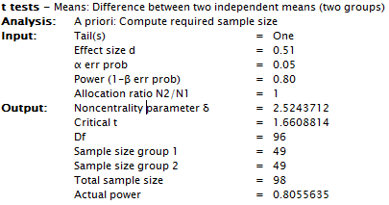

Materials used in the experiments

Experiment 1

Conditions

Action society Action expectations
Imagine a society that is mostly driven by action. Most, if not all, of the people living in this society are very proactive and action-oriented, strongly valuing action over inaction. The norms in this society are for people to keep busy and minimize idle time.
(Questions about the society)
Now try and imagine this action-driven society, and the following situation taking place in that society: In this action-driven society, there are two soccer teams (note: soccer is sometimes called football in some countries, but we are referring to the ball kicking game). John and David both coach a soccer team. John is the coach of BlueBlue, and David is the coach of RedRed.
Both coaches lost the last game their teams played with a score of 4–0.
On Sunday the teams are going to play again, and both coaches need to make a decision whether to change the playing team or leave it to be the same as the team who played in the last game.
- Coach John decides to take action: He replaces three players with three new players.
- Coach David decides to not take action and to not change his team.

Action society Inaction expectations
Imagine a society that is mostly driven by action. Most, if not all, of the people living in this society are very proactive and action-oriented, strongly valuing action over inaction. The norms in this society are for people to keep busy and minimize idle time.
(Questions about the society)
Now try and imagine this action-driven society, and the following situation taking place in that society: In this action-driven society, there are two soccer teams (note: soccer is sometimes called football in some countries, but we are referring to the ball kicking game). John and David both coach a soccer team. John is the coach of BlueBlue, and David is the coach of RedRed.
Both coaches won the last game their teams played with a score of 4-0.
On Sunday the teams are going to play again, and both coaches need to make a decision whether to change the playing team or leave it to be the same as the team who played in the last game.
- Coach John decides to take action: He replaces three players with three new players.
- Coach David decides to not take action and to not change his team.

Inaction society Action expectations
Imagine a society that is mostly driven by inaction. Most, if not all, of the people living in this society are very passive and oriented towards inaction, strongly valuing the status-quo over taking action. The norms in this society are for people to refrain from action and maximize idle time.
(Questions about the society)
Now try and imagine this inaction-driven society, and the following situation taking place in that society: In this inaction-driven society, there are two soccer teams (note: soccer is sometimes called football in some countries, but we are referring to the ball kicking game). John and David both coach a soccer team. John is the coach of BlueBlue, and David is the coach of RedRed.
Both coaches lost the last game their teams played with a score of 4–0.
On Sunday the teams are going to play again, and both coaches need to make a decision whether to change the playing team or leave it to be the same as the team who played in the last game.
- Coach John decides to take action: He replaces three players with three new players.
- Coach David decides to not take action and to not change his team.

Inaction society Inaction expectations
Imagine a society that is mostly driven by inaction. Most, if not all, of the people living in this society are very passive and oriented towards inaction, strongly valuing the status-quo over taking action. The norms in this society are for people to refrain from action and maximize idle time.
(Questions about the society)
Now try and imagine this inaction-driven society, and the following situation taking place in that society: In this inaction-driven society, there are two soccer teams (note: soccer is sometimes called football in some countries, but we are referring to the ball kicking game). John and David both coach a soccer team. John is the coach of BlueBlue, and David is the coach of RedRed.
Both coaches won the last game their teams played with a score of 4-0.
On Sunday the teams are going to play again, and both coaches need to make a decision whether to change the playing team or leave it to be the same as the team who played in the last game.
- Coach John decides to take action: He replaces three players with three new players.
- Coach David decides to not take action and to not change his team.

Manipulation check
In such a society which of the following is the more normative behavior?
(1 – Action, 2- inaction, 3 - Neither)

* Note: following the manipulation check there were seven additional questions added after the manipulation about the social norms . Namely, about realism ("How similar is this society to the society in the country where you currently live?"), perceived responsibility for action ("In such a society, how responsible are people for the negative outcomes resulting from their actions") and for inaction ("In such a society, how responsible are people for the negative outcomes resulting from their ‎inactions?"), perceived intent for action ("In such a society, to what extent are actions perceived as deliberate and intentional?‎") and for inaction ("In such a society, to what extent are inactions perceived as deliberate and intentional?"), and importance of morality ("Based on your intuition, how moral are the people living in such a society?" and "Based on your intuition, how important is it for people to be moral in this society?"). These questions were not analysed, but are provided in the dataset.

Dependent variables

Perceived regret
The teams play according to the coaches' decisions. The results of the match on Sunday is that both teams lost 3–0. Consider that both coaches are members of an action-driven society, and both coaches were influenced by results of the first game. Who feels greater regret over losing the game, coach John or coach David?
- Definitely David for not taking action
- Most likely David for not taking action
- Probably David for not taking action
- Probably John for taking action
- Most likely John for taking action
- Definitely John for taking action

Perceived joy
Let's examine a different possible result. Suppose that the teams played according to the coaches' decisions, and the results were that both teams won 3-0. Consider that both coaches are members of an action-driven society, and both coaches were influenced by results of the first game. Who feels greater joy over winning the game, coach John or coach David?
- Definitely David for not taking action
- Most likely David for not taking action
- Probably David for not taking action
- Probably John for taking action
- Most likely John for taking action
- Definitely John for taking action

Experiment 2

Conditions

Action norms Action past behavior
Mr. Paul and Mr. George are stock traders who work for A&M Finance. Most, if not all, of the stock traders working for A&M Finance are very action-driven, eager and proactive decision makers, strongly valuing action over inaction. The norms in this company are for people to keep looking for new opportunities for investment with the unofficial motto of "go for it!".
Paul and George are employees favoring action. In past investment decision situations when Paul and George were faced with the options of taking action or not taking action they have shown a clear preference for action.
- Paul has made the decision to invest in company A. During the past year he considered switching to invest stock in company C, but he decided against it. He now finds out that the investment would have been better off by $1,000,000 if he had switched to the stock of company C.
- George has made the decision to invest in company B. During the past year he switched the investment to stock in company A. He now finds out that the investment would have been better off by $1,000,000 if he had kept his investment in stock for company B.

Action norms Inaction past behavior
Mr. Paul and Mr. George are stock traders who work for A&M Finance. Most, if not all, of the stock traders working for A&M Finance are very action-driven, eager and proactive decision makers, strongly valuing action over inaction. The norms in this company are for people to keep looking for new opportunities for investment with the unofficial motto of "go for it!".
Paul and George are employees favoring the status-quo. In past investment decision situations when Paul and George were faced with the options of taking action or not taking action they have shown a clear preference for inaction.
- Paul has made the decision to invest in company A. During the past year he considered switching to invest stock in company C, but he decided against it. He now finds out that the investment would have been better off by $1,000,000 if he had switched to the stock of company C.
- George has made the decision to invest in company B. During the past year he switched the investment to stock in company A. He now finds out that the investment would have been better off by $1,000,000 if he had kept his investment in stock for company B.

Inaction norms Action past behavior
Mr. Paul and Mr. George are stock traders who work for B&N Finance. Most, if not all, of the stock traders working for B&N Finance are very careful and cautious decision makers, strongly valuing the status-quo over taking action. The norms in this company are for people to not act unless they are certain it is necessary, with the unofficial motto of "if it isn't broken, don't fix it!".
Paul and George are employees favoring action. In past investment decision situations when Paul and George were faced with the options of taking action or not taking action they have shown a clear preference for action.
- Paul has made the decision to invest in company A. During the past year he considered switching to invest stock in company C, but he decided against it. He now finds out that the investment would have been better off by $1,000,000 if he had switched to the stock of company C.
- George has made the decision to invest in company B. During the past year he switched the investment to stock in company A. He now finds out that the investment would have been better off by $1,000,000 if he had kept his investment in stock for company B.

Inaction norms Inaction past behavior
Mr. Paul and Mr. George are stock traders who work for B&N Finance. Most, if not all, of the stock traders working for B&N Finance are very careful and cautious decision makers, strongly valuing the status-quo over taking action. The norms in this company are for people to not act unless they are certain it is necessary, with the unofficial motto of "if it isn't broken, don't fix it!".
Paul and George are employees favoring the status-quo. In past investment decision situations when Paul and George were faced with the options of taking action or not taking action they have shown a clear preference for inaction.
- Paul has made the decision to invest in company A. During the past year he considered switching to invest stock in company C, but he decided against it. He now finds out that the investment would have been better off by $1,000,000 if he had switched to the stock of company C.
- George has made the decision to invest in company B. During the past year he switched the investment to stock in company A. He now finds out that the investment would have been better off by $1,000,000 if he had kept his investment in stock for company B.

Control norms action past behavior
Mr. Paul and Mr. George are stock traders who work for C&O Finance.
Paul and George are employees favoring action. In past investment decision situations when Paul and George were faced with the options of taking action or not taking action they have shown a clear preference for action.
- Paul has made the decision to invest in company A. During the past year he considered switching to invest stock in company C, but he decided against it. He now finds out that the investment would have been better off by $1,000,000 if he had switched to the stock of company C.
- George has made the decision to invest in company B. During the past year he switched the investment to stock in company A. He now finds out that the investment would have been better off by $1,000,000 if he had kept his investment in stock for company B.

Control norms inaction past behavior
Mr. Paul and Mr. George are stock traders who work for C&O Finance.
Paul and George are employees favoring the status-quo. In past investment decision situations when Paul and George were faced with the options of taking action or not taking action they have shown a clear preference for inaction.
- Paul has made the decision to invest in company A. During the past year he considered switching to invest stock in company C, but he decided against it. He now finds out that the investment would have been better off by $1,000,000 if he had switched to the stock of company C.
- George has made the decision to invest in company B. During the past year he switched the investment to stock in company A. He now finds out that the investment would have been better off by $1,000,000 if he had kept his investment in stock for company B.

Quiz comprehension questions
Participants were required to answer the comprehension questions correctly in order to proceed to the next page (Qualtrics validation).
What are the social norms in Paul's and George’s company?
- Proactivity (action)
- Status quo (inaction)
- It doesn’t say
What are Paul and George's past behavioral preference?
- Proactivity (action)
- Status quo (inaction)
- It doesn’t say
Paul's final investment decision involved which of the following?
- Switching investments (action)
- Not switching investments (inaction)
George's final investment decision involved which of the following?
- Switching investments (action)
- Not switching investments (inaction)
At the end, Paul and George both had finally invested in which company?
- Company A
- Company B
- Company C

Manipulation checks

Norms
Whose investment decision is more common in the company?
- Definitely inaction Paul
- Most likely inaction Paul
- Probably inaction Paul
- Probably action George
- Most likely action George
- Definitely action George

Past behavior
Whose investment decision is more in line with past behavior?
- Definitely inaction Paul
- Most likely inaction Paul
- Probably inaction Paul
- Probably action George
- Most likely action George
- Definitely action George

Dependent variables

Regret
Considering the company behavioral norms and Paul and George’s personal behavioral tendencies, who feels greater regret over his investment decision?
- Definitely inaction Paul
- Most likely inaction Paul
- Probably inaction Paul
- Probably action George
- Most likely action George
- Definitely action George

Experiment 3

Conditions

Action past behavior Action expectations

John and David both coach soccer teams. John is the coach of BlueBlue, and David is the coach of RedRed. Both John and David are soccer coaches that favor action.

In past games when John and David were faced with the option of changing the line-up or keeping the same line-up, they have both shown a clear preference for action and making a change.​

Both coaches lost the last game their teams played with a score of 4–0. This puts pressure on both to change the line-up (action) to avoid another loss.

On Sunday the teams are going to play again, and both coaches need to make a decision whether to change the team line-up or leave it to be the same as the team who played in the last game.

Coach John decides to take action: He replaces three of the players with three new players.

Coach David decides to not take action and to not change his team's line-up.

Action past behavior inaction expectations
John and David both coach soccer teams. John is the coach of BlueBlue, and David is the coach of RedRed. Both John and David are soccer coaches that favor action.
In past games when John and David were faced with the option of changing the line-up or keeping the same line-up, they have both shown a clear preference for action and making a change.​
Both coaches won the last game their teams played with a score of 4-0. This puts pressure on both of them to keep the current line-up (inaction) to repeat another win.
On Sunday the teams are going to play again, and both coaches need to make a decision whether to change the team line-up or leave it to be the same as the team who played in the last game.
- Coach John decides to take action: He replaces three of the players with three new players.
- Coach David decides to not take action and to not change his team's line-up.

Inaction past behavior action expectations
John and David both coach soccer teams. John is the coach of BlueBlue, and David is the coach of RedRed. Both John and David are soccer coaches that favor the status-quo.
In past games when John and David were faced with the option of changing the line-up or keeping the same line-up, they have both shown a clear preference for inaction and not changing the line-up.​
Both coaches lost the last game their teams played with a score of 4–0. This puts pressure on both to change the line-up (action) to avoid another loss.
On Sunday the teams are going to play again, and both coaches need to make a decision whether to change the team line-up or leave it to be the same as the team who played in the last game.
- Coach John decides to take action: He replaces three of the players with three new players.
- Coach David decides to not take action and to not change his team's line-up.

Inaction past behavior inaction expectations
John and David both coach soccer teams. John is the coach of BlueBlue, and David is the coach of RedRed. Both John and David are soccer coaches that favor the status-quo.
In past games when John and David were faced with the option of changing the line-up or keeping the same line-up, they have both shown a clear preference for inaction and not changing the line-up.​
Both coaches won the last game their teams played with a score of 4-0. This puts pressure on both of them to keep the current line-up (inaction) to repeat another win.
On Sunday the teams are going to play again, and both coaches need to make a decision whether to change the team line-up or leave it to be the same as the team who played in the last game.
- Coach John decides to take action: He replaces three of the players with three new players.
- Coach David decides to not take action and to not change his team's line-up.

Quiz comprehension questions
Participants were required to answer the comprehension questions correctly in order to proceed to the next page (Qualtrics validation).
What are John and David's past behavioral preference?
- Change (action)
- Status quo (inaction)
What was the outcome of the last game played?
- They both lost the last game (more pressure to take action)
- They both won the last game (more pressure to keep the status-quo)
Finally, what did John decide to do for the upcoming game?
- Change the line-up (action)
- Keep the same line-up (inaction)
Finally, what did David decide to do for the upcoming game?
- Change the line-up (action)
- Keep the same line-up (inaction)

Dependent variables

Regret
Now, imagine the following result: The teams play according to the coaches' decisions. The results of the match on Sunday were that both teams lost 3–0. Consider that both coaches have general action behavioral tendencies, and both coaches were under some pressure for action because of the results of the previous game. Who feels greater regret over losing the game, inaction coach David or action coach John?
- Definitely David for not taking action
- Most likely David for not taking action
- Probably David for not taking action
- Probably John for taking action
- Most likely John for taking action
- Definitely John for taking action

Joy
Let's examine a different possible result. Imagine the following instead... The teams played according to the coaches' decisions. The results of the match were that both teams won 3-0. Consider that both coaches have general action behavioral tendencies, and both coaches were under some pressure for action because of the results of the previous game. Who feels greater joy over winning the game, inaction coach David or action coach John?
- Definitely David for not taking action
- Most likely David for not taking action
- Probably David for not taking action
- Probably John for taking action
- Most likely John for taking action
- Definitely John for taking action

Experiment 4

Pre-registration
The experiment was pre-registered on the OSF before data collection began: https://osf.io/22yuf/?view_only=20c49ee09b4a47ac85c33824524ef3c8

Below is a copy-paste from the pre-registration. Hypotheses 1, 3, and 4 were supported. Hypothesis 2 was not supported, and it discussed.

Intro: see Feldman and Albarracín (2017) and initial manuscript draft for a full introduction to the action-effect and normality categories.
Summary of three experiments conducted so far:
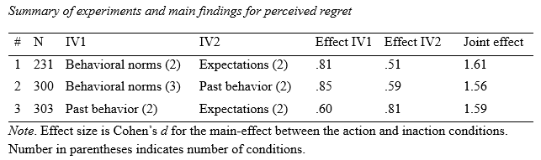

A. Hypotheses
Description of essential elements
- The three normality categories (past behavior normality, role/situational expectations normality, and social norms normality) are distinct and will all have unique medium to strong impact on the regret action-effect.
- Based on experiments #1 to #3 we expect that for regret social norms normality would have the strongest effect followed by expectations normality and finally past behavior normality.
- The joint effects of any two types of the three normality categories on regret would result in strong effects (in previous experiments: d = 1.56 to 1.61).
- The joint effects of all three normality categories for regret would result in the strongest effect and a complete reversal of the action-effect.

B. Methods
Description of essential elements
Design
List, based on your hypotheses from section A:
- Independent variables
  - Behavioral norms normality: action versus inaction.
  - Expectations normality: action versus inaction.
  - Social norms normality: action versus inaction.
- Dependent variables:
  - Regret (main DV of interest, based on the action-effect)
  - Joy (supplementary DV, weak to very weak effects expected)
- Third variables acting as covariates or moderators: none.
Planned sample
- Pre-selection rules: American MTurkers.
- Planned sample size: The smallest effect detected for regret in the 3 experiments so far was d = .51. For power = .80 alpha of .05 and one-tail contrasts for these effects require a sample size of 49 per condition. With 8 conditions, we will run a minimum of 400 participants.
- No termination rule.

Exclusion criteria
- We might exclude based on timers. Completing the session (expected ~5min) within less than 2 minutes would serve as an exclusion criteria, but we will check for data quality in such cases.
We will include questions about English comprehension and seriousness in participation.
In any case, we will report results both with and without exclusion of participants and data+code of the full sample before exclusions will be made available to reviewers and readers.

Procedure
- See attached Qualtrics survey for full procedure and materials. Materials are fixed order display. Randomization is evenly presented (Qualtrics option).

C. Analysis plan
Confirmatory analyses
Describe the analyses that will test each main prediction from the hypotheses section. For each one, include:
- The statistical technique: three-way ANOVA with two-way ANOVAs and t-test contrasts.
- Regret and joy DVs are single-item, no calculations required.

Recommended elements
Specify contingencies and assumptions, such as:
- No missing data, imposed by Qualtrics checks.
- Single items – no reliability criteria needed.
- DVs: no anticipated data transformations required.

Answer the following final questions:
Has data collection begun for this project?
- No, data collection has not begun
The (estimated) start and end dates for this project are (optional): Soon after pre-registration
Any additional comments before I pre-register this project (optional): None.

Conditions

Action social norms - Action past behavior - Action expectations
Imagine a society that is mostly driven by action. Most, if not all, of the people living in this society are very proactive and action-oriented, strongly valuing action over inaction.
In this action-driven society, there are two soccer teams. John and David both coach a soccer team. John is the coach of BlueBlue, and David is the coach of RedRed.
Both John and David are soccer coaches that favor action. In past games when John and David were faced with the option of changing the line-up or keeping the same line-up, they have both shown a clear preference for action and making a change.​
Both coaches lost the last game their teams played with a score of 4–0. This puts pressure on both to change the line-up to avoid another loss (action expectations).
On Sunday the teams are going to play again, and both coaches need to make a decision whether to change the playing team or leave it to be the same as the team who played in the last game.
- Coach John decides to take action: He replaces three of the players with three new players.
- Coach David decides to not take action and to not change his team's line-up.

Action social norms - Action past behavior - Inaction expectations
Imagine a society that is mostly driven by action. Most, if not all, of the people living in this society are very proactive and action-oriented, strongly valuing action over inaction.
In this action-driven society, there are two soccer teams. John and David both coach a soccer team. John is the coach of BlueBlue, and David is the coach of RedRed.
Both John and David are soccer coaches that favor the status-quo. In past games when John and David were faced with the option of changing the line-up or keeping the same line-up, they have both shown a clear preference for inaction and not changing the line-up.​
Both coaches lost the last game their teams played with a score of 4–0. This puts pressure on both to change the line-up to avoid another loss (action expectations).
On Sunday the teams are going to play again, and both coaches need to make a decision whether to change the playing team or leave it to be the same as the team who played in the last game.
- Coach John decides to take action: He replaces three of the players with three new players.
- Coach David decides to not take action and to not change his team's line-up.

Action social norms - Inaction past behavior - Action expectations
Imagine a society that is mostly driven by action. Most, if not all, of the people living in this society are very proactive and action-oriented, strongly valuing action over inaction.
In this action-driven society, there are two soccer teams. John and David both coach a soccer team. John is the coach of BlueBlue, and David is the coach of RedRed.
Both John and David are soccer coaches that favor action. In past games when John and David were faced with the option of changing the line-up or keeping the same line-up, they have both shown a clear preference for action and making a change.​
Both coaches won the last game their teams played with a score of 4-0. This puts pressure on both of them to keep the current line-up to repeat another win (inaction expectations).
On Sunday the teams are going to play again, and both coaches need to make a decision whether to change the playing team or leave it to be the same as the team who played in the last game.
- Coach John decides to take action: He replaces three of the players with three new players.
- Coach David decides to not take action and to not change his team's line-up.

Action social norms - Inaction past behavior - Inaction expectations
Imagine a society that is mostly driven by action. Most, if not all, of the people living in this society are very proactive and action-oriented, strongly valuing action over inaction.
In this action-driven society, there are two soccer teams. John and David both coach a soccer team. John is the coach of BlueBlue, and David is the coach of RedRed.
Both John and David are soccer coaches that favor the status-quo. In past games when John and David were faced with the option of changing the line-up or keeping the same line-up, they have both shown a clear preference for inaction and not changing the line-up.​
Both coaches won the last game their teams played with a score of 4-0. This puts pressure on both of them to keep the current line-up to repeat another win (inaction expectations).
On Sunday the teams are going to play again, and both coaches need to make a decision whether to change the playing team or leave it to be the same as the team who played in the last game.
- Coach John decides to take action: He replaces three of the players with three new players.
- Coach David decides to not take action and to not change his team's line-up.

Inaction social norms - Action past behavior - Action expectations
Imagine a society that is mostly driven by inaction. Most, if not all, of the people living in this society are very passive and oriented towards inaction, strongly valuing the status-quo over taking action.
In this inaction-driven society, there are two soccer teams. John and David both coach a soccer team. John is the coach of BlueBlue, and David is the coach of RedRed.
Both John and David are soccer coaches that favor action. In past games when John and David were faced with the option of changing the line-up or keeping the same line-up, they have both shown a clear preference for action and making a change.​
Both coaches lost the last game their teams played with a score of 4–0. This puts pressure on both to change the line-up to avoid another loss (action expectations).
On Sunday the teams are going to play again, and both coaches need to make a decision whether to change the playing team or leave it to be the same as the team who played in the last game.
- Coach John decides to take action: He replaces three of the players with three new players.
- Coach David decides to not take action and to not change his team's line-up.

Inaction social norms - Action past behavior - Inaction expectations
Imagine a society that is mostly driven by inaction. Most, if not all, of the people living in this society are very passive and oriented towards inaction, strongly valuing the status-quo over taking action.
In this inaction-driven society, there are two soccer teams. John and David both coach a soccer team. John is the coach of BlueBlue, and David is the coach of RedRed.
Both John and David are soccer coaches that favor the status-quo. In past games when John and David were faced with the option of changing the line-up or keeping the same line-up, they have both shown a clear preference for inaction and not changing the line-up.​
Both coaches lost the last game their teams played with a score of 4–0. This puts pressure on both to change the line-up to avoid another loss (action expectations).
On Sunday the teams are going to play again, and both coaches need to make a decision whether to change the playing team or leave it to be the same as the team who played in the last game.
- Coach John decides to take action: He replaces three of the players with three new players.
- Coach David decides to not take action and to not change his team's line-up.

Inaction social norms - Inaction past behavior - Action expectations
Imagine a society that is mostly driven by inaction. Most, if not all, of the people living in this society are very passive and oriented towards inaction, strongly valuing the status-quo over taking action.
In this inaction-driven society, there are two soccer teams. John and David both coach a soccer team. John is the coach of BlueBlue, and David is the coach of RedRed.
Both John and David are soccer coaches that favor action. In past games when John and David were faced with the option of changing the line-up or keeping the same line-up, they have both shown a clear preference for action and making a change.​
Both coaches won the last game their teams played with a score of 4-0. This puts pressure on both of them to keep the current line-up to repeat another win (inaction expectations).
On Sunday the teams are going to play again, and both coaches need to make a decision whether to change the playing team or leave it to be the same as the team who played in the last game.
- Coach John decides to take action: He replaces three of the players with three new players.
- Coach David decides to not take action and to not change his team's line-up.

Inaction social norms - Inaction past behavior - Inaction expectations
Imagine a society that is mostly driven by inaction. Most, if not all, of the people living in this society are very passive and oriented towards inaction, strongly valuing the status-quo over taking action.
In this inaction-driven society, there are two soccer teams. John and David both coach a soccer team. John is the coach of BlueBlue, and David is the coach of RedRed.
Both John and David are soccer coaches that favor the status-quo. In past games when John and David were faced with the option of changing the line-up or keeping the same line-up, they have both shown a clear preference for inaction and not changing the line-up.​
Both coaches won the last game their teams played with a score of 4-0. This puts pressure on both of them to keep the current line-up to repeat another win (inaction expectations).
On Sunday the teams are going to play again, and both coaches need to make a decision whether to change the playing team or leave it to be the same as the team who played in the last game.
- Coach John decides to take action: He replaces three of the players with three new players.
- Coach David decides to not take action and to not change his team's line-up.

Quiz comprehension questions
What are the social norms in John and David's society?
- Proactivity (action)
- Status quo (inaction)
What are John and David's past behavioral preference?
- Change (action)
- Status quo (inaction)
What was the outcome of the last game played?
- They both lost the last game (more pressure to take action)
- They both won the last game (more pressure to keep the status-quo)
Finally, what did John decide to do for the upcoming game?
- Change the line-up (action)
- Keep the same line-up (inaction)
Finally, what did David decide to do for the upcoming game?
- Change the line-up (action)
- Keep the same line-up (inaction)

Dependent variables

Regret
Now, imagine the following result: The teams play according to the coaches' decisions. The results of the match on Sunday were that both teams lost 3–0. Consider that both coaches are members of an action-driven society, with general action behavioral tendencies, and both coaches were under some pressure for action because of the results of the previous game. Who feels greater regret over losing the game, action coach John or inaction coach David?
- Definitely David for not taking action
- Most likely David for not taking action
- Probably David for not taking action
- Probably John for taking action
- Most likely John for taking action
- Definitely John for taking action

Joy
Let's examine a different possible result. Imagine the following instead... The teams played according to the coaches' decisions. The results of the match were that both teams won 3-0. Consider that both coaches are members of an action-driven society, with general action behavioral tendencies, and both coaches were under some pressure for action because of the results of the previous game. Who feels greater joy over winning the game, action coach John or inaction coach David?
- Definitely David for not taking action
- Most likely David for not taking action
- Probably David for not taking action
- Probably John for taking action
- Most likely John for taking action
- Definitely John for taking action

Results for perceived joy
We found no effects for perceived joy. Below are the ANOVA analysis table and descriptives plot.

ANOVA table:
 |  | Sum of Squares |  | df |  | Mean Square |  | F |  | p |  | η²p
Society condition |  | 0.0236 |  | 1 |  | 0.0236 |  | 0.0100 |  | 0.920 |  | 0.000
Expectations condition |  | 0.0269 |  | 1 |  | 0.0269 |  | 0.0115 |  | 0.915 |  | 0.000
Past-behavior condition |  | 4.5157 |  | 1 |  | 4.5157 |  | 1.9219 |  | 0.166 |  | 0.005
Society condition ✻ Expectations condition |  | 4.7187 |  | 1 |  | 4.7187 |  | 2.0083 |  | 0.157 |  | 0.005
Society condition ✻ Past-behavior condition |  | 0.0352 |  | 1 |  | 0.0352 |  | 0.0150 |  | 0.903 |  | 0.000
Expectations condition ✻ Past-behavior condition |  | 6.4424 |  | 1 |  | 6.4424 |  | 2.7419 |  | 0.099 |  | 0.007
Society condition ✻ Expectations condition ✻ Past-behavior condition |  | 0.0407 |  | 1 |  | 0.0407 |  | 0.0173 |  | 0.895 |  | 0.000
Residuals |  | 928.0886 |  | 395 |  | 2.3496
Plot:
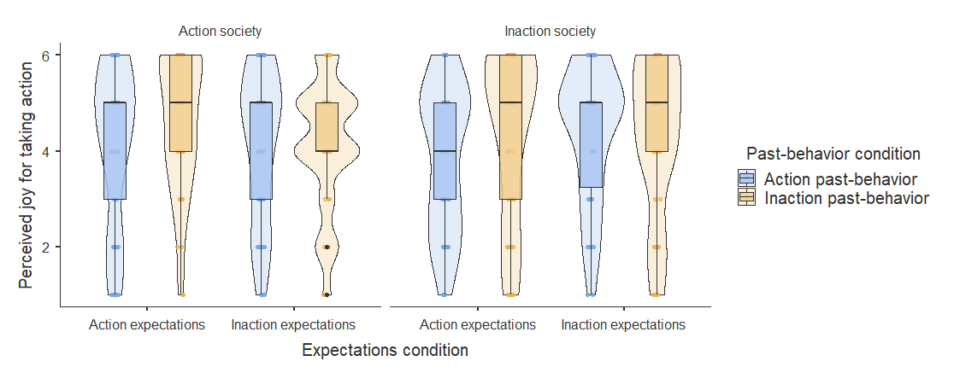

Procedure and data disclosures

Data collection
In all experiments, data collection was completed before conducting an analysis of the data.
Please note that Experiment 1 was combined in a data collection with other studies by several researchers as part of a 1-hour participant pool session.

Data exclusions
No participants were excluded.

Conditions reporting
All collected conditions are reported.

Variables reporting
All dependent variables are reported.

Clarification about control condition
In Experiment 1 we used established manipulations from previous literature. The prior outcomes manipulation was adopted from Zeelenberg et al. (2002) and the social norms manipulation was adopted from Feldman and Albarracin (2017) and both had control conditions in those articles. In Experiment 2, the manipulations past-behavior in the classic action-effect scenario has not been previously used in such a way, and we therefore felt it necessary to also assess the baseline effect of past-behavior normality when there was no manipulation of social norms.

Additional findings, tables, and figures

Experiment 1

Post Hoc Tests
Post Hoc Comparisons - Social norms Condition
Comparison
Social norms Condition |  |  |  |  |  |  | Social norms Condition |  |  |  | Mean Difference |  |  |  | SE |  | df |  | t |  | p_{tukey}
Action society |  |  | - |  |  |  | Inaction society |  |  |  | -1.102 |  |  |  | 0.173 |  | 227.000 |  | -6.361 |  | < .001
Post Hoc Comparisons - Expectations Condition
Comparison
Expectations Condition |  |  |  |  |  |  |  | Expectations Condition |  |  |  | Mean Difference |  |  | SE |  | df |  | t |  | p_{tukey}
Lost last game |  |  |  | - |  |  |  | Won last game |  |  |  | -0.729 |  |  | 0.173 |  | 227.000 |  | -4.207 |  | < .001

Post Hoc Comparisons - Social norms Condition ✻ Expectations Condition
Comparison
Social norms Condition |  | Expectations Condition |  |  |  | Social norms Condition |  | Expectations Condition |  | Mean Difference |  | SE |  | df |  | t |  | p_{tukey}
Action society |  | Lost last game |  | - |  | Action society |  | Won last game |  | -0.684 |  | 0.247 |  | 227 |  |  | -2.775 |  | 0.030
 |  |  |  | - |  | Inaction society |  | Lost last game |  | -1.057 |  | 0.245 |  | 227 |  |  | -4.325 |  | < .001
 |  |  |  | - |  | Inaction society |  | Won last game |  | -1.831 |  | 0.246 |  | 227 |  |  | -7.457 |  | < .001
 |  | Won last game |  | - |  | Inaction society |  | Lost last game |  | -0.373 |  | 0.245 |  | 227 |  |  | -1.526 |  | 0.423
 |  |  |  | - |  | Inaction society |  | Won last game |  | -1.147 |  | 0.246 |  | 227 |  |  | -4.670 |  | < .001
Inaction society |  | Lost last game |  | - |  | Inaction society |  | Won last game |  | -0.774 |  | 0.243 |  | 227 |  |  | -3.178 |  | 0.009

Figures
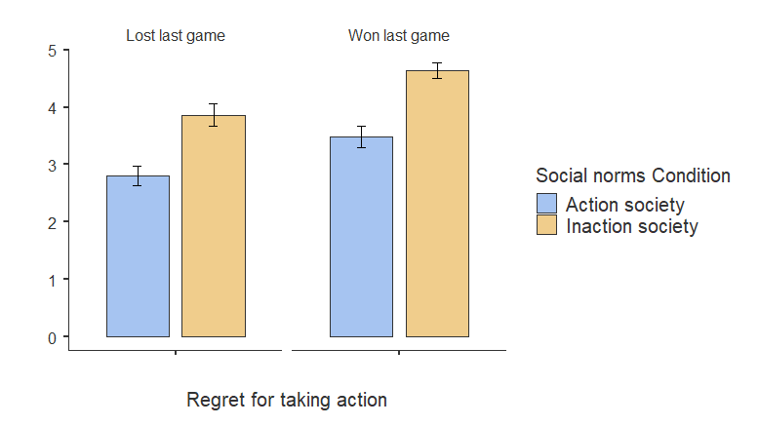
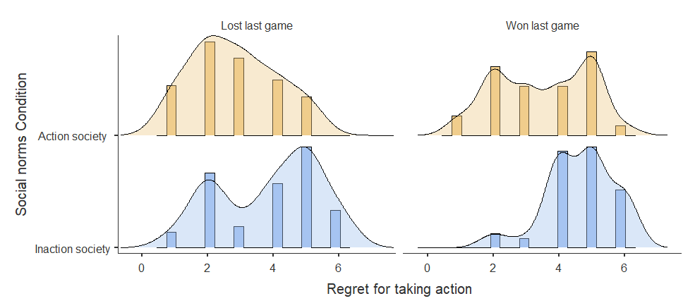
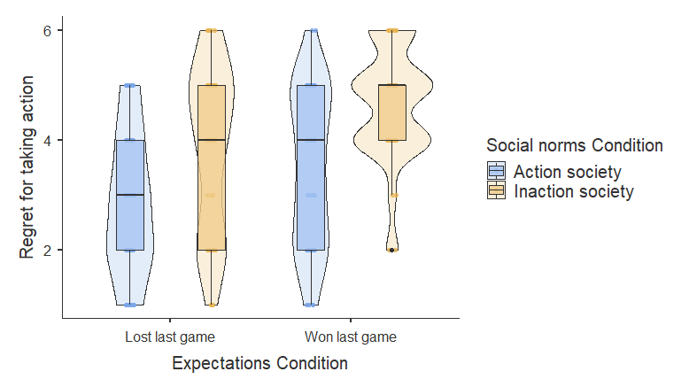

Experiment 1 after exclusions
We report the results for experiment 1 when excluding participants failing the manipulation checks. The exclusion had close to no impact on the results, and therefore the main manuscript reports findings of analyses conducted on the full dataset.

Table 2
Experiment 1: Means, standard deviations, and Cohen d effects for perceived regret (after exclusions)
 | Action expectations | Inaction expectations | Cohen d | Total
Action Society | 2.83 (1.27) [53] | 3.49 (1.46) [51] | .49 | 3.15 (1.40) [104]
Inaction Society | 3.89 (1.54) [54] | 4.71 (1.03) [51] | .63 | 4.29 (1.37) [105]
Cohen d | .76 | .97 | - | .82
Total | 3.36 (1.50) [107] | 4.10 (1.40) [101] | .51 | 3.72 (1.49) [209]
Note. Parentheses indicate standard deviation. Brackets indicate the number of participants.

Table 3
Experiment 1: Means, standard deviations, and Cohen d effects for perceived joy (after exclusions)
 | Action expectations | Inaction expectations | Cohen d | Total
Action Society | 4.36 (1.32) [53] | 4.20 (1.25) [51] | .13 | 4.28 (1.28) [104]
Inaction Society | 4.31 (1.45) [54] | 4.16 (1.39) [51] | .11 | 4.24 (1.42) [105]
Cohen d | .03 | .03 | - | .03
Total | 4.34 (1.38) [107] | 4.18 (1.32) [102] | .12 | 4.26 (1.35) [209]
Note. Parentheses indicate standard deviation. Brackets indicate the number of participants.

Experiment 2

Post hoc comparisons
Post Hoc Comparisons - Social Norms Condition
Comparison
Social Norms Condition |  |  |  |  | Social Norms Condition |  |  | Mean Difference |  |  | SE |  | df |  | t |  | p_{tukey}
Action company |  |  | - |  | Inaction company |  |  | -1.327 |  |  | 0.209 |  | 294.000 |  | -6.361 |  | < .001
 |  |  | - |  | Control company |  |  | -0.629 |  |  | 0.215 |  | 294.000 |  | -2.928 |  | 0.010
Inaction company |  |  | - |  | Control company |  |  | 0.697 |  |  | 0.217 |  | 294.000 |  | 3.208 |  | 0.004
Post Hoc Comparisons - Past Behavior Condition
Comparison
Past Behavior Condition |  |  |  |  | Past Behavior Condition |  |  |  | Mean Difference |  | SE |  | df |  | t |  | p_{tukey}
Action past behavior |  |  | - |  | Inaction past behavior |  |  |  | -0.934 |  | 0.174 |  | 294.000 |  | -5.355 |  | < .001

Post Hoc Comparisons - Social Norms Condition ✻ Past Behavior Condition
Comparison
Social Norms Condition |  | Past Behavior Condition |  |  |  | Social Norms Condition |  | Past Behavior Condition | Mean Difference |  |  | SE |  |  | df |  |  | t |  | p_{tukey}
Action company |  | Action past behavior |  | - |  | Action company |  | Inaction past behavior |  | -1.048 |  |  | 0.291 |  |  | 294 |  |  | -3.596 |  | 0.005
 |  |  |  | - |  | Inaction company |  | Action past behavior |  | -1.578 |  |  | 0.293 |  |  | 294 |  |  | -5.391 |  | < .001
 |  |  |  | - |  | Inaction company |  | Inaction past behavior |  | -2.123 |  |  | 0.296 |  |  | 294 |  |  | -7.178 |  | < .001
 |  |  |  | - |  | Control company |  | Action past behavior |  | -0.548 |  |  | 0.301 |  |  | 294 |  |  | -1.823 |  | 0.452
 |  |  |  | - |  | Control company |  | Inaction past behavior |  | -1.758 |  |  | 0.306 |  |  | 294 |  |  | -5.746 |  | < .001
 |  | Inaction past behavior |  | - |  | Inaction company |  | Action past behavior |  | -0.530 |  |  | 0.294 |  |  | 294 |  |  | -1.803 |  | 0.465
 |  |  |  | - |  | Inaction company |  | Inaction past behavior |  | -1.075 |  |  | 0.297 |  |  | 294 |  |  | -3.619 |  | 0.005
 |  |  |  | - |  | Control company |  | Action past behavior |  | 0.500 |  |  | 0.302 |  |  | 294 |  |  | 1.655 |  | 0.563
 |  |  |  | - |  | Control company |  | Inaction past behavior |  | -0.711 |  |  | 0.307 |  |  | 294 |  |  | -2.312 |  | 0.193
Inaction company |  | Action past behavior |  | - |  | Inaction company |  | Inaction past behavior |  | -0.545 |  |  | 0.298 |  |  | 294 |  |  | -1.825 |  | 0.451
 |  |  |  | - |  | Control company |  | Action past behavior |  | 1.030 |  |  | 0.303 |  |  | 294 |  |  | 3.397 |  | 0.010
 |  |  |  | - |  | Control company |  | Inaction past behavior |  | -0.180 |  |  | 0.309 |  |  | 294 |  |  | -0.583 |  | 0.992
 |  | Inaction past behavior |  | - |  | Control company |  | Action past behavior |  | 1.575 |  |  | 0.306 |  |  | 294 |  |  | 5.144 |  | < .001
 |  |  |  | - |  | Control company |  | Inaction past behavior |  | 0.365 |  |  | 0.311 |  |  | 294 |  |  | 1.170 |  | 0.851
Control company |  | Action past behavior |  | - |  | Control company |  | Inaction past behavior |  | -1.210 |  |  | 0.316 |  |  | 294 |  |  | -3.829 |  | 0.002

Figures
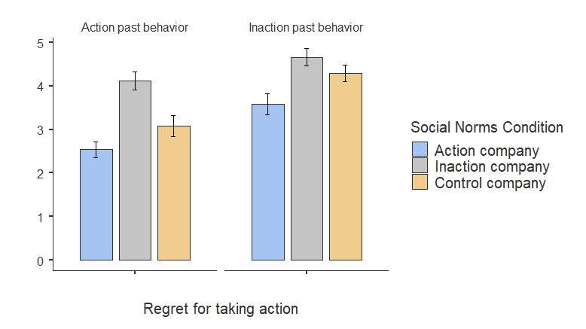
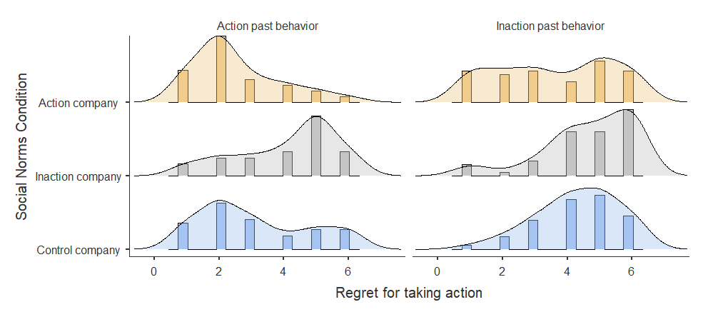
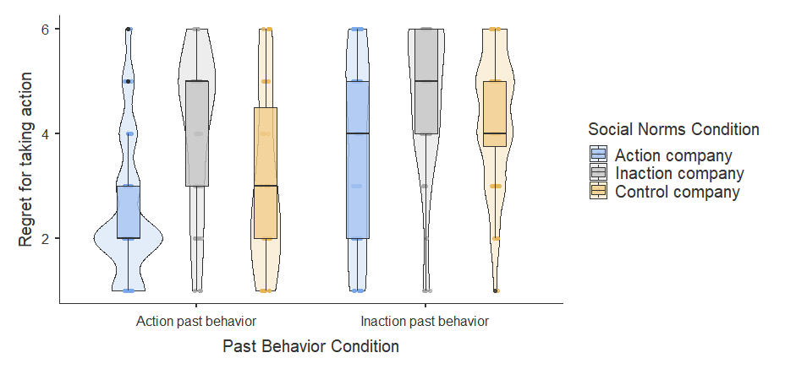

Experiment 3

Post hoc
Post Hoc Comparisons - Past behavior Condition
Comparison
Past behavior Condition |  |  |  |  |  |  | Past behavior Condition |  |  |  | Mean Difference |  |  | SE |  | df |  | t |  | p_{tukey}
Action past behavior |  |  | - |  |  |  | Inaction past behavior |  |  |  | -0.892 |  |  | 0.161 |  | 299.000 |  | -5.535 |  | < .001
Post Hoc Comparisons - Expectations Condition
Comparison
Expectations Condition |  |  |  |  |  |  |  | Expectations Condition |  |  |  | Mean Difference |  | SE |  | df |  | t |  | p_{tukey}
Action expectations |  |  |  | - |  |  |  | Inaction expectations |  |  |  | -1.172 |  | 0.161 |  | 299.000 |  | -7.273 |  | < .001

Post Hoc Comparisons - Past behavior Condition ✻ Expectations Condition
Comparison
Past behavior Condition |  | Expectations Condition |  |  |  | Past behavior Condition |  | Expectations Condition |  | Mean Difference |  | SE |  | df |  | t |  | p_{tukey}
Action past behavior |  | Action expectations |  | - |  | Action past behavior |  | Inaction expectations |  | -1.147 |  | 0.229 |  | 299 |  | -5.007 |  | < .001
 |  |  |  | - |  | Inaction past behavior |  | Action expectations |  | -0.867 |  | 0.229 |  | 299 |  | -3.784 |  | 0.001
 |  |  |  | - |  | Inaction past behavior |  | Inaction expectations |  | -2.064 |  | 0.227 |  | 299 |  | -9.101 |  | < .001
 |  | Inaction expectations |  | - |  | Inaction past behavior |  | Action expectations |  | 0.280 |  | 0.229 |  | 299 |  | 1.223 |  | 0.613
 |  |  |  | - |  | Inaction past behavior |  | Inaction expectations |  | -0.917 |  | 0.227 |  | 299 |  | -4.045 |  | < .001
Inaction past behavior |  | Action expectations |  | - |  | Inaction past behavior |  | Inaction expectations |  | -1.197 |  | 0.227 |  | 299 |  | -5.280 |  | < .001

Figures
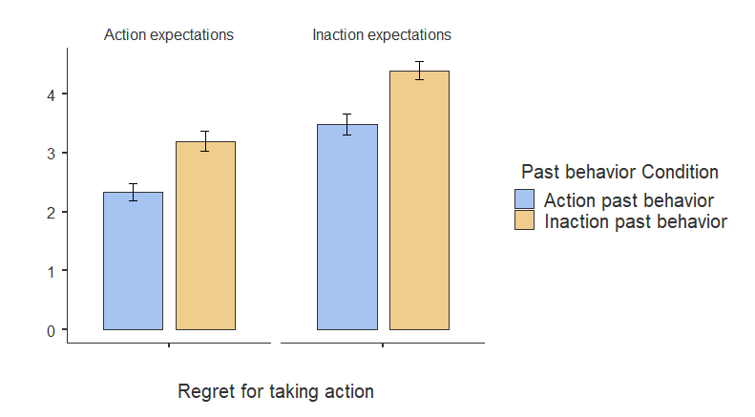
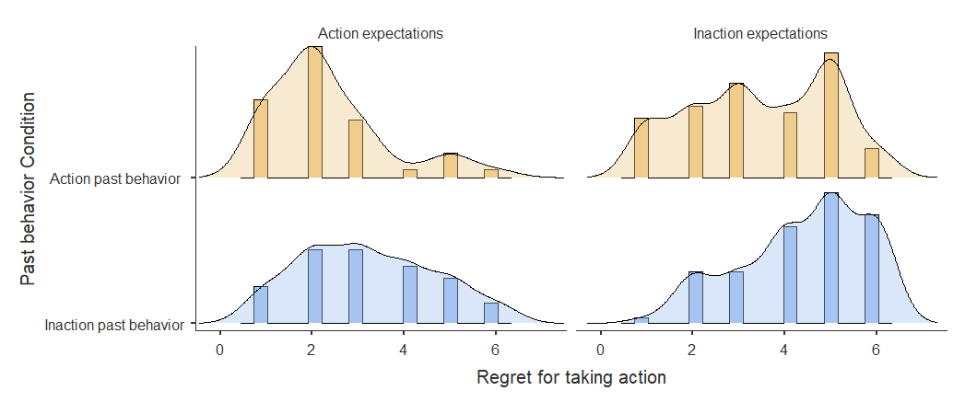
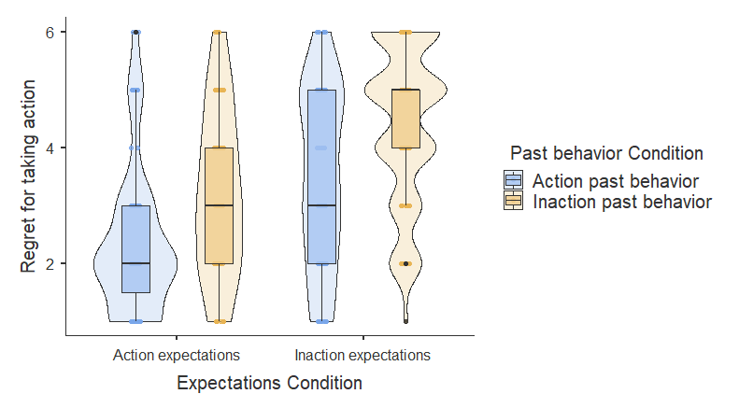

Experiment 4 violin and estimation plots

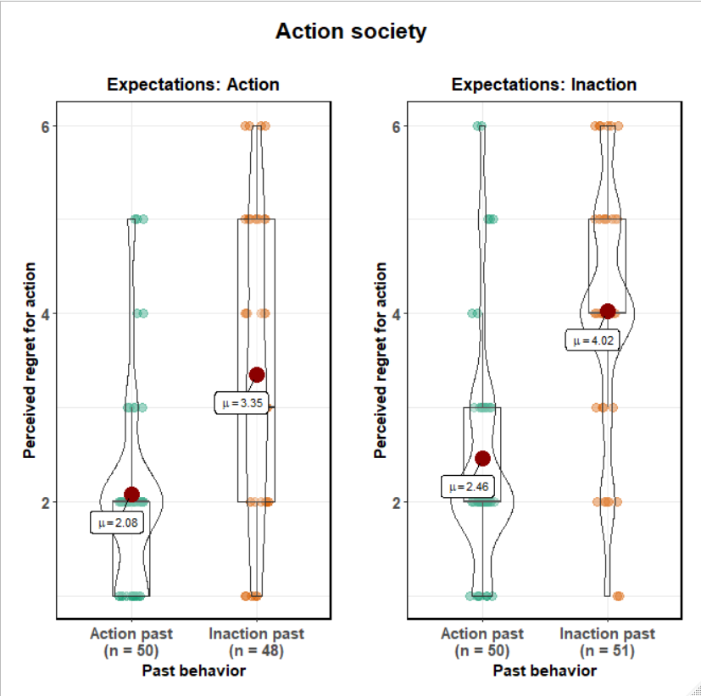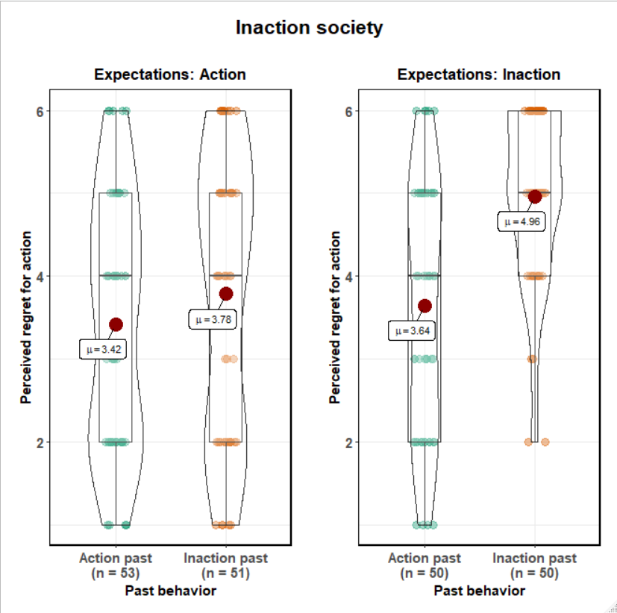

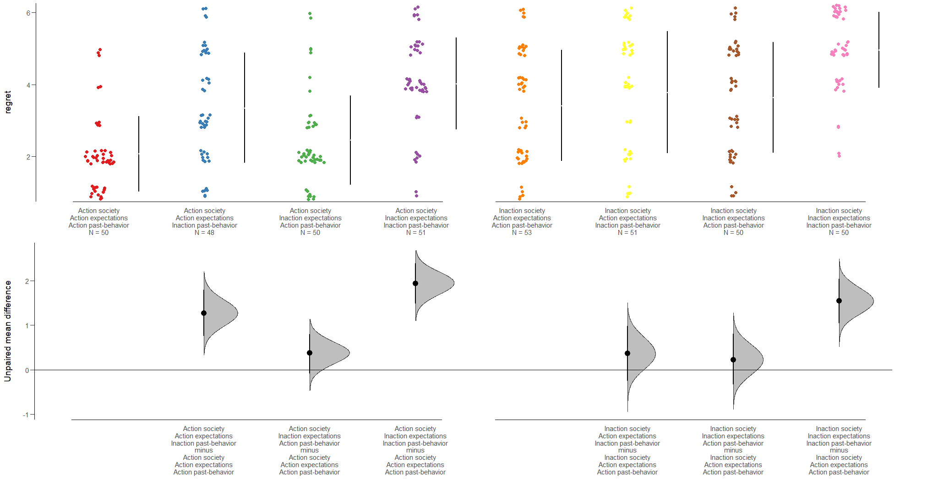

Joy findings figures

Experiment 1
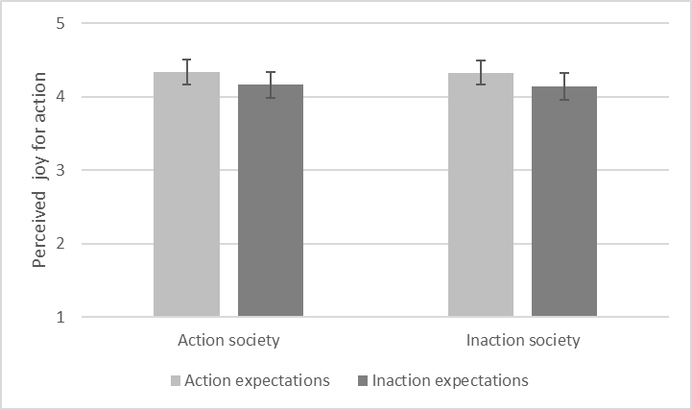

Experiment 3
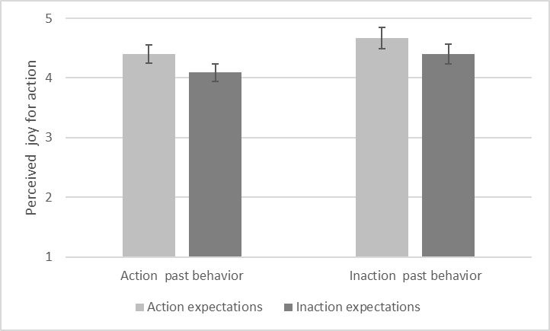
Figure 2. Experiment 3 plot for perceived joy (1 = higher perceived joy for inaction; 6 = higher perceived joy for action). Error bars indicate standard error.

Experiment 4
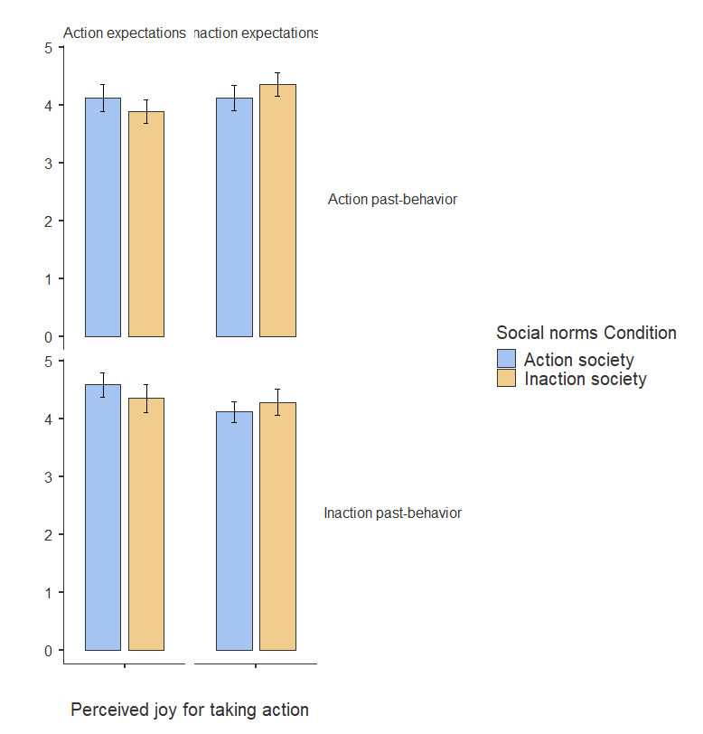

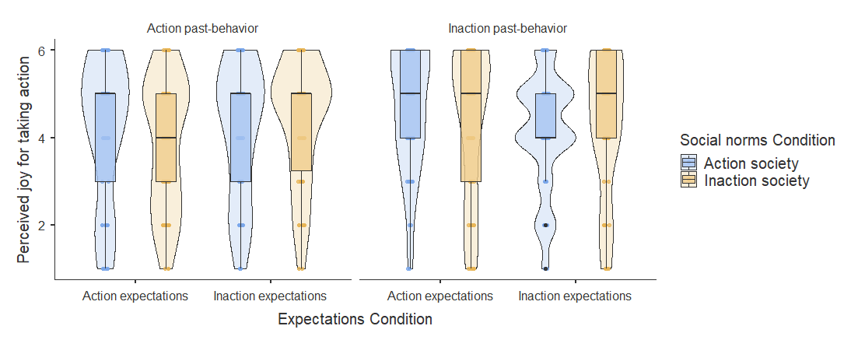

Gender differences
Review process requested that I add analyses of gender interactions. Across all experiments and all manipulations I found no indication for gender differences.

Experiment 1
 |  | Sum of Squares |  | df |  | Mean Square |  | F |  | p |  | η²p
Social norms Condition |  | 68.252 |  | 1 |  | 68.252 |  | 38.712 |  | < .001 |  | 0.148
Expectations Condition |  | 29.272 |  | 1 |  | 29.272 |  | 16.603 |  | < .001 |  | 0.069
gender |  | 0.006 |  | 1 |  | 0.006 |  | 0.003 |  | 0.954 |  | 0.000
Social norms Condition ✻ Expectations Condition |  | 0.169 |  | 1 |  | 0.169 |  | 0.096 |  | 0.757 |  | 0.000
Social norms Condition ✻ gender |  | 0.096 |  | 1 |  | 0.096 |  | 0.055 |  | 0.816 |  | 0.000
Expectations Condition ✻ gender |  | 0.005 |  | 1 |  | 0.005 |  | 0.003 |  | 0.956 |  | 0.000
Social norms Condition ✻ Expectations Condition ✻ gender |  | 0.158 |  | 1 |  | 0.158 |  | 0.090 |  | 0.765 |  | 0.000
Residuals |  | 393.170 |  | 223 |  | 1.763

Experiment 2
 |  | Sum of Squares |  | df |  | Mean Square |  | F |  | p |  | η²p
Social Norms Condition |  | 88.844 |  | 2 |  | 44.422 |  | 19.242 |  | < .001 |  | 0.118
Past Behavior Condition |  | 61.692 |  | 1 |  | 61.692 |  | 26.723 |  | < .001 |  | 0.085
gender |  | 0.072 |  | 1 |  | 0.072 |  | 0.031 |  | 0.860 |  | 0.000
Social Norms Condition ✻ Past Behavior Condition |  | 5.762 |  | 2 |  | 2.881 |  | 1.248 |  | 0.289 |  | 0.009
Social Norms Condition ✻ gender |  | 1.125 |  | 2 |  | 0.562 |  | 0.244 |  | 0.784 |  | 0.002
Past Behavior Condition ✻ gender |  | 0.128 |  | 1 |  | 0.128 |  | 0.055 |  | 0.814 |  | 0.000
Social Norms Condition ✻ Past Behavior Condition ✻ gender |  | 1.378 |  | 2 |  | 0.689 |  | 0.298 |  | 0.742 |  | 0.002
Residuals |  | 664.870 |  | 288 |  | 2.309

Experiment 3
 |  | Sum of Squares |  | df |  | Mean Square |  | F |  | p |  | η²p
Past behavior Condition |  | 59.454 |  | 1 |  | 59.454 |  | 29.891 |  | < .001 |  | 0.092
Expectations Condition |  | 101.775 |  | 1 |  | 101.775 |  | 51.168 |  | < .001 |  | 0.148
gender |  | 0.575 |  | 1 |  | 0.575 |  | 0.289 |  | 0.591 |  | 0.001
Past behavior Condition ✻ Expectations Condition |  | 0.030 |  | 1 |  | 0.030 |  | 0.015 |  | 0.903 |  | 0.000
Past behavior Condition ✻ gender |  | 0.058 |  | 1 |  | 0.058 |  | 0.029 |  | 0.864 |  | 0.000
Expectations Condition ✻ gender |  | 0.654 |  | 1 |  | 0.654 |  | 0.329 |  | 0.567 |  | 0.001
Past behavior Condition ✻ Expectations Condition ✻ gender |  | 0.003 |  | 1 |  | 0.003 |  | 0.002 |  | 0.968 |  | 0.000
Residuals |  | 586.768 |  | 295 |  | 1.989

Experiment 4
 |  | Sum of Squares |  | df |  | Mean Square |  | F |  | p |  | η²p
Social norms Condition |  | 96.759 |  | 1 |  | 96.759 |  | 50.683 |  | < .001 |  | 0.116
Expectations Condition |  | 40.071 |  | 1 |  | 40.071 |  | 20.990 |  | < .001 |  | 0.051
Past-behavior Condition |  | 130.470 |  | 1 |  | 130.470 |  | 68.342 |  | < .001 |  | 0.150
gender |  | 5.592 |  | 1 |  | 5.592 |  | 2.929 |  | 0.088 |  | 0.008
Social norms Condition ✻ Expectations Condition |  | 0.931 |  | 1 |  | 0.931 |  | 0.488 |  | 0.485 |  | 0.001
Social norms Condition ✻ Past-behavior Condition |  | 7.886 |  | 1 |  | 7.886 |  | 4.131 |  | 0.043 |  | 0.011
Expectations Condition ✻ Past-behavior Condition |  | 10.342 |  | 1 |  | 10.342 |  | 5.417 |  | 0.020 |  | 0.014
Social norms Condition ✻ gender |  | 2.717 |  | 1 |  | 2.717 |  | 1.423 |  | 0.234 |  | 0.004
Expectations Condition ✻ gender |  | 1.859 |  | 1 |  | 1.859 |  | 0.974 |  | 0.324 |  | 0.003
Past-behavior Condition ✻ gender |  | 0.176 |  | 1 |  | 0.176 |  | 0.092 |  | 0.762 |  | 0.000
Social norms Condition ✻ Expectations Condition ✻ Past-behavior Condition |  | 3.147 |  | 1 |  | 3.147 |  | 1.648 |  | 0.200 |  | 0.004
Social norms Condition ✻ Expectations Condition ✻ gender |  | 0.081 |  | 1 |  | 0.081 |  | 0.042 |  | 0.837 |  | 0.000
Social norms Condition ✻ Past-behavior Condition ✻ gender |  | 2.909 |  | 1 |  | 2.909 |  | 1.524 |  | 0.218 |  | 0.004
Expectations Condition ✻ Past-behavior Condition ✻ gender |  | 0.278 |  | 1 |  | 0.278 |  | 0.146 |  | 0.703 |  | 0.000
Social norms Condition ✻ Expectations Condition ✻ Past-behavior Condition ✻ gender |  | 0.346 |  | 1 |  | 0.346 |  | 0.181 |  | 0.670 |  | 0.000
Residuals |  | 738.815 |  | 387 |  | 1.909

Discussion sections moved from main manuscript
I found that (1) all three normality categories had unique impact on the action-effect, with no interactions, (2) all normality categories had consistent medium to large impact on the action-effect (d = .51 to d =.85, with one exception d = .39), (3) the joint effects of the normality categories consistently resulted in very strong effects, much stronger than the individual normality categories on their own (for two normality categories: d = 1.56 to 1.61; all three: d = 2.75), (4) normality had weak to no effect over perceived joy.
[...]
Comparing effect-size of the three normality categories, in Experiment 1 social-norms had a stronger effect than expectations, in Experiment 2 social-norms had stronger effect than past-behavior, and in Experiment 3 expectations had stronger effect than past-behavior. I therefore expected and pre-registered the hypothesis that if manipulated together in a single scenario social-norms would have the strongest effect and past-behavior the weakest effect. However, in Experiment 4 that included the three types of normality, past-behavior emerged as the strongest effect and expectations as the weakest effect. The overall effects as indicated by a mini meta-analysis summarizing the results across the four experiments suggest that the effects for all three normality categories are quite similar, with moderate to strong effects. Therefore, I caution against drawing any conclusions from specific patterns observed in comparing normality categories in one experiment, and instead infer that all three seem important.
[...]
I successfully replicated previous studies on the impact of normality on the action-effect, with Experiments 1, 3, and 4 replicating the effects of expectations normality (Zeelenberg et al., 2002), Experiments 1, 2, and 4 replicating the effects of social-norms normality (Feldman & Albarracín, 2017), and Experiment 2, 3, and 4 replicating the effects of past-behavior normality (Seta et al., 2001).

