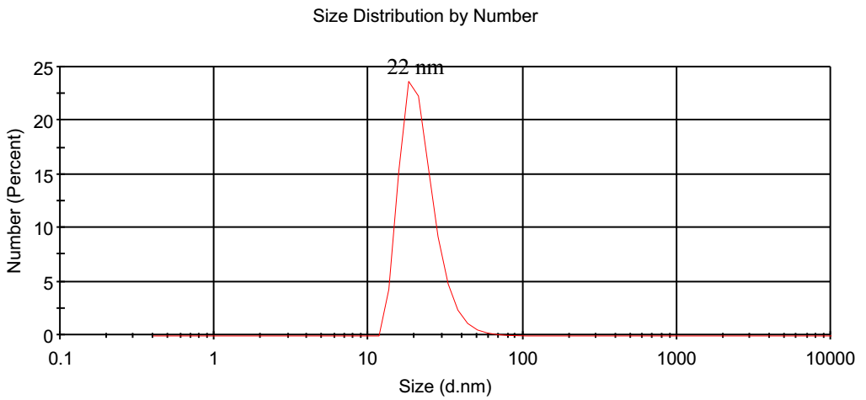
Figure S₁: Dynamic light scattering results of PLGA-PEG micelle
Figure S2: Uv-Vis spectra of A) Piperacillin/Tazibactam and B) Piperacillin/Tazibactam loaded PLGA-PEG micelle
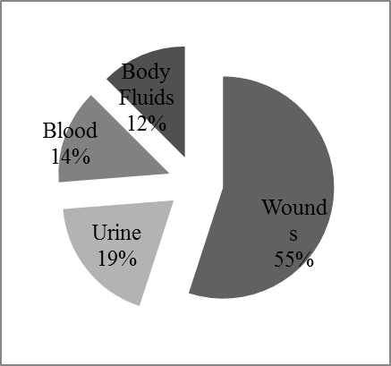
Figure S₃: Frequency of p. aeruginosa isolated from various tissues of the body

Figure S₄: Motility inhibition test of free and polymer drug form against on p. aeruginosa isolates

