Appendix
Table 3. An overview of the bicycle types, speeds and scenarios included in the study.
Bicycle type | Accident scenario and speed |  |  |  |  | Total number of tests
 | Sideway falls | Sudden stop |  | Sideways dislocation of front wheel
 | 0 km/h | 15 km/h | 25 km/h | 15 km/h | 25 km/h
Lady’s bicycle | 4 | 2 | 2 | 3 | 2 | 13
Commuter bicycle | 4 | 3 | 3 | 3 | 2 | 15
Pedelec | 4 | 2 | 2 | 2 | 3 | 13
Recumbent bicycle | 4 | 2 | 2 | 2 | 2 | 12
Sum: | 16 | 9 | 9 | 10 | 9 | 53

 | 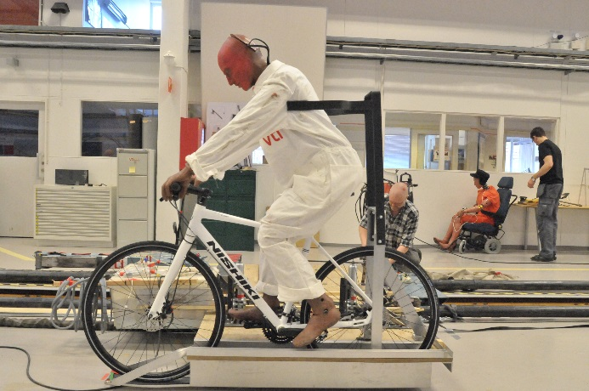
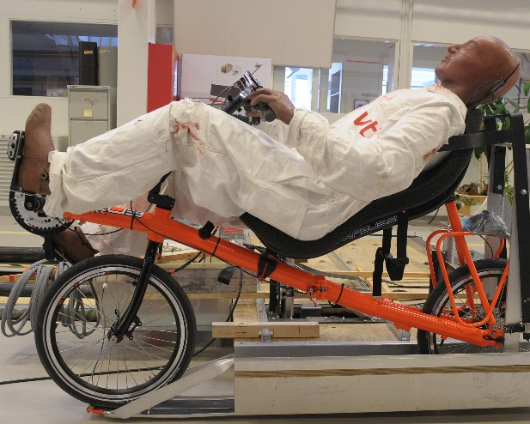 | 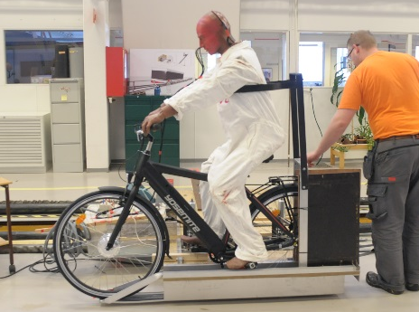
Figure 2. The four different types of bicycles included in the study: lady’s bicycle (top left), commuter bicycle (top right), recumbent bicycle (bottom left) and pedelec (bottom right).

Instruments and Equipment
The bicycle propulsion system used in the simulations consisted of a custom-made rig (Figure 3) mounted on top of a sledge normally used when crash testing child restraint systems at VTI (https://www.vti.se/en/research-areas/crash-safety-testing/child-car-seats/). The sledge runs on a rail and is powered by a cable system connected to two electric motors capable of accelerating the sledge from 0 to 110 km/h at 47 meters. The speed can be adjusted with an accuracy of 0.1 km/h. During testing, the actual speed is measured using photocells to control the exact sampling rate.
The rig was mainly constructed of plywood reinforced with an aluminum frame. At the far end of the rig an aluminum chute was constructed where the bicycles could be wedged (resembling a large rear-facing bicycle rack). The crash test dummy was supported by a fixture behind the back - at the torso - and under the arms. The crash test dummy and the bicycle were hereby fixed and kept in position during the propulsion phase of the rig when the sledge was accelerated to the desired speed. When the sledge was braked, the bicycle continued to roll freely forward, straight out of the chute and at the right speed before the "crash". The aim was to "deliver" the bicycle with the crash test dummy in a similar way and at the same spot in each test.
To be able to record the accelerations in the head during impact, there is a measuring system connected to the crash test dummy. Due to its weight, the measuring system could not be mounted on the bicycles as that would have influenced the test results. It could neither be mounted on the test rig since the cords did not have sufficient reach for the freerolling distance of the bicycles. Instead, the measuring system was placed in a plastic box that also left the test rig when the sledge was braked and slipped along the floor in the same direction as the bicycles.
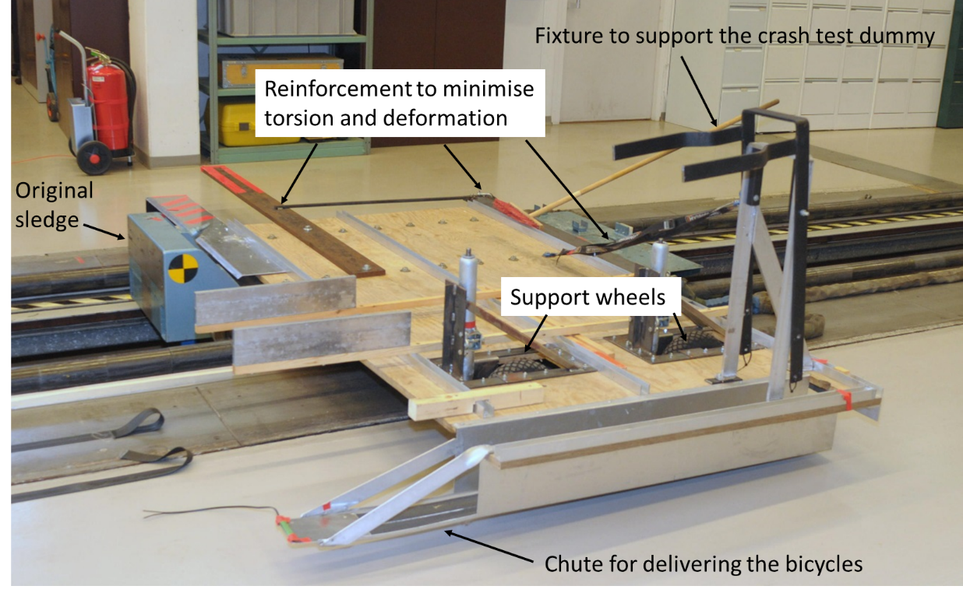
Figure 3. The custom-made rig for crash testing bicycles on top of the sledge normally used when crash testing child restraint systems at VTI.
To simulate crash test scenario 1, “the sudden stop”, a metal hook was mounted on the front wheel (Figure 4). When the wheel had turned three-quarter of a revolution, the hook was stuck in the fork of the bicycle and a sudden stop occurred. For evaluation reasons, it was important to be able to control the exact position where "the sudden stop" would occur.
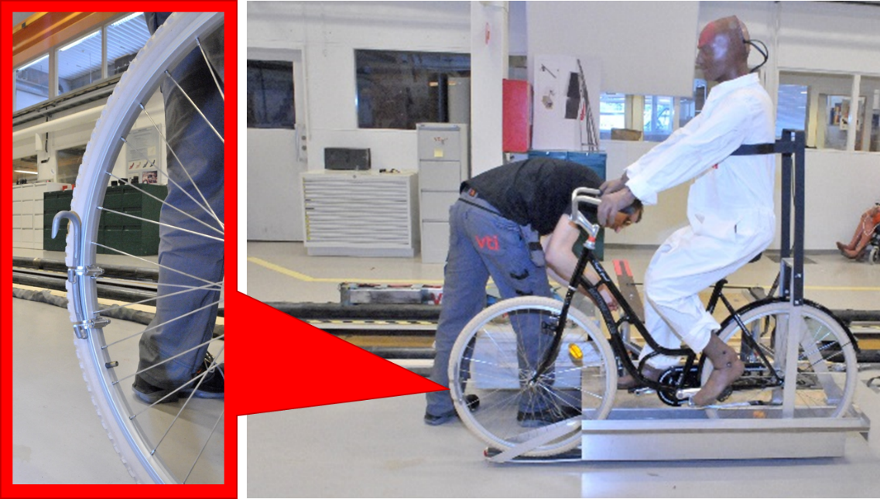
Figure 4. The metal hook mounted on the front wheel to simulate a sudden stop.
To simulate crash test scenario 2, a “sideways dislocation of the front wheel”, a square steel tube was mounted on the floor one meter in front of the stopping point of the rig. The tube had the dimensions 150*150 mm and was installed obliquely so that the front wheel of the bicycle would hit the tube at a 20-degree angle (Figure 5). The height of 150 mm fairly corresponds to curb stones normally used in Sweden.
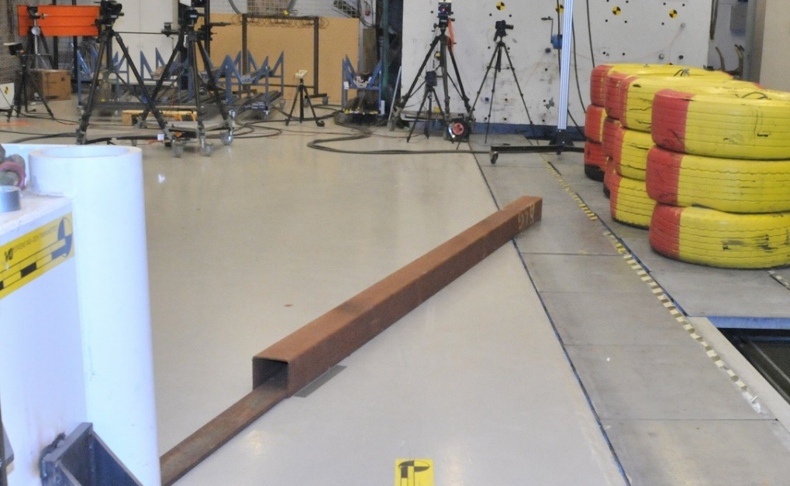
Figure 5. The square steel tube used to simulate a sideways dislocation of the front wheel.

Photos and additional results

Figure 6. Head impact (HIC36) at sideway falls with four different types of bicycles. Four consecutive crash tests for each bicycle type. Raw data filtered using a CFC 1000 filter.

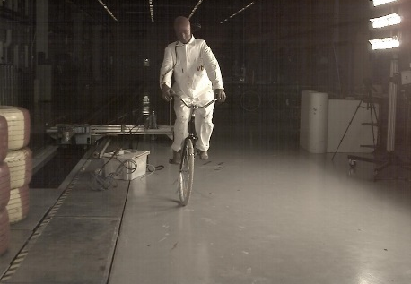 | 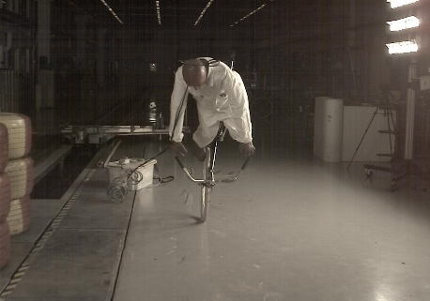 | 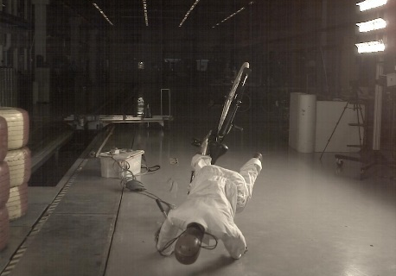
Figure 7. Photo sequence of a crash test simulating a sudden stop with the lady’s bicycle in 25 km/h, illustrating a falling motion over the handle bars.
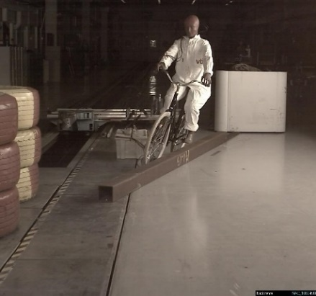 | 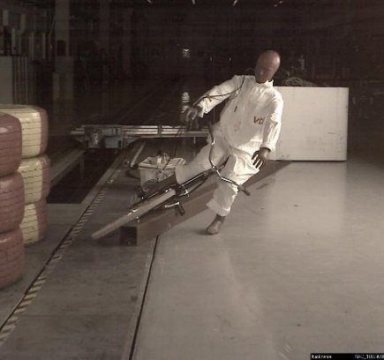 | 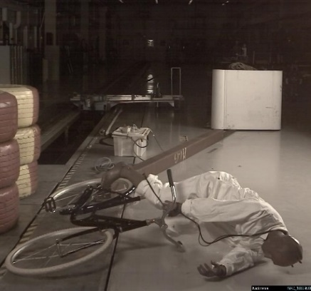
Figure 8. Photo sequence of a crash test simulating a sideways dislocation of the front wheel of a lady’s bicycle in 25 km/h, illustrating a falling motion to the side.

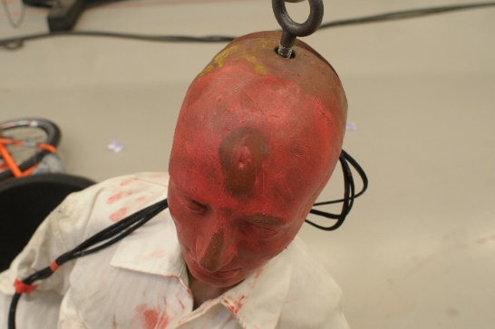 | 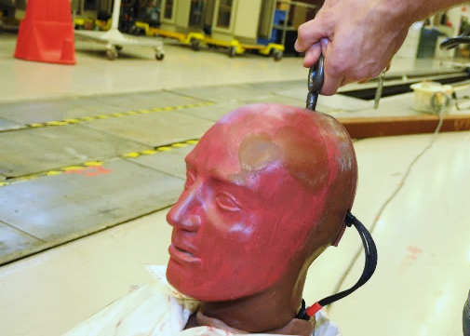
Figure 9. Illustrations of the impact location at the forehead from a sudden stop (left picture) and to the side of the head from a sideways dislocation of the front wheel (right picture). The head impact location appears as stripped spots in the red colored paste smeared on the crash test dummy head.
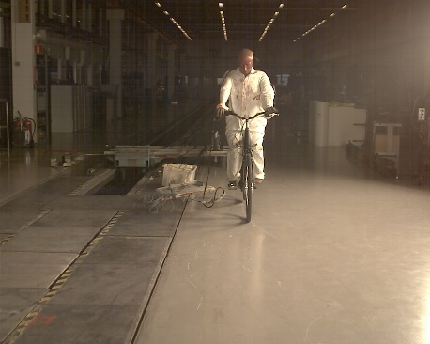 | 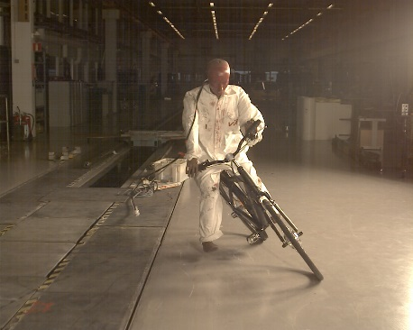 | 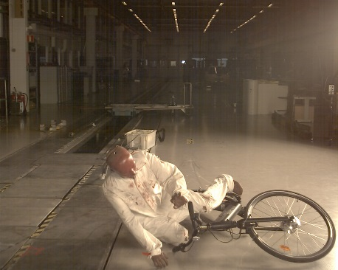
Figure 10. Photo sequence of a crash test simulating a sudden stop with the pedelec in 25 km/h resulting in a falling motion to the side instead of over the handle bars.
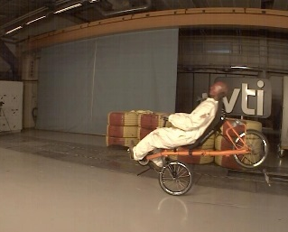
Figure 11. Photo sequence of a crash test simulating a sudden stop with the recumbent bicycle in 25 km/h resulting in a forward falling motion over the front wheel.

Table 4. Throwing distance (meters) from to the initial point of the crash to the point of head impact to the ground, after simulated single-bicycle crashes in 15 or 25 km per hour on four different types of bicycles. *Estimated values.
Bicycle type | Sudden stop |  | Sideways dislocation
 | 15 km/h | 25 km/h | 15 km/h | 25 km/h
Lady’s bicycle
Test 1 | 3,1 | 5,7 | 3,3 | 4,2
Test 2 | 4,0 | 6,3 | 3,6* | 4,5
Test 3 |  |  | 3,8*
Commuter bicycle
Test 1 | 3,4 | 7,0* | 3,01 | 4,7
Test 2 | 3,2 | 4,94 | No hit | 3,9
Test 3 | 3,2 | 5,34 | No hit
Pedelec
Test 1 | Fall backwards | 6,3 | 3,6* | 4,18
Test 2 | Fall to the side | 6,7 | 3,4 | 4,9
Test 3 |  |  |  | 3,8
Recumbent bicycle
Test 1 | 4,1 | 7,4 | 2,1 | 3,3
Test 2 | 2,7 | 4,7 | 2,1 | 2,75

