# SUPPLEMENTARY MATERIAL

## Upstream characteristics maps.

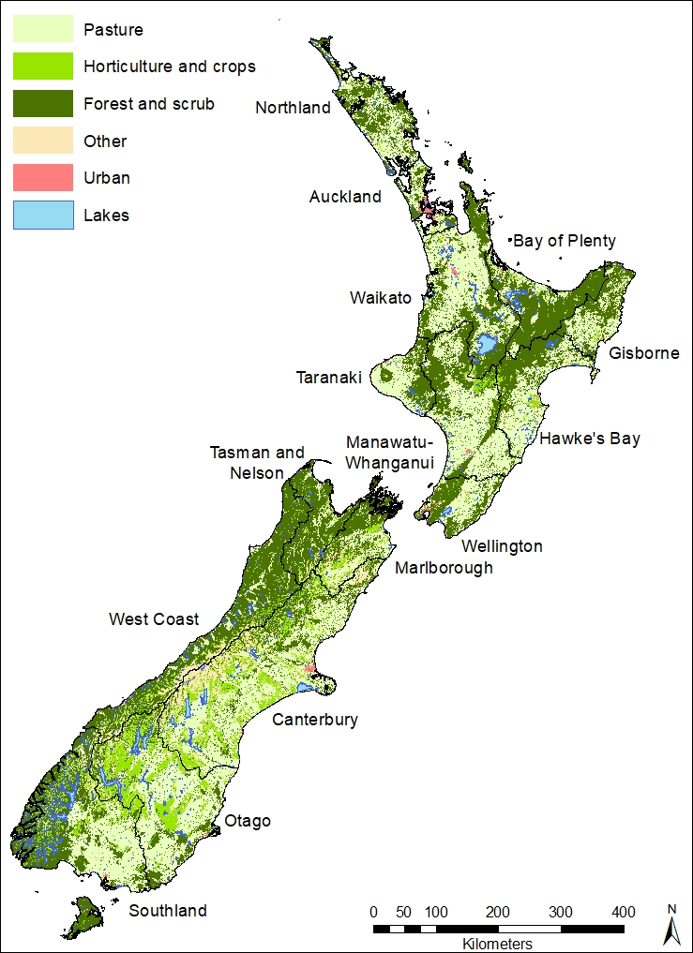

SM Figure 1 Land use; the CLUES land use classes have been aggregated into broad classes for map clarity.

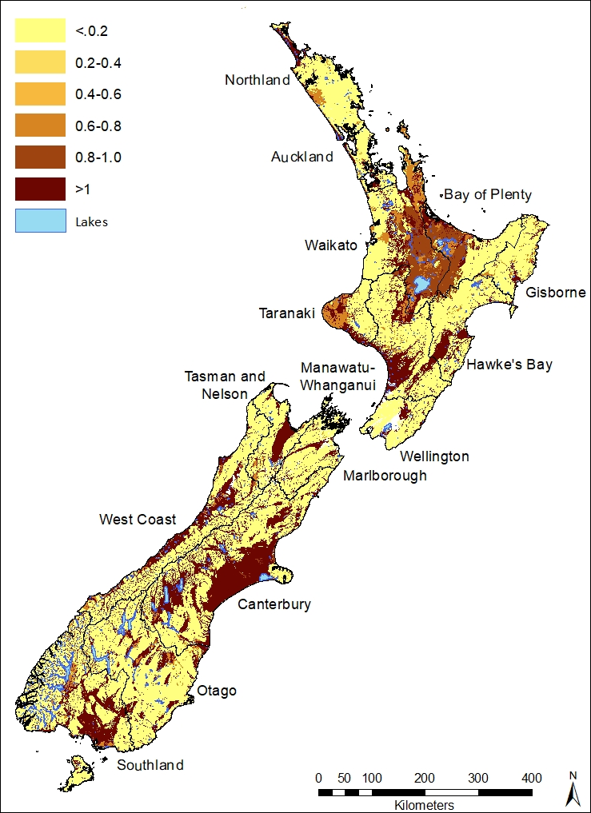

SM Figure 2 Hydraulic conductivity (m/day) of the vadose zone. Data supplied by GNS.

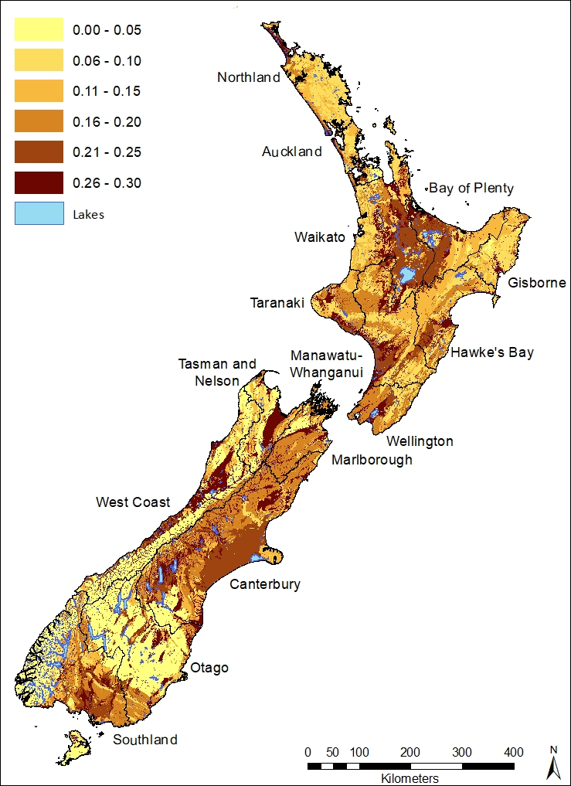

SM Figure 3 Fraction of porosity in the vadose zone. Data supplied by GNS.

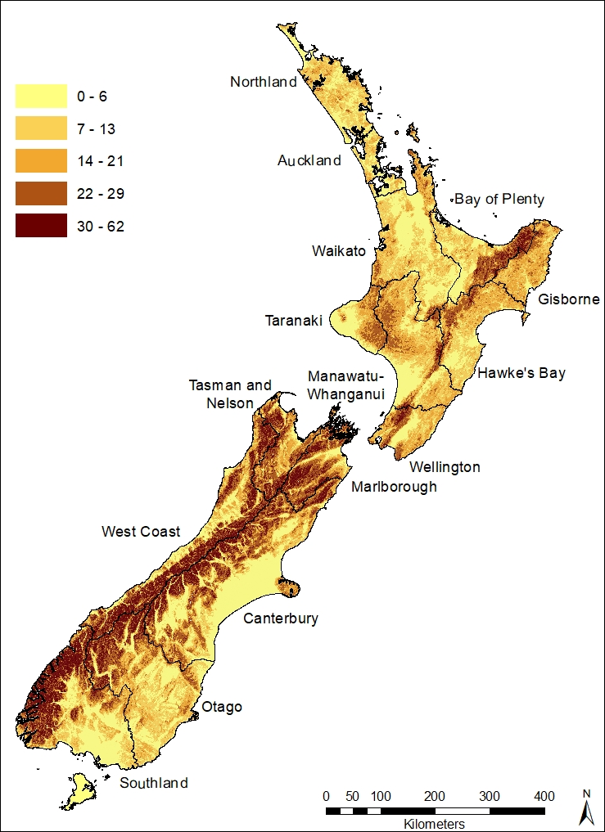

SM Figure 4 Slope (degrees) derived from a 30-m resolution digital terrain model.

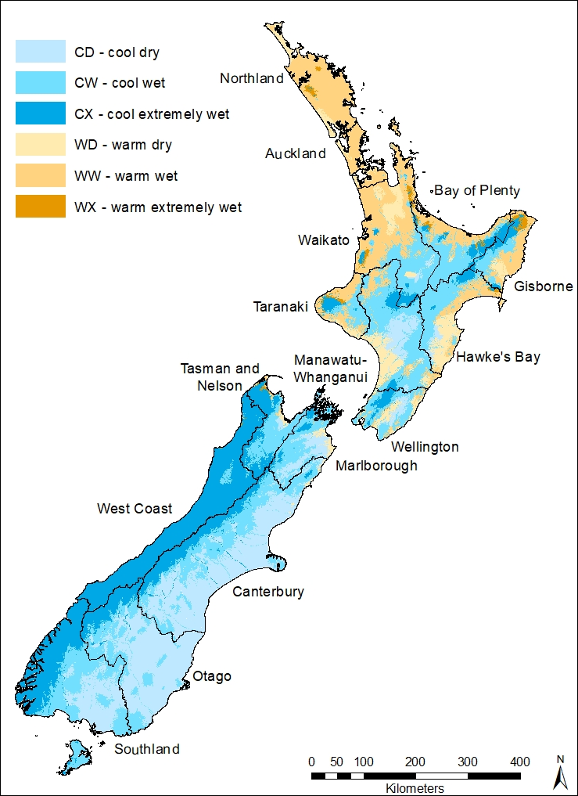

SM Figure 5 Spatial distribution of the REC climate classes

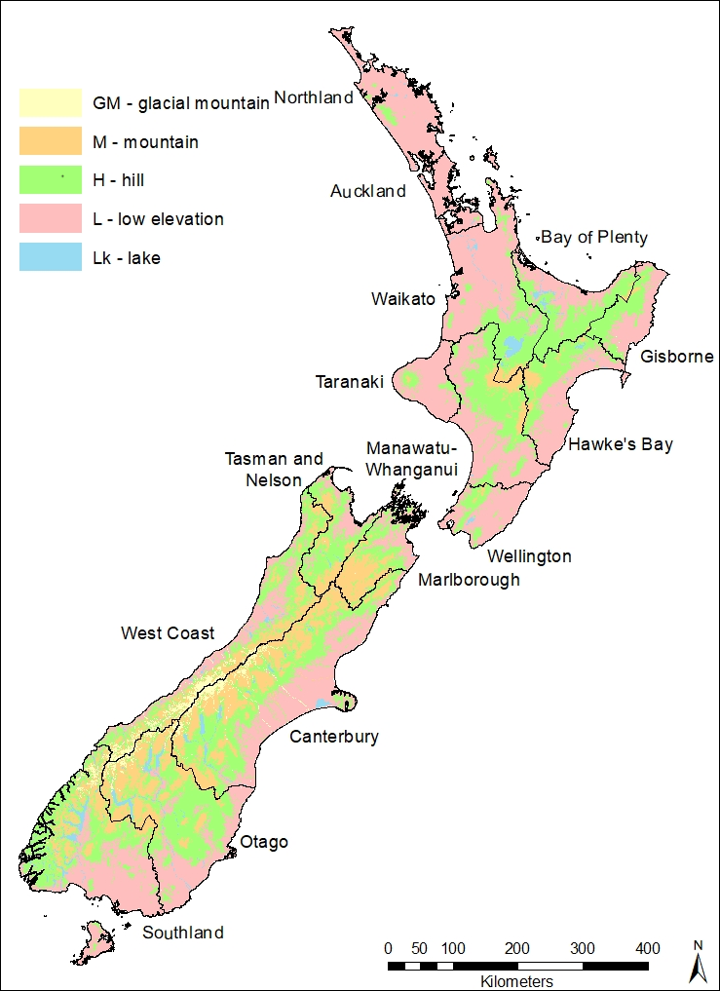

SM Figure 6 Spatial distribution of the REC source of flow classes

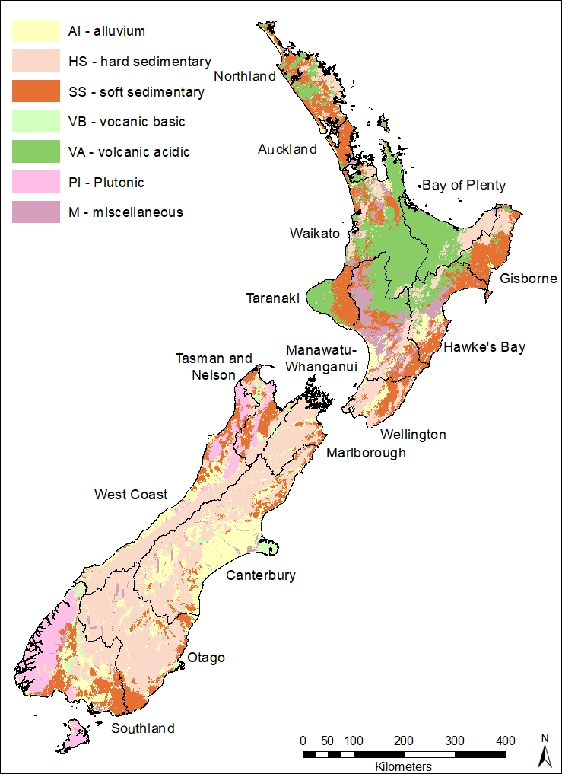

SM Figure 7 Spatial distribution of the REC geology classes

## Regression plots for significant relationships



SM Figure 8 Upstream land use proportion against model residuals for significant (p<5%) relationships



SM Figure 9 Upstream average slope against model residuals for TN with no attenuation



SM Figure 10 Baseflow index against model residuals for significant (p<5%) relationships

## Box plots for classes with significant differences

 

SM Figure 11 Box-plots by super region for TN with and without attenuation







SM Figure 12 Box-plots by climate class for *E. coli* and TN with and without attenuation