

S1. The XRD patterns of the red, yellow, white and black (4% masterbatch) propylene BCF yarns

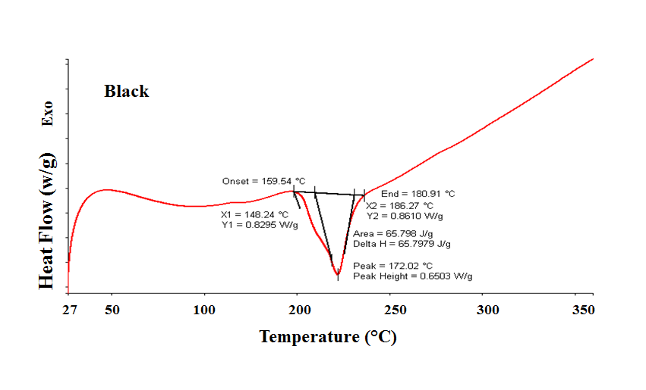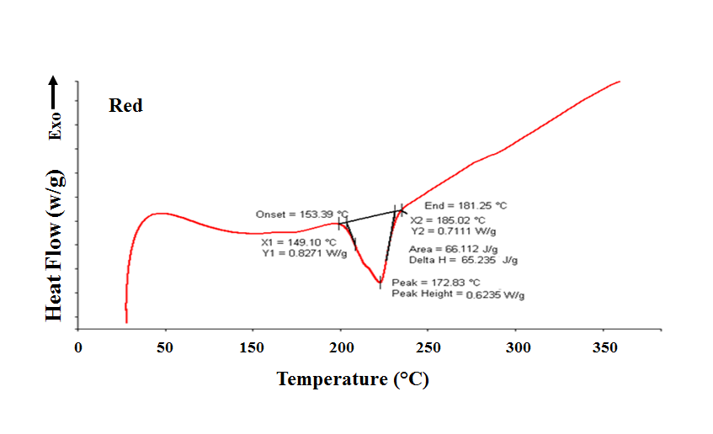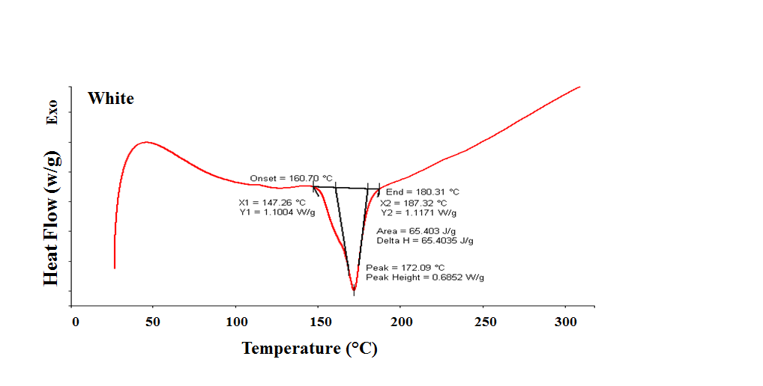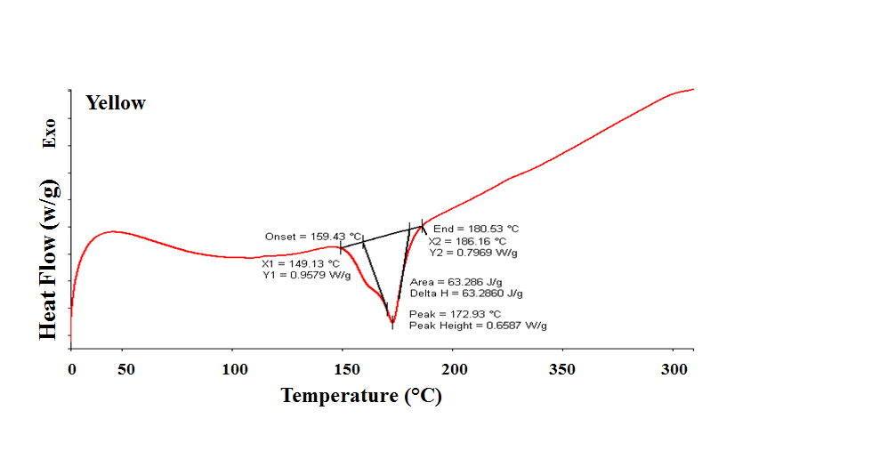

**Heat Flow (w/g) Exo**

S2. DSC thermograms of the black, red, white and yellow (4% masterbatch) propylene BCF yarns



S3. FTIR spectra of five pigments employed in this work