Table S1. The concentrations of suspended solids (SS), carbon (C), nitrogen (N), and phosphorus (P) in the artificial runoff water from soils as affected by vegetated ridge (VR) and sandbag (SB) treatmentsª.
Water quality parameter |  | First artificial runoff experiment  (August 3) |  |  |  | Second artificial runoff experiment  (August 10) |  |  |  | Event mean concentration
 |  | Control | VR | SB |  | Control | VR | SB |  | Control | VR | SB
SS (g L⁻¹) |  | 2.9 (1.5) | 3.0 (1.3) | 2.1 (0.5) |  | 1.7 (0.5) | 2.1 (1.3) | 2.5 (0.4) |  | 2.2 (0.9) | 2.5 (1.2) | 2.3 (0.4)
C (mg L⁻¹)^{b} | DOC | 0.4 (0.3) | 0.9 (0.3) | 0.2 (0.2) |  | 0.5 (0.2) | 0.7 (0.3) | 0.5 (0.0) |  | 0.5 (0.1) | 0.8 (0.3) | 0.3 (0.1)
 | POC | 38.6 (18.5) | 49.2 (23.3) | 30.6 (9.4) |  | 27.8 (7.3) | 18.7 (6.6) | 24.0 (9.0) |  | 32.4 (12.0) | 31.2 (12.8) | 25.6 (4.1)
 | TOC | 53.6 (15.5) | 50.1 (23.4) | 30.9 (9.6) |  | 28.3 (7.5) | 19.6 (6.4) | 24.4 (9.0) |  | 31.7 (12.9) | 32.1 (12.7) | 25.9 (4.0)
N (mg L⁻¹)^{c} | DN | 3.3 (0.5) | 3.0 (0.6) | 2.9 (0.6) |  | 3.2 (0.2) | 4.6 (1.9) | 3.3 (0.2) |  | 3.3 (0.2) | 4.0 (1.3) | 3.1 (0.2)
 | PN | 5.0 (2.4) | 5.5 (2.4) | 4.1 (1.3) |  | 3.3 (0.9) | 2.4 (0.9) | 2.9 (1.1) |  | 4.0 (1.5) | 3.7 (1.4) | 3.2 (0.5)
 | TN | 8.4 (2.0) | 8.5 (2.7) | 7.0 (1.9) |  | 6.5 (1.0) | 7.0 (2.7) | 5.8 (1.5) |  | 7.3 (1.4) | 7.6 (2.6) | 6.1 (0.6)
P (mg L⁻¹)^{d} | DP | 0.6 (0.1) | 0.6 (0.1) | 0.6 (0.2) |  | 0.5 (0.0) | 0.5 (0.1) | 0.4 (0.1) |  | 0.6 (0.1) | 0.5 (0.1) | 0.4 (0.1)
 | PP | 6.2 (2.3) | 4.3 (0.2) | 2.4 (0.8) |  | 2.0 (0.5) | 1.3 (0.5) | 2.4 (0.5) |  | 3.0 (1.3) | 2.0 (0.7) | 2.7 (0.7)
 | TP | 7.0 (2.3) | 5.0 (0.2) | 3.0 (1.0) |  | 2.5 (0.5) | 1.8 (0.5) | 2.8 (0.6) |  | 3.6 (1.3) | 2.6 (0.8) | 3.3 (0.9)
Values are the means of triplicates with standard errors of the means in the parenthesis, and the effect of treatments on water quality parameters assessed with analysis of variance was not significant at α=0.05 and thus no P value was provided.
ª Details of the artificial runoff experiment are provided in Table 3.
^{b} DOC, dissolved organic C; POC, particulate organic C; TOC, total organic C.
^{c} DN, dissolved N; PN, particulate N; TN, total N.
^{d} DP, dissolved P; PP, particulate P; TP, total P.
Table S2. The concentrations of suspended solids in the natural runoff water from soils as affected by vegetated ridge (VR) and sandbag (SB) treatments.
Treatment | Event numberª |  |  |  |  |  | Event mean concentration
 | 1 | 2 | 3 | 4 | 5 | 6
 | g L⁻¹
Control | 14.2 (5.8) | 1.4 (0.6) | 9.9 (4.6) | 2.5 (1.0) | 10.4 (4.9) | 12.8 (4.7) | 9.9 (4.0)
VR | 20.6 (7.4) | 4.2 (2.0) | 23.0 (12.7) | 2.1 (0.9) | 5.8 (2.7) | 5.9 (2.6) | 7.6 (3.6)
SB | 13.2 (6.0) | 3.1 (1.3) | 9.2 (2.3) | 2.4 (0.7) | 12.7 (8.0) | 11.7 (8.4) | 10.5 (6.3)
Values are the means of triplicates with standard errors of the means in the parenthesis, and the effect of treatments on water quality parameters assessed with analysis of variance was not significant at α=0.05 and thus no P value was provided.
ª Details of the natural runoff experiment are provided in Table 2.

Table S3. The concentrations of dissolved (DOC), particulate (POC), and total (TOC) organic carbon in the natural runoff water from soils as affected by vegetated ridge (VR) and sandbag (SB) treatments.
Treatment | Water chemistry | Event numberª |  |  |  |  |  | Event mean concentration
 |  | 1 | 2 | 3 | 4 | 5 | 6
 |  | mg L⁻¹
Control | DOC | 1.9 (0.3) | 0.6 (0.2) | 1.8 (0.3) | 3.3 (0.2) | 2.3 (0.8) | 1.1 (0.7) | 1.7 (0.5)
 | POC | 90.0 (36.3) | 32.5 (12.2) | 24.4 (11.1) | 52.3 (12.2) | 7.1 (3.4) | 11.2 (4.5) | 31.4 (8.1)
 | TOC | 91.9 (36.5) | 33.1 (12.4) | 26.2 (11.2) | 55.6 (12.2) | 9.4 (4.2) | 17.5 (0.6) | 33.9 (8.3)
VR | DOC | 2.6 (0.7) | 0.8 (0.2) | 2.6 (0.6) | 4.1 (0.8) | 1.6 (0.3) | 2.1 (1.0) | 1.9 (0.4)
 | POC | 142.1 (64.5) | 86.6 (41.8) | 61.2 (36.3) | 42.4 (10.5) | 3.1 (1.4) | 4.0 (2.0) | 29.9 (16.9)
 | TOC | 144.8 (64.0) | 87.4 (41.7) | 63.8 (37.0) | 46.5 (11.1) | 4.7 (1.6) | 6.1 (1.7) | 32.8 (17.9)
SB | DOC | 1.5 (0.3) | 0.7 (0.3) | 2.0 (0.2) | 2.7 (0.4) | 2.2 (0.8) | 1.6 (1.2) | 1.8 (0.7)
 | POC | 98.4 (52.7) | 75.2 (33.5) | 22.8 (5.2) | 70.5 (17.4) | 8.2 (5.7) | 9.3 (7.1) | 38.7 (26.1)
 | TOC | 99.9 (53.1) | 75.8 (33.8) | 24.8 (5.3) | 73.2 (17.7) | 10.4 (6.5) | 10.9 (8.2) | 40.1 (26.5)
Values are the means of triplicates with standard errors of the means in the parenthesis, and the effect of treatments on water quality parameters assessed with analysis of variance was not significant at α=0.05 and thus no P value was provided.
ª Details of the natural runoff experiment are provided in Table 2.

Table S4. The concentrations of dissolved (DN), particulate (PN), and total (TN) nitrogen in the natural runoff water from soils as affected by vegetated ridge (VR) and sandbag (SB) treatments.
Treatment | Water chemistry | Event numberª |  |  |  |  |  | Event mean concentration
 |  | 1 | 2 | 3 | 4 | 5 | 6
 |  | mg L⁻¹
Control | DN | 1.1 (0.2) | 1.2 (0.1) | 1.0 (0.1) | 2.2 (0.7) | 2.8 (0.7) | 2.6 (0.2) | 2.3 (0.3)
 | PN | 10.3 (4.2) | 3.7 (1.5) | 2.9 (1.3) | 7.0 (1.8) | 0.9 (0.5) | 1.1 (0.4) | 4.0 (1.3)
 | TN | 11.4 (4.2) | 4.9 (1.5) | 3.9 (1.2) | 9.2 (2.5) | 3.7 (0.5) | 3.7 (0.3) | 5.8 (1.1)
VR | DN | 1.1 (0.2) | 1.4 (0.2) | 1.2 (0.1) | 2.4 (0.2) | 3.0 (0.8) | 2.5 (0.5) | 2.4 (0.4)
 | PN | 15.4 (6.6) | 9.5 (4.4) | 7.1 (4.1) | 5.2 (1.4) | 0.5 (0.0) | 0.4 (0.2) | 4.1 (2.1)
 | TN | 16.5 (6.8) | 10.9 (4.2) | 8.3 (4.1) | 7.6 (1.2) | 3.9 (0.0) | 3.0 (0.6) | 6.3 (1.9)
SB | DN | 0.8 (0.2) | 1.2 (0.2) | 1.1 (0.1) | 1.1 (0.4) | 2.0 (1.0) | 2.4 (0.1) | 1.9 (0.4)
 | PN | 10.7 (5.5) | 8.4 (3.8) | 2.6 (0.6) | 8.5 (1.9) | 1.3 (0.0) | 1.0 (0.7) | 4.7 (2.8)
 | TN | 11.5 (5.7) | 9.6 (4.0) | 3.7 (0.7) | 9.6 (2.1) | 4.3 (0.0) | 3.3 (0.6) | 6.5 (2.6)
Values are the means of triplicates with standard errors of the means in the parenthesis, and the effect of treatments on water quality parameters assessed with analysis of variance was not significant at α=0.05 and thus no P value was provided.
ª Details of the natural runoff experiment are provided in Table 2.

Table S5. The concentrations of dissolved (DP), particulate (PP), and total (TP) phosphorus in the natural runoff water from soils as affected by vegetated ridge (VR) and sandbag (SB) treatments.
Treatment | Water chemistry | Event numberª |  |  |  |  |  | Event mean concentration
 |  | 1 | 2 | 3 | 4 | 5 | 6
 |  | mg L⁻¹
Control | DP | 1.4 (0.1) | 0.6 (0.1) | 1.1 (0.1) | 0.9 (0.1) | 1.0 (0.1) | 0.9 (0.0) | 1.0 (0.1)
 | PP | 7.3 (2.6) | 1.9 (0.7) | 1.8 (0.8) | 3.1 (1.0) | 0.4 (0.2) | 0.6 (0.2) | 2.1 (0.5)
 | TP | 8.7 (2.7) | 2.4 (0.9) | 3.0 (0.9) | 4.0 (1.1) | 1.4 (0.3) | 1.6 (0.3) | 3.0 (0.5)
VR | DP | 1.4 (0.2) | 0.8 (0.1) | 1.3 (0.3) | 1.2 (0.3) | 1.0 (0.1) | 0.8 (0.2) | 1.0 (0.2)
 | PP | 9.8 (3.3) | 5.1 (2.8) | 5.7 (2.8) | 2.4 (1.2) | 0.2 (0.1) | 0.2 (0.1) | 2.2 (1.3)
 | TP | 11.2 (3.4) | 5.8 (2.8) | 7.0 (3.0) | 3.6 (1.5) | 1.2 (0.2) | 1.1 (0.2) | 3.4 (1.6)
SB | DP | 1.6 (0.1) | 0.8 (0.3) | 1.2 (0.1) | 1.1 (0.3) | 0.9 (0.0) | 0.8 (0.1) | 0.9 (0.1)
 | PP | 5.7 (3.4) | 4.0 (1.7) | 1.4 (0.3) | 3.5 (0.2) | 0.5 (0.3) | 0.7 (0.5) | 2.0 (1.3)
 | TP | 7.4 (3.4) | 4.8 (1.9) | 2.6 (0.4) | 4.8 (0.5) | 1.4 (0.3) | 1.5 (0.6) | 3.0 (1.5)
Values are the means of triplicates with standard error of the means in the parenthesis, and the effect of treatments on water quality parameters assessed with analysis of variance was not significant at α=0.05 and thus no P value was provided.
ª Details of the natural runoff experiment are provided in Table 2.

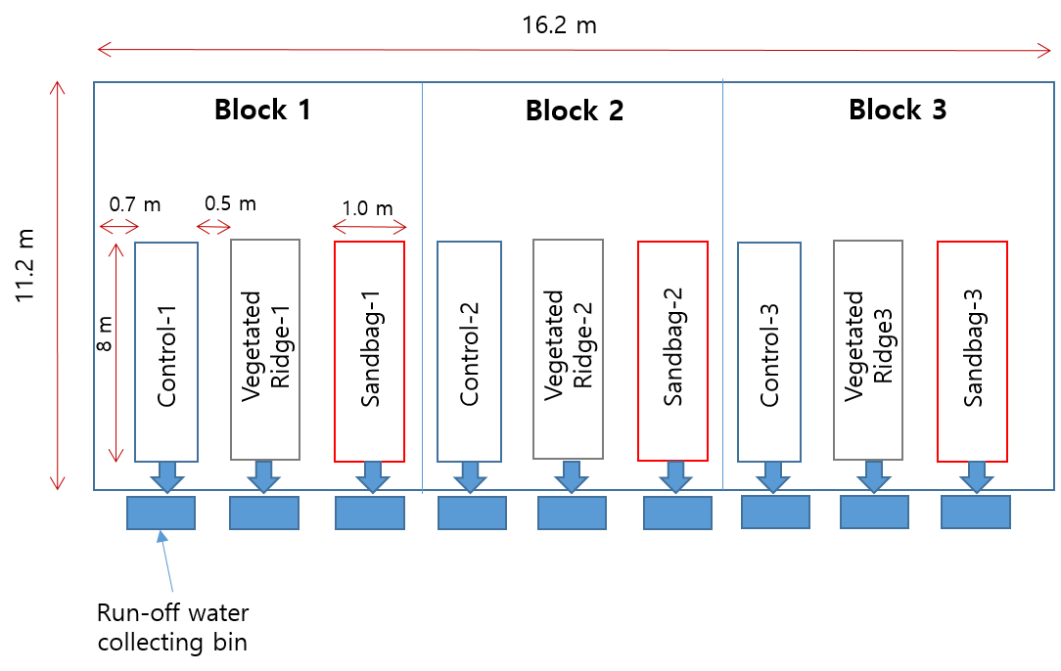
Fig. S1. Schematic design of the experimental plots.

