Appendices
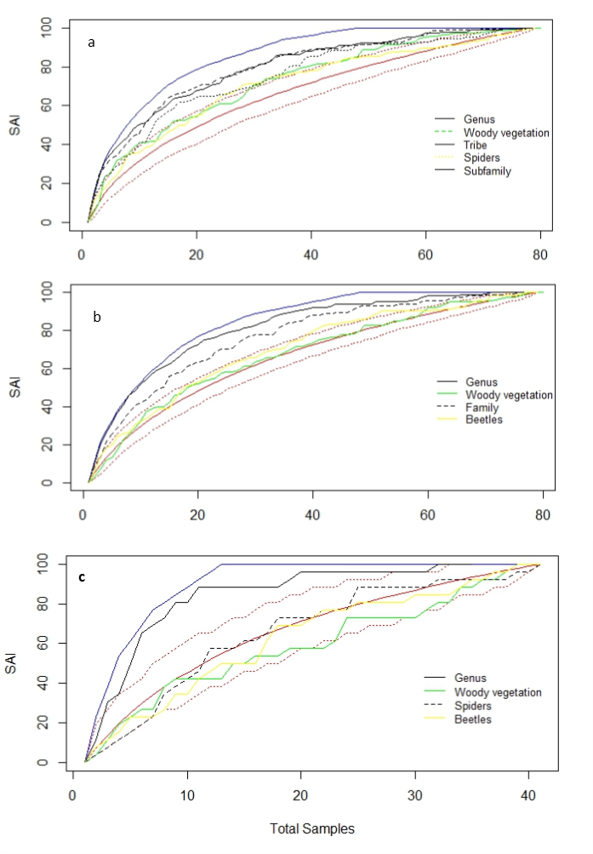
Appendix 2 Assessment of cross and within-taxon surrogacy using the Species Accumulation Index (SAI) of surrogate efﬁciency. The red lines represent the mean and 95% SAI confidence intervals when sites are randomly selected. a) Coleoptera, b) Araneae, c) Diplopoda.
Appendix 3. List of tree species, with abundance counts at each site showing count of abundance per site (with a maximum of 8 sampling points per site).

Tree or woody shrub | BAR | BEN | BLN | BLS | GON | GOR | LUD | MAR | MAS | NWA
Acalypha glabrata |  |  | 1 |  | 1
Adansonia digitata |  |  |  |  | 2 | 1 | 3 | 1 |  | 2
Albizia anthelmintica |  |  |  | 1
Albizia brevifolia |  |  |  |  | 1 |  |  |  |  | 1
Androstachys johnsonii |  |  |  |  | 1 |  |  |  |  | 1
Artabotrys brachypetalus |  |  |  |  | 2 |  |  |  | 1 | 1
Balanites maughamii |  | 1 |  |  |  |  |  |  | 1
Berchemia zeyheri |  | 1 |  |  | 1
Boscia albitrunca |  |  |  | 2 | 1 | 1 | 1 | 2 | 1 | 2
Boscia filipes |  |  |  |  | 1
Boscia foetida |  |  |  |  |  |  |  | 1 | 1
Brachylaena huillensis |  |  |  |  |  |  |  |  | 2
Brachylaena transvaalensis |  |  |  |  |  |  |  |  | 1
Bridelia mollis |  |  |  | 1 | 3 |  |  |  | 1 | 1
Burkea africana |  |  |  |  | 1 | 2 |  |  | 2
Cadaba termitaria |  |  |  | 1
Canthium armatum |  | 2 | 2 | 2 | 1 | 1 |  |  | 2
Capparis tomentosa |  |  |  | 1
Carissa edulis |  | 1
Cassia abbreviata |  |  |  |  |  |  |  |  | 1
Clerodendrum glabrum |  | 2 |  |  | 1 |  |  |  | 1
Coddia rudis |  | 2 |  |  | 1 |  |  |  | 3
Colophospermum mopane | 8 |  |  |  |  |  | 8 | 8 |  | 2
Combretum apiculatum | 6 |  | 3 | 4 |  | 5 | 6 | 2 | 2 | 3
Combretum erythrophyllum |  | 1
Combretum hereroense |  | 5 |  | 2 | 1 |  |  |  | 1
Combretum imberbe |  | 1 | 1 |  |  |  | 1 |  |  | 1
Combretum molle |  | 1 |  |  |  | 2 |  | 1 | 2
Combretum mossambicense |  |  | 3 | 1 |  |  |  |  |  | 1
Combretum padoides | 2
Combretum vendae |  |  |  |  |  |  |  |  | 2
Combretum zeyheri |  |  |  |  | 2 | 2 |  |  | 3
Commiphora africana |  |  | 5 |  |  |  | 1 | 1
Commiphora angolensis |  |  | 1
Commiphora edulis |  |  |  |  |  |  | 1
Commiphora glandulosa |  |  | 1 |  |  |  | 4 | 3 | 1 | 4
Commiphora marlothii |  |  |  |  |  |  |  |  |  | 1
Commiphora mollis | 2 |  | 7 | 2 | 2 | 1 | 4 | 3 | 2 | 3
Commiphora pyracanthoides |  |  | 1 |  | 1 | 1 |  | 3
Commiphora schimperi |  |  |  |  |  |  |  |  | 1
Commiphora tenuipetiolata |  |  |  |  |  |  |  | 2 |  | 5
Commiphora viminea |  |  |  |  |  | 1
Cordia monoica |  |  |  |  | 1 | 1 | 1
Croton gratissimus |  |  |  |  | 1
Croton pseudopulchellus |  |  |  |  | 1 |  |  |  |  | 1
Dalbergia nitidula |  |  |  |  |  | 1
Dichrostachys cinerea |  | 1 |  |  | 1 |  | 1
Diospyros lycioides |  | 1
Diospyros villosa |  | 3
Dombeya rotundifolia |  | 2 |  | 1 |  |  |  |  | 2
Dovyalis zeyheri |  | 1
Ehretia rigida |  | 5 |  | 2 | 3 |  |  |  | 1
Elaeodendron transvaalensis |  | 1
Elephantorrhiza burkei |  |  |  |  | 1 |  |  |  | 1
Empogona kirkii |  |  |  |  |  | 2
Englerophytum magalismontanum |  |  |  |  |  |  |  |  | 1
Euclea crispa |  | 1
Euclea divinorum |  | 1 |  | 1
Euclea natalensis |  |  |  |  | 2 |  |  |  | 3
Euclea schimperi |  | 1 |  | 6
Flueggea virosa |  |  | 1 |  | 1
Gardenia resiniflua |  |  |  |  |  |  |  | 1 |  | 3
Gardenia volkensii |  |  | 1
Grewia bicolor | 4 | 2 | 3 | 8 | 1 | 1 | 6 | 8 | 2 | 8
Grewia flava | 2 |  | 4 | 3
Grewia flavescens | 1 | 6 | 8 | 6 | 4 | 1 | 5 | 2 | 1 | 3
Grewia hexamita |  |  |  |  | 4 |  |  |  |  | 5
Grewia monticola |  |  |  |  | 1 | 1 |  |  | 2 | 1
Grewia retinervis |  |  |  |  |  | 3
Grewia subspathulata | 3 | 1 | 5 | 1 | 1 | 1 | 4 | 2 |  | 1
Grewia tenax |  |  |  |  |  |  | 1
Grewia villosa |  |  | 1 |  | 3 |  | 2 |  |  | 1
Gymnosporia buxifolia |  | 2
Gymnosporia glaucophylla |  | 1
Gymnosporia pubescens |  |  |  |  |  |  |  | 1
Gymnosporia senegalensis |  | 2
Gyrocarpus americanus |  |  |  |  | 1
Heteropyxis natalensis |  |  |  |  |  |  |  |  | 1
Hexalobus monopetalu |  |  |  | 1 | 2 | 2 |  |  | 2
Hyperacanthus amoenus |  |  |  |  |  |  |  |  | 2
Indigofera subcorymbosa |  |  |  |  |  |  |  |  | 1
Kirkia acuminata |  |  |  |  | 4 | 1 |  | 2 |  | 2
Kirkia wilmsii |  |  |  |  |  |  |  |  | 1
Lannea schweinfurthii |  |  |  |  | 1 |  | 5 |  |  | 1
Lycium cinereum |  |  |  |  |  | 1
Maerua parvifolia |  |  |  | 1 | 1 |  | 1
Maesa lanceolata |  |  |  |  |  |  |  |  |  | 1
Markhamia zanzibarica |  |  | 1
Obetia tenax |  |  |  |  | 1
Ochna inermis |  |  |  | 1 | 1 | 1 | 2 | 1 |  | 3
Ochna pulchra |  |  |  |  |  | 3 |  |  | 2
Olea africana |  |  |  |  |  |  |  |  | 1
Olea enervis |  |  |  |  |  |  |  |  | 1
Orbivestus cinerascens |  |  | 1
Ormocarpum trichocarpum |  | 4 |  | 1 |  |  |  |  | 1
Ozoroa paniculosa |  | 1 | 2 | 0 |  |  |  |  | 2
Pappea capensis |  | 2 |  | 1 | 1 |  |  |  | 6
Pavetta eylesii |  |  |  |  | 2
Peltophorum africanum |  | 3 | 1 | 2 | 1 | 1 |  |  | 2
Philenoptera violaceae |  |  | 1 | 1 | 2 |  |  | 1
Phyllanthus reticulatus |  |  | 1
Pseudolachnostylis maprouneifolia |  |  |  |  | 1 | 2 |  |  | 1
Psiadia punctulata |  |  |  |  | 2 |  |  |  | 3 | 3
Psydrax livida |  |  |  |  | 1 | 1 |  |  | 1
Ptaeroxylon obliquum |  |  |  |  | 1
Pterocarpus rotundifolius |  |  |  |  |  |  |  |  | 3
Pyrostria hystrix |  |  |  | 1
Rhigozum zambesiacum | 2 |  |  |  |  |  | 1
Rhoicissus sp. |  |  |  |  |  |  |  |  | 1
Schotia brachypetala |  |  |  | 4 | 1 |  |  | 1
Sclerocarya birrea |  | 2 | 7 |  |  | 1 | 3 | 2 | 2 | 1
Scolopia zeyheri |  | 1
Searsia leptodictya |  |  |  | 2 | 1 |  |  |  | 1
Searsia magalismontana subsp. coddii |  |  |  |  |  |  |  |  | 1
Searsia pentheri |  | 2
Senegalia ataxacantha |  |  |  |  |  |  |  |  | 1
Senegalia burkei |  |  |  |  |  | 1
Senegalia caffra |  | 4 |  |  |  |  |  |  | 1
Senegalia erubescens |  |  |  |  |  |  | 2 |  |  | 1
Senegalia nigrescens | 2 |  | 6 | 5 | 1 |  | 2 | 1 |  | 5
Senegalia schweinfurthii |  |  |  |  | 2
Senegalia senegal | 1 |  |  |  |  |  |  | 2 |  | 2
Senegalia welwitschii |  |  |  |  | 1
Senna petersiana |  |  |  |  | 1
Sesamothamnus lugardii |  |  |  |  |  |  |  |  |  | 1
Spirostachys africana |  |  | 1 | 2
Sterculia rogersii |  |  |  |  | 1 |  |  | 4 |  | 1
Strychnos madagascariensis |  |  |  | 3 | 3 | 3 |  |  | 2 | 1
Strychnos pungens |  |  |  |  |  | 1
Tarchonanthus parvicapitulatus |  |  |  |  |  |  |  |  | 2
Teclea pilosa |  | 2
Terminalia prunioides | 2 |  | 3 |  | 3 | 1 | 6 | 6 |  | 4
Terminalia sericea |  |  | 2 | 1 | 2 | 3 |  |  | 2
Tinnea rhodesiana |  |  |  |  |  |  | 1 |  |  | 2
Toddaliopsis bremekampii |  |  |  |  | 1 |  |  |  | 1
Vachellia gerrardii |  | 5 |  | 3
Vachellia karroo |  | 1 |  |  | 1
Vachellia nebrownii |  |  |  |  |  |  |  | 1
Vachellia nilotica |  | 2 | 1
Vachellia permixta |  | 5
Vachellia rehmanniana |  | 2 |  |  |  |  |  |  | 1
Vachellia robusta |  |  |  | 1 |  |  |  | 1
Vachellia tortilis | 3 | 2 | 3 | 4 | 2 |  | 3 | 3 | 1 | 2
Vangueria dryadum |  |  |  |  | 4 |  |  |  | 1
Vangueria infausta |  | 1 |  |  | 1 |  |  |  | 1
Vangueria lasiantha |  |  |  |  |  | 1
Vangueria parvifolium |  |  |  |  |  | 2
Vitex pooara |  |  |  |  | 1
Vitex rehmannii |  |  |  |  |  |  |  |  | 4
Ximenia americana | 3 |  |  | 3 | 1 |  | 2 | 4 | 1 | 1
Ximenia caffra |  |  | 1 |  | 1
Ziziphus mucronata |  | 6 | 1 | 8 | 3 |  |  |  | 1
Ziziphus rivularis |  | 1

