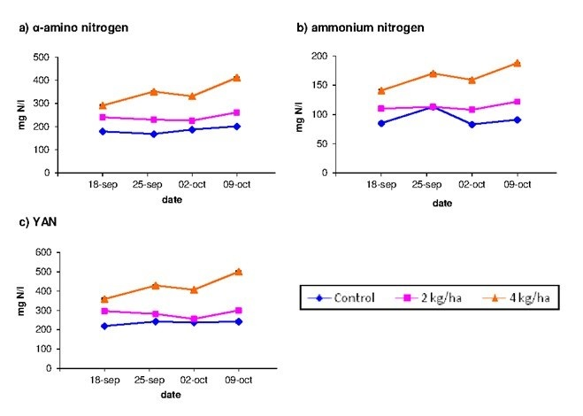
Figure S1. Evolution of amino nitrogen (a), ammonium nitrogen (b) and yeast assimilable nitrogen (YAN) (c) in control musts and in musts obtained from vines with foliar urea fertilization.

Table S1. Coefficients of linear discriminants
 | LD1 | LD2
Phosphoserine | 0.28464574 | 0.3245030
Asparticacid | -0.01790553 | 0.9881373
Glutamicacid | -0.65060752 | -0.8319516
Phosphoethanolamine | 0.63473990 | 0.7165766
Serine | 7.32226330 | 0.7204632
Asparagine | -1.38756771 | -1.7972411
Glycine | -1.03962549 | 0.7149691
Taurine | -2.34919046 | -3.5123645
Histidine | 1.54048708 | -0.7730192
γ-Aminobutyricacid | -2.37237401 | -3.5123645
Threonine | 1.54048708 | -0.7730192
Alanine | -3.18694773 | 4.2276188
Arginine | -3.19467867 | 1.4473360
Proline | 0.36940133 | -2.7614262
Tyrosine | -0.48640132 | 2.0283725
Valine | -0.15894999 | 0.8370905
Methionine | 0.23685137 | 1.4286660
Isoleucine | 0.90830376 | 0.6929498
Leucine | -0.06664520 | -0.5849377
Phenylalanine | 0.17927391 | -1.1772778
Tryptophan | -1.78851229 | 2.1467836
Lysine | 1.45308646 | 0.3409647

Table S2. Repeated measures ANOVA.
 | Effect | DF_{n} | DF_{d} | F | p-value
Glutamic acid | Treatment  Time  Treatment*Time | 2  3  6 | 9  27  27 | 534.29  24.62  3.88 | 4.4*10⁻¹⁰  6.9*10⁻⁸  0.0063
Arginine | Treatment  Time  Treatment*Time | 2  3*0.44ª  6*0.44ª | 9  27*0.44ª  27*0.44ª | 489.03  10.01  6.67 | 6.6*10⁻¹⁰  0.0054  0.0078
Aspartic acid | Treatment  Time  Treatment*Time | 2  3*0.22ª  6*0.22ª | 9  27*0.22ª  27*0.22ª | 333.01  31.60  6.57 | 3.7*10⁻⁹  1.2*10⁻⁵  0.0047
Asparagine | Treatment  Time  Treatment*Time | 2  3*0.03ª  6*0.03ª | 9  27*0.03ª  27*0.03ª | 2340.41  9.48  19.23 | 3.7*10⁻⁹  0.0085  0.0002
Alanine | Treatment  Time  Treatment*Time | 2  3*0.37ª  6*0.37ª | 9  27*0.37ª  27*0.37ª | 188.36  19.94  18.87 | 4.5*10⁻⁸  0.001  0.0004
Serine | Treatment  Time  Treatment*Time | 2  3*0.39ª  6*0.39ª | 9  27*0.39ª  27*0.39ª | 588.92  5.87  7.12 | 2.9*10⁻⁷  0.0307  0.0091
Threonine | Treatment  Time  Treatment*Time | 2  3*0.04ª  6*0.04ª | 9  27*0.04ª  27*0.04ª | 150.05  10.96  16.78 | 1.2*10⁻⁷  0.0007  6.3*10⁻⁶
γ-Aminobutyric acid | Treatment  Time  Treatment*Time | 2  3*0.01ª  6*0.01ª | 9  27*0.01ª  27*0.01ª | 386.42  2.86  3.72 | 1.9*10⁻⁹  0.1161  0.0534
ªAs the Mauchly sphericity condition was rejected the degrees of freedom (DF) of the F-distribution were multiplied by the Greenhouse-Geisser correction.

If dv is the dependent variable in the regression model, a classical ANOVA study would consider the model:
dv = β₀ + β₁*Time + β₂*Treatment + β₃*Time*Treatment + ε (M1)
This is a fixed effect model, because the β values are considered fixed. As in this work, we repeated measures in individuals throughout the time, we can consider that β₀ randomly changes from individual to individual, this would be model M2, or β₁ is random, model M3, or both are random, model M4. These models are known in the statistical literature as mixed models because some β values remain fixed and the rest of β values are random.
In any case, model M1 is a basic model, which is improved with models M2, M3 and M4 since the variability of the error ε decreases significantly. In Table S2 a summary of that study is shown. In this Table, the chosen model for each amino acid is indicated and the significant β values (p-value<0.05) are reported along with their variability in case of random effects (an empty cell means that there are no significant effects throughout the time).

Table S3
Amino acid | Model(s) chosen | Time effect
 |  | C | T1 | T2
Glutamic acid | M1, M3 | - | 4.9 (0.37) | 5.3 (0.93)
Arginine | M1, M3 | - | - | 36.6 (6.2)
Aspartic acid | M1, M2 | - | 7.18 | 9
Asparagine | M1(=M3) | - | - | -
Alanine | M1(=M3) | 4.32 | 11.6 | -3.2
Serine | M1, M3 | - | - | 3.4 (0.2)
Threonine | M1(=M3) | - | - | -
γ-Aminobutyric acid | M1, M3 | - | 4 (0.93) | -

Observe that M1 model is chosen in all the cases, although sometimes models M3 and M2 are also appropriate. Choosing M1 means that the evolution throughout the time, if significant, is quite stable and the inclusion of random β values hardly diminishes the error variability.
In order to select one model vs another one we have used the ratio likelihood test along with the Akaike criterion for model selection. In terms of ratio likelihood test, the inclusion of random slopes or intercepts does not significantly reduces the variance error, however, the Akaike Criterion provide similar values to the M1 model and the M3 model (M2 model for aspartic acid) except for alanine, threonine and asparagine where any advantage is found including random slopes. In those cases, M1 model and M3 model provide the same estimates for the slopes.

