Supporting Information
UV-DRS Spectra and Band Gap Determination of TiO₂ nanoparticles

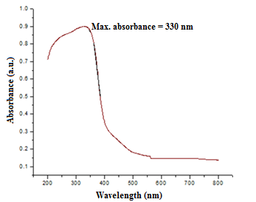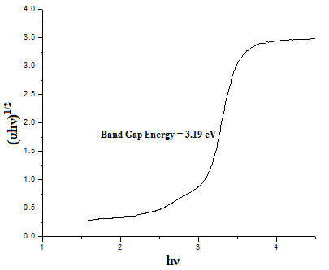

Fig. 1 DRS spectrum and band gap determination of TiO₂ nanoparticles
Fig.1 shows the diffuse reflectance spectrum and band gap determination of TiO₂ nanoparticles. From the diffuse reflectance spectra, it can be determined that TiO₂ nanoparticles are having absorption around 330 nm. The band gap energy is determined by extrapolating the linear portion of (αhν) ^{1/2} on hν axis, and it is found that TiO₂ nanoparticles have a band gap energyof 3.19 eV.
Optimization of MgO in TiO₂/MgO nanocomposite
The concentration of MgO nanoparticles in TiO₂/MgO nanocomposite is an important factor in determining the photodegradation efficiency of the nanocomposite in degrading the dye solution. Concentrations of 3 wt.%, 5wt.% and 10 wt.% MgO in TiO₂/MgO nanocomposite was studied. 3 wt.% MgO in TiO₂/MgO nanocomposite is found to have better efficiency than 5 wt.% and 10 wt.% MgO.

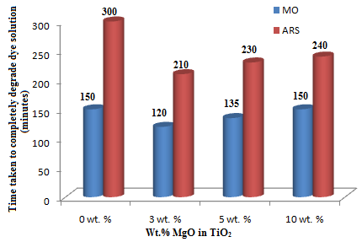
Fig. 2 Optimization of Wt. % of MgO in TiO₂/MgO nanocomposite

Reusability of the photocatalyst
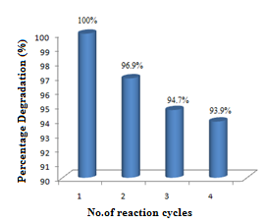
Fig. 3 Reusability of TiO₂/MgO/Chitosan hydrogel in degrading MO

Kinetics of the photocatalytic reaction with respect to the initial dye concentration of MO and ARS is as shown in fig. 4.

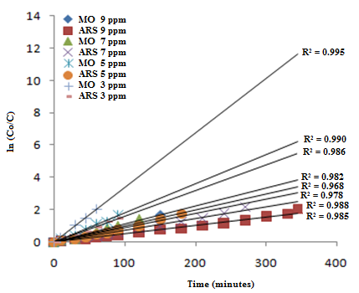

Fig. 4 Degradation kinetics in degrading MO and ARS dye solution
It can be seen from figure that as the initial concentration of the MO dye increases from 3 ppm to 9 ppm, the degradation rate decreases from 0.031892min⁻¹ to 0.011698min⁻¹. In the case of ARS, as the initial concentration of the dye increases from 3 ppm to 9 ppm, the degradation rate decreases from 0.014897min⁻¹ to 0.005816min⁻¹.
Photocatalytic Degradation Kinetics
A plot of -ln(C/C₀) against t will give a straight line if the reaction is of first order. Kinetics of the photocatalytic reaction with respect to the initial dye concentration of MO and ARS is shown in supporting information. As the initial concentration of the MO dye increases from 3 ppm to 9 ppm, the degradation rate decreases from 0.031892 min⁻¹ to 0.011698 min⁻¹. In the case of ARS, as the initial concentration of the dye increases from 3 ppm to 9 ppm, the degradation rate decreases from 0.014897 min⁻¹ to 0.005816 min⁻¹.
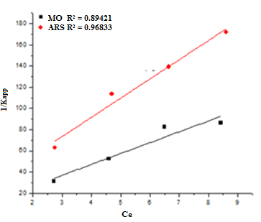
Fig. 5 L-H kinetics for MO and ARS degradation

The degradation of MO and ARS as a function of irradiation time using TiO₂/MgO nanocomposite and TiO₂/MgO/chitosan hydrogel is shown in fig.6.

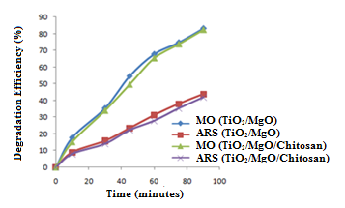
Fig.6 Degradation efficiency of TiO₂/MgO nanocomposite and
TiO₂/MgO/Chitosan hydrogels in degrading MO and ARS

Langmuir and Freundlich adsorption isotherms thus obtained are shown in Fig. 7.

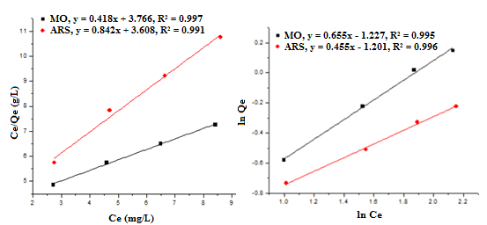
Fig.7 Langmuir and Freundlich adsorption isotherm for MO and ARS

