Supplemental material

Synergistic photocatalytic and Fenton-like degradation of organic contaminants using peroxymonosulfate activated by CoFe2O4@*g*-C3N4 composite

**Xu Guo, Shasha Ai, Dan Yang, Lei Zhao, Hanming Ding[1]\***

*School of Chemistry and Molecular Engineering, East China Normal University, 500 DongchuanRoad, Shanghai 200241, China*

**Figure captions:**

**Figure S1.** TEM images of (a) *g*-C3N4 nanosheets and (b) CN-CoFe2O4-3.

**Figure S2.** XPS full spectra of *g*-C3N4 and CN-CoFe2O4-3.

**Figure S3.** High-resolution XPS spectrum of O 1s of CN-CoFe2O4-3.

**Figure S4.** UV-vis diffuse reflectance spectra of the as-prepared samples.

**Figure S5.** Photocatalytically-assisted Fenton-like catalytic degradation curves of RhB over CN-CoFe2O4-3 and the sample of mechanically mixed CoFe2O4 and *g*-C3N4, which has a same loading content of CoFe2O4 with that of CN-CoFe2O4-3.

**Figure S6.** (a) Degradation curves of *p*-CP under different conditions. (b) The corresponding kinetic fitted curves for the degradation of *p*-CP. (c) The evolution of UV-vis spectra during the photocatalytically-assisted Fenton-like catalytic degradation of *p*-CP over CN-CoFe2O4-3.

**Figure S7.** The evolution of UV-vis spectra during the photocatalytically-assisted Fenton-like catalytic degradation of RhB over CN-CoFe2O4-3.

**Figure S8.** Schematic diagram of two possible mechanisms to explain [charge separation](https://www.sciencedirect.com/topics/physics-and-astronomy/polarization-charge-separation): (a) conventional heterojunction-type and (b) direct Z-scheme mechanism.

**Figure S9**. •OH-trapping photoluminescence spectra of *g*-C3N4 and CN-CoFe2O4-3 samples under visible-light irradiation for 2 h in a solution of [coumarin](https://www.sciencedirect.com/topics/chemistry/coumarin) at room temperature.

**Figure S10.** The degradation curves of RhB with different co-existing anions over CN-CoFe2O4-3 in the photocatalytically-assisted Fenton-like processes.

**Figure S11.** The degradation curves of RhB under different initial pH values over CN-CoFe2O4-3 in the photocatalytically-assisted Fenton-like processes.

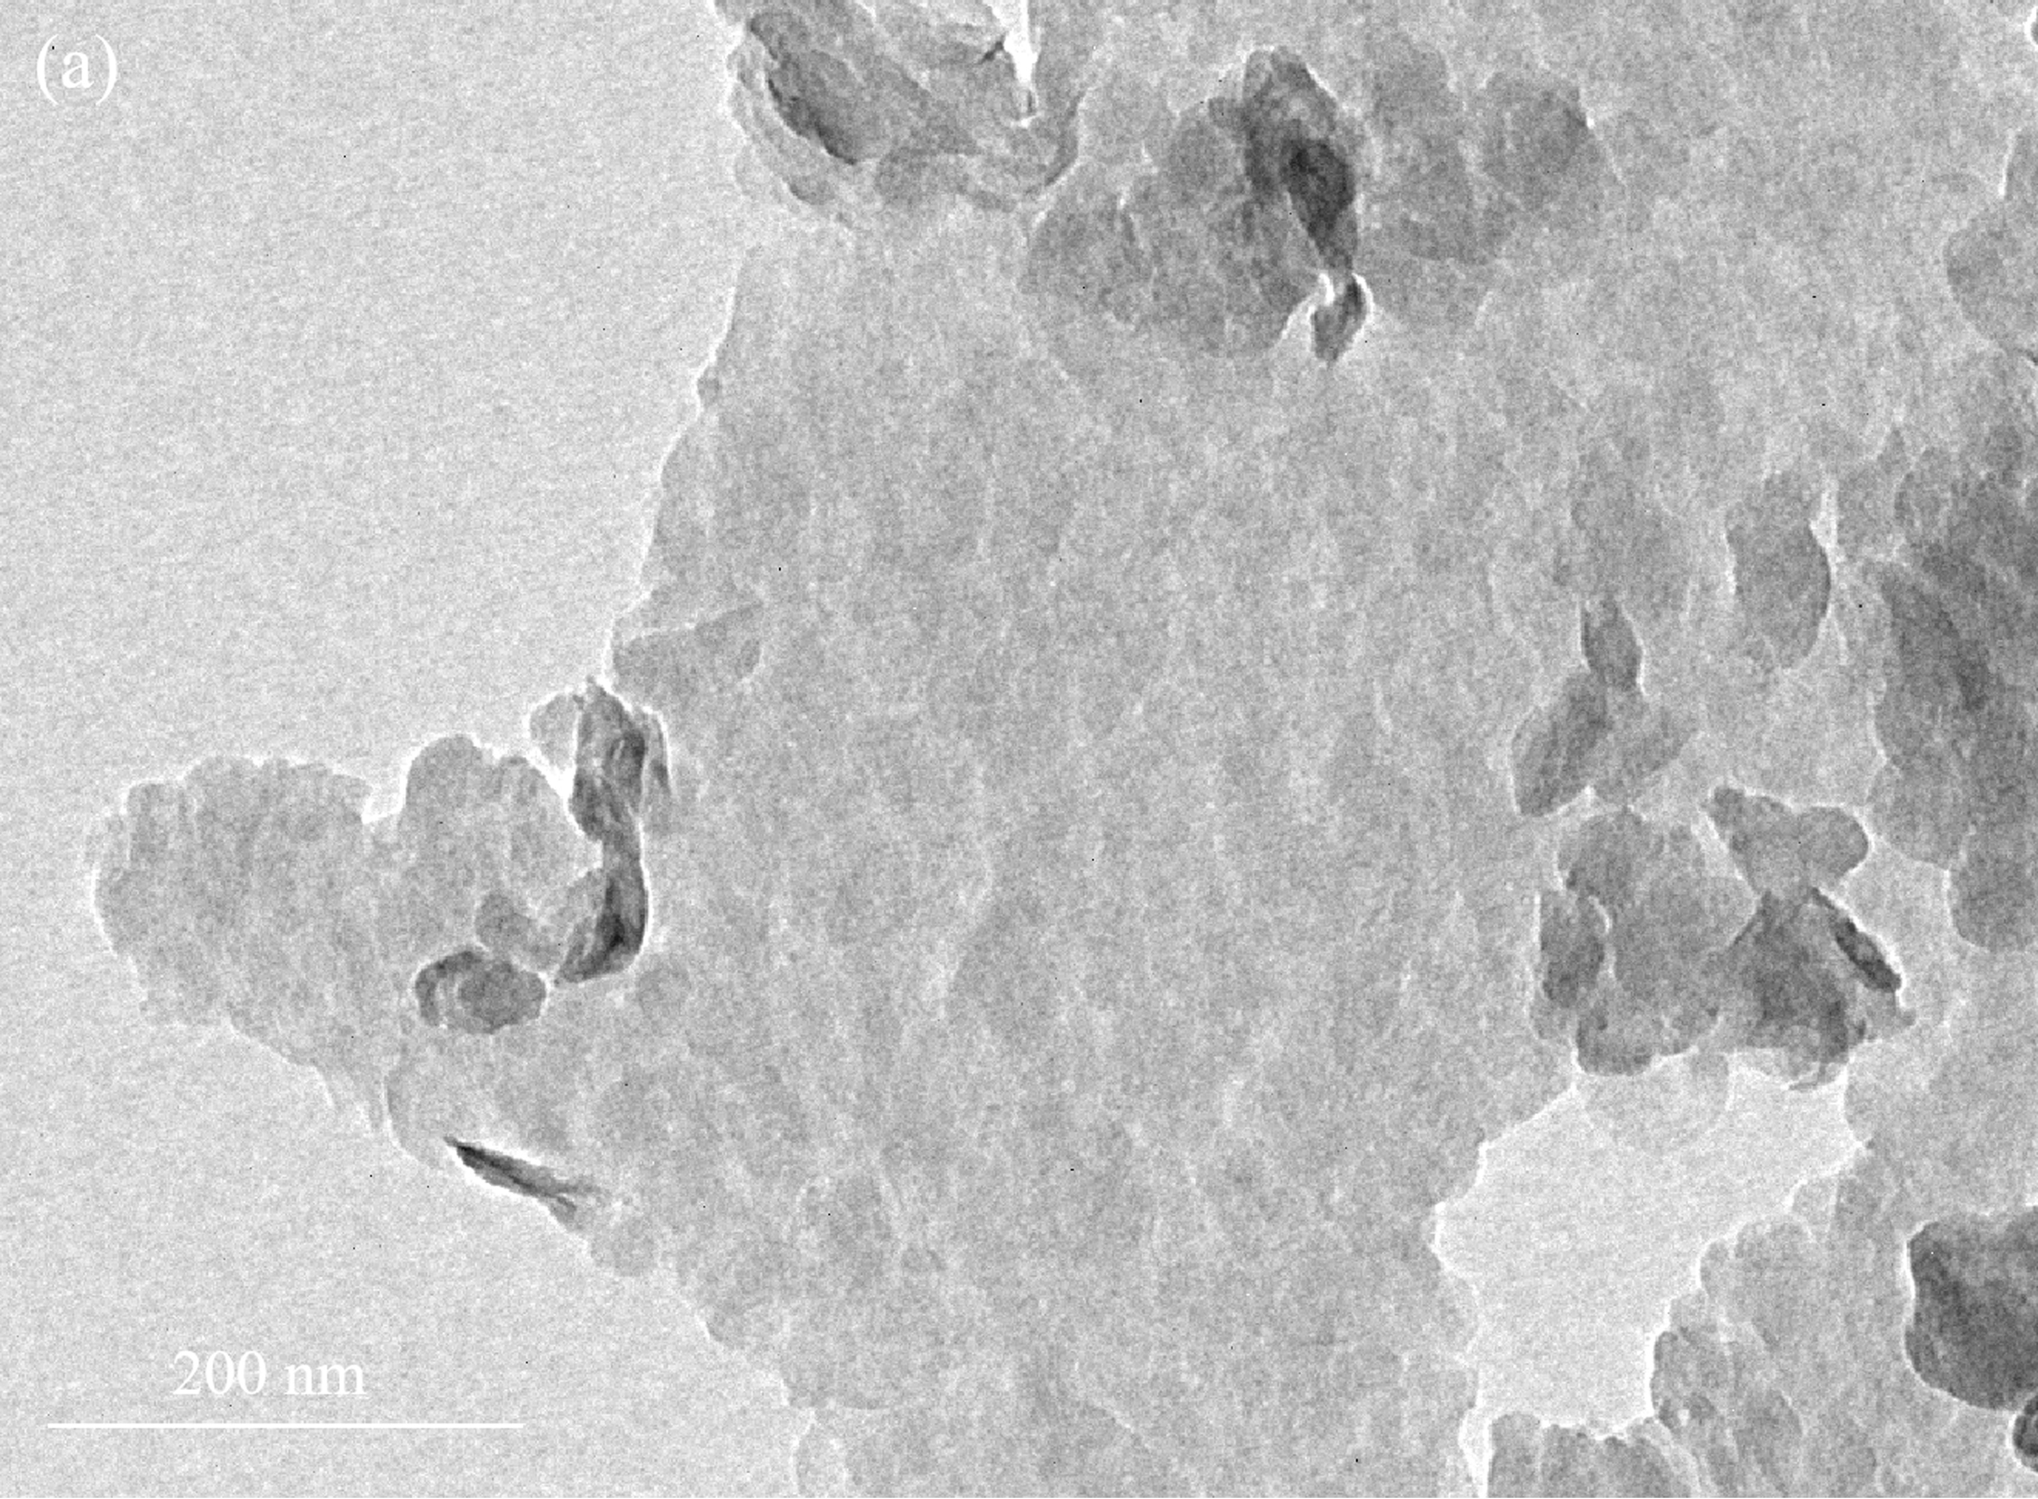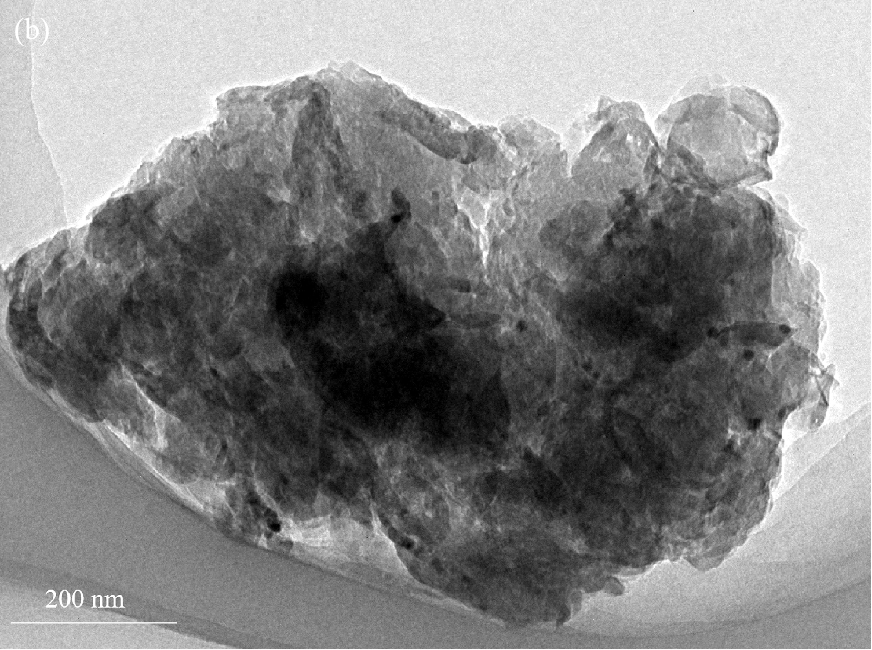

**Figure S1.** TEM images of (a) *g*-C3N4 nanosheets and (b) CN-CoFe2O4-3.



**Figure S2.** XPS full spectra of *g*-C3N4 and CN-CoFe2O4-3.



**Figure S3.** High-resolution XPS spectrum of O 1s of CN-CoFe2O4-3.



**Figure S4.** UV-vis diffuse reflectance spectra of the as-prepared samples.



**Figure S5.** Photocatalytically-assisted Fenton-like catalytic degradation curves of RhB over CN-CoFe2O4-3 and the sample of mechanically mixed CoFe2O4 and *g*-C3N4, which has a same loading content of CoFe2O4 with that of CN-CoFe2O4-3.



**Figure S6.** (a) Degradation curves of *p*-CP under different conditions. (b) The corresponding kinetic fitted curves for the degradation of *p*-CP. (c) The evolution of UV-vis spectra during the photocatalytically-assisted Fenton-like catalytic degradation of *p*-CP over CN-CoFe2O4-3.



**Figure S7.** The evolution of UV-vis spectra during the photocatalytically-assisted Fenton-like catalytic degradation of RhB over CN-CoFe2O4-3.

Two possible mechanisms to explain the improved [charge separation](https://www.sciencedirect.com/topics/physics-and-astronomy/polarization-charge-separation) are illustrated in [Figure S](https://www.sciencedirect.com/science/article/pii/S0169433217316720#fig0040)8. In the traditional heterojunction-type photocatalytic system ([Figure S](https://www.sciencedirect.com/science/article/pii/S0169433217316720#fig0040)8a), the electrons in the VB of *g*-C3N4 and CoFe2O4 are excited to the CB of *g*-C3N4 and CoFe2O4 under solar light, respectively. Then the photogenerated electrons in the CB of *g*-C3N4 with more negative energy potential transfer to the CB of CoFe2O4, while the photogenerated holes in the VB of CoFe2O4 with more positive energy potential migrate to the VB of *g*-C3N4. Therefore, the photoinduced electrons and holes are accumulated in the CB of CoFe2O4 and the VB of *g*-C3N4, respectively, resulting in the separation of photoinduced charge carriers. In the direct Z-scheme photocatalytic system ([Figure S](https://www.sciencedirect.com/science/article/pii/S0169433217316720#fig0040)8b), both CoFe2O4 and *g*-C3N4 can generate electrons and holes under light [excitation](https://www.sciencedirect.com/topics/physics-and-astronomy/excitation). Then the photogenerated electrons in the CB of CoFe2O4 transfer and combine with the photogenerated holes in the VB of *g*-C3N4, leaving the electrons in the CB of *g*-C3N4 and the holes in the VB of CoFe2O4, thus maintaining the strong electron [reducibility](https://www.sciencedirect.com/topics/chemistry/reducibility) in the CB of *g*-C3N4 and the strong hole oxidizability in the VB of CoFe2O4.

To determine the more plausible charge separation mechanism of CoFe2O4/*g*-C3N4 composite, the hydroxyl radicals (•OH) generated from the surfaces of pure *g*-C3N4, CoFe2O4 and CN-CoFe2O4-3 were investigated by the [photoluminescence](https://www.sciencedirect.com/topics/chemistry/photoluminescence) analysis with [coumarin](https://www.sciencedirect.com/topics/chemistry/coumarin) as a probe molecule. The PL spectra of the samples under visible light irradiation for 2 h are shown in Figure S9, and the PL intensity at 448 nm can reflect the amount of hydroxyl radicals [1, 2].

For the samples of *g*-C3N4 and CoFe2O4, the VB potential of them are more negative than the [oxidation potential](https://www.sciencedirect.com/topics/chemistry/oxidation-potential) of OH−/•OH (1.99 V) [3, 4]. Therefore, the holes in both of pure *g*-C3N4 and CoFe2O4 are unable to oxidize OH− into •OH. Pure *g*-C3N generates a little amount of hydroxyl radicals (•OH) with weak PL signals. This is attributed to the indirect generation of •OH originated from •O2− [5], which is produced due to the more negative CB potential of *g*-C3N4 than the reduction potential of O2/•O2−. For the sample of CN-CoFe2O4-3, a lower PL peak signal at 448 nm than sample *g*-C3N4 was detected. These results strongly imply that CN-CoFe2O4-3 complies with the conventional heterojunction-type rather than the direct Z-scheme reaction mechanism. Due to the more positive potential of CoFe2O4 than that of O2/•O2− [4], the photogenerated electrons transferring from the CB of *g*-C3N4 into the CB of CoFe2O4 cannot reduce O2 into •O2−. If CN-CoFe2O4-3 follows the direct Z-scheme reaction mechanism, more photogenerated electrons accumulated in the CB of *g*-C3N4 can reduce the dissolved O2 into •O2−, thus the concentration of •OH should be higher than that in pure *g*-C3N4.

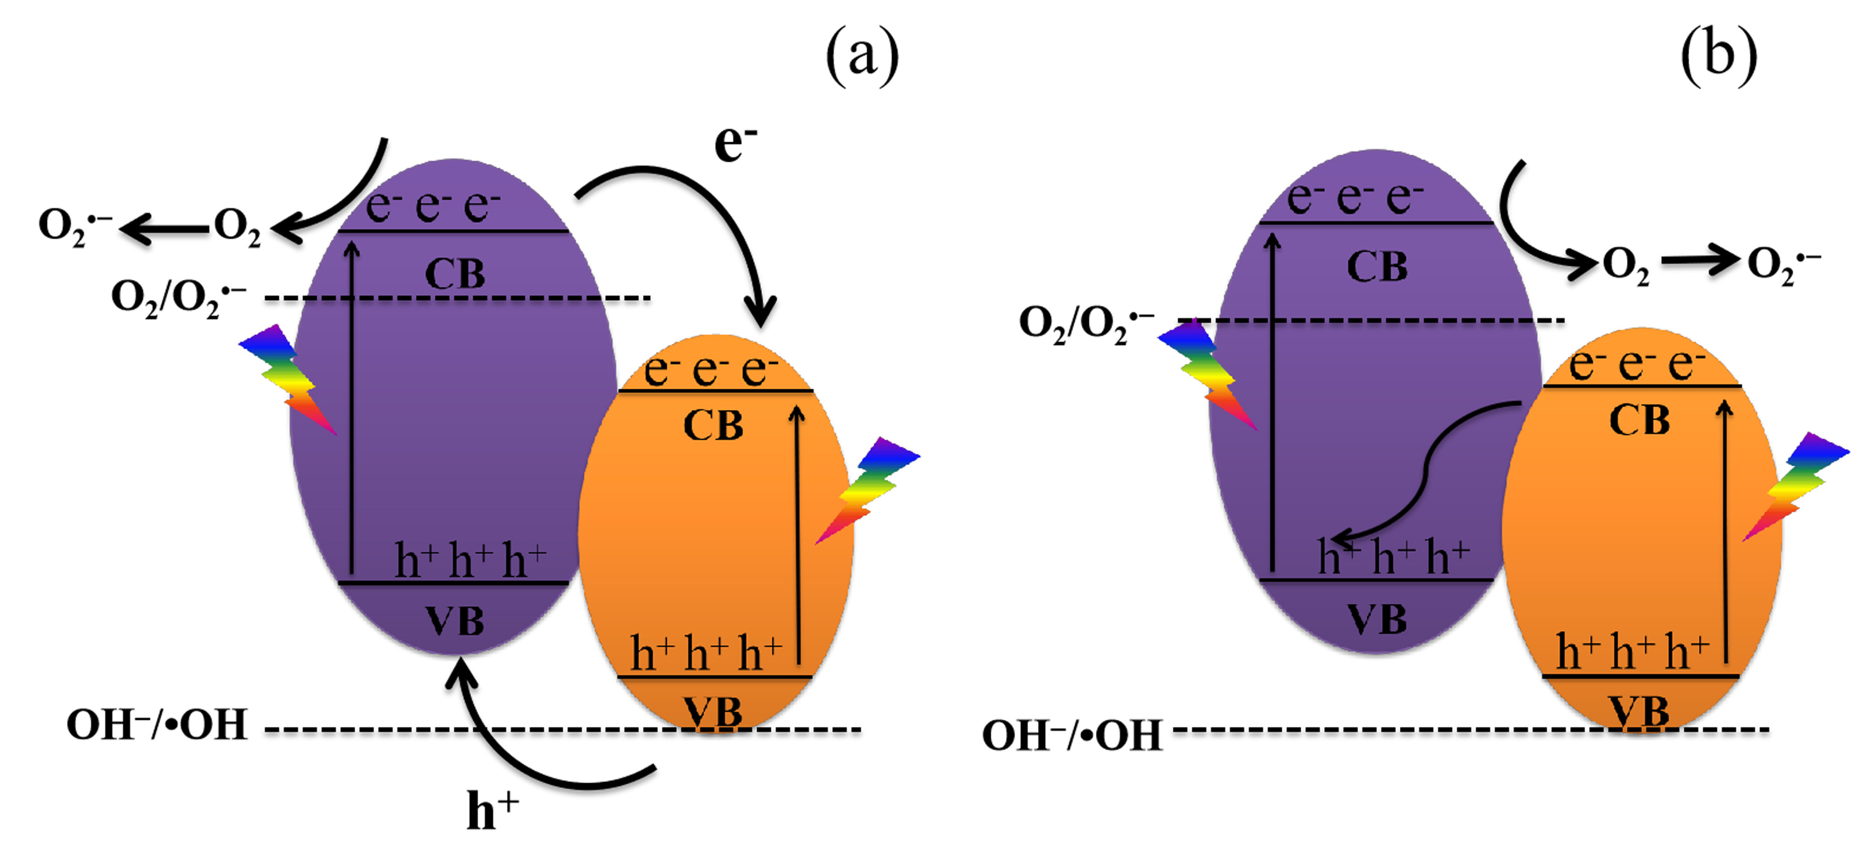

**Figure S8.** Schematic diagram of two possible mechanisms to explain [charge separation](https://www.sciencedirect.com/topics/physics-and-astronomy/polarization-charge-separation): (a) conventional heterojunction-type and (b) direct Z-scheme mechanism.



**Figure S9**. •OH-trapping photoluminescence spectra of *g*-C3N4 and CN-CoFe2O4-3 samples under visible-light irradiation for 2 h in a solution of [coumarin](https://www.sciencedirect.com/topics/chemistry/coumarin) at room temperature.



**Figure S10.** The degradation curves of RhB with different co-existing anions over CN-CoFe2O4-3 in the photocatalytically-assisted Fenton-like processes.



**Figure S11.** The degradation curves of RhB under different initial pH values over CN-CoFe2O4-3 in the photocatalytically-assisted Fenton-like processes.

**References**

[1] Cai L, Long Q, Yin C. Synthesis and characterization of high photocatalytic activity and stable Ag3PO4/TiO2 fibers for photocatalytic degradation of black liquor. Appl Surf Sci. 2014;319:60-7.

[2] He Y, Zhang L, Wang X, et al. Enhanced photodegradation activity of methyl orange over Z-scheme type MoO3–*g*-C3N4 composite under visible light irradiation. RSC Adv. 2014;4:13610-9.

[3] Christoforidis KC, Montini T, Bontempi E, et al. Synthesis and photocatalytic application of visible-light active *β*-Fe2O3/*g*-C3N4 hybrid nanocomposites. Appl Catal B: Environ. 2016;187:171-80.

[4] Jing L, Xu Y, Huang S, et al. Novel magnetic CoFe2O4 /Ag/Ag3VO4 composites: Highly efficient visible light photocatalytic and antibacterial activity. Appl Catal B: Environ. 2016;199:11-22.

[5] Meng A, Zhu B, Zhong B, et al. Direct Z-scheme TiO2/CdS hierarchical photocatalyst for enhanced photocatalytic H2-production activity. Appl Surf Sci. 2017;422:518-27.

1. * Corresponding author. E-mail: hmding@chem.ecnu.edu.cn; Tel: +86-21-54340061