Structural properties and thermal behavior of novel interaction product 4-amino-5-(furan-2-yl)-4H-1,2,4-triazole-3-thione with molecular iodine
Victoria A. Ivolginaª, Margarita S. Chernov’yantsª, Leonid D. Popovª, Vitaliy V. Suslonov^{b}, Natalya A. Avtushenkoª, Nikolay V. Luanguzovª
ªDepartment of Chemistry, Southern Federal University, Zorge St. 7, 344090 Rostov-on-Don, Russia
^{b}St.Petersburg State University, 7/9 Universitetskaya nab., St. Petersburg, 199034 Russia
Email: vickaivolgina@yandex.ru
Supplemental Materials

Table S 1: Crystal data and structure refinement for C₆H₆N₄OS∙I₂
Compound | 1
Empirical Formula | C₆H₆I₂N₄OS
Formula Weight | 436.01
Crystal System / Space Group | Monoclinic/ P2₁
a / Å | 10.4679(6)
b / Å | 4.6885(3)
c / Å | 11.6913(8)
α / ° | 90
β / ° | 92.903(6)
γ / ° | 90
V / Å³ | 573.06(7)
Z | 2
D _{calc} (g/cm³) | 2.527
μ (mm⁻¹) | 44.641
Crystal size (mm) | 0.1 × 0.05 × 0.05
Color / Shape | Dark-brown/ needle-like
Temp (K) | 100(2)
Theta range for collection | 7.572 to 144.99
Reflections collected | 4909
Independent reflections | 2259 [R_{int} = 0.0628, R_{sigma} = 0.0762]
Data/restraints/parameters | 2259/1/128
Goodness of fit on F² | 1.048
Final R indices [I > 2σ(I)] | R₁ = 0.0423, wR₂ = 0.0989
R indices (all data) | R₁ = 0.0458, wR₂ = 0.1020
Largest difference peak/hole | 1.13/-0.99

Table S 2: Bond Lengths for C₆H₆N₄OS∙I₂
Atom | Atom | Length/Å |  | Atom | Atom | Length/Å
I1 | I2 | 2.82(11) |  | N4 | C5 | 1.30(16)
I1 | S1 | 2.80(3) |  | C5 | C2 | 1.45(2)
S1 | C10 | 1.69(14) |  | O6 | C7 | 1.37(17)
N1 | N3 | 1.40(13) |  | O6 | C2 | 1.37(16)
N1 | C10 | 1.37(18) |  | C7 | C8 | 1.36(2)
N1 | C5 | 1.36(18) |  | C8 | C1 | 1.42(2)
C10 | N2 | 1.33(17) |  | C1 | C2 | 1.35(19)
N2 | N4 | 1.37(16)

Table S 3: Bond Angles for C₆H₆N₄OS∙I₂
Atom | Atom | Atom | Angle/˚ |  | Atom | Atom | Atom | Angle/˚
S1 | I1 | I2 | 171.74(8) |  | N1 | C5 | C2 | 125.3(11)
C10 | S1 | I1 | 97.4(5) |  | N4 | C5 | N1 | 111.1(12)
C10 | N1 | N3 | 126.9(11) |  | N4 | C5 | C2 | 123.5(12)
C5 | N1 | N3 | 124.8(12) |  | C7 | O6 | C2 | 106.5(11)
C5 | N1 | C10 | 108.1(10) |  | C8 | C7 | O6 | 110.3(12)
N1 | C10 | S1 | 126.6(10) |  | C7 | C8 | C1 | 106.2(12)
N2 | C10 | S1 | 130.1(11) |  | C2 | C1 | C8 | 106.9(13)
N2 | C10 | N1 | 103.2(11) |  | O6 | C2 | C5 | 113.9(11)
C10 | N2 | N4 | 113.8(10) |  | C1 | C2 | C5 | 136.0(13)
C5 | N4 | N2 | 103.6(11) |  | C1 | C2 | O6 | 110.1(13)

Table S 4: Bond lengths and torsion angles (Å, °)
Bond lengths (Å)
I(1)-I(2) - 2.8182(11)
I(1)-S(1) - 2.798(3)
S(1)-C(10) - 1.687(14)
Torsion angles (°)
I(2)-I(1)-S(1)-C(10): -102.3(7)
I(1)-S(1)-C(10)-N(1): 134(1)
I(1)-S(1)-C(10)-N(2): -45(1)
Bond angles (°)
I(2)-I(1)-S(1): 2.0583(6)
I(1)-S(1)-C(10): 171.74(8)

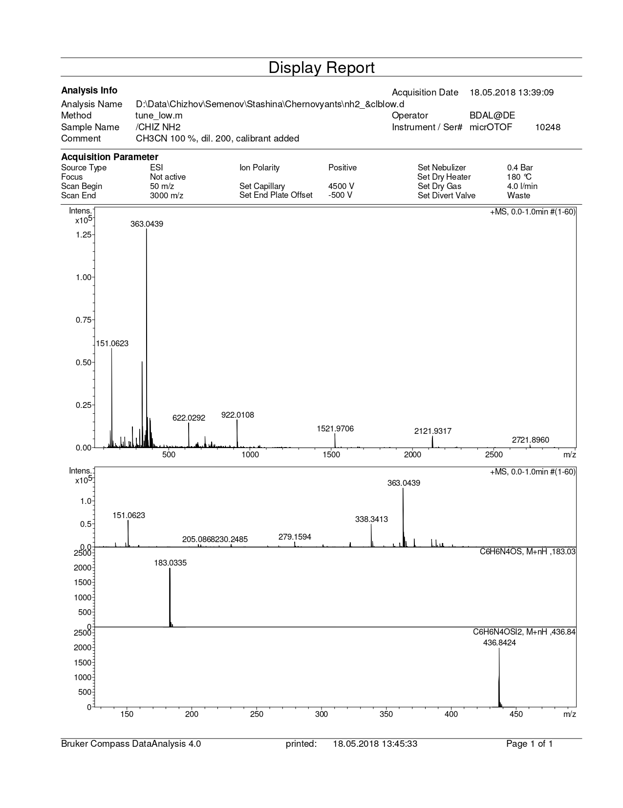
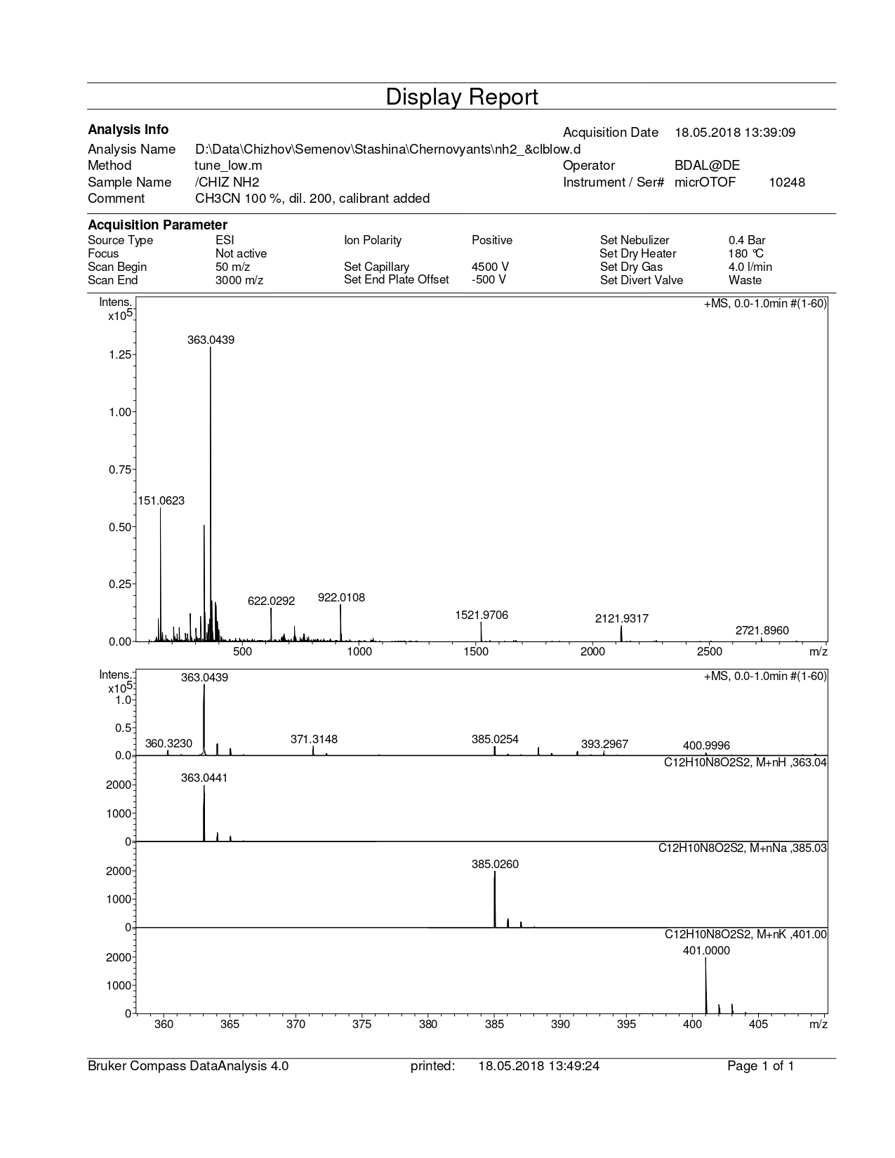
Figure S 1: Mass-spectra of C₆H₆N₄OS∙I₂

Figure S 2: Raman spectrum of C₆H₆N₄OS∙I₂

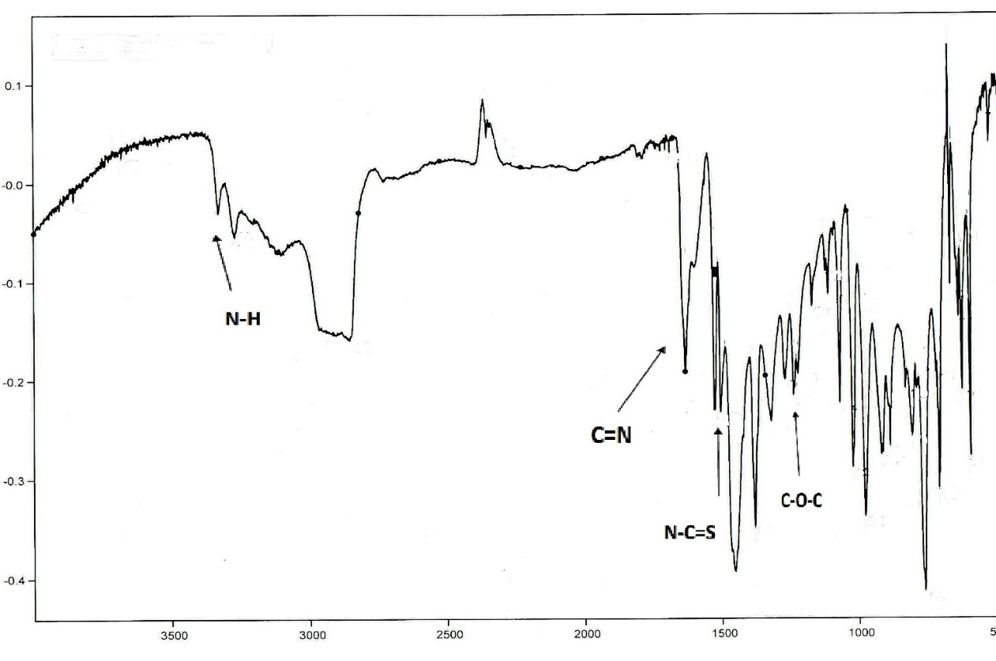
Figure S 3: FT-IR spectrum of C₆H₆N₄OS∙I₂
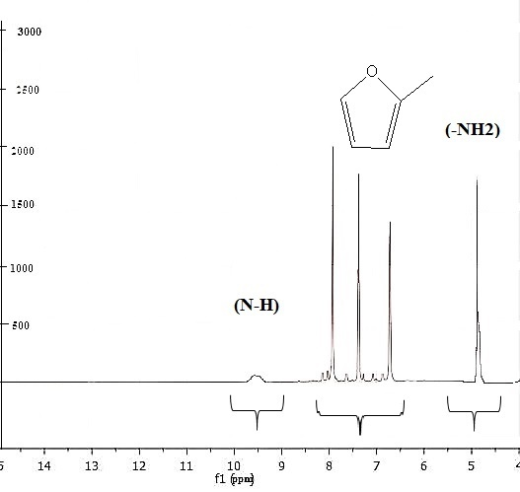
Figure S 4: ¹H NMR (250 MHz, DMSO) of C₆H₆N₄OS∙I₂
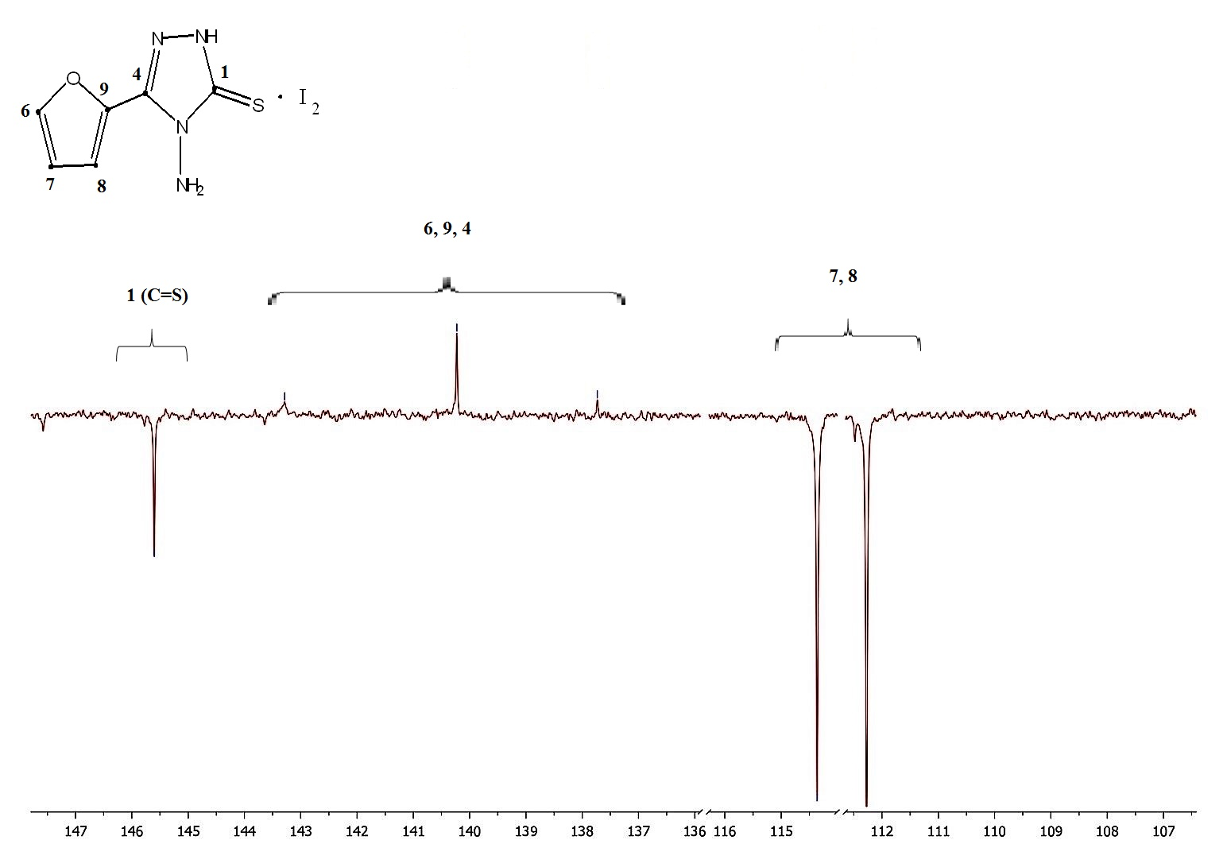
Figure S 5: ¹³C NMR (62.9 MHz, DMSO) of C₆H₆N₄OS∙I₂

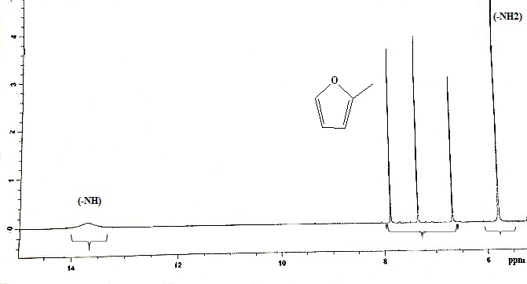
Figure S 6: ¹H NMR (600 MHz, DMSO) of 4-amino-5-(furan-2-yl)-4H-1,2,4-triazole-3-thione

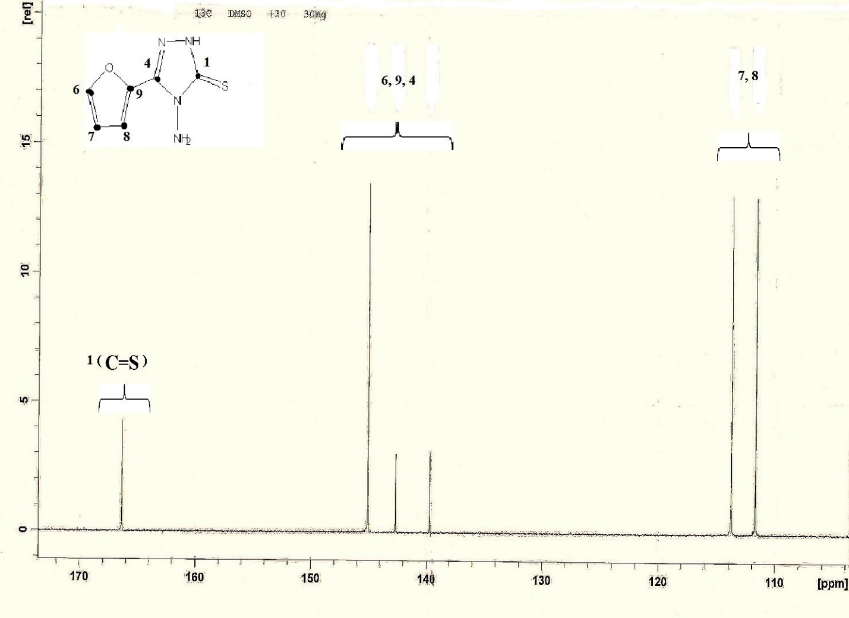
Figure S 7: ¹³C (151 MHz, DMSO) of 4-amino-5-(furan-2-yl)-4H-1,2,4-triazole-3-thione

