ⓢ Supporting information

Physical hydrogels prepared from cationically modified pectin with tunable sol-gel phase transition behaviors
Nootcharee Kunkit^{1,4}, Thanapon Deekaikam¹, Saranporn Chaimuang², Jeeraporn Pekkoh² and Kiattikhun Manokruang^{1,3}*
¹Department of Chemistry, Faculty of Science, Chiang Mai University, Chiang Mai 50200, Thailand
²Department of Biology, Faculty of Science, Chiang Mai University, Chiang Mai 50200, Thailand
³Materials Science Research Center, Faculty of Science, Chiang Mai University, Chiang Mai 50200, Thailand
⁴Graduate School, Chiang Mai University, Chiang Mai 50200, Thailand

*E-mail : kiattikhun.m@cmu.ac.th

Determination of the grafting oercentage of APA on the copolymers by proton nuclear magnetic resonance (¹H-NMR) spectroscopy.
Structural characterization of pec-g-APA copolymers was determined by using ¹H-NMR spectroscopic technique in D₂O. ¹H-NMR spectra were recorded by a 400 MHz NMR spectrometer (Bruker Model Avance) at room temperature and proton chemical shifts (δ) were given in ppm. Also, the percentage of the APA grafted on pectin can be quantitatively determined by the integration ratio of methoxy proton (H-4) of pectin and the methylene protons of APA (2, 4, 6 and 8) unit through the following equation;
grafting percentage =$\frac{{\text{I}}_{\text{APA}}}{\text{8×}{\text{I}}_{\text{pec}}}\text{x 100}$

𝐼_{APA} and 𝐼_{pec} are integration bands of the methylene protons of APA (2, 4, 6 and 8) and the methoxy protons of pectin (H-4) respectively. The NMR spectra of the reactants (native pectin and APA) were shown in Figure S.1 and the integration bands of the copolymers were shown in Figure S.2 for pec-g-APA0.50, pec-g-APA0.45 and pec-g-APA0.40. The results showed that the grafting values of the APA were 46, 34 and 28 %, respectively for pec-g-APA0.50, pec-g-APA0.45 and pec-g-APA0.40.
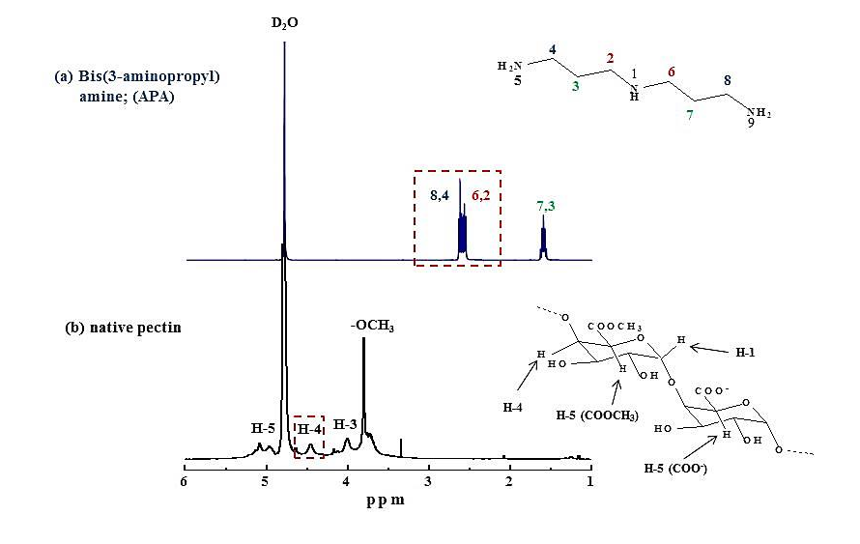
Figure S.1. ¹H-NMR spectra of the reactants polymer (native pectin and APA)

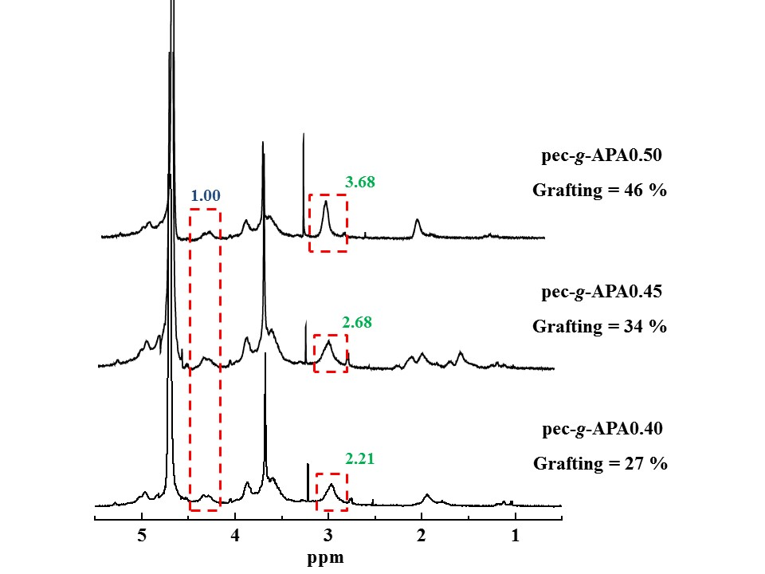
Figure S.2. APA grafting percentages were 46, 34 and 28%, respectively for pec-g-APA0.50, pec-g-APA0.45 and pec-g-APA0.40.

