SUPPLEMENTARY MATERIAL
Design potential selective inhibitors for human leukocyte common antigen-related (PTP-LAR) with fragment replace approach
Jing-Wei Wu^{a,1}, Huan Zhang ^{b,1}, Wei-Ya Li^{a,1},Xue Tang^{c}, Hong-Lian Liª, Xin-Hua Lu^{d}, Zhi-Hui Zheng^{d}, Ying Ma^{a,*}, Run-Ling Wang^{a,}*
ªTianjin Key Laboratory on Technologies Enabling Development of Clinical Therapeutics and Diagnostics (Theranostics), School of Pharmacy, Tianjin Medical University, Tianjin 300070, China; Tel/Fax: +86-22-83336690;
^{b}Department of Pharmacy, Tianjin Medical University General Hospital, Tianjin 300052, China; Tel/Fax: +86-22-60362235;
^{c}Tasly Research Institute, Tasly Holding Group Co., Ltd, Tianjin
^{d}New Drug Research and Development Center of North China Pharmaceutical Group Corporation, National Microbial Medicine Engineering and Research Center, Hebei Industry Microbial Metabolic Engineering &Technology Research Center, Key Laboratory for New Drug Screening Technology of Shijiazhuang City, Shijiazhuang, Hebei, China.
¹ These authors contributed equally to this work;
*Corresponding author. Email-address: maying@tmu.edu.cn (Y Ma); wangrunling@tmu.edu.cn (R.-L. Wang).

Figure S1 Relationship between the experimental pIC₅₀ and the docking score of 20 inhibitors of LAR (R²=0.93).

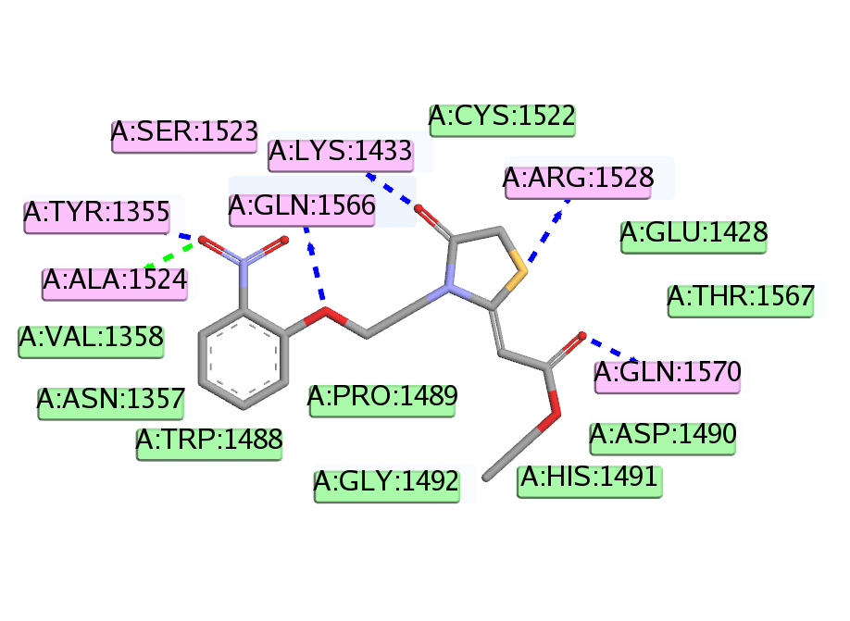
Figure S2 The 2D diagram of LAR-compound 7f.
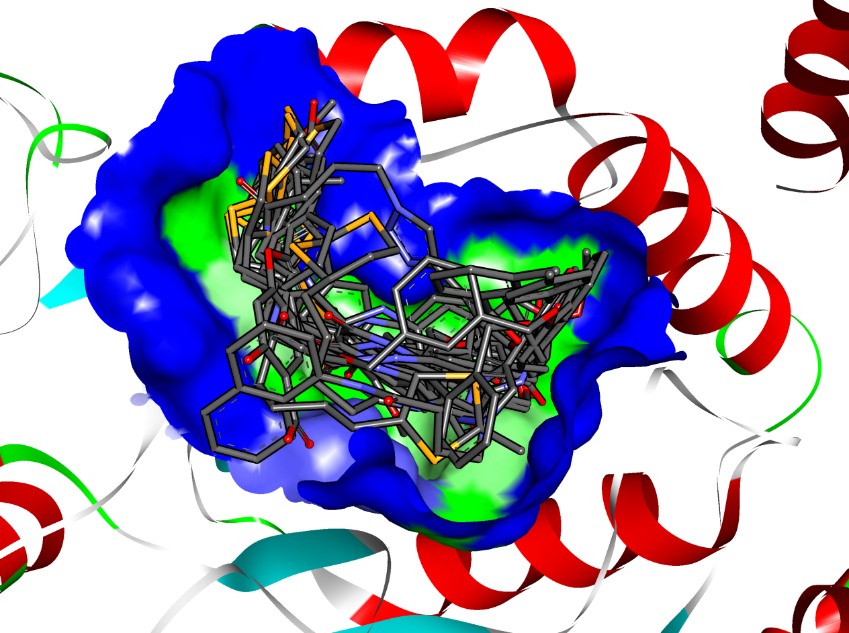
Figure S3 The docked poses of 20 inhibitors of PTP-LAR

