**Supplementary Material**

**Biocidal spray product exposure: measured gas, particle and surface concentrations compared with spray model predictions**

Per Axel Clausen1, Thit Aarøe Mørck2, Alexander Christian Østerskov Jensen, Torben Wilde Schou2, Vivi Kofoed-Sørensen1, Ismo K. Koponen1, Marie Frederiksen1, Ann Detmer2, Michael Fink2, Asger W. Nørgaard1, Peder Wolkoff1

1National Research Centre for the Working Environment, Lersø Parkallé 105, DK-2100 Copenhagen 2100, Denmark

2DHI Water Environment Health, Agern Allé 5, DK-2970 Hørsholm, Denmark

*Analysis of samples*

Volatile organic compounds (VOCs) sampled on Tenax TA: The Tenax TA tubes were analysed by thermal desorption gas chromatography and mass spectrometry (TD-GC-MS) using a Perkin Elmer Turbo Matrix 350 thermal desorber coupled to a Bruker SCION TQ GC-MS system (Bruker Daltonics, Bremen, DE). Desorption was carried out in a He flow of 1 ml/min at 275°C for 20 min and desorbed VOCs collected in a cold trap at -20°C, followed by flash desorption of the cold trap at 275°C for 1.5 min transferring the VOCs to the GC column. The column was a 5% phenyl polydimethylsiloxane of 30 m x 0.25 mm with 0.25µm film thickness (VF-5MS, Agilent Technologies, US). The GC oven program was 40°C for 2 min, then 20°C/min to 150°C hold for 10 min, then 5°C/min to 275° hold for 6 min, and finally 3°C/min to 300°C hold for 1 min. The transfer line and the source were kept at 280°C. The MS was operated with electron ionization (EI), in scan mode (mass range m/z 40-500) and SIM mode (see Table 0S).

Extraction of wipes and XAD-2 tubes and analysis with split less injection GC-MS/MS: XAD tubes were carefully broken and the contents of XAD-2 and cotton pulled into a 10-ml vial and covered with 5 ml methanol and extracted in ultra-sonic bath for 30 min. Wipes were covered with 6 ml of methanol in a 10-ml glass vial and extracted 30 min in an ultra-sonic bath. Extracts were kept in freezer until analysis. The extracts were analysed by injection of 1 µl using a Bruker CP-8400 auto sampler and a programmable temperature vaporizing (PTV) injector at 220°C at a column He flow of 1 ml/min. The column was a 5% phenyl polydimethylsiloxane of 30 m x 0.25 mm with 0.25µm film thickness (VF-5MS, Agilent Technologies, US). The GC oven program was 40°C for 1 min, then 20°C/min to 150°C, then 5°C/min to 230°C hold for 6 min, and finally 3°C/min to 300° hold for 1 min. Transfer line and MS source were kept at 275°C. The MS was operated with electron ionization (EI), in scan mode (mass range m/z 50-500) and selected ion MS/MS mode for specific ions related to each biocide. Collision energy, precursor and product ions are shown in Table 0S. The concentration of permethrin was reported as a mixture of cis- and trans- isomers.

Extraction of wipes and XAD-2 tubes and analysis with LC-MS: Extraction and storage of the wipes and XAD-2 tubes was identical to the procedure used for GC-MS/MS analysis described above. LC-MS analysis was performed using an Agilent 1200 LC system (Agilent Technologies, Palo Alto, CA, USA) coupled to a Bruker Daltonics micro-Q-TOF MS with electrospray ionization interface (Bruker Daltonics). An Agilent, Zorbax Eclipse plus C18 column (2.1 x 50 mm and 1.8 μm particle size) was used for the separation. For 1,2-benzisothiazol-3(2H)-one the flow rate was 0.5 ml/min and the injection volume 20 μl. Chromatographic separation was achieved using solvent A: water with 2 mM ammonium acetate and 0.1% formic acid and solvent B: methanol with 2 mM ammonium acetate and 0.1% formic acid. Gradient conditions started at 50 % A and 50 % B and changed to 10 % A and 90 % B over 10 min. Finally, gradient composition was changed to initial condition (50 % A and 50 % B) over 1 min and then held at this condition for 1 min before next injection. The column oven temperature was held at 30°C. C12-benzalkonium and C14-benzalkonium chlorides were analysed using a flow rate of 0.3 ml/min and an injection volume of 5 μl. The column oven temperature was held at 50°. Chromatographic separation was achieved with a method identical to the one used for 1,2-benzisothiazol-3(2H)-one described above, except that the gradient was changed over 25 min. For both methods the source temperature was 200°, N2 drying gas 6 l/min, and nebulizer pressure 1.0 bar. Scan was from 50-3000 m/z. Extracted ion chromatograms were used for quantitation and peak identification (see Table 0S).

Additional samples on filters for personal dermal exposure: The operator who performed the spraying carried a glass fibre filter on the forehead and on the forearm to measure the deposited amount of spray substances on areas that potentially could cause dermal exposure. The filters were extracted and analysed for biocides and VOCs with procedures identical to those used for extraction and analysis of XAD-2 tubes. The method was not validated.

Calibration curves and analytical performance: Three stock solutions in methanol containing biocide substances, toluene and decane were produced. The stock solutions were diluted with methanol to 6-9 different concentration levels in the range of 0.001 - 100 ng/µl (see Table 1S). The standard solutions were kept at -18°C, when not in use. For Tenax TA 5 µl of the standard solutions were spiked on the tubes in a He flow of 60 ml/min for 3 min to purge the methanol. Calibration curves for all substances listed in the *Chemicals* paragraph were prepared. All other VOCs were quantified in equivalents of toluene or decane. More volatile VOCs were calibrated with toluene and less volatile with decane (see Table 1S). LOD values were estimated as three times the standard deviation of 20 measurements of the lowest standard and divided with the slope of the calibration curve, see Table 2S. The LODs were in the order of 0.1 – 1 µg/m3 at a sampling volume of 2 l. Recovery from wipes was estimated by spiking 20 wipes with 100 µl of a mixture containing the substances and then extracted and analysed as described above (see Table 3S). Analytical data were corrected for the recovery and represent the mean of a left and right wipe sample.

Table 1S. List of chemicals in three biocide spray products according to datasheet and/or measured.

|  |  |  |  |  |  |  |
| --- | --- | --- | --- | --- | --- | --- |
| Product | Substance | Structure | Sum formula | Content  (%) | Vapor pressure$  (mmHg @20°C) | CAS Number |
| *Biocide 1* | Alkanes | n-, iso-, cyclic: C6 -C16 |  | ~30£ | 124-0.001 |  |
| Dimethoxy methane | (CH3O)2CH2 | C3H8O2 | ~10 | 370 | 109-87-5 |
| Phenylethyl alcohol | http://www.sigmaaldrich.com/content/dam/sigma-aldrich/structure8/146/mfcd00002886.eps/_jcr_content/renditions/mfcd00002886-large.png | C8H10O |  | 0.09 | 60-12-8 |
| Lilial  2-methyl-3-isopropylphenyl propionaldehyde |  | C14H20O |  | 0.006 | 80-54-6 |
| Nopyl acetate  6,6-dimethylbicyclo-(3,1,1)-2-heptene-2-ethyl acetate | http://www.sigmaaldrich.com/content/dam/sigma-aldrich/structure3/170/mfcd02181025.eps/_jcr_content/renditions/mfcd02181025-large.png | C13H20O2 |  | 0.02 | 105-133-148 |
| Piperonyl butoxide* | http://www.sigmaaldrich.com/content/dam/sigma-aldrich/structure5/127/mfcd00005842.eps/_jcr_content/renditions/mfcd00005842-large.png | C19H30O5 | 1.1 | 5·10-6 | 51-03-6 |
| Pyrethrum extract* | http://www.sigmaaldrich.com/content/dam/sigma-aldrich/structure1/151/mfcd00078611.eps/_jcr_content/renditions/mfcd00078611-large.png | C21H28O3  C22H28O5 | 0.25 |  | 8003-34-7 |
| Permethrin* | http://www.sigmaaldrich.com/content/dam/sigma-aldrich/structure6/116/mfcd00041809.eps/_jcr_content/renditions/mfcd00041809-large.png | C21H20Cl2O3 | 0.216 | 2·10-8 | 52645-53-1 |
| Other fragrances | α-Terpineol, dihydromyrcenol, eugenol, helional |  |  |  |  |
| *Biocide 2* | 1,2-propanediol |  | C3H8O2 |  | 0.2 | 57-55-6 |
| 1,2,4-Trimethylbenzene | http://www.sigmaaldrich.com/content/dam/sigma-aldrich/structure8/105/mfcd00008527.eps/_jcr_content/renditions/mfcd00008527-large.png | C9H12 | ~2.2§ | 1.9 | 96-63-6 |
| Propylbenzene | http://www.sigmaaldrich.com/content/dam/sigma-aldrich/structure8/115/mfcd00009377.eps/_jcr_content/renditions/mfcd00009377-large.png | C9H12 |  | 3.1 | 103-65-1 |
| Indane | http://www.sigmaaldrich.com/content/dam/sigma-aldrich/structure8/078/mfcd00003795.eps/_jcr_content/renditions/mfcd00003795-large.png | C9H10 |  | 1.5 | 496-11-7 |
| λ-Cyhalothrin * | http://www.sigmaaldrich.com/content/dam/sigma-aldrich/structure4/029/mfcd07370148.eps/_jcr_content/renditions/mfcd07370148-large.png | C23H19ClF3NO3 | 9.7 | &2·10-9 | 91465-08-6 |
| 1,2-Benzisothiazol-  3(2H)-one | http://www.sigmaaldrich.com/content/dam/sigma-aldrich/structure9/152/mfcd00127753.eps/_jcr_content/renditions/mfcd00127753-large.png | C7H5NOS | 0.23 | 2.6·10-5 | 2634-33-5 |
| *Biocide 3* | Benzalkonium chlorides* | https://upload.wikimedia.org/wikipedia/commons/thumb/2/28/Benzalkonium_chloride_Structure_V.1.svg/1280px-Benzalkonium_chloride_Structure_V.1.svg.png | C6H5CH2N(CH3)2RCl (R=C8H17 to C18H37) | 9.5# | +5·10-6  n = 12 | 63449-41-2 |

*Active substance. £Contains also ~50% butane as propellant. §Contains also i.a. oxygen containing polymeric stabilizers. #Contains also ~15% polypropylene glycol, ~3% ethanolamine, and ~3% ethanol. $Approximate vapor pressure calculated using ChemSpider. &Wang et al. (1997). +US EPA Chemistry Dashboard.

Table 2S. Limit of detection (LOD) of substances sampled on XAD-2 sampling tubes and by wiping of surfaces.

|  |  |  |  |  |
| --- | --- | --- | --- | --- |
| Substance | Conc. LOD  ng/µl | LOD  ng/µl | LOD air samples  µg/m³ | LOD surfaces  µg/m² |
| 1.2 Benzisothiazol-3(2H)-one | 0.4 | 0.06 | ~ 14 | ~17 |
| Benzyldimethyldodecylammonium chloride | 0.003 | 0.005 | ~1 | ~ 2 |
| Benzyldimethyltetradecylammonium chloride | 0.001 | 0.003 | ~1 | ~ 1 |
| Piperonyl butoxide a | 0.001 | 0.23 | ~57 | ~ 68 |
| Pyrethrum extract a | 0.3 | 0.30 | ~74 | ~ 89 |
| Permethrin a | 0.5 | 0.07 | ~17 | ~ 20 |
| Lambda-Cyhalothrin a | 0.2 | 0.09 | ~22 | ~ 26 |
| Toluene (TIC ion 91) | 1 | 3.3 | ~833 | ~ 999 |
| Decane (TIC ion 57) | 1 | 0.6 | ~154 | ~ 185 |

1. By MS-MS analysis.

Table 3S. Sampling and analytical conditions.

|  |  |  |  |  |  |  |  |  |  |
| --- | --- | --- | --- | --- | --- | --- | --- | --- | --- |
| Product | components | samples | method | SIM | Precurser | Product | | colision energy | scan |
| *Biocide 1* | Alkanes | tenax and XAD tubes | TD-GC-MS | 57 |  |  |  | | 40-500 m/z |
| Dimethoxy methane | tenax and XAD tubes | TD-GC-MS |  |  |  |  | | 40-500 m/z |
| Phenylethyl Alcohol | tenax and XAD tubes | TD-GC-MS |  |  |  |  | | 40-500 m/z |
| Lilial | tenax and XAD tubes | TD-GC-MS |  |  |  |  | | 40-500 m/z |
| Piperonyl Butoxide * | Tenax, XAD and wipes | TD-GC-MS/GC-MS-MS | 176 | 176 | 131 | 25 | | 40-500 m/z |
| Pyrethrum ectract* | Tenax, XAD and wipes | TD-GC-MS/GC-MS-MS | 123 | 123 | 81 | 20 | | 40-500 m/z |
| Permethrin* | Tenax, XAD and wipes | TD-GC-MS/GC-MS-MS | 183 | 183 | 168 | 30 | | 40-500 m/z |
| *Biocide 2* | 1,2,4-Trimethylbenzene | tenax and XAD tubes | TD-GC-MS |  |  |  |  | | 40-500 m/z |
| Propylbenzene | tenax and XAD tubes | TD-GC-MS |  |  |  |  | | 40-500 m/z |
| Indane | tenax and XAD tubes | TD-GC-MS |  |  |  |  | | 40-500 m/z |
| lambda-Cyhalothrin * | Tenax, XAD and wipes | TD-GC-MS/GC-MS-MS | 197 | 197 | 141 | 8 | | 40-500 m/z |
| 1,2-Benzisothiazol-3(2H)-one | XAD and wipes | LC-MS (ion153) |  |  |  |  | | 50-3000 m/z |
| propylene glycol | tenax and XAD tubes | TD-GC-MS | 45 |  |  |  | | 40-500 m/z |
| *Biocide 3* | Benzyldimethyl**dode**cylammonium | XAD and wipes | LC-MS (ion304) |  |  |  |  | | 50-3000 m/z |
|  | Benzyldimethyl**tetra**decylammonium | XAD and wipes | LC-MS (ion332) |  |  |  |  | | 50-3000 m/z |
| others | toluene | tenax and XAD tubes | TD-GC-MS/GC-MS-MS | 91 |  |  |  | | 40-500 m/z |
|  | Decane | tenax and XAD tubes | TD-GC-MS/GC-MS-MS | 57 |  |  |  | | 40-500 m/z |

Table 4S. Recovery of selected substances from wiping.

|  |  |  |  |
| --- | --- | --- | --- |
| Substance | Number samples | Recovery % | SD |
| 1.2 Benzisothiazol-3(2H)-one | 20 | 77 | 3 |
| Lambda-Cyhalothrin | 20 | 115 | 16 |
| Permethrin | 20 | 110 | 11 |
| Pyrethrum extract | 20 | 121 | 20 |
| Piperonyl butoxide | 20 | 63 | 10 |
| Benzyldimethyldodecylammonium chloride | 19 | 88 | 9 |
| Benzyldimethyltetradecylammonium  chloride | 19 | 104 | 17 |

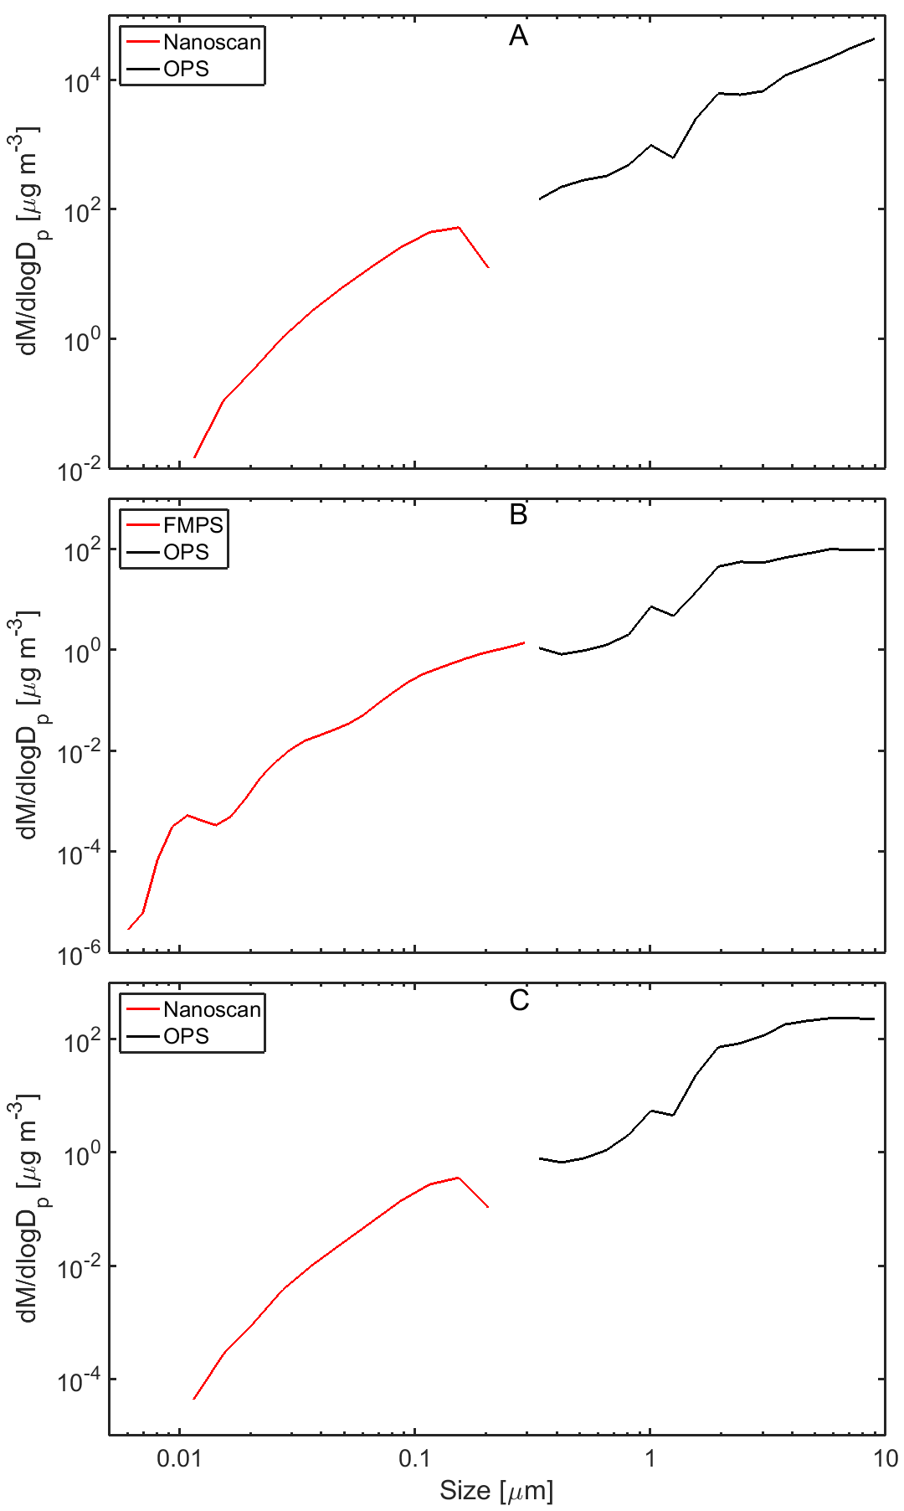

Figure 1S. Mass distributions in the aerosols between 5 and 10 min after spraying based on Nanoscan, FMPS, and OPS measurement performed in separate experiment in the climatic chamber. Mass concentrations were calculated assuming spherical particles at density 1.2 g/cm3 for (A) *Biocide 1*, (B) *Biocide 2*, and (C) *Biocide 3*.

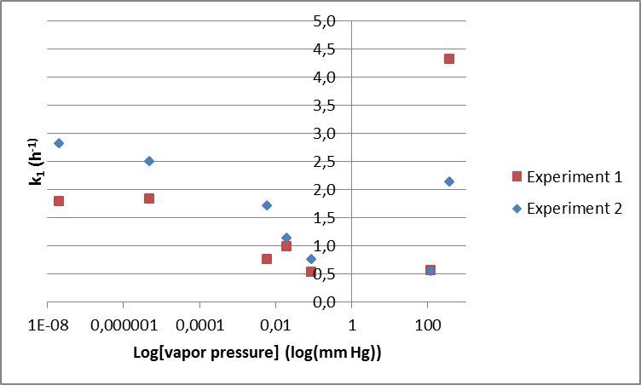

Fig. 2S. Relationship between the 1st order decay constants (k1) for airborne substances emitted from *Biocide 1* and log(vapor pressure).

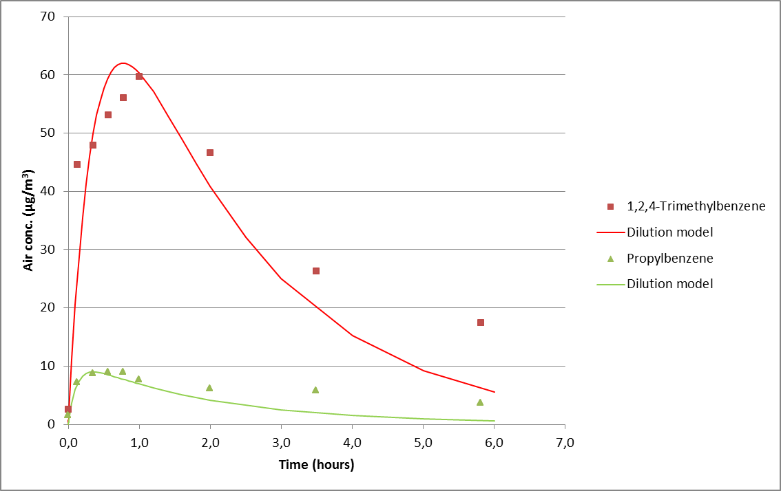

Fig. 3S. *Biocide 2*: A first order decay model that takes into account the air exchange rate fitted to the experimental points (Equation(2)).

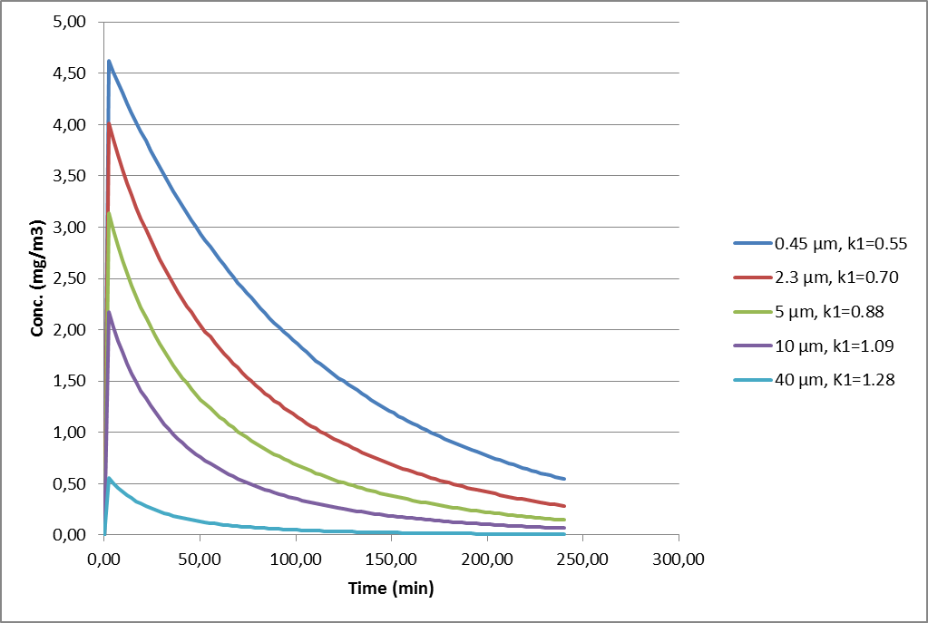

Fig. 4S. Concentration versus time curves simulated in ConsExpo Web using the Many Parameter scenario for piperonyl butoxide in *Biocide 1*, however, only varying the median diameter of the aerosol particles. The k1 constants are the rate constant of the 1st order decay fitted to the simulated concentrations.