Novel Dibenzosuberene Substituted Aroyl Selenoureas: Synthesis, Crystal Structure, DFT, Molecular Docking and Biological Studies
Moideen Musthafaª, Ramaiah Konakanchi^{b}, Rakesh Ganguly^{c,*}, Anandaram Sreekant^{a,*}
ªDepartment of Chemistry, National Institute of Technology, Tiruchirappalli 620015, India
^{b}Department of Chemistry, National Institute of Technology, Warangal 506004, India
^{c}Division of Chemistry & Biological Chemistry, Nanyang Technological University, Singapore 639798, Singapore
Email: sreekanth@nitt.edu
Supplemental Materials
1. Single crystal X-ray diffraction studies
X-ray diffraction data was collected on a Bruker Kappa diffractometer at 100(2) K and 103(2) K equipped with a CCD detector, employing Mo K α radiation (λ = 0.71073 Å), with the SMART suite of programs. ^{[1]} All data were processed and corrected for Lorentz and polarization effects with SAINT and absorption effects with SADABS. ^{[2]} Structural solution and refinement were carried out with the SHELXTL suite of programs; the structures were refined (weighted least squares refinement on F²) to convergence. All the non-hydrogen atoms in the compounds were refined anisotropically by full-matrix least-squares refinement. ^{[3]}
2. Density Functional Theory study
Quantum chemical computations were carried out using GAUSSIAN 09 software. The DFT method, used the basis set combination 6-311++G(d,p). Geometry optimisation was carried out for varied parameters of molecules. The optimised molecules were used to analyse molecular docking studies also.
3. Molecular Docking protocol
Docking studies are prominent tools to assessment of the binding affinity of the ligand-protein receptor. All synthesised compounds were subjected to in silico molecular docking using the AutoDock Tools (ADT) version 1.5.6 and the AutoDock version 4.2.5.1 docking program. The 3D-structures of all the synthesised compounds were prepared using chem3 Dpro 12.0 software. The optimised 3D structures were saved in .pdb format. The structure of the E. coli MurB (PDB ID: 1MBB) protein was extracted from the protein data bank (http://www.rcsb.org/pdb). The bound ligand and water molecules in protein were removed by using the Discovery Studio Visualizer version 4.0 to prepare the protein. Nonpolar hydrogens were merged, and gasteiger charges were added to the protein. The grid file was saved in .gpf format. The three-dimensional grid box of 60 x 60 x 60 Å³ dimensions was created around the protein with a spacing of 0.3750 Å. Genetic algorithm was used with the population, and the maximum number of evaluations was 150 and 25, 00,000, respectively. The docking output file was saved as Lamarckian Ga (4.2) in. dpf format. The ligand-protein complex binding sites were visualised by Maestro Elements Visualizer, version 3.8.^{[4]}
4. Biological Evaluation
4.1 Antimicrobial activity
In vitro antimicrobial activity of the compounds (1-3) were evaluated against three gram-negative bacteria such as (Pseudomonas aeruginosa (MTCC 2453), Klebsiella pneumoniae (MTCC 109) and Escherichia coli (MTCC 40)), three gram-positive bacteria including (Bacillus subtilis (MTCC 96), Staphylococcus aureus (MTCC 121) and Staphylococcus epidermidis (MTCC 2639)) and three fungal strains like Aspergillus niger, Aspergillus flavus and Curvularia lunata, respectively. Standard pathogenic microbial cultures were procured from the Microbial Type Culture Collection and Gene Bank (MTCC), Chandigarh, India, which is recognized by the World Intellectual Property Organization (WIPO). Sterile antibiotic discs (6 mm in diameter, prepared using Whatmann No. 1 paper) were placed over the nutrient agar medium. 1 to 100 µg/mL of the compounds (initially dissolved in DMSO) was transferred to each disc with the help of a micropipette. The experiments were carried out in triplicate, and the results were taken as a mean ± SD. Minimum inhibitory concentrations (MICs) of all the synthesized compounds are reported in µg/mL. The samples were incubated at 37 °C for 24 h (bacteria) and at 25 °C for 48 h (fungi), respectively. Streptomycin and Nystatin were used as positive controls (standards) for bacteria and fungi, respectively.
Figure S 1: Synthesis of 5H-dibenzo[a,d][7]annulen-5-amine
Figure S 2: UV-Visible spectral data of compounds (1-3)
Figure S 3: FT-IR spectra of compounds (1-3)

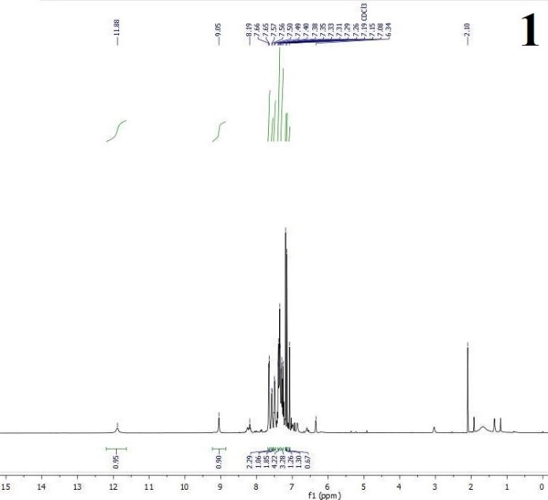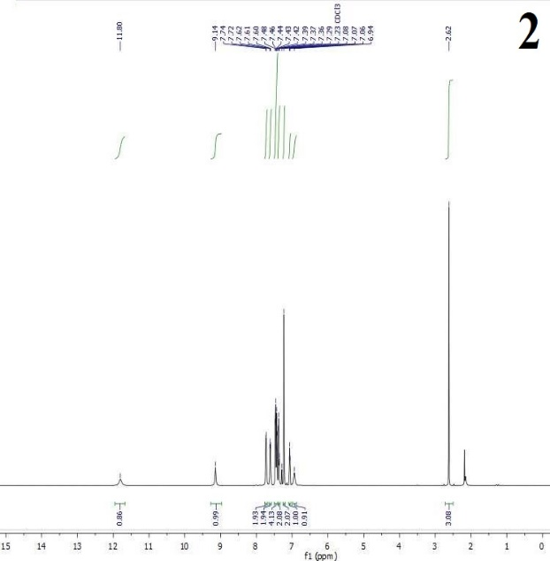
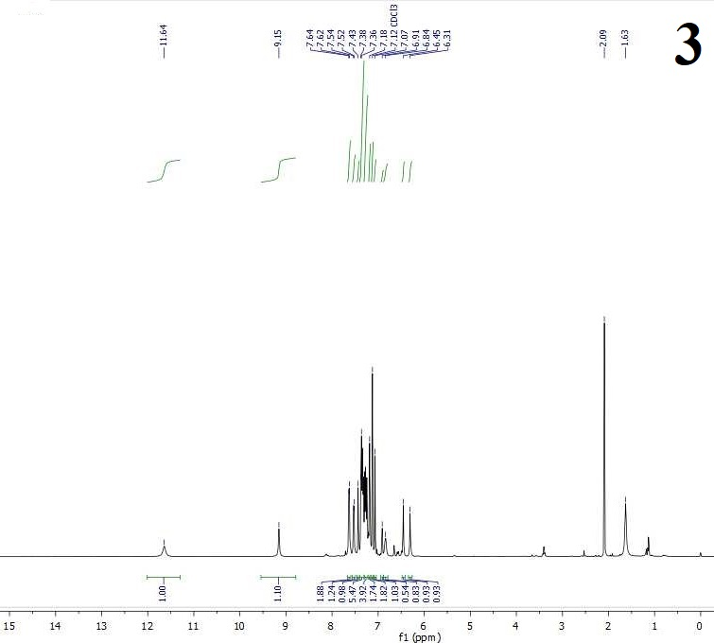
Figure S 4: ¹H NMR of compounds (1-3)
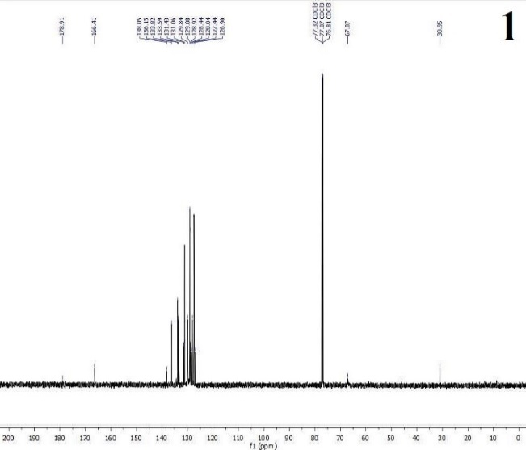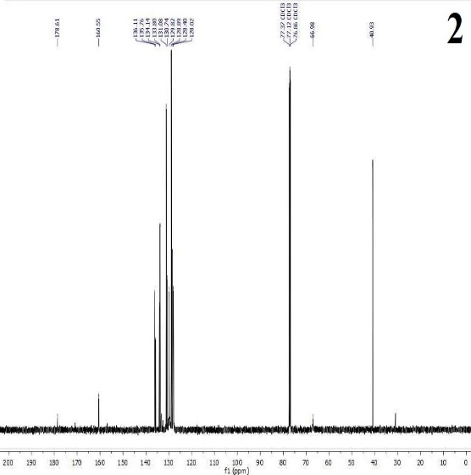
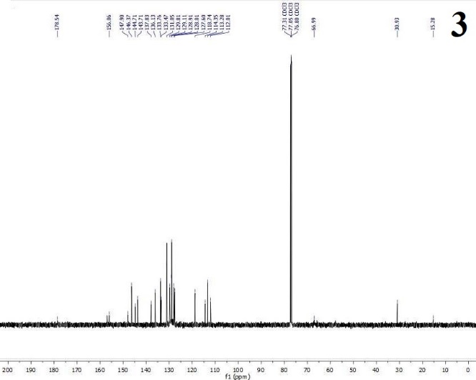
Figure S 5: ¹³C NMR of compounds (1-3)

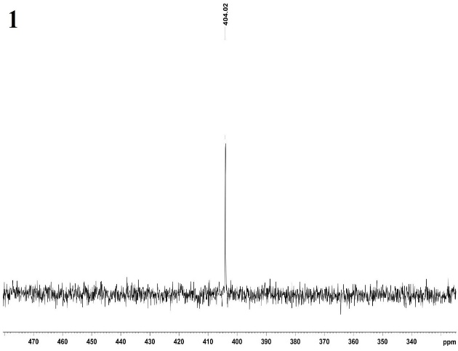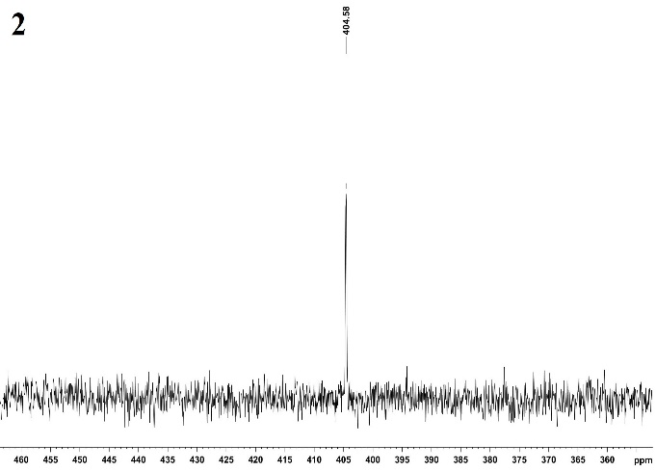
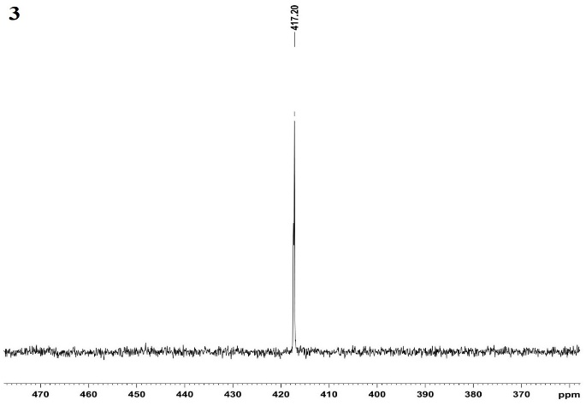
Figure S 6. ⁷⁷Se NMR of compounds (1-3)
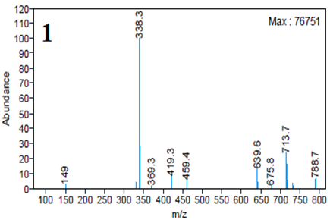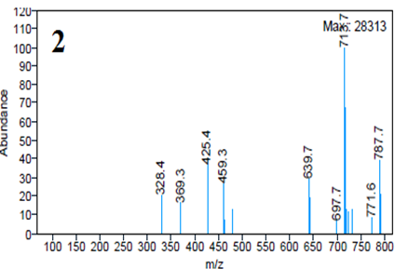
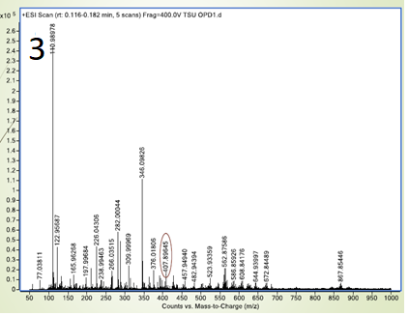
Figure S 7: Mass spectra of compounds (1-3)
Figure S 8: The Molecular electrostatic surfaces (MEP) of compounds (1-3)
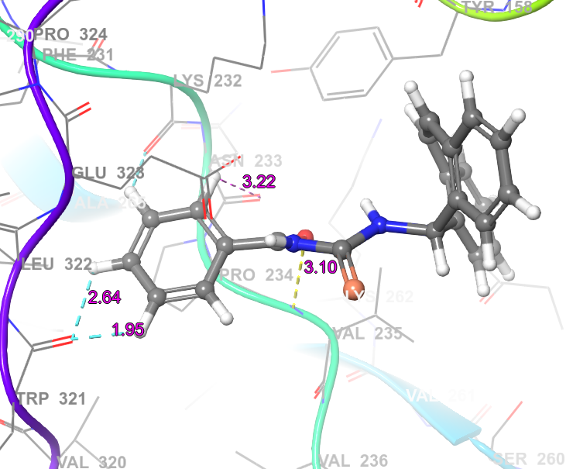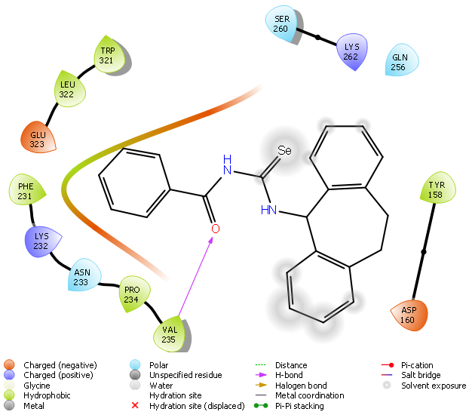
Figure S 9: The docking poses of the compound (1) with the protein 1MBT
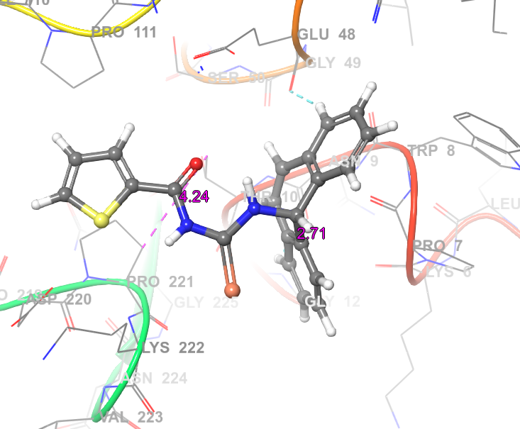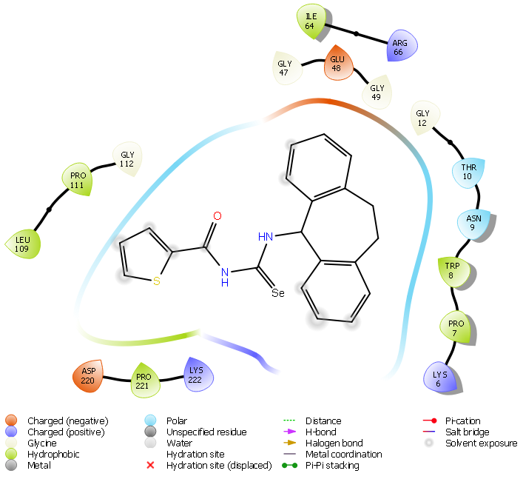
Figure S 10: The docking poses of the compound (2) with the protein 1MBT
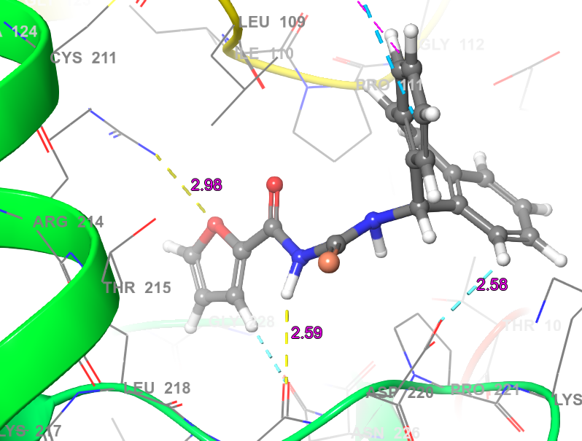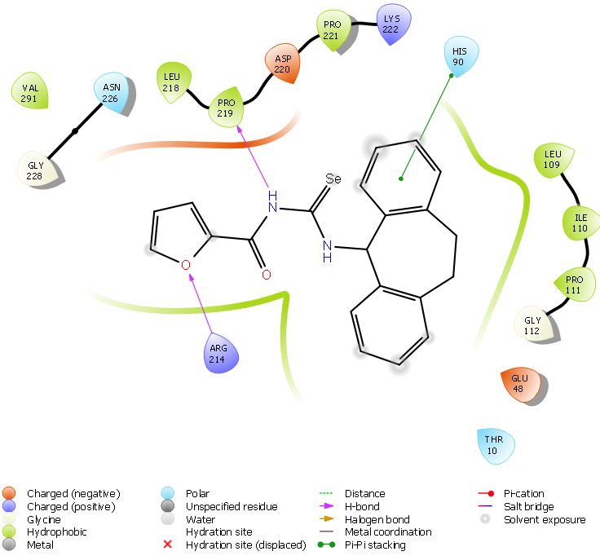
Figure S 11: The docking poses of the compound (3) with the protein 1MBT
Table S 1: UV-Visible data of compounds (1-3)
Compound | π-π* | n-π*
1 | 285 | 322
2 | 281 | 325
3 | 280 | 324

Table S 2: Infrared absorption frequencies (cm⁻¹) of compounds (1-3)
Compound | ʋ(H˗N-C=O)cm⁻¹ | ʋ(H˗N-C=Se)cm⁻¹ | ʋ(C=O)cm⁻¹ | ʋ(C=Se) cm⁻¹
1 | 3398 | 3313 | 1671 | 1257
2 | 3389 | 3314 | 1675 | 1251
3 | 3410 | 3314 | 1637 | 1295

Table S 3: Crystal Structure and Data Refinement Parameters for 1 and 2
Compound | 1 | 2
Empirical Formula | C₂₃H₁₈N₂OSe | C₂₁H₁₆N₂OSSe
Formula Weight | 417.35 | 423.39
Crystal System / Space Group | Monoclinic, P121/n 1 | Triclinic, P-1
a / Å | 9.7506(5) | 8.1343(15)
b / Å | 12.3428(5) | 10.042(2)
c / Å | 15.5799(8) | 14.037(2)
α / ° | 90 | 91.784
β / ° | 95.624(2) | 102.480
γ / ° | 90 | 97.339
V / Å³ | 1866.01(16) | 1108.3(4)
Z | 4 | 2
D _{calc} (g/cm³) | 1.486 | 1.503
μ (mm⁻¹) | 2.027 | 1.905
Crystal size (mm) | 0.060 x 0.100 x0.120 | 0.240 x 0.260 x 0.420
Color / Shape | light yellow block | yellow block
Temp (K) | 103(2) | 100(2)
Theta range for collection | 2.11 to 28.43 | 2.46 to 25.68
Reflections collected | 20805 | 15873
Independent reflections | 4207 | 4195
Data/restraints/parameters | 4681 / 0 / 244 | 4195 / 0 / 273
Goodness of fit on F² | 1.002 | 1.048
Final R indices [I > 2σ(I)] | R1 = 0.0352,  wR2 = 0.0722 | R1 = 0.0754,  wR2 = 0.2060
R indices (all data) | R1 = 0.0592,  wR2 = 0.0799 | R1 = 0.0947,  wR2 = 0.2261
Largest difference peak/hole | 0.526 and -0.542 | 2.415 and -1.751

Table S 4: Calculated energy values for compounds (1-3)
Parameters | 1 | 2 | 3
Energy (au) | -3471.16 | -3792.21 | -3469.22
Dipole moment (Debye) | 3.77 | 3.30 | 3.45
E_{HOMO} (eV) | -5.12 | -5.31 | -5.29
E_{LUMO} (eV) | -1.59 | -1.98 | -1.76
E_{HOMO}-_{LUMO} (eV) | 3.53 | 3.32 | 3.53
E_{HOMO-1} (eV) | -5.42 | -5.55 | -5.53
E_{LUMO+1} (eV) | -1.13 | -1.28 | -1.26
E_{(HOMO-1)-(LUMO+1)} (eV) | 4.29 | 4.27 | 4.27
Hardness (η) | 1.76 | 1.66 | 1.76
Chemical Potential (μ) | -3.36 | -3.64 | -3.52
Electronegativity (χ) | 3.36 | 3.64 | 3.52
Electrophilicity index (ω) | 6.39 | 7.98 | 7.04

Table S 5: The MIC of the compounds synthesized against bacterial growth (μg / mL)
Compound | S. aureus | B. subtilis | S. epidermidis | E. coli | K. pneumoniae | P. aeruginosa
1 | 26.8 | 41.7 | >100 | 11.3 | 18.6 | 48.9
2 | >100 | 25.6 | >100 | >100 | 30.7 | 56.4
3 | 10.5 | 11.9 | 9.5 | 3.6 | 10.8 | 21.8
Streptomycin | 3.7 | 4.7 | 2.6 | 1.5 | 3.2 | 6.5

Table S 6: The MIC of compounds synthesized against fungal growth (μg / mL)
Compound | A. niger | P. notatum | C. lunata
1 | 25.3 | 36.1 | 45.8
2 | >100 | >100 | 63.2
3 | 19.4 | 11.4 | 24.8
Nystatin | 9.2 | 4.6 | 6.5

References
1. SMART Version 5.628, Bruker AXS Inc., Madison, WI, USA, 2001.
2. G.M. Sheldrick, SADABS University of Gӧttingen, Gӧttingen, Germany, 1996.
3. SHELXTL Version 5.1, Bruker AXS Inc., Madison, WI, USA, 1997.
4. Bhat, M. A.; Banoo, R.; Rashid, H.; Ashraf, A.; Gul, S.; Jameel, S.; Butcher, R. J.; Lone, S. H. Synthesis, Characterization, and Theoretical Studies of (E)-t-Butyl-2-((E)-2-Methyl-3-Phenylallylidene) Hydrazine Carboxylate and (E)-t-Butyl-2-((E)-3-Phenylallylidene) Hydrazine Carboxylates as a Possible Mcl-1 Antagonists. J. Mol, Struct., 2019, 1181, 197–202. https://doi.org/10.1016/j.molstruc.2018.12.061.

