SUPPLEMENTARY MATERIAL

Long-term Ambient Fine Particulate Matter and DNA Methylation in Inflammation Pathways: Results from the Sister Study

Cuicui Wang *, Katie M. O’Brien, Zongli Xu, Dale P. Sandler, Jack A. Taylor, and Clarice R. Weinberg

Corresponding author: Cuicui Wang, Harvard University T.H. Chan School of Public Health, Department of Environmental Health Boston, MA, USA. Email: cuicuiwang@hsph.harvard.edu Tel: 617-384-8836.

Table of Contents | Page
Table S1. Percentage changes (mean and 95% confidence interval) in LINE-1, and methylation at gene-specific loci associated with an increase of 5 µg/m³ increase in PM_{2.5} in main analyses. | 3
Table S2. Percentage changes (mean and 95% confidence interval) in LINE-1, and methylation at gene-specific loci associated with an increase of 5 µg/m³ increase in PM_{2.5} in main analyses. | 4
Figure S1. Distribution of LINE-1, and methylation at gene-specific locus. | 5
Figure S2. Distribution of mean annual PM_{2.5} in random sub-cohort 1 and 2. | 6
Figure S3A. Percentage changes in DNA methylation associated with a 5 µg/m³ increase in ambient PM_{2.5} at each decile of the methylation distribution, in subjects who spent more than 4 hours per week outdoors. The X-axis refers to diffent quantiles; the Y-axis refers to the corresponding changes (mean and 95% confidence interval). (Number of subjects in LINE-1 analysis is 491; number of subjects in locus-specific analysis is 882.) | 7
Figure S3B. Percentage changes in DNA methylation (expressed in %5mC with 95% CI) associated with a 5 µg/m³ increase in ambient PM_{2.5} according to the deciles of the methylation distribution, in younger and older women. The X-axis refers to diffent quantiles; the Y-axis refers to the corresponding changes (mean and 95% confidence interval). (The median age in LINE-1 analysis is 56.2, the median age in locus-specific analyses is 57.0) | 8

Table S1. Genes’ information, the locations of the amplified region and each CpG sites in our previous panel study [1].
Genes | Chromosome | Amplicon |  | Length | promoter | CpGs (position)
 |  | Start | End |  |  | pos 1 | pos 2 | pos 3 | pos 4 | pos 5
TNF-α | 6 | -217 | -86 | 132 | no | -151 | -123 ª
ICAM-1 | 19 | -483 | -234 | 250 | no | -298 | -291 | -280
CD40L | X | -66 | 12 | 79 | no | -37 | -29
IL-6 | 7 | 472 | 608 | 137 | yes | Intron 2 | Intron 2
TLR-2 | 4 | -289 | -109 | 182 | no | -143 ^{b} | -139 | -137 | -129 ^{c} | -125
ª as cg21370522 in the Sister Study
^{b} as cg16547110 in the Sister Study
^{c} as cg 06405222 in the Sister Study
Abbreviations: TNF-α, tumor necrosis factor-alpha; ICAM-1, Intercellular adhesion molecule-1; CD40L, CD40L ligand; IL-6, interleukin-6; TLR-2, Toll-like receptor-2;

Table S2. The percentage changes (95% CI) in LINE-1, and methylation at locus-specific loci associated with an increase of 5 µg/m³ increase in PM_{2.5} in main analyses.
 | LINE-1 | TNF- α at cg21370522 | TLR-2 at cg16547110 | TLR-2 at cg06405222
Linear regression | -0.13 (-0.51,0.25) | -6.5 (-13.34, 0.35) | -2.62 (-7.25, 2.00) | 0.91 (-3.46, 5.28)
Quantile regression
10th | -0.35 (-0.97, 0.28) | -15.99 (-31.54, -0.43) * | -1.51 (-10.65, 7.62) | -2.79 (-9.26, 3.67)
20th | -0.32 (-0.81, 0.16) | -7.46 (-19.61, 4.69) | -3.12 (-9.66, 3.41) | -2.07 (-7.67, 3.53)
30th | -0.43 (-0.89, 0.04) | -6.43 (-15.82, 2.97) | -3.09 (-9.15, 2.97) | 0.66 (-4.90, 6.22)
40th | -0.34 (-0.70, 0.02) | -6.85 (-14.88, 1.18) | -2.95 (-8.48, 2.58) | 0.72 (-3.59, 5.03)
50th | -0.31 (-0.70, 0.07) | -5.01 (-11.80, 1.79) | -2.72 (-8.34, 2.91) | -1.07 (-5.26, 3.12)
60th | -0.05 (-0.52, 0.42) | -4.52 (-12.58, 3.54) | -2.05 (-9.13, 5.03) | -1.31 (-7.30, 4.67)
70th | 0.07 (-0.35, 0.50) | 0.73 (-6.49, 7.96) | -2.11 (-7.54, 3.33) | 2.09 (-3.64, 7.82)
80th | -0.20 (-0.67, 0.27) | -0.30 (-9.06, 8.47) | 0.05 (-6.36, 6.45) | 4.62 (-1.90, 11.13)
90th | -0.01 (-0.82, 0.80) | 0.49 (-8.60, 9.58) | 0.55 (-6.36, 7.46) | 8.82 (-1.67, 19.32)
Abbreviations: LINE-1: long interspersed nucleotide element; TNF-α, tumor necrosis factor-alpha; TLR-2, Toll-like receptor-2; PM_{2.5}, particulate matter having an aerodynamic diameter less than or equal to 2.5 μm.
*p<0.05

Figure S1. Distribution of LINE-1, and methylation at gene-specific locus.
Abbreviations: LINE-1, long interspersed nucleotide element; TNF-α, tumor necrosis factor-alpha; TLR-2, Toll-like receptor-2.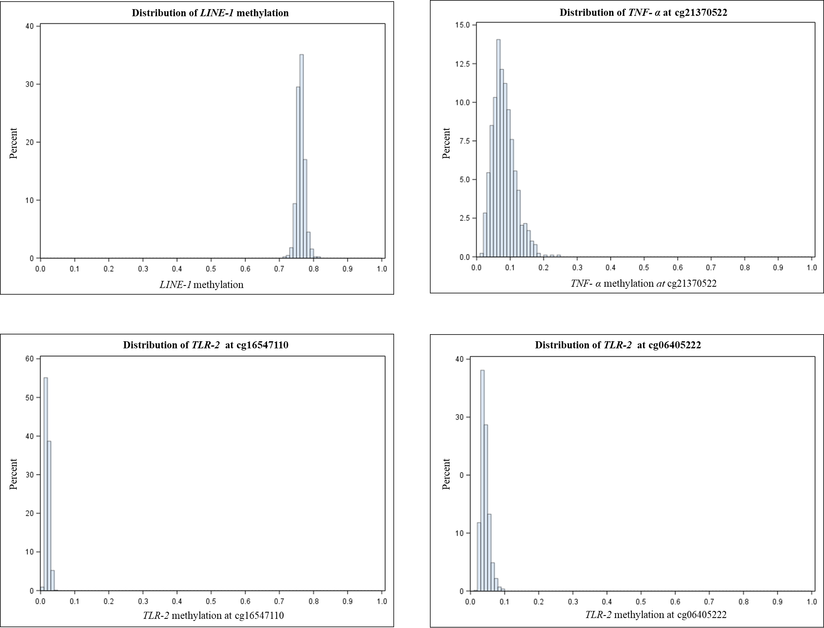
Figure S2. Distribution of mean annual PM_{2.5} in random sub-cohort 1 and 2.
Abbreviations:PM_{2.5}, particulate matter having an aerodynamic diameter less than or equal to 2.5 μm.

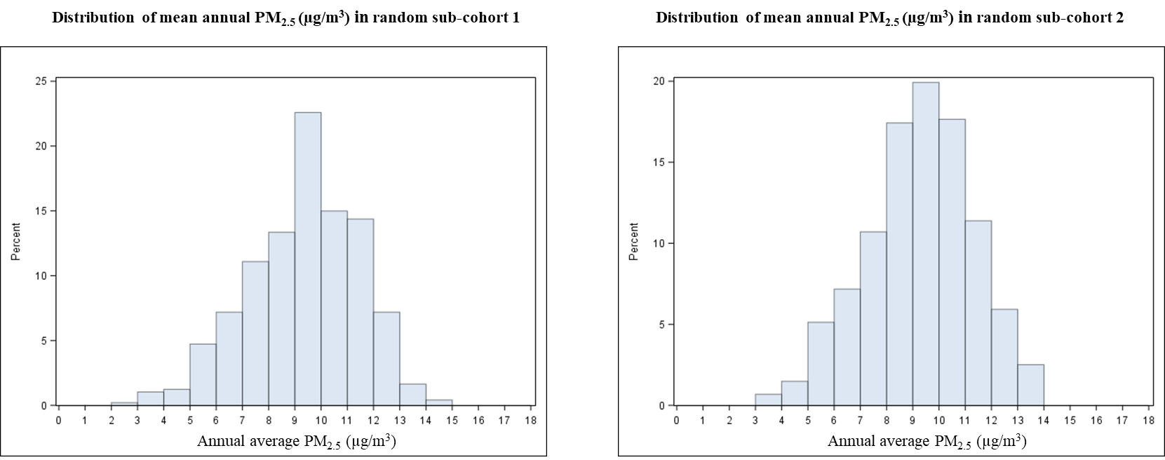

Figure S3A. Percentage change in DNA methylation associated with a 5 µg/m³ increase in ambient PM_{2.5} at each decile of the methylation distribution, in subjects who spent more than 4 hours per week outdoors. The X-axis refers to different quantiles; the Y-axis refers to the corresponding changes (mean and 95% confidence interval). (Number of subjects in LINE-1 analysis is 491; number of subjects in locus-specific analysis is 882.)
Abbreviations: LINE-1, long interspersed nucleotide element; TNF-α, tumor necrosis factor
-alpha; TLR-2, Toll-like receptor-2; PM_{2.5}, particulate matter having an aerodynamic diameter
less than or equal to 2.5 μm.
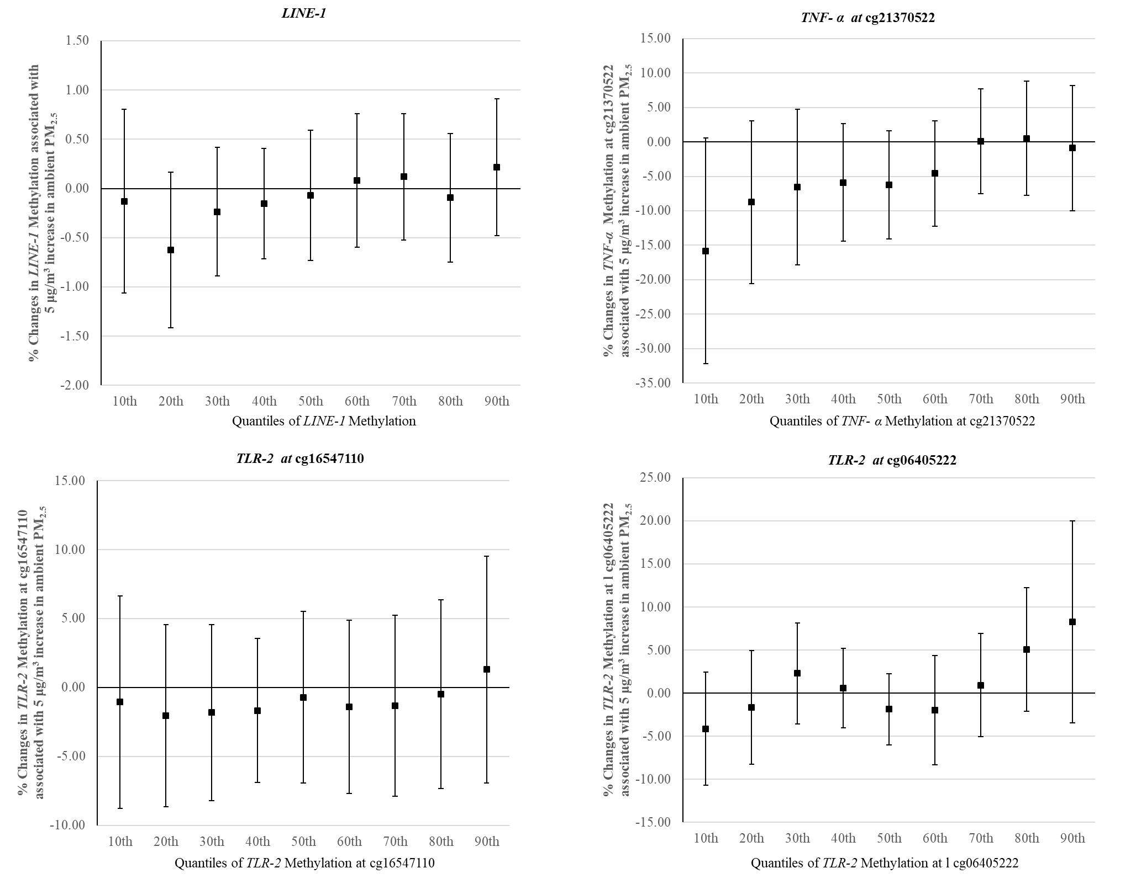

Figure S3B. Percentage changes in DNA methylation (expressed in %5mC with 95% CI) associated with a 5 µg/m³ increase in ambient PM_{2.5} according to the deciles of the methylation distribution, in younger and older women. The X-axis refers to different quantiles; the Y-axis refers to the corresponding changes (mean and 95% confidence interval). (The median age in LINE-1 analysis is 56.2, the median age in locus-specific analyses is 57.0)
Abbreviations: LINE-1, long interspersed nucleotide element; TNF-α, tumor necrosis factor
-alpha; TLR-2, Toll-like receptor-2; PM_{2.5}, particulate matter having an aerodynamic diameter
less than or equal to 2.5 μm.
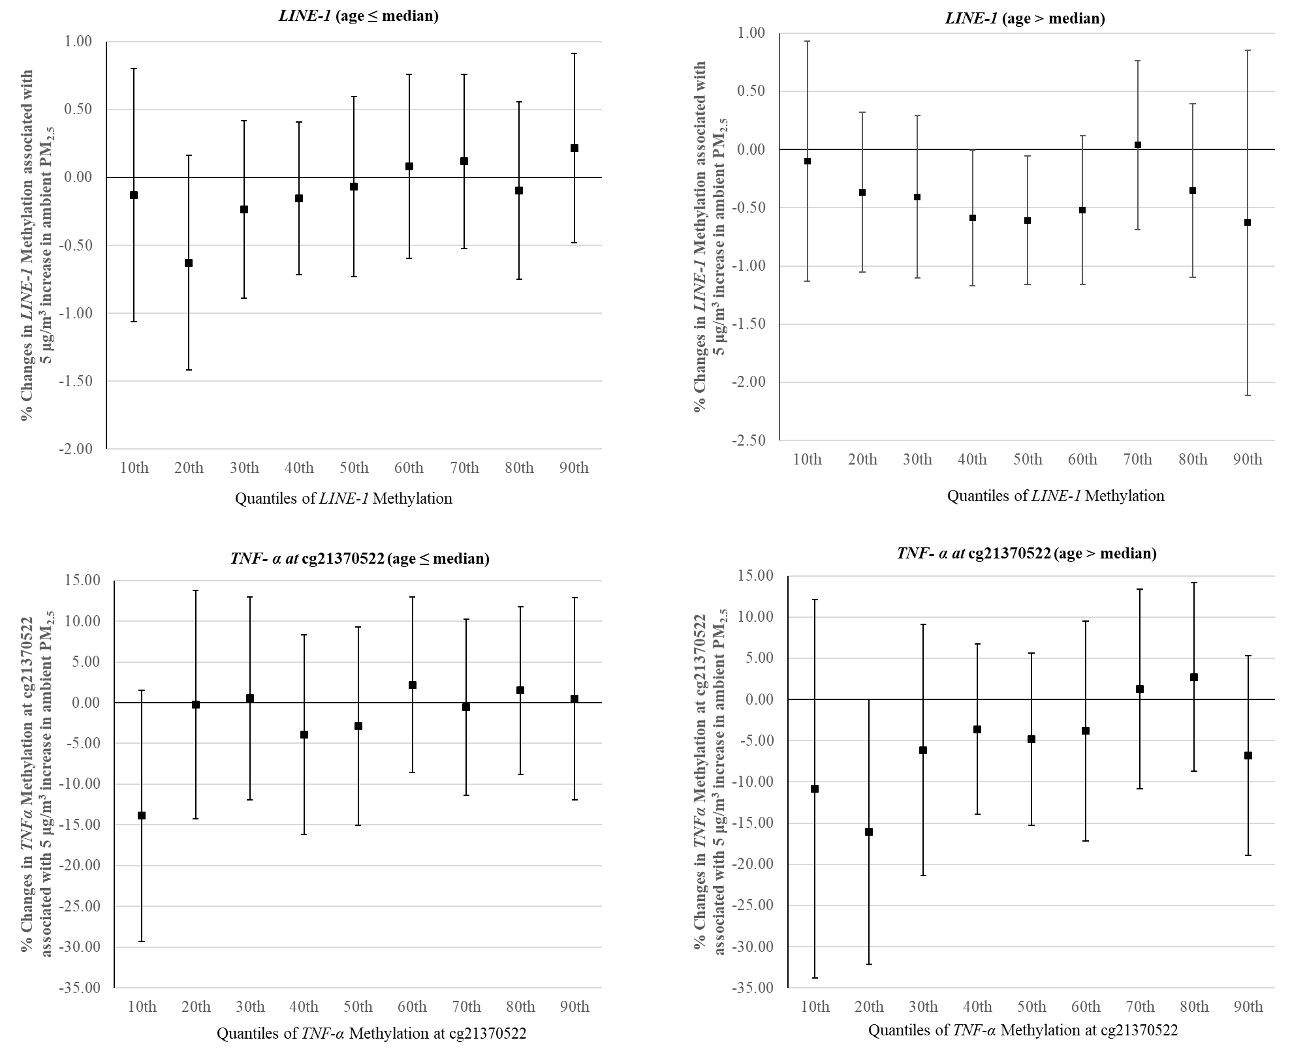

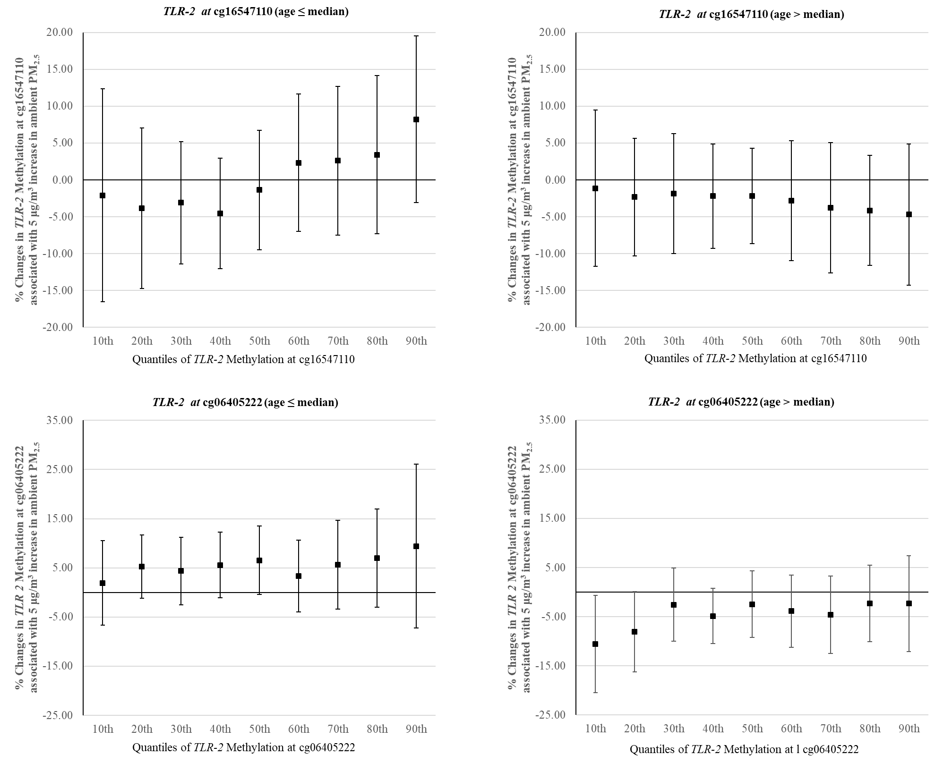
Reference
- Wang C, Chen R, Shi M, et al. Possible Mediation by Methylation in Acute Inflammation Following Personal Exposure to Fine Particulate Air Pollution. Am J Epidemiol 2017; PubMed PMID: 29020142; PubMed Central PMCID: 5860518; http://dx.doi.org/10.1093/aje/kwx277.

