A Combined X-ray Crystallography and Theoretical Study of PPh₂CH₂SPh and PPh₂C₆H₄SMe Ligands
Siti Syaida Siratª*, Hafiz Malik Hussien Abdelnasir^{b}, Omar bin Shawkataly^{c}
ª School of Chemistry and Environment, Faculty of Applied Sciences, Universiti Teknologi MARA, Negeri Sembilan Branch, Kuala Pilah Campus, 72000 Kuala Pilah, Negeri Sembilan, Malaysia.
^{b}Department of Chemistry, Alzaiem Alazhari University, 1933, Khartoum, Sudan.
^{c}Chemical Sciences Programme, School of Distance Education, Universiti Sains Malaysia, 11800 USM, Penang, Malaysia.
Email: sitisyaida@uitm.edu.my
Supplemental Materials
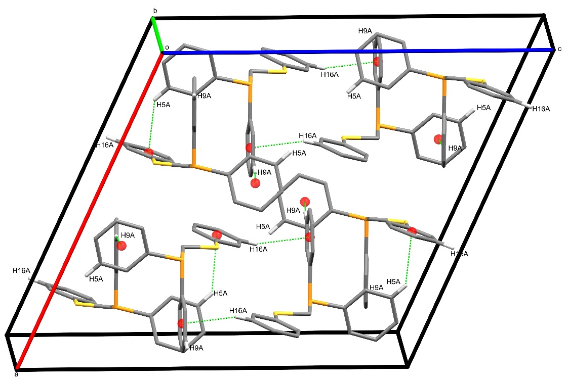
Figure S 1: Crystal packing of 1: C16–H16A···Cg(2) in the c-direction and the interaction with C9–H5A···Cg(3) shows 2D sheet in ac-plane.
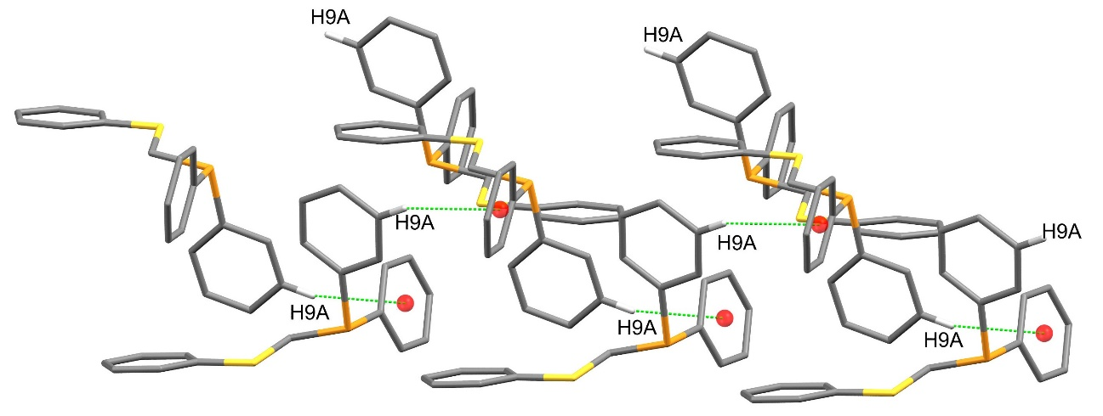
Figure S 2: Crystal packing of 1: C9–H9A···Cg(1) in the b-direction.

Table S 1: C–H···π interaction geometries for 1 and 2.
Structure | C–H···Cg (Å) | C–H (Å) | H···Cg (Å) | C···Cg (Å) | C–H···Cg (°)
1 | C5–H5A···Cg(3) | 0.95 | 2.96 | 3.7125(17) | 137
 | C16–H16A···Cg(2) | 0.95 | 2.78 | 3.6245(16) | 149
 | C9–H9A···Cg(1) | 0.95 | 2.95 | 3.8464(15) | 158
2 | C4–H4A···Cg(2) | 0.95 | 2.80 | 3.6428(13) | 148
 | C11–H11A···Cg(1) | 0.95 | 2.68 | 3.5880(14) | 160

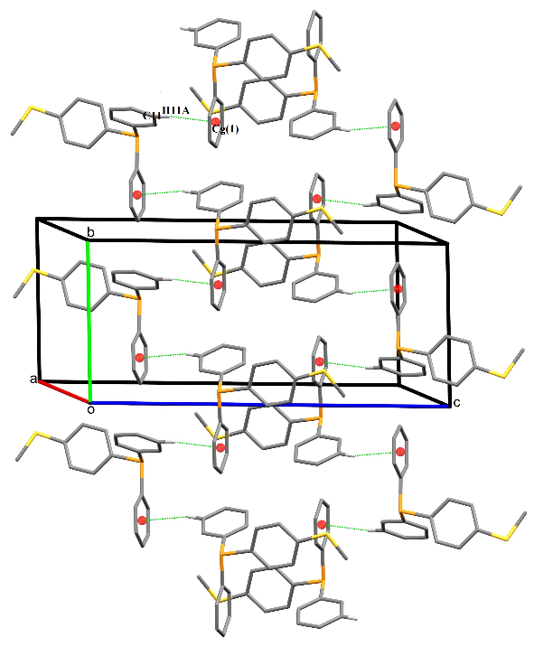
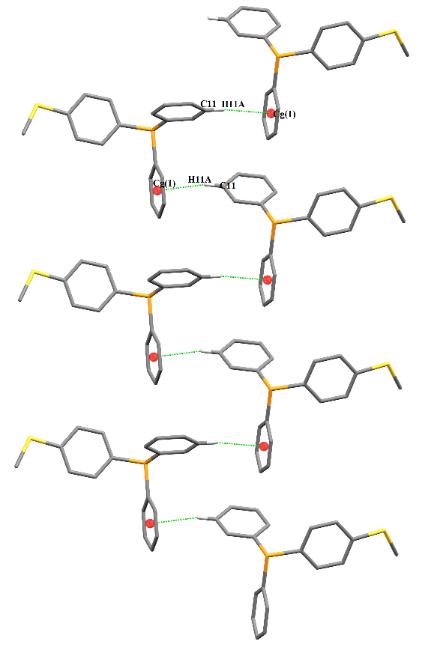
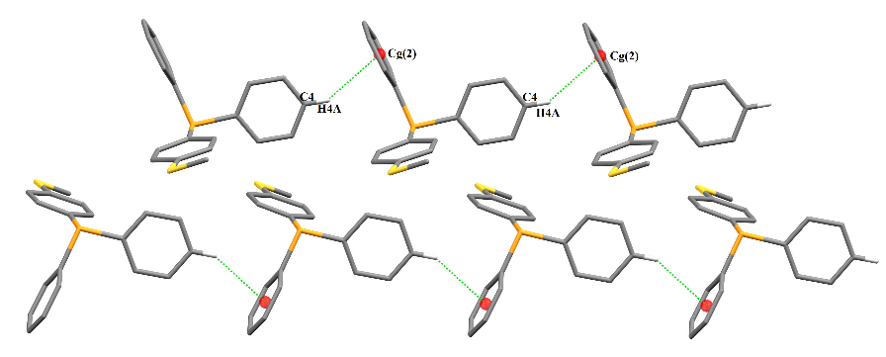

c
a
b

Figure S 3: Crystal packing of 2: [C11–H11A···Cg(1) and C4–H4A···Cg(2)] shows head-to-head arrangement along b-direction.

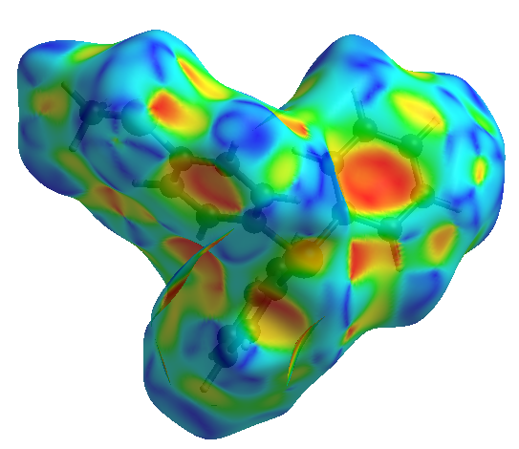
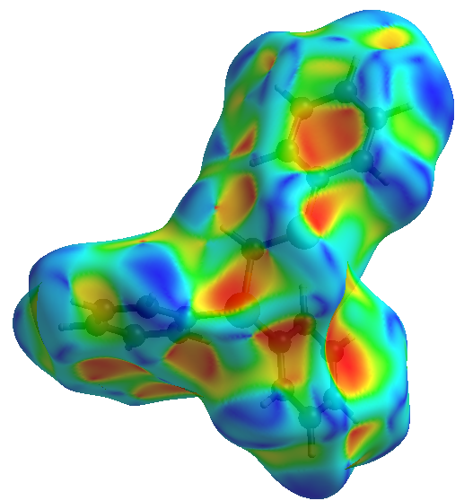

(1) (2)
Figure S 4: Hirshfeld surfaces 1 and 2 mapped over shape-index with a red spot (inside
the black arrows) signifying the involvement of the C–H···π interactions.

