Transition Metal Complexes of α-Aminophosphonates Part II: Synthesis, Spectroscopic Characterization and In Vitro Anticancer Activity of Copper(II) Complexes of α-Aminophosphonates
Mariam Ahmed Azzam^{1*}, Hanaa Abdel Latif El-Boraey², Ibrahim El Tantawy El Sayed²
¹Applied Organic Chemistry Department, National Research Centre, Dokki, Giza, Egypt
²Chemistry Department, Faculty of Science, El-Menoufia University, Shebin El Koom, Egypt
Email: mariam_ahmed_987@yahoo.com
Supplemental Materials

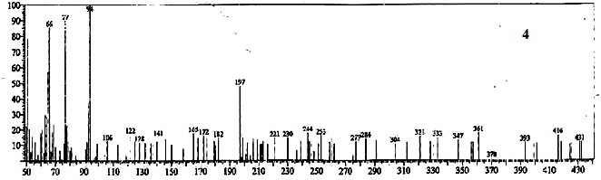
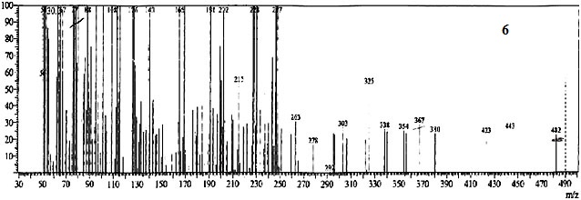

Figure S 1: The electron impact (EI) mass spectra of the free ligands 4, 6.

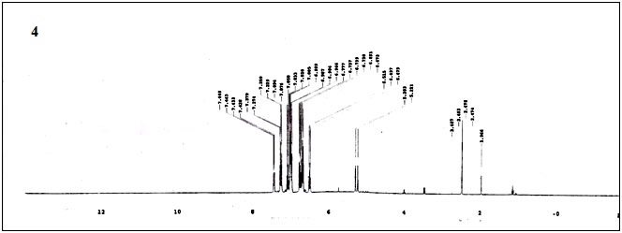
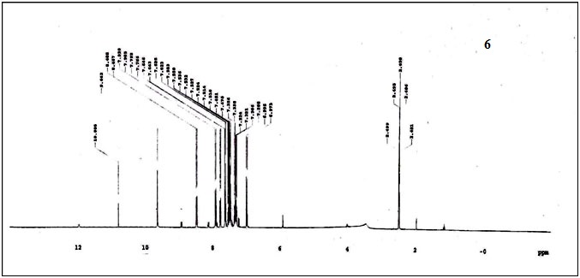

Figure S 2: The ¹H NMR spectra of the free ligands 4, 6.

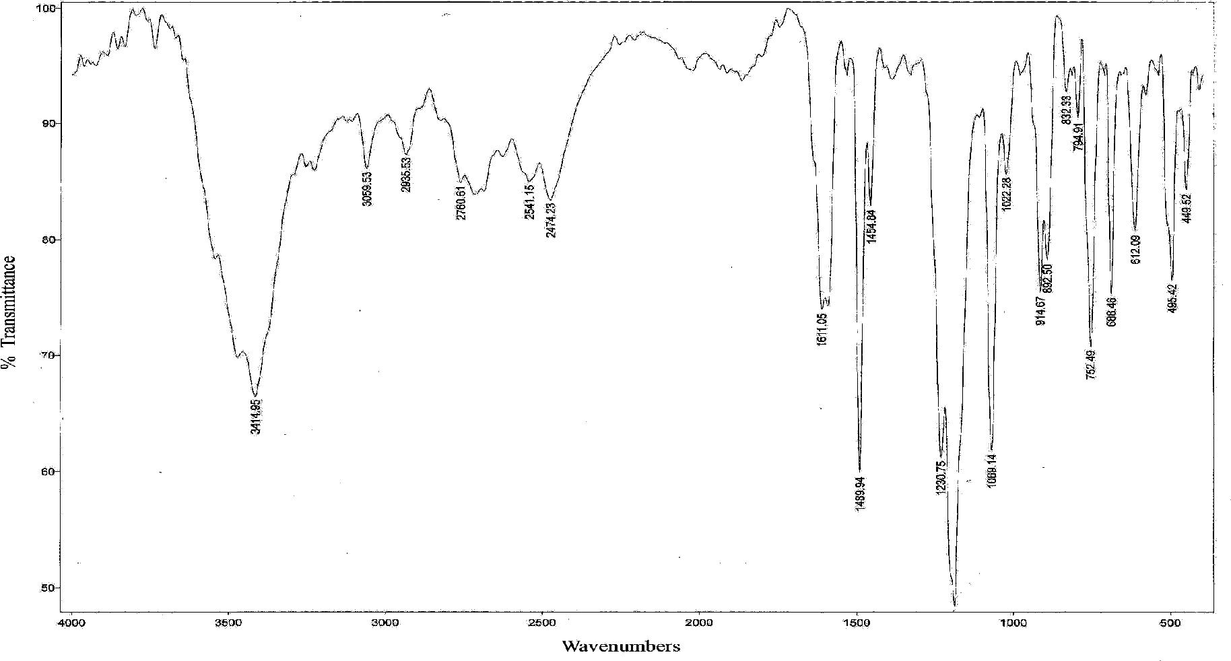
4

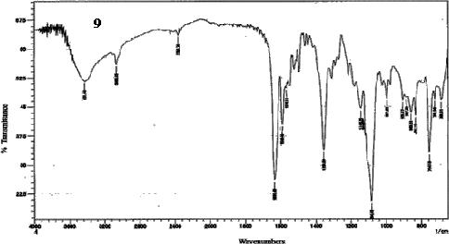
6

Figure S 3: The IR spectra of the free ligands4, 6.
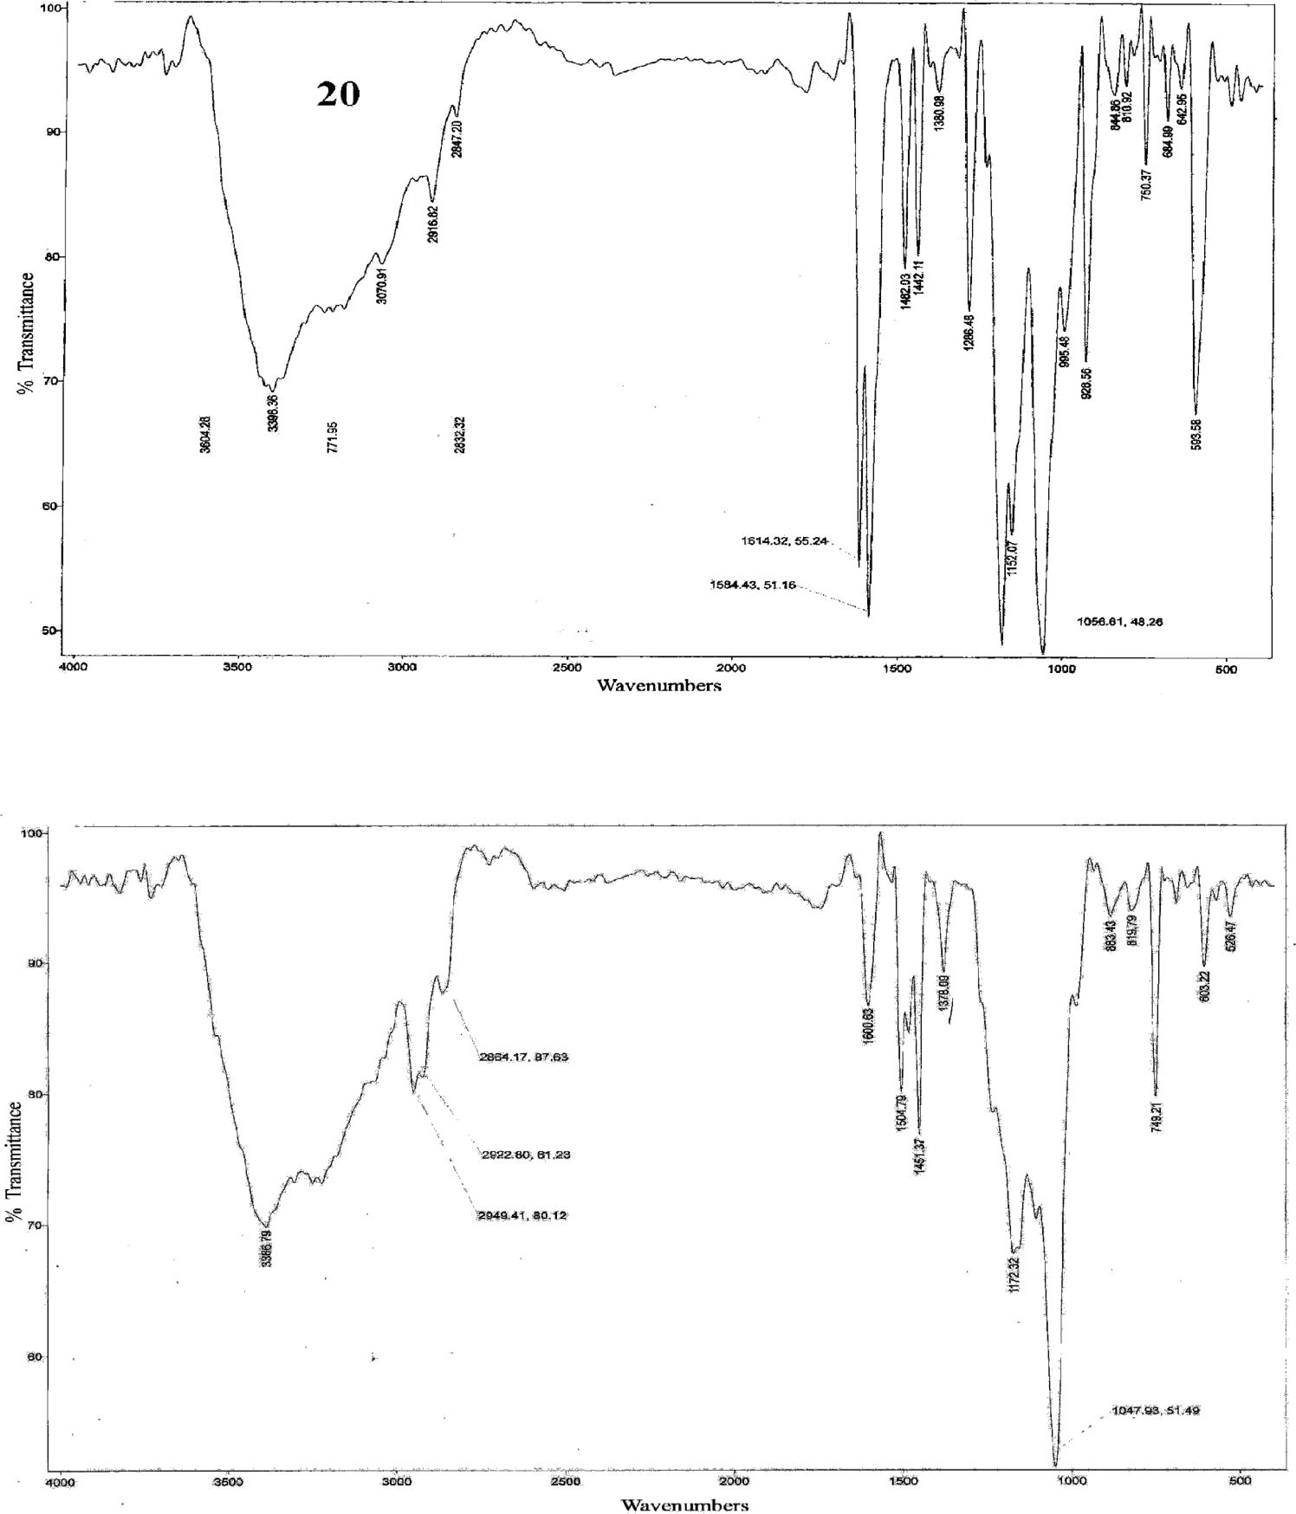
5a

5b

Figure S 4: The IR spectra of the copper(II) complexes 5a, 5b.
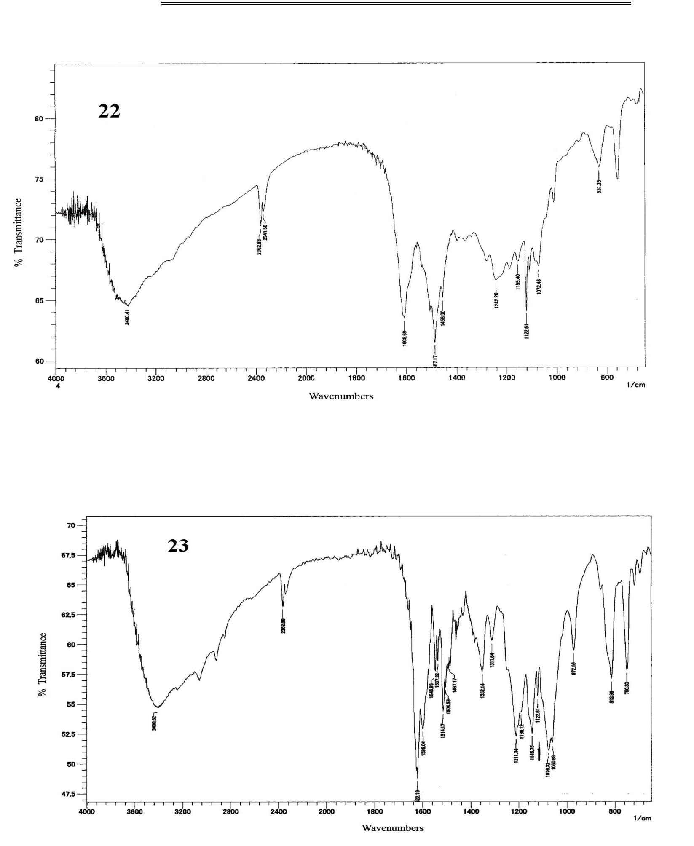
5c

7a

Figure S 5: The IR spectra of the copper(II) complexes 5c, 7a.

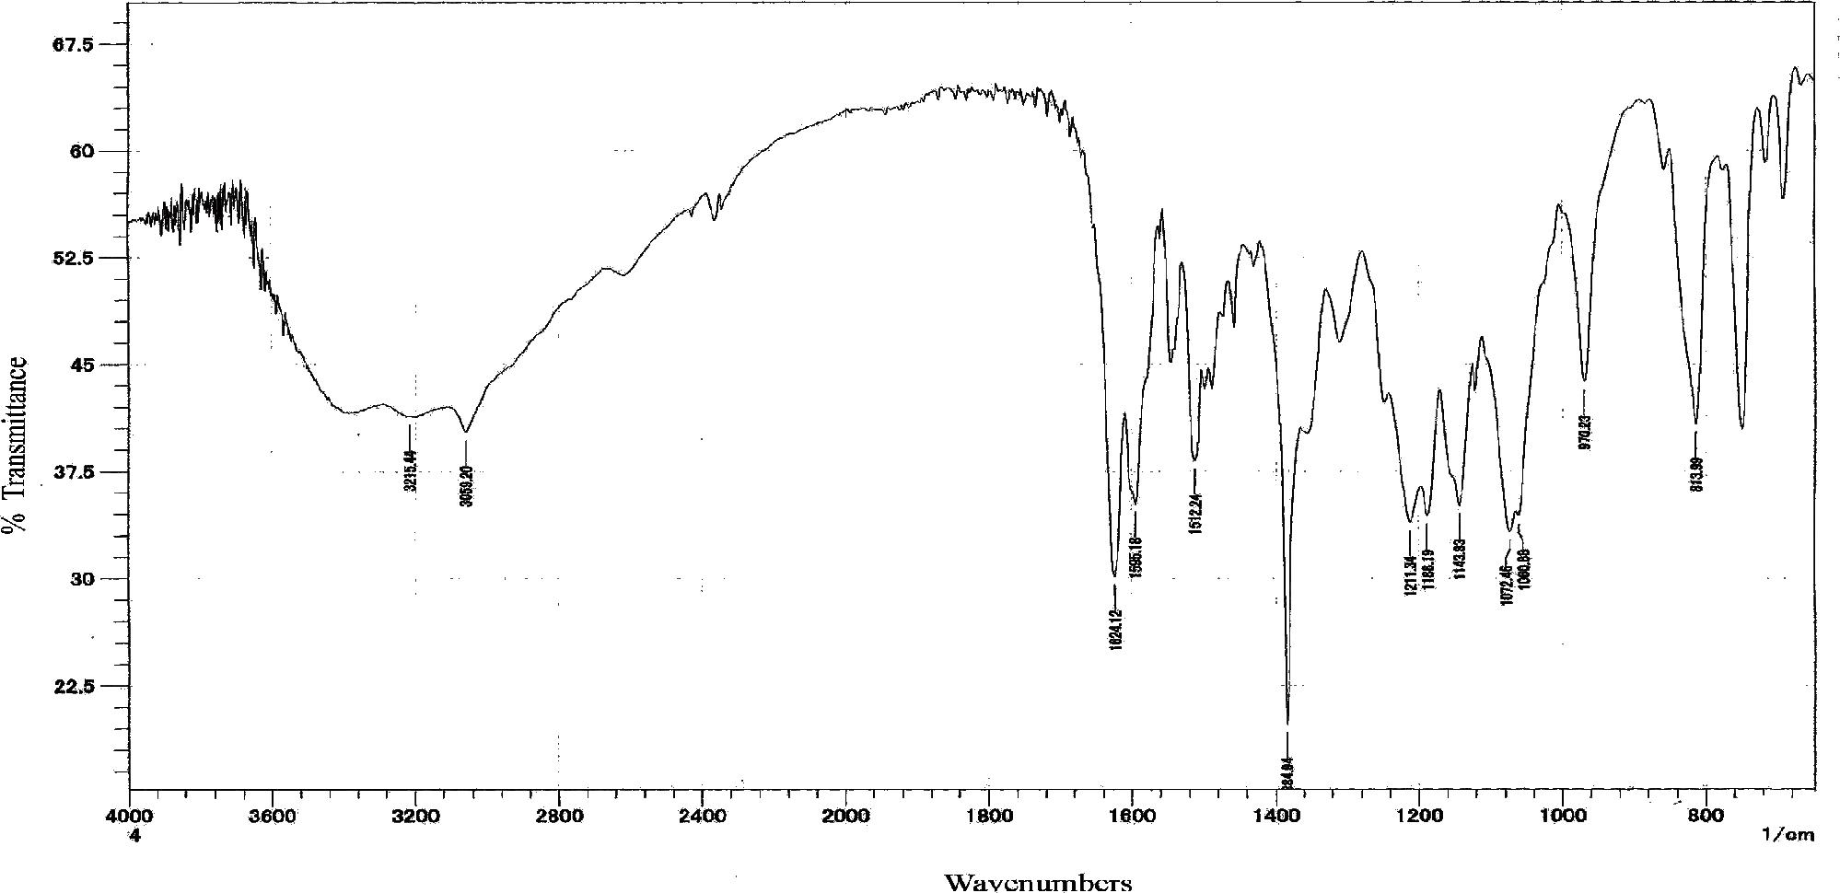
7b

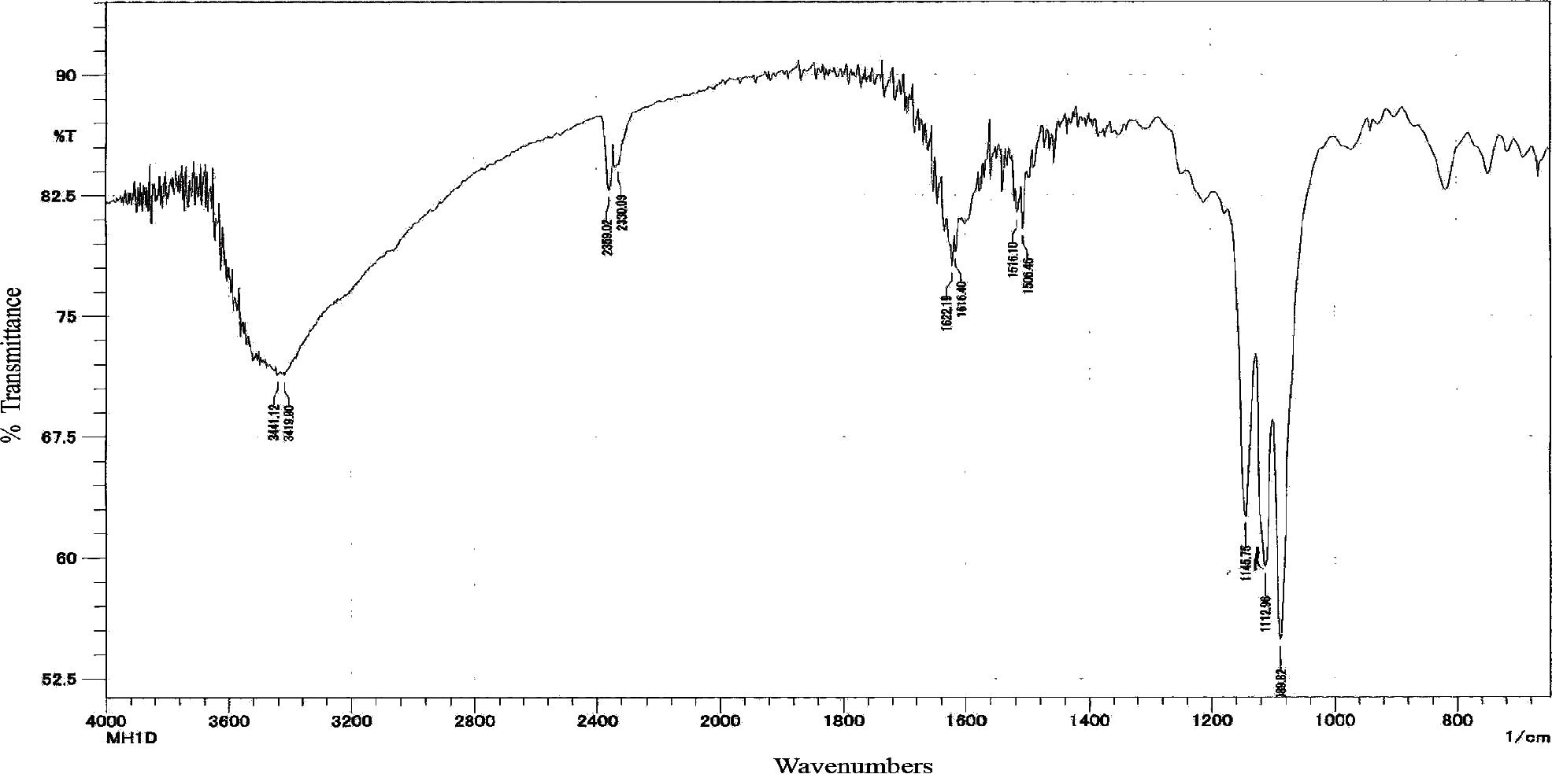

7c

Figure S 6: The IR spectra of the copper(II) complexes 7b, 7c.
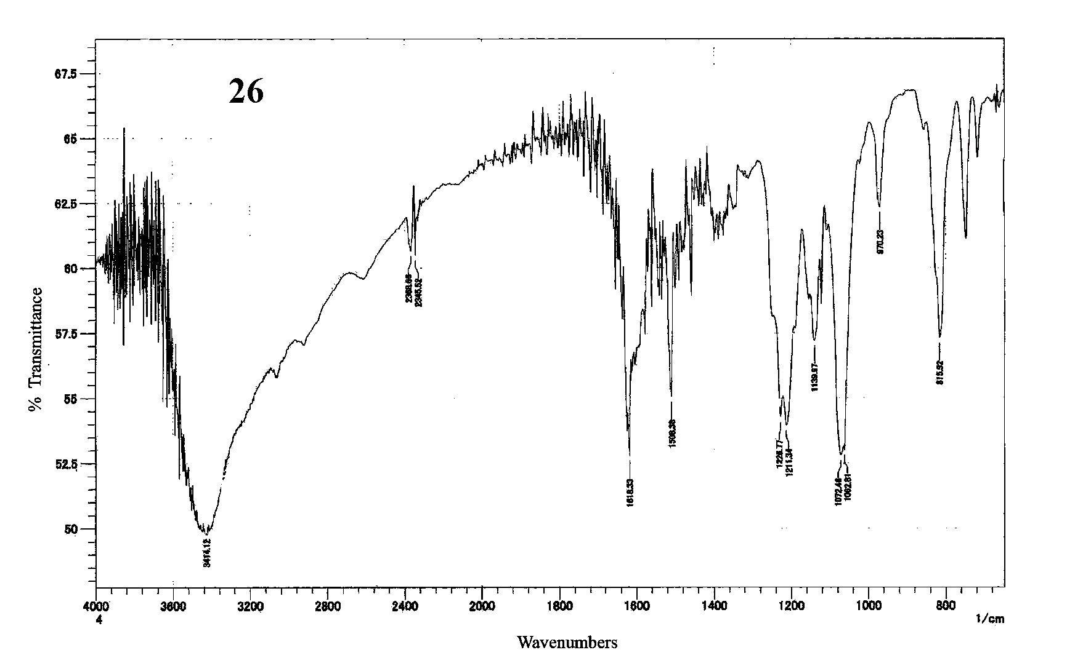
7d

Figure S 7: The IR spectra of the copper(II) complex 7d.

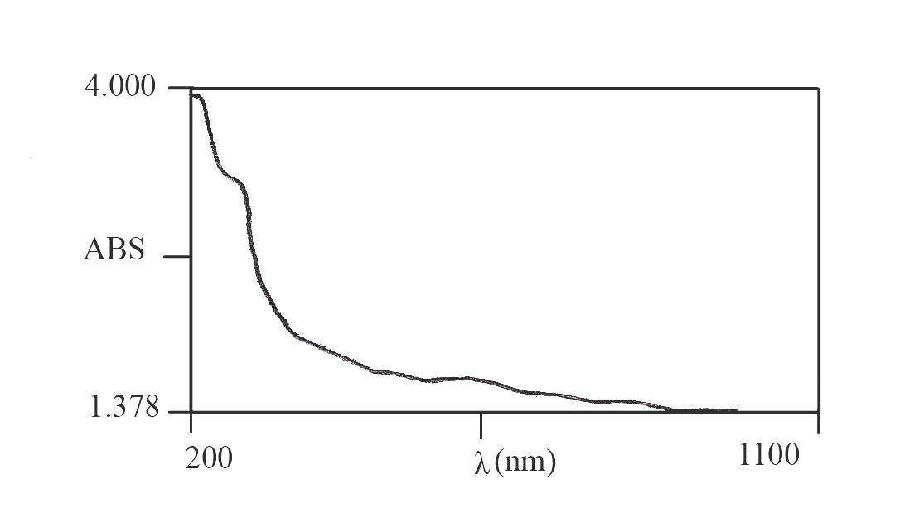
4

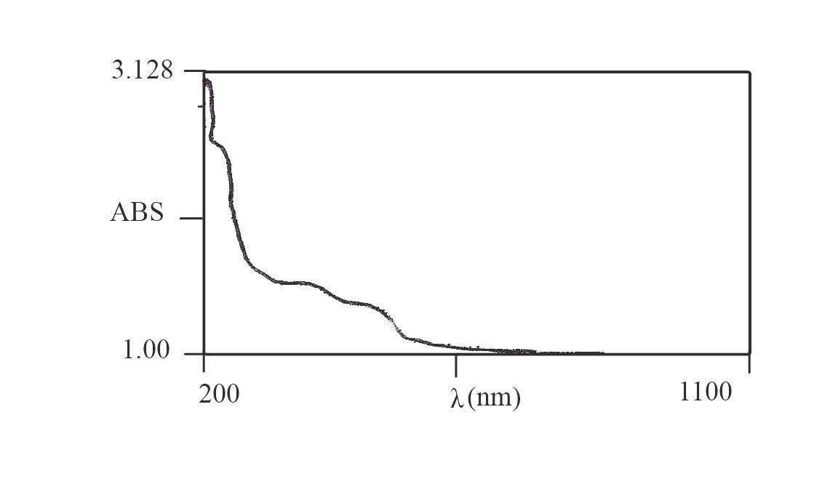

6

Figure S 8: The UV spectra of the ligands 4, 6.
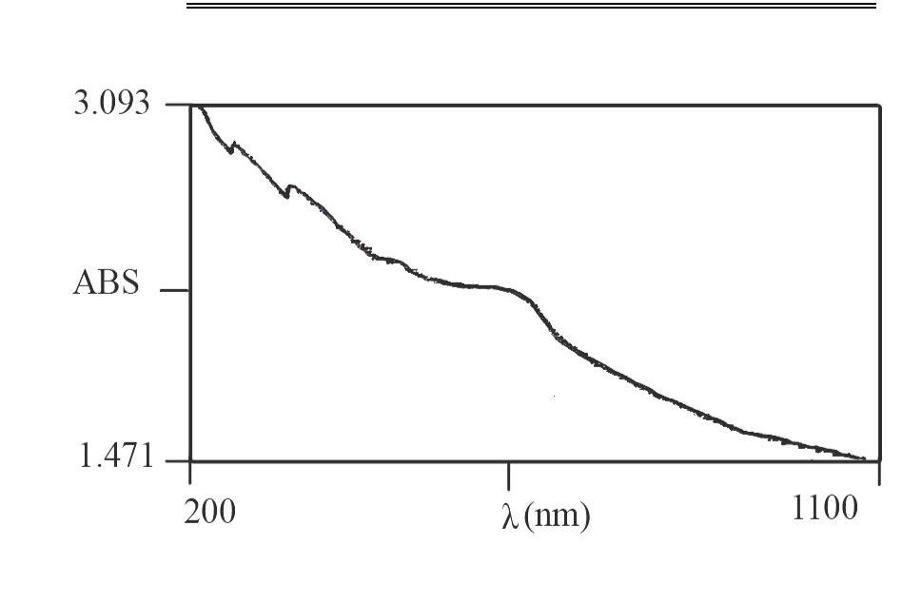
5a

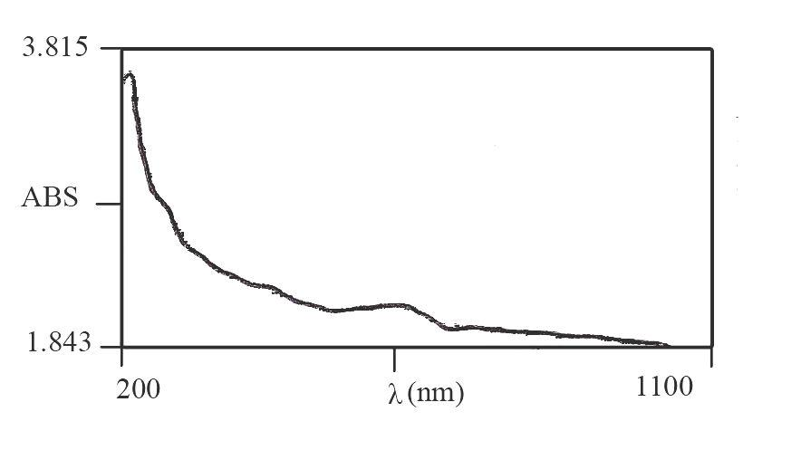

5b

Figure S 9: The UV spectra of the copper(II) complexes 5a, 5b.

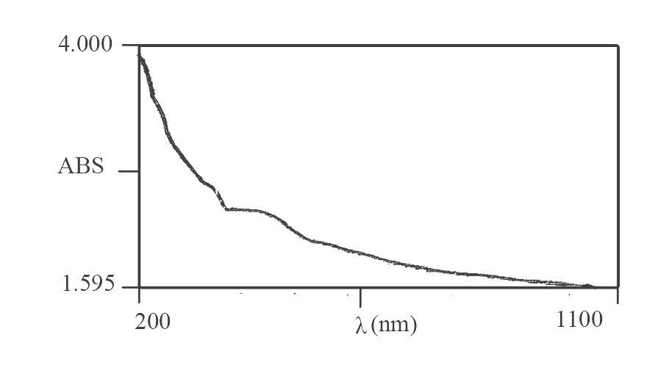
5c

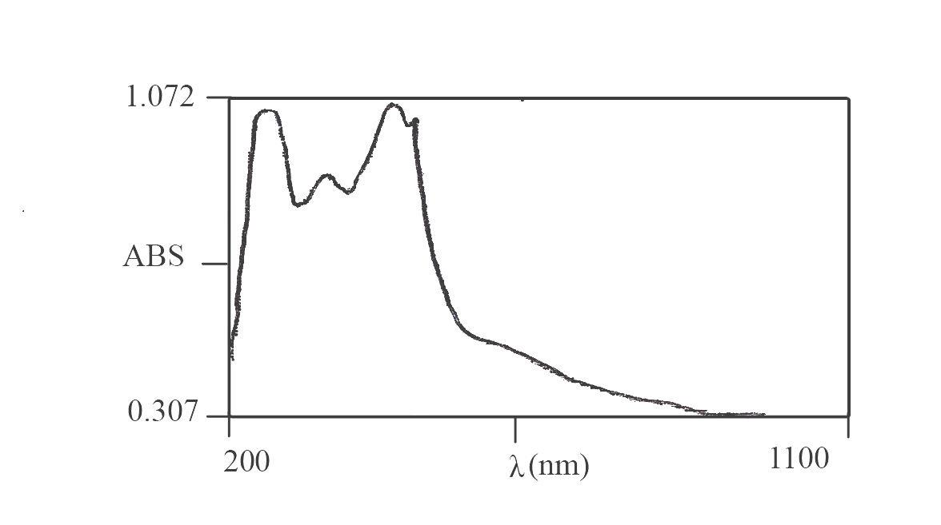

7a

Figure S 10: The UV spectra of the copper(II) complexes 5c, 7a.

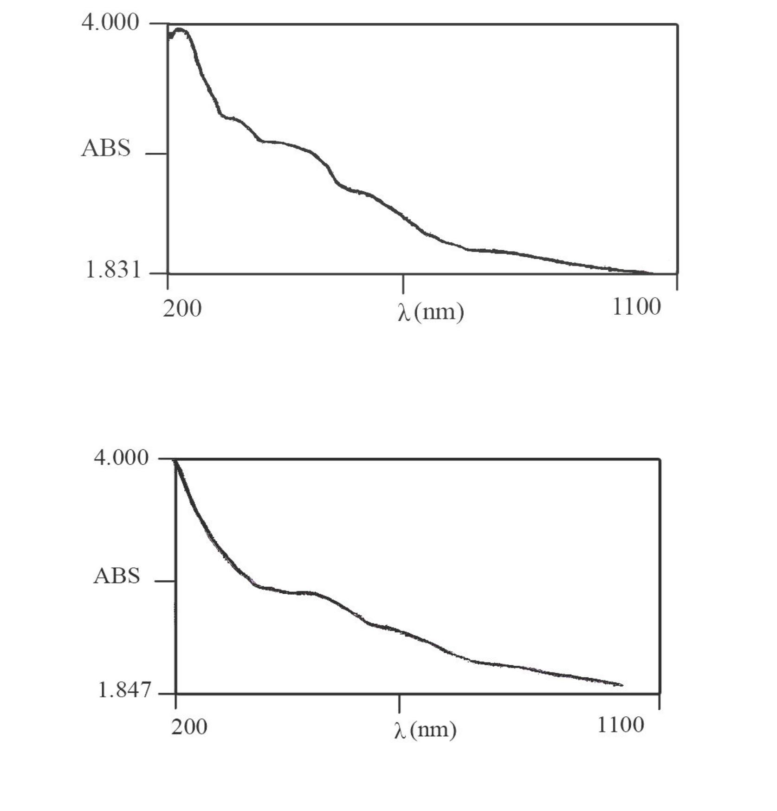
7b

7c

Figure S 11: The UV spectra of the copper(II) complexes 7b, 7c.

7d

Figure S 12: The UV spectra of the copper(II) complex 7d.

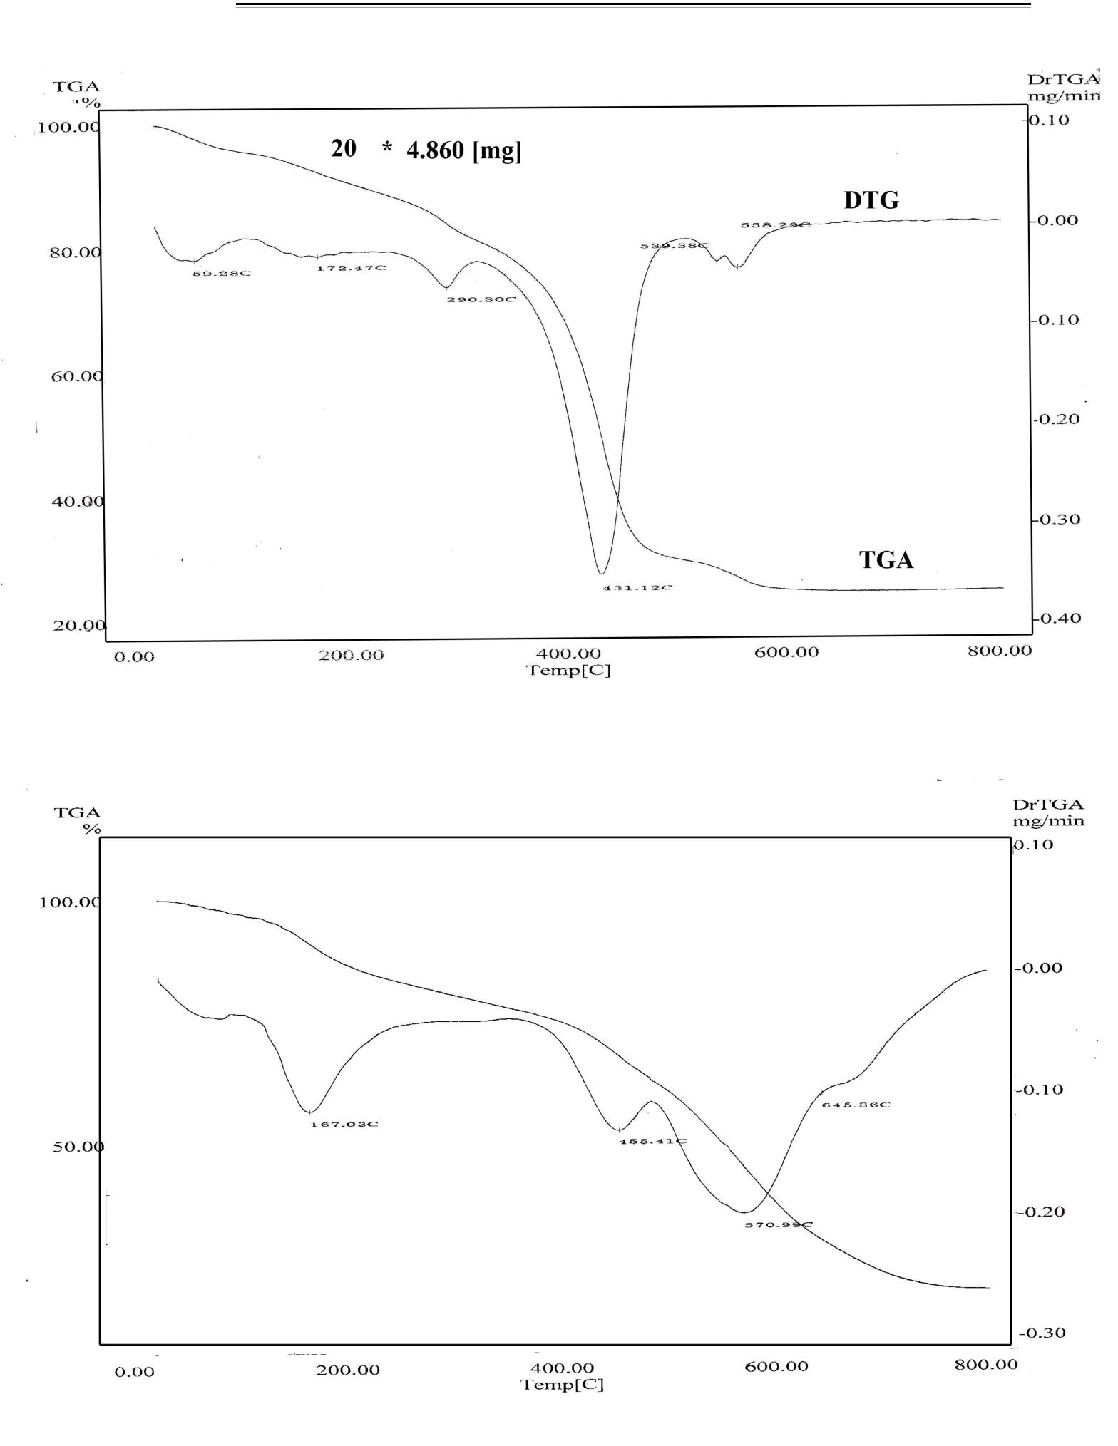

5a

5b

Figure S 13: TG/ DTG curve of the copper(II) complexes 5a, 5b.

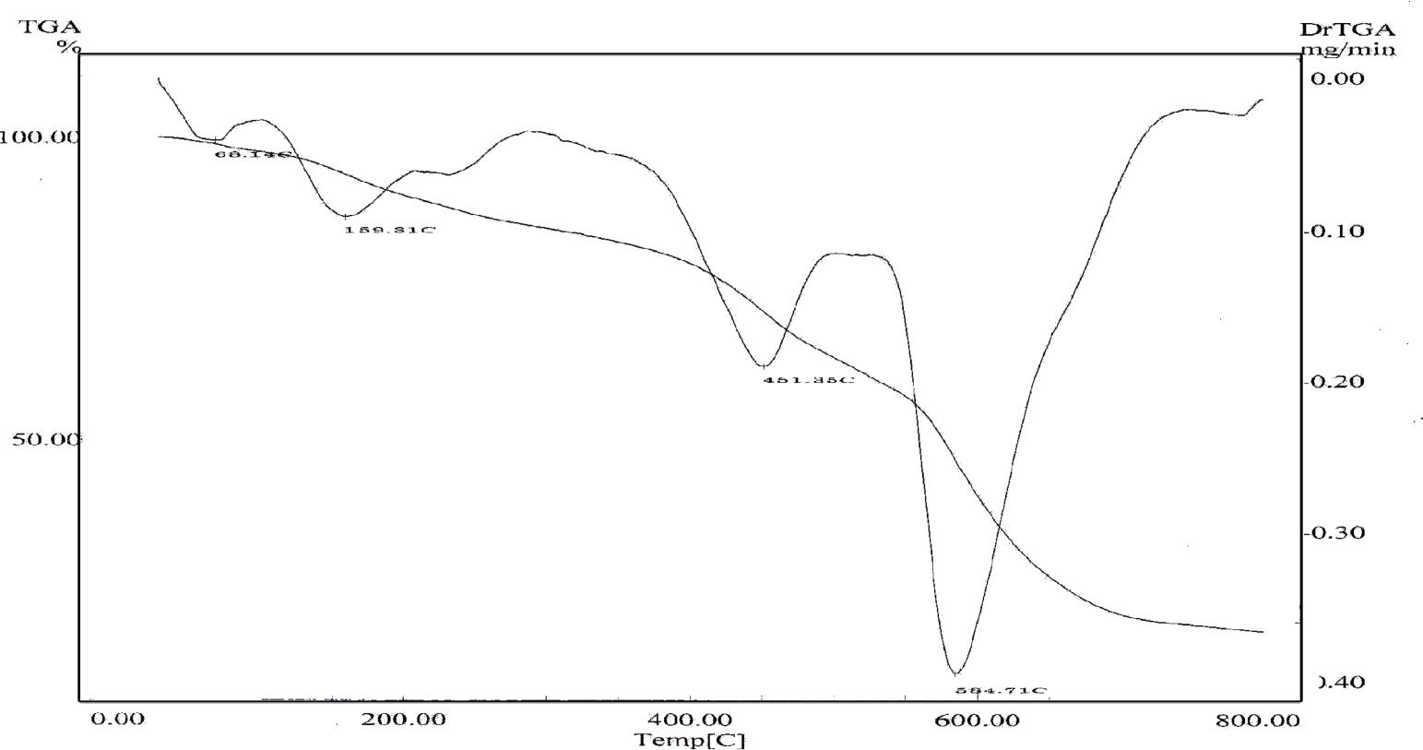
5c

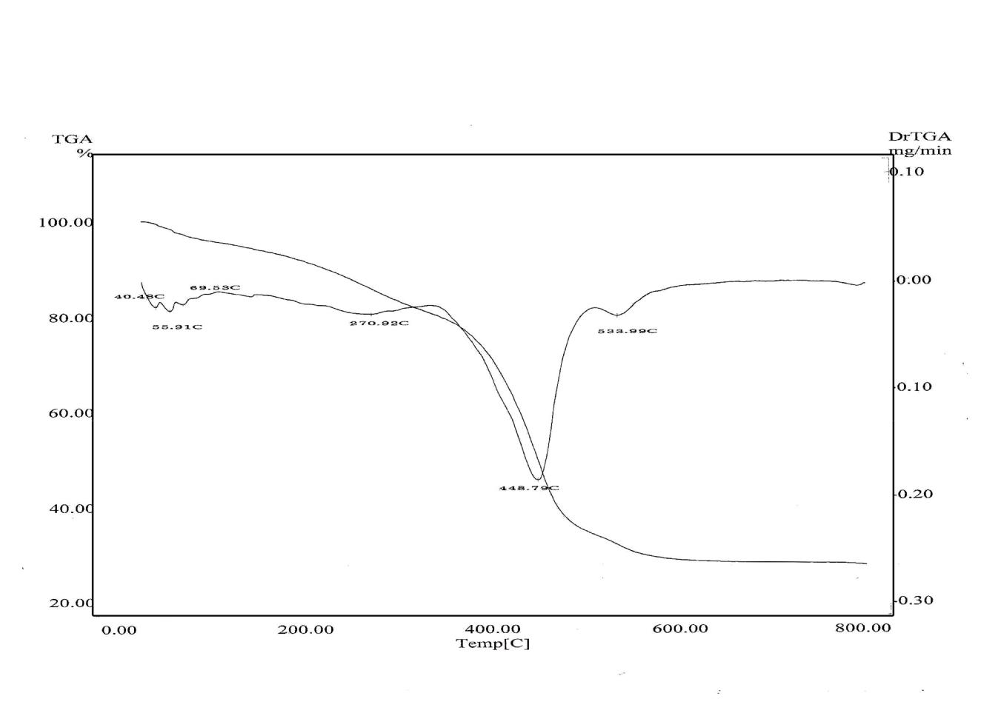

7a

Figure S 14: TG/ DTG curve of the copper(II) complexes 5c, 7a.
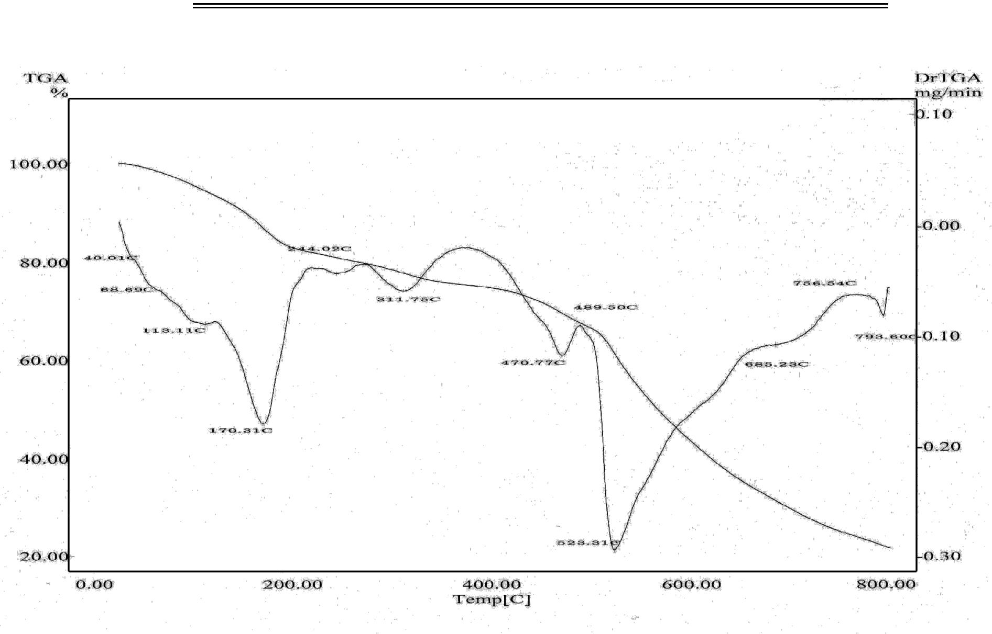
7b

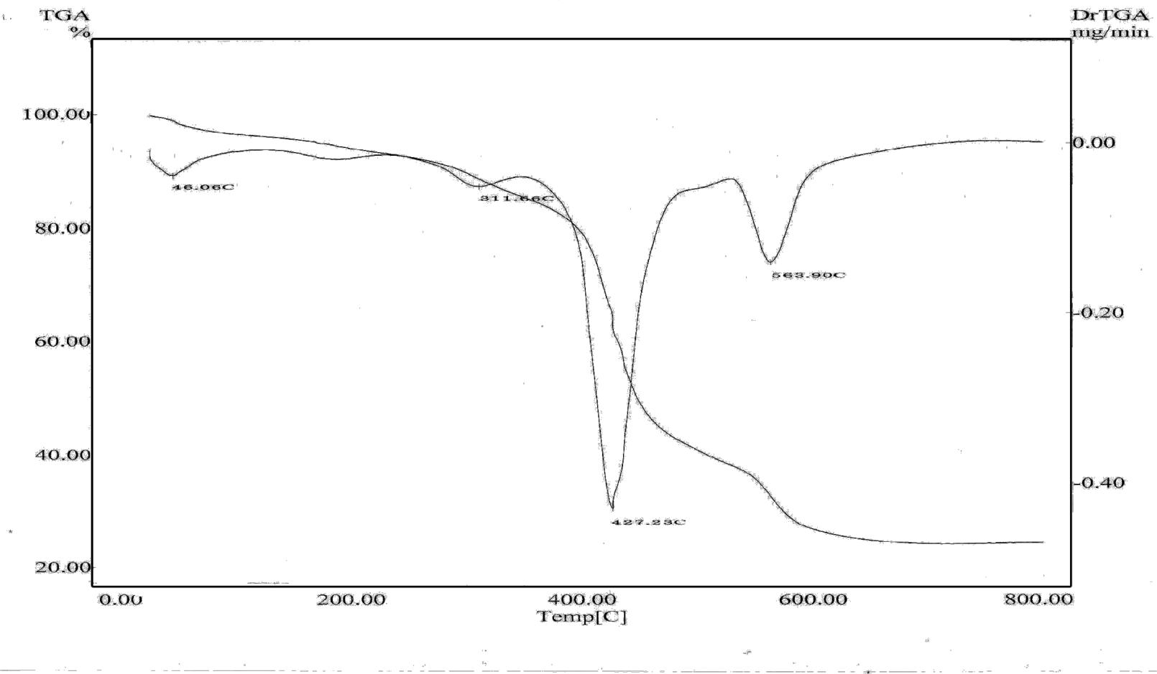

7d

Figure S 15: TG/ DTG curve of the copper(II) complexes 7b, 7d.

