First study of Rhodium(I) complexes with chiral sulfur-containing terpenoids as catalytic systems for ketone hydrosilylation
Vladimir M. Uvarovª, Dimitry A. de Vekkiª
ªDepartment of Chemical Technology of Polymers. St. Petersburg State Institute of Technology, St. Petersburg, Russia
Email: vladi.uvarov@yandex.ru
Supplemental Materials

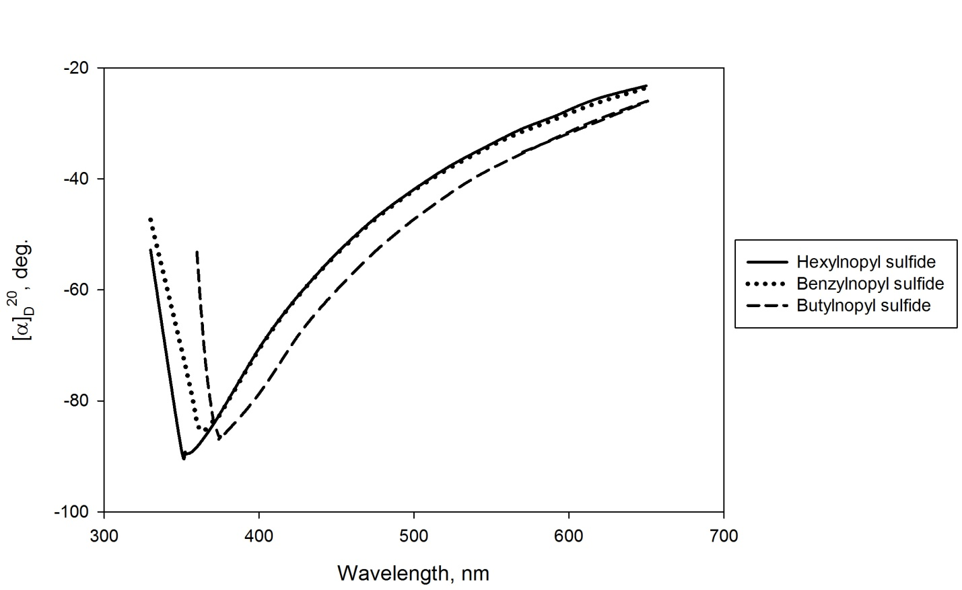
Figure S 1: Optical rotatory dispersion of (1R)-hexyl-, benzyl- and butylnopyl sulfides

Figure S 2: ¹H NMR spectrum of (1S)-camphorsulfonic acid chloride

Figure S 3: ¹H NMR spectrum of (1S)-10-camphorthiol
Figure S 4: ¹³С NMR spectrum of (1S)-10-camphorthiol

Figure S 5: ¹H NMR spectrum of tosylate of (1R)-nopol

Figure S 6: ¹H NMR spectrum of (1R)-butylnopyl sulfide
Figure S 7: ¹³C NMR spectrum of (1R)-butylnopyl sulfide

Figure S 8: ¹H NMR spectrum of (1R)-hexylnopyl sulfide
Figure S 7: ¹³C NMR spectrum of (1R)-hexylnopyl sulfide

Figure S 8: ¹H NMR spectrum of (1R)-benzylnopyl sulfide
Figure S 9: ¹³C NMR spectrum of (1R)-benzylnopyl sulfide

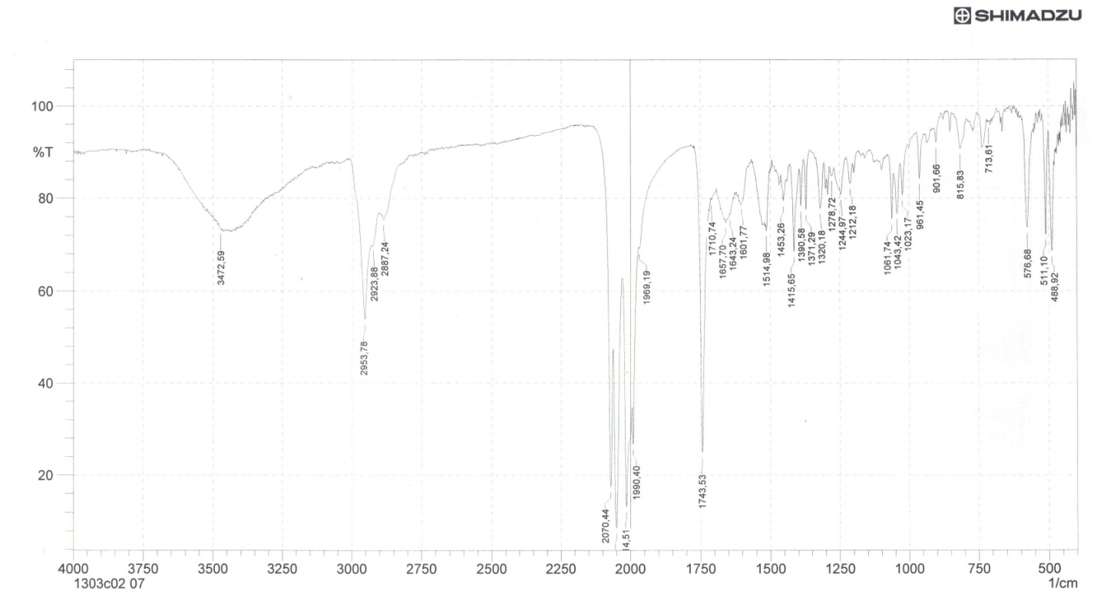
Figure S 10: IR spectrum of bis-μ-di[(+)-10-camphrothiolato]dicarbonylrhodium(I)
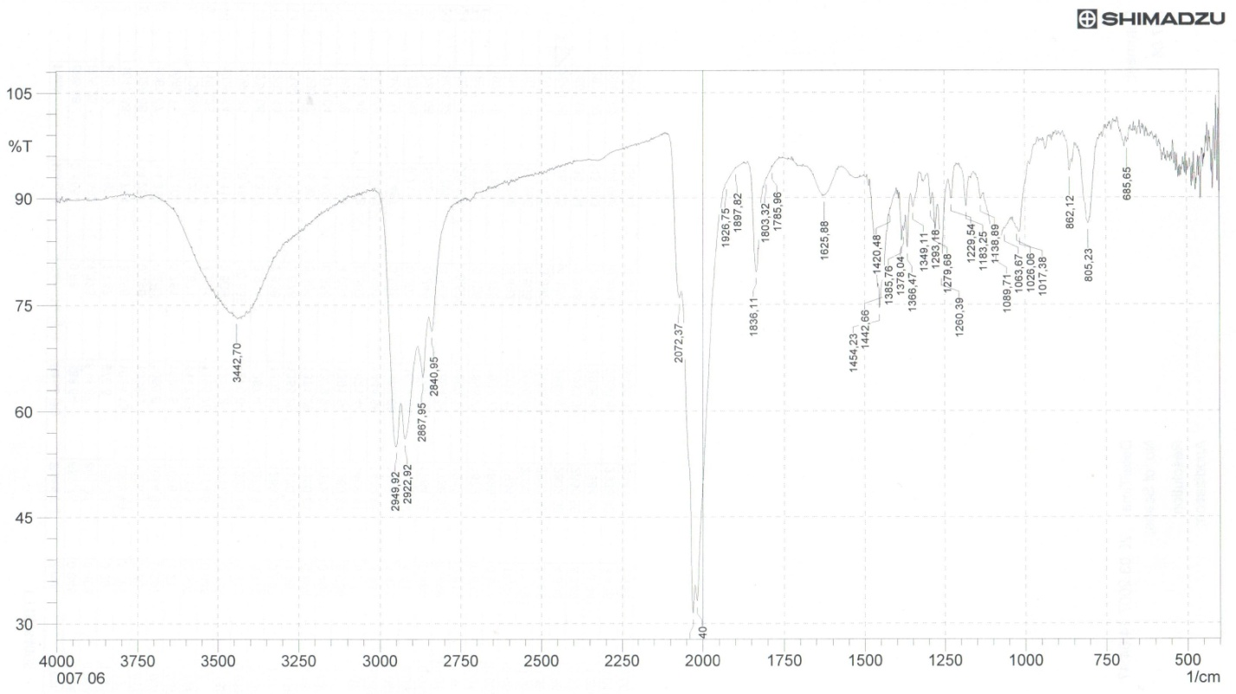
Figure S 11: IR spectrum of bis-μ-di[(+)-neomenthylthiolato]dicarbonylrhodium(I)
Figure S 12: ¹H NMR spectrum of Bis-μ-di[(+)-10-camphrothiolato]dicarbonylrhodium(I)
Figure S 13: ¹³С NMR spectrum of Bis-μ-di[(+)-10-camphrothiolato]dicarbonylrhodium(I)

