Supplementary Information
Contents Page No
- Possible antigenic sites of MurG 2
- Possible binding sites of MurG 3
- Multiple sequence alignment 5
- Resolution of candidate templates 6
- Pair-wise sequence alignment 7
- Secondary structure of MurG 8
- Evaluation of MurG model 9
- Interaction of MurG with ligands 13
- Pairwise structure alignment 21
- Hydrophobic interaction of top four selected ligands 22
Table 1. The possible antigenic sites predicted using the EMBOSS-Antigenic program
SNo | Position of antigenic site | Antigenic site sequence
1. | 264-299 | EADLIICRAGALTVTEVATAGVAAVFVPLPIAVDDH
2. | 141-152 | LSRVAKVVCEAF
3. | 246-255 | NLTVQVLPFI
4 | 20-44 | GGHVFPALAVAKQLQQQGCQVSWLA
5 | 97-136 | QLKVDAVAGFGGYVAGPGGLAARLLGIPVLIHEQNAVAGF
6 | 355-362 | TQHVVDLI
7 | 192-201 | PLNILIVGGS
8 | 304-319 | AKFLADVGAAKICQQS
9 | 212-244 | PPALKQLEVPLNIFHQCGQQQVEATQALYADAP
10 | 75-88 | IRKLAAPFKILKAT
11 | 159-166 | SEKVVTTG
12 | 323-332 | PEVLNQLFTT
13 | 59-68 | IPIYQIDIQG
14 | 174-180 | TDILSPK

Table 2. Binding site prediction of MurG using different types of prediction tools
Estimated binding site using CASTp | Estimated binding site using PockDrug | Estimated binding site using CavitypPlus | Estimated binding site using 3DLigandSite | Common binding site
Gly18, Ser201 | Gly20 | Gly18, Gly199 | Thr19 | Gly20
Thr19, Leu202 | Ile255 | Thr19, Gly200 | Gly20 | Arg170
Gly20, Gly203 | Arg170 | Gly20, Ser201 | Gly21 | Gly200
Gly21, Gln227 | Ile173 | Gly21, Leu202 | His22 | Ser201
His22, Gln230 | Val198 | His22, Gly203 | Arg170 | Gln227
Val23, Phe254 | Gly200 | Val23, Ala204 | Gly200 | Phe254
Phe24, Ile255 | Ser201 | Phe24, Gln227 | Ser201 | Leu275
Leu27, Glu256 | Gln227 | Pro25, Gly229 | Gln227 | Thr276
Ala28, Met258 | Phe254 | Leu27, Gln230 | Phe254 | Glu279
Lys31, Tyr262 | Met258 | Ala28, Pro253 | Gly273
Gln32, Ile268 | Tyr262 | Val29, Phe254 | Ala274
Gln35, Cys270 | Ile268 | Lys31, Ile255 | Leu275
Met49, Arg271 | Cys270 | Trp42, Glu256 | Thr276
Arg52, Gly273 | Leu275 | Met49, Asp257 | Val277
Leu53, Ala274 | Thr276 | Glu50, Met258 | Glu279
Asp56, Leu275 | Glu279 | Arg52, Ala259
Gln57, Thr276 |  | Leu53, Tyr262
Gln130, Glu279 |  | Leu54, Ile268
Asn131, Thr282 |  | Asp56, Ile269
Val133, Leu292 |  | Gln57, Cys270
Gly135, Ile294 |  | Phe106, Arg271
Thr165, His299 |  | Gly107, Ala272
Asn167, Gln300 |  | Gly108, Gly273
Pro168, Asn303 |  | Glu129, Ala274
Val169, Arg347 |  | Gln130, Leu275
Arg170, Ala350 |  | Asn131, Thr276
Arg171, Gln351 |  | Val133, Val277
Glu172 |  | Ala134, Thr278
Ile173 |  | Gly135, Glu279
Thr174 |  | Phe136, Leu292
Val198 |  | Thr137, Ile294
Gly199 |  | Asn138, Asp297
Gly200 |  | Asn167, Asp298
Gln356 |  | Pro168, His299
Thr355 |  | Val169, Gln300
Ala354 |  | Arg170, Asn303
Asn353 |  | Arg171, Ile173
Pro352 |  | Glu172, Val198

Figure 1. Multiple sequence alignment
Reference sequence (1): MurG
Identities normalised by aligned length.
Colored by: identity
cov pid 1 [ . . . . : . . . 80
1 MurG 100.0% 100.0% MTDSQQSKPKHVMMMAAGTGGHVFPALAVAKQLQQQGCQVSWLATPTGMENRLLKDQNIPIYQIDIQG------VRGNGV
2 3S2U 95.3% 46.6% M-------KGNVLIMAGGTGGHVFPALACAREFQARGYAVHWLGTPRGIENDLVPKAGLPLHLIQVSG------LRGKGL
3 1F0K 96.4% 41.4% M---MSGQGKRLMVMAGGTGGHVFPGLAVAHHLMAQGWQVRWLGTADRMEADLVPKHGIEIDFIRISG------LRGKGI
4 2IYF 95.3% 18.5% MT--TQTTPAHIAMFSIAAHGHVNPSLEVIRELVARGHRVTYAIPPVFADKVAATGPRPVLYHSTLPGPDADPEAWGSTL
5 4M83 95.3% 18.5% MT--TQTTPAHIAMFSIAAHGHVNPSLEVIRELVARGHRVTYAIPPVFADKVAATGARPVLYHSTLPGPDADPEAWGSTL
cov pid 81 . 1 . . . . : . 160
1 MurG 100.0% 100.0% IRKLAAPFKILKATFSAMRYMKQLKVDAV--AGFGGYVAGPGGLAARLLGIPVLIHEQNAVA--GFTNAQLSRVAKVVCE
2 3S2U 95.3% 46.6% KSLVKAPLELLKSLFQALRVIRQLRPVCV--LGLGGYVTGPGGLAARLNGVPLVIHEQNAVA--GTANRSLAPIARRVCE
3 1F0K 96.4% 41.4% KALIAAPLRIFNAWRQARAIMKAYKPDVV--LGMGGYVSGPGGLAAWSLGIPVVLHEQNGIA--GLTNKWLAKIATKVMQ
4 2IYF 95.3% 18.5% LDNVE-PF--LNDAIQALPQLADAYADDIPDLVLHDITSYPARVLARRWGVPAVSLSPNLVAWKGYEEEVAEPMWREPRQ
5 4M83 95.3% 18.5% LDNVE-PF--LNDAIQALPQLADAYADDIPDLVLHDITSYPARVLARRWGVPAVSLSPNLVAWKGYEEEVAEPMWREPRQ
cov pid 161 . . . 2 . . . . 240
1 MurG 100.0% 100.0% A---------------------FPNTFPASEKVVTTGNP---------VRREITDILSPKWRYDEREQA------GKPLN
2 3S2U 95.3% 46.6% A---------------------FPDTFPASDKRLTTGNP---------VRGELF--------LDAHARA---PLTGRRVN
3 1F0K 96.4% 41.4% A---------------------FPGAFPNAE---VVGNP---------VRTDVLALPLPQQRLAGREGP---------VR
4 2IYF 95.3% 18.5% TERGRAYYARFEAWLKENGITEHPDTFASHPPRSLVLIPKALQPHADRVDEDVYTFVGACQGDRAEEGGWQRP-AGAEKV
5 4M83 95.3% 18.5% TERGRAYYARFEAWLKENGITEHPDTFASHPPRSLVLIPKALQPHADRVDEDVYTFVGACQGDRAEEGGWQRP-AGAEKV
cov pid 241 : . . . . 3 . . 320
1 MurG 100.0% 100.0% ILIVGGSLGAKALNERLPPALKQ--LEVPLNI--FHQCGQQQVEATQALYADAPANLTVQVLPFIEDMAKAYSEADLIIC
2 3S2U 95.3% 46.6% LLVLGGSLGAEPLNKLLPEALAQVPLEIRPAI--RHQAGRQHAEITAERYRTVA--VEADVAPFISDMAAAYAWADLVIC
3 1F0K 96.4% 41.4% VLVVGGSQGARILNQTMPQVAAK--LGDSVTI--WHQSGKGSQQSVEQAYAEAG-QPQHKVTEFIDDMAAAYAWADVVVC
4 2IYF 95.3% 18.5% VLV---SLGSAFTKQ--PAFYREC-VRAFGNLPGWHLVLQIGRKVTPAELGELP--DNVEVHDWVPQLA-ILRQADLFVT
5 4M83 95.3% 18.5% VLV---SLGSAFTKQ--PAFYREC-VRAFGNLPGWHLVLQIGRKVTPAELGELP--DNVEVHDWVPQLA-ILRQADLFVT
cov pid 321 . . : . . . . 4 400
1 MurG 100.0% 100.0% RAGALTVTEVATAGVAAVFVPLPIAVDDHQTANAKFLADVGAAKICQQSTMTPEVL-NQLFTTLMNRQLLTEMAVKARQH
2 3S2U 95.3% 46.6% RAGALTVSELTAAGLPAFLVPLPHAIDDHQTRNAEFLVRSGAGRLLPQKSTGAAELAAQLSEVLMHPETLRSMADQARSL
3 1F0K 96.4% 41.4% RSGALTVSEIAAAGLPALFVPF-QHKDRQQYWNALPLEKAGAAKIIEQPQLSVDAVANTLAG--WSRETLLTMAERARAA
4 2IYF 95.3% 18.5% HAGAGGSQEGLATATPMIAVP--QAVD--QFGNADMLQGLGVARKLATEEATADLLRETALALVDDPEVARRLRRIQAEM
5 4M83 95.3% 18.5% HAGAGGSQEGLATATPMIAVP--QAVD--QFGNADMLQGLGVARKLATEEATADLLRETALALVDDPEVARRLRRIQAEM
cov pid 401 . . . ] 437
1 MurG 100.0% 100.0% AQPNATQHVVDLIQKM---------------------
2 3S2U 95.3% 46.6% AKPEATRTVVDACLEVARGLEHHHHHH----------
3 1F0K 96.4% 41.4% SIPDATERVANEVSRVARALEHHHHHH----------
4 2IYF 95.3% 18.5% AQEGGTRRAADLIEAE---LPARHERQEPVGDRPNGG
5 4M83 95.3% 18.5% AQEGGTRRAADLIEAE---LPARHERQEPVGDRPNGG
The Multiple Sequence Alignment of MurG sequence from A. baumannii with the UDP-N-acetylglucosamine-N-acetylmuramyl (pentapeptide) pyrophosphoryl-undecaprenol N-acetylglucosamine transferase from Escherichia coli (Strain K12) (1F0K), Pseudomonas aeruginosa (strain ATCC 15692) (3S2U), as well as Oleandomycin glycosyltransferase from Streptomyces antibioticus (2IYF, 4M83).
Figure 2. Resolution of Candidate Templates

Weighted pair-group average clustering based on a distance matrix:

.-------------------------------------------- 3s2uA @2.2 66.0000
|
.---------------------------------------------------------- 1f0kA @1.9 89.5000
|
| .--- 2iyfA @1.7 1.0000
| |
.------------------------------------------------------------ 4m83A @1.7

+----+----+----+----+----+----+----+----+----+----+----+----+
93.0400 77.1100 61.1800 45.2500 29.3200 13.3900 -2.5400
85.0750 69.1450 53.2150 37.2850 21.3550 5.4250
This indicated that the resolution of each template displayed during modeling by modeler

Figure 3. Pair-wise Sequence Alignment
#=======================================
# Aligned_sequences: 2
# 1: MurG
# 2: 1F0K
# Matrix: EBLOSUM62
# Gap_penalty: 10.0
# Extend_penalty: 0.5
# Length: 359
# Identity: 159/359 (44.3%)
# Similarity: 219/359 (61.0%)
# Gaps: 15/359 (4.2%)
# Score: 693.0
#=======================================

MurG 10 KHVMMMAAGTGGHVFPALAVAKQLQQQGCQVSWLATPTGMENRLLKDQNI 59
|.:|:||.||||||||.||||..|..||.||.||.|...||..|:....|
1F0K 7 KRLMVMAGGTGGHVFPGLAVAHHLMAQGWQVRWLGTADRMEADLVPKHGI 56

MurG 60 PIYQIDIQGVRGNGVIRKLAAPFKILKATFSAMRYMKQLKVDAVAGFGGY 109
.|..|.|.|:||.|:...:|||.:|..|...|...||..|.|.|.|.|||
1F0K 57 EIDFIRISGLRGKGIKALIAAPLRIFNAWRQARAIMKAYKPDVVLGMGGY 106

MurG 110 VAGPGGLAARLLGIPVLIHEQNAVAGFTNAQLSRVAKVVCEAFPNTFPAS 159
|:|||||||..|||||::||||.:||.||..|:::|..|.:|||..||.:
1F0K 107 VSGPGGLAAWSLGIPVVLHEQNGIAGLTNKWLAKIATKVMQAFPGAFPNA 156

MurG 160 EKVVTTGNPVRREITDILSPKWRYDEREQAGKPLNILIVGGSLGAKALNE 209
|.| |||||.::..:..|:.|...|| .|:.:|:||||.||:.||:
1F0K 157 EVV---GNPVRTDVLALPLPQQRLAGRE---GPVRVLVVGGSQGARILNQ 200

MurG 210 RLPPALKQLEVPLNIFHQCGQQQVEATQALYADA--PANLTVQVLPFIED 257
.:|....:|...:.|:||.|:...::.:..||:| |.: :|..||:|
1F0K 201 TMPQVAAKLGDSVTIWHQSGKGSQQSVEQAYAEAGQPQH---KVTEFIDD 247

MurG 258 MAKAYSEADLIICRAGALTVTEVATAGVAAVFVPLPIAVDDHQTANAKFL 307
||.||:.||:::||:|||||:|:|.||:.|:|||.. ..|..|..||..|
1F0K 248 MAAAYAWADVVVCRSGALTVSEIAAAGLPALFVPFQ-HKDRQQYWNALPL 296

MurG 308 ADVGAAKICQQSTMTPE-VLNQLFTTLMNRQLLTEMAVKARQHAQPNATQ 356
...|||||.:|..::.: |.|.| ...:|:.|..||.:||..:.|:||:
1F0K 297 EKAGAAKIIEQPQLSVDAVANTL--AGWSRETLLTMAERARAASIPDATE 344

MurG 357 HVVDLIQKM 365
.|.:.:.::
1F0K 345 RVANEVSRV 353
Pairwise sequence alignment among MurG and the UDP-N-acetylglucosamine-N-acetylmuramyl (pentapeptide) pyrophosphoryl-undecaprenol N-acetylglucosamine transferase (1F0K) from Escherichia coli (Strain K12) showing the conserved regions in green color.

Figure 4. Secondary Structure of MurG
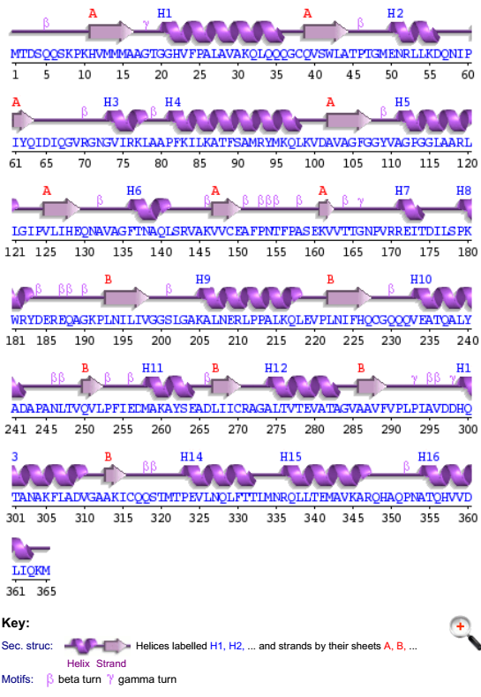

Figure 5. Model Evaluation score of MurG

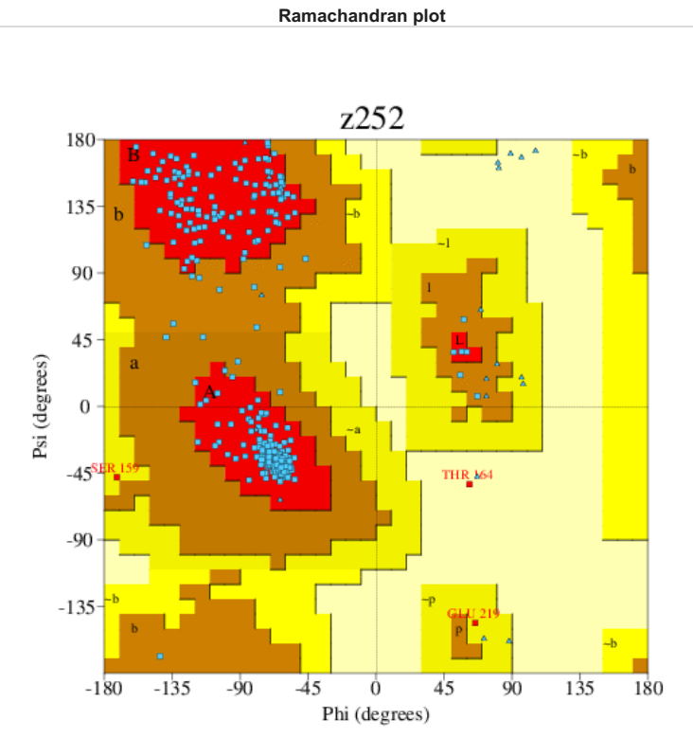

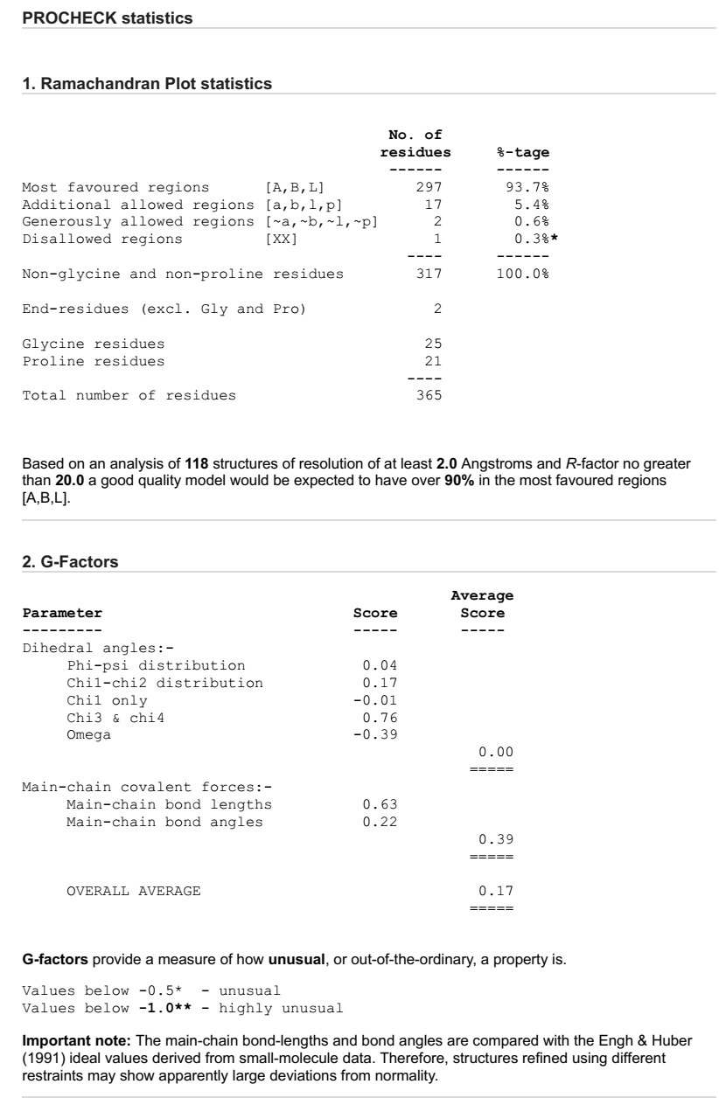
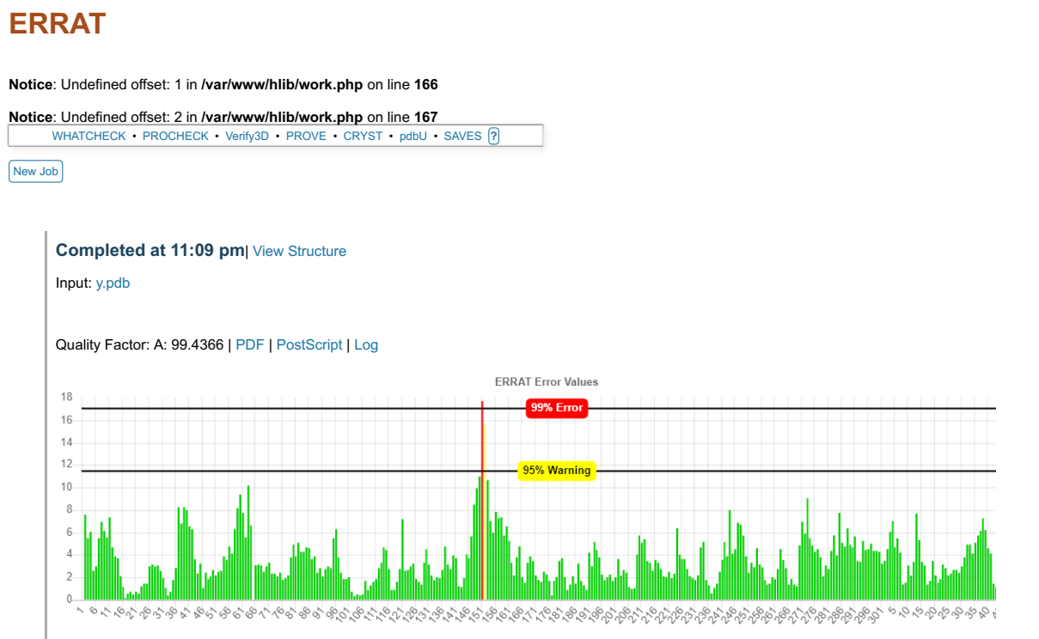
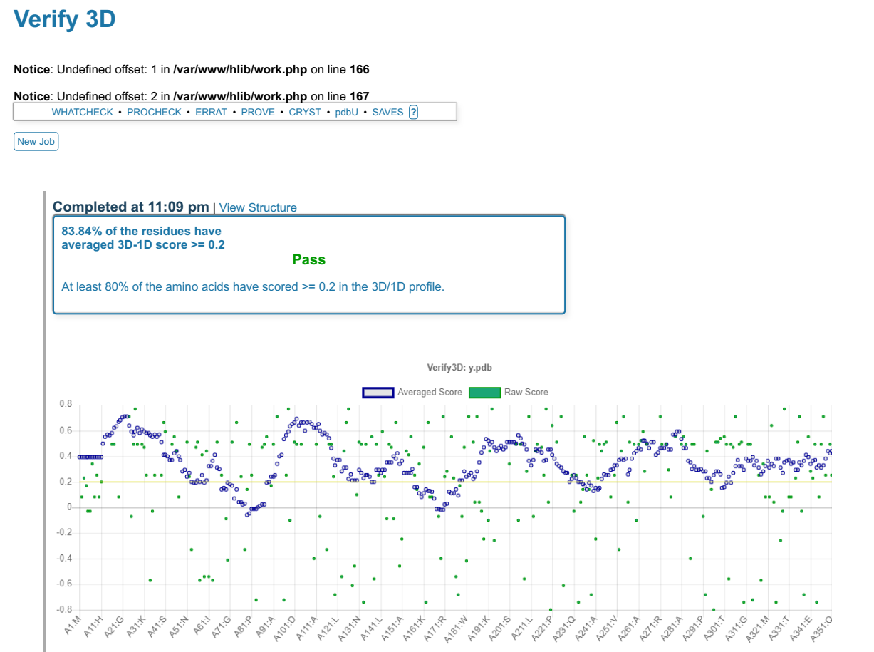

Model evaluation score of MurG structure using PROCHECK, ERRAT, and Verify_3D after energy minimization

Figure 6. Interactions of MurG with Ligands
(a)
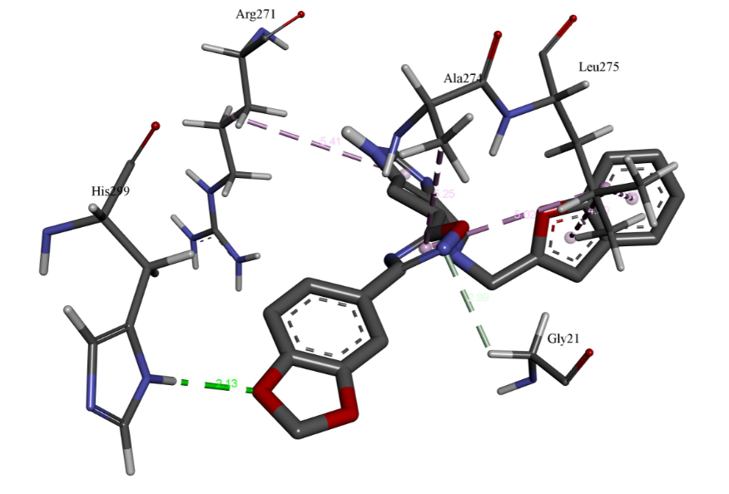
(b) (c)
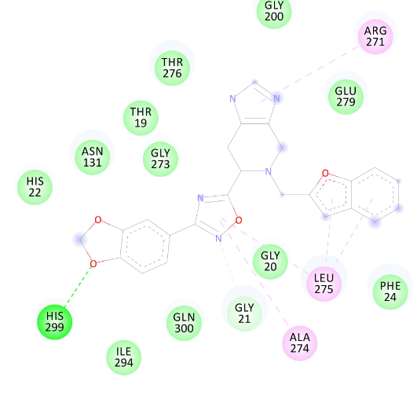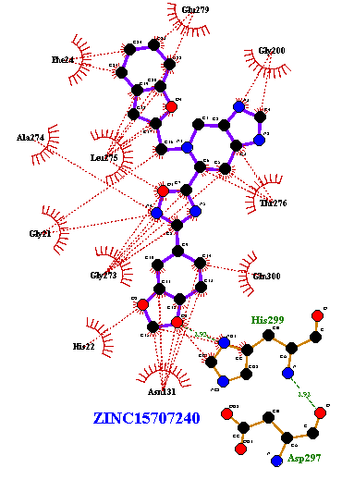
Interactions of ligand ZINC15707240 to the MurG (a) three-dimensional orientation of catalytic site residues of MurG interacting with compound ZINC15707240 (sliver) through hydrogen bond (green bond color) and pi-interaction (pinkish bond color) (b) two-dimensional representation of MurG residues (slightly green without bond formation) interacting with ligand ZINC15707240 by van der Waals interactions (c) two-dimensional representation of MurG residues (connected with red lines) interacting with ligand ZINC15707240 via hydrophobic interactions.

(a)
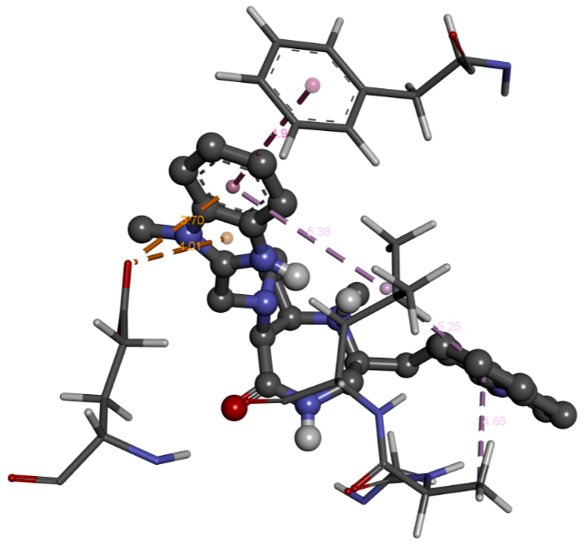
(b) (c)
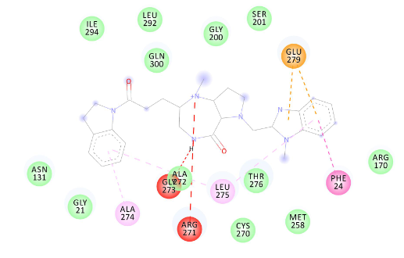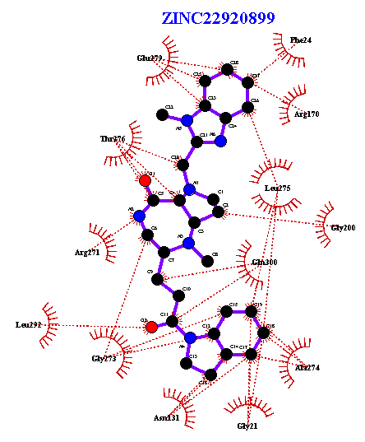
Interactions of ligand ZINC22920899 to the MurG (a) three-dimensional orientation of catalytic site residues of MurG interacting with compound ZINC22920899 (sliver) through pi-interaction (b) two-dimensional representation of MurG residues interacting with ligand ZINC22920899 dominated by van der Waals interactions (slightly green color without bond formation) (c) two-dimensional representation of MurG residues interacting with ligand ZINC22920899 via hydrophobic interactions.

(a)
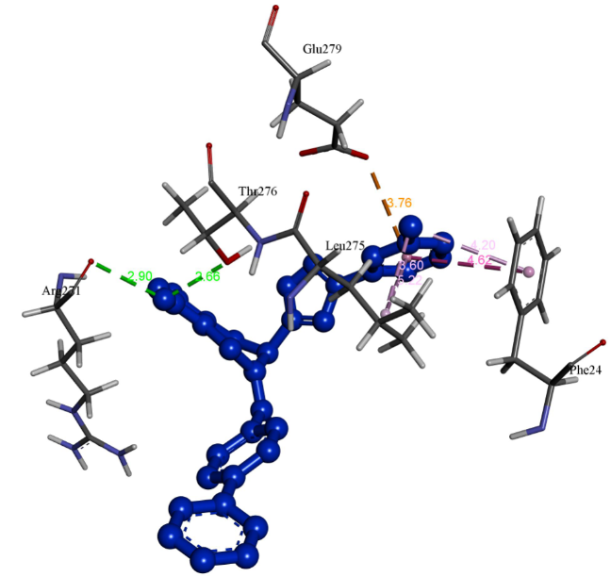
(b) (c)
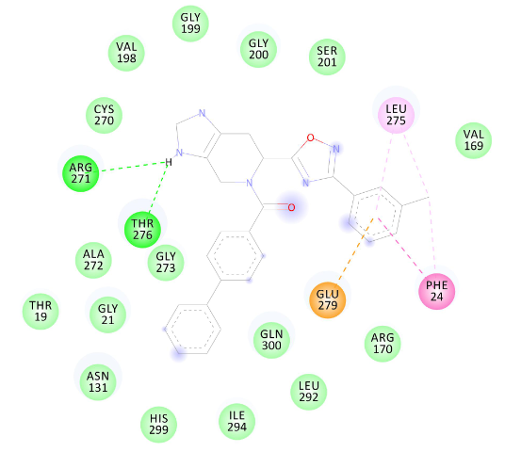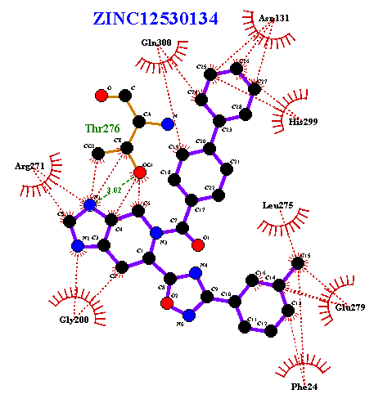
Interactions of ligand ZINC12530134 to the MurG (a) three-dimensional orientation of catalytic site residues of MurG interacting with compound ZINC12530134 (blue) through hydrogen bond (green bond color) and pi-interaction (pinkish bond color) (b) two-dimensional representation of MurG residues (slightly green color without bond formation) interacting with ligand ZINC12530134 by van der Waals interactions (c) two-dimensional representation of MurG residues (connected with red lines) interacting with ligand ZINC12530134 via hydrophobic interactions.
(a)
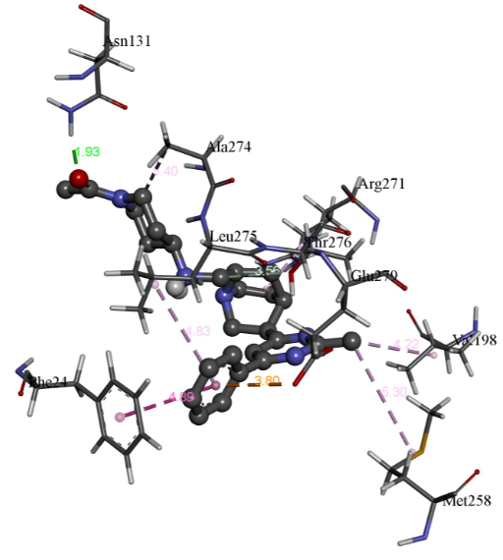
(b) (c)
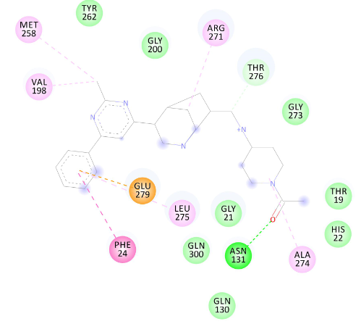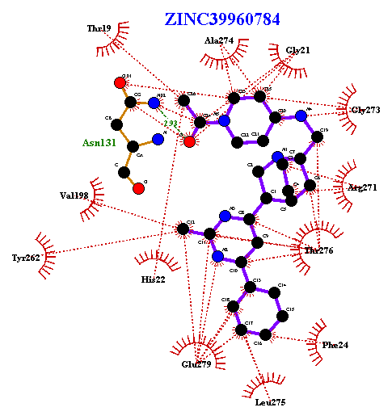
Interactions of ligand ZINC39960784 to the MurG (a) three-dimensional orientation of catalytic site residues of MurG interacting with compound ZINC39960784 (sliver) through hydrogen bond (green bond color) and pi-interaction (pinkish bond color) (b) two-dimensional representation of MurG residues (slightly green color without bond formation) interacting with ligand ZINC39960784 by van der Waals interactions (c) two-dimensional representation of MurG residues (connected with red lines) interacting with ligand ZINC39960784 via hydrophobic interactions.
(a)
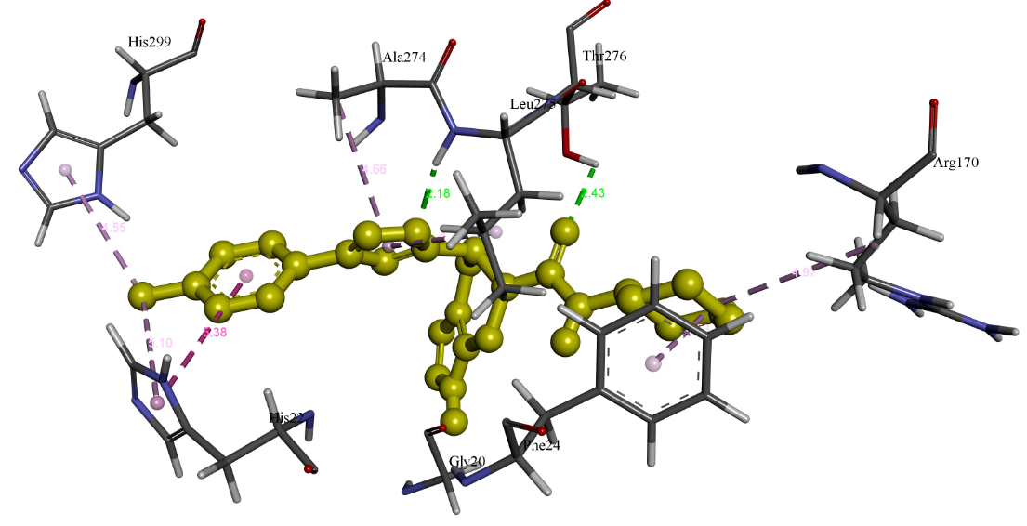
(b) (c)
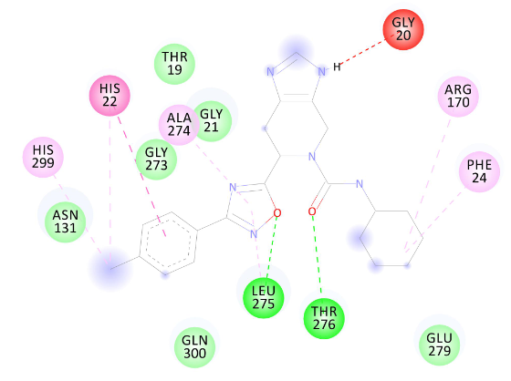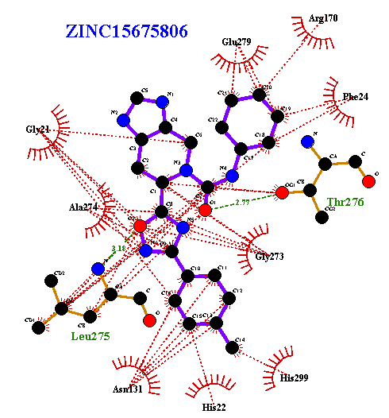

Interactions of ligand ZINC15675806 to the MurG (a) three-dimensional orientation of catalytic site residues of MurG interacting with compound ZINC15675806 (yellowish) through hydrogen bond (green bond color) and pi-interaction (pinkish bond color) (b) two-dimensional representation of MurG residues (slightly green color without bond formation) interacting with ligand ZINC15675806 by van der Waals interactions (c) two-dimensional representation of MurG residues (connected with red lines) interacting with ligand ZINC15675806 via hydrophobic interactions.
(a)
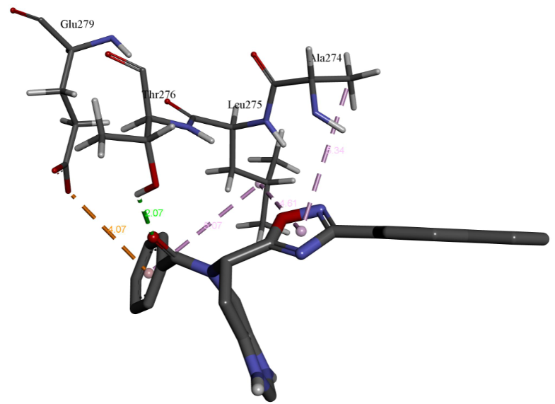
(b) (c)
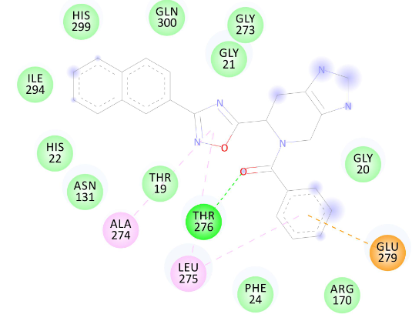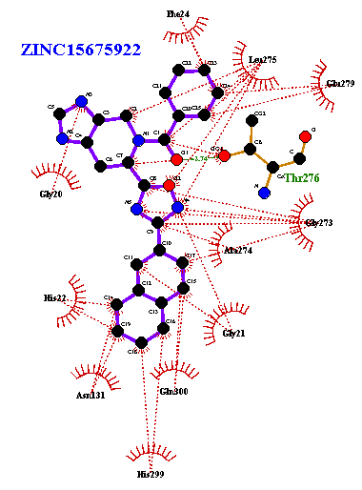
Interactions of ligand ZINC15675922 to the MurG (a) three-dimensional orientation of catalytic site residues of MurG interacting with compound ZINC15675922 (slivery) through hydrogen bond (green bond color) and pi-interaction (pinkish bond color) (b) two-dimensional representation of MurG residues (slightly green color without bond formation) interacting with ligand ZINC15675922 by van der Waals interactions (c) two-dimensional representation of MurG residues (connected with red lines) interacting with ligand ZINC15675922 via hydrophobic interactions.
(a)
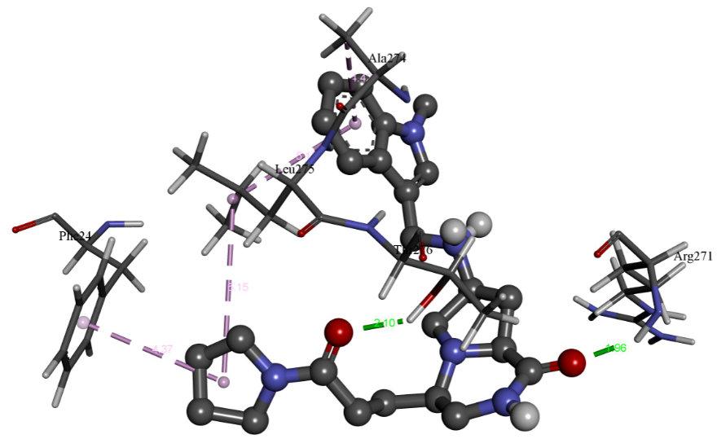
(b) (c)
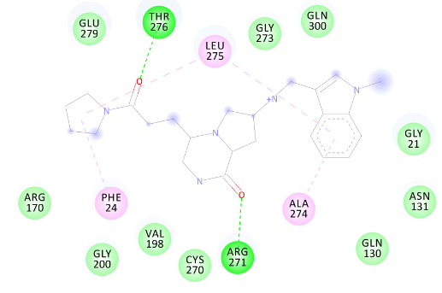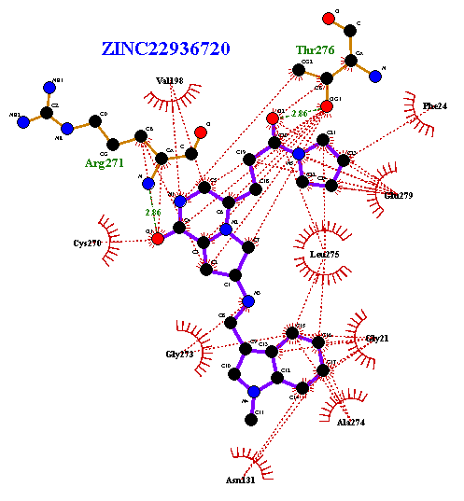
Interactions of ligand ZINC22936720 to the MurG (a) three-dimensional orientation of catalytic site residues of MurG interacting with compound ZINC22936720 (slivery) through hydrogen bond (green bond color) and pi-interaction (pinkish bond color) (b) two-dimensional representation of MurG residues (slightly green color without bond formation) interacting with ligand ZINC22936720 by van der Waals interactions (c) two-dimensional representation of MurG residues (connected with red lines) interacting with ligand ZINC22936720 via hydrophobic interactions.
(a)
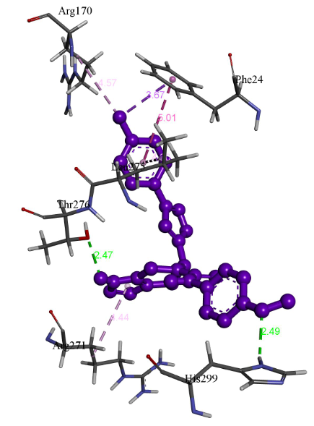
(b) (c)
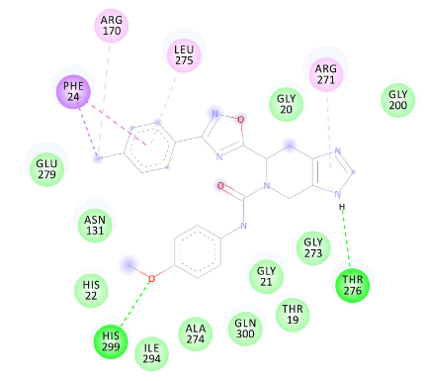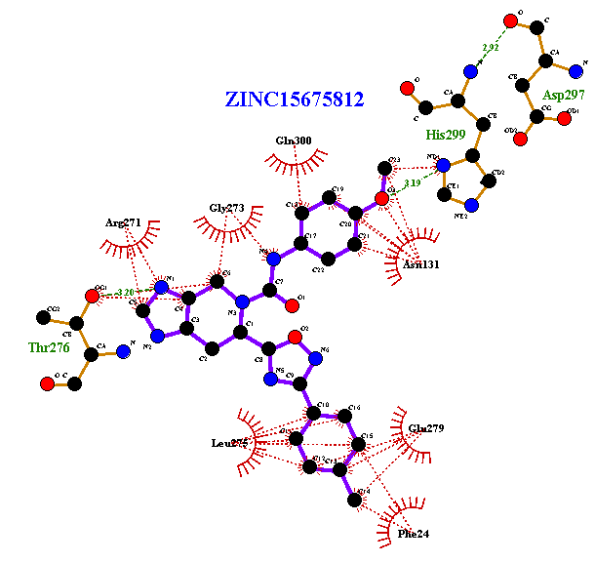
Interactions of ligand ZINC15675812 to the MurG (a) three-dimensional orientation of catalytic site residues of MurG interacting with compound ZINC15675812 (purple) through hydrogen bond (green bond color) and pi-interaction (pinkish bond color) (b) two-dimensional representation of MurG residues (slightly green color without bond formation) interacting with ligand ZINC15675812 by van der Waals interactions (c) two-dimensional representation of MurG residues (connected with red lines) interacting with ligand ZINC15675812 via hydrophobic interactions.

Figure 7. Pairwise Structure alignment obtained from FATCAT webserver using Flexible approach.

Align pdb1.pdb 365 with pdb2.pdb 351
P-value 0.00e+00 Afp-num 42510 Identity 43.54% Similarity 60.67%
Block 0 afp 42 score 977.92 rmsd 0.77 gap 16 (0.05%)

. : . : . : . : . : . : . :
Chain 1: 10 KHVMMMAAGTGGHVFPALAVAKQLQQQGCQVSWLATPTGMENRLLKDQNIPIYQIDIQGVRGNGVIRKLA
1111111111111111111111111111111111111111111111111111111111111111111111
Chain 2: 7 KRLMVMAGGTGGHVFPGLAVAHHLMAQGWQVRWLGTADRMEADLVPKHGIEIDFIRISGLRGKGIKALIA

. : . : . : . : . : . : . :
Chain 1: 80 APFKILKATFSAMRYMKQLKVDAVAGFGGYVAGPGGLAARLLGIPVLIHEQNAVAGFTNAQLSRVAKVVC
1111111111111111111111111111111111111111111111111111111111111111111111
Chain 2: 77 APLRIFNAWRQARAIMKAYKPDVVLGMGGYVSGPGGLAAWSLGIPVVLHEQNGIAGLTNKWLAKIATKVM

. : . : . : . : . : . : . :
Chain 1: 150 EAFPNTFPASEKVVTTGNPVRREITDILSPKWRYDEREQAGKPLNILIVGGSLGAKALNERLPPALKQLE
11111111 11111 1111111111111111111111 11111111111111111111111111111
Chain 2: 147 QAFPGAFP-NAEVV--GNPVRTDVLALPLPQQRLAGRE---GPVRVLVVGGSQGARILNQTMPQVAAKLG

. : . : . : . : . : . : . :
Chain 1: 220 VPLNIFHQCGQQQVEATQALYADAPANLTVQVLPFIEDMAKAYSEADLIICRAGALTVTEVATAGVAAVF
111111111111111111111111111 111111111111111111111111111111111111111111
Chain 2: 211 DSVTIWHQSGKGSQQSVEQAYAEAGQP-QHKVTEFIDDMAAAYAWADVVVCRSGALTVSEIAAAGLPALF

. : . : . : . : . : . : . :
Chain 1: 290 VPLPIAVDDHQTANAKFLADVGAAKICQQSTMTPEVLNQLFTTLMNRQLLTEMAVKARQHAQPNATQHVV
111111 1111111111111111111111111111111111111 1111111111111111111111111
Chain 2: 280 VPFQHK-DRQQYWNALPLEKAGAAKIIEQPQLSVDAVANTLAGW-SRETLLTMAERARAASIPDATERVA

.
Chain 1: 360 DLIQKM
111111
Chain 2: 348 NEVSRV

The pairwise structure alignment of MurG model structure and its template (1F0K) structure
Figure 8. Hydrophobic interaction of top four selected ligands with MurG model structure
a b

C d

Two-dimensional representation of MurG interacting with ligand ZINC09186673, ZINC08856120, ZINC08439415 and ZINC08857096 mainly via hydrophobic interactions. Hydrophobic contacts are represented by red arc with spokes radiating towards the ligand atoms they contact. The contacted atoms are shown with spokes radiating back.

