Synthesis of Multifunctional Copolymers of Poly(methylphenylsilane) with (R)-N-(1-phenylethyl)methacrylamide, Disperse Red 1 Methacrylate and Their Optical and Photoluminescence Properties
Km. Meenu¹, Dibyendu S. Bag², Rekha Lagarkha³, Radha Tomar⁴ and, Arvind Kumar Gupta⁵
^{1, 2}Defence Material and Stores Research and Development Establishment (DMSRDE) P. O., G. T. Road, Kanpur-208013, INDIA
³Department of Chemistry Bundelkhand University Jhansi-284128, INDIA
⁴SOS in Chemistry, Jiwaji University, Gwalior-474011, INDIA
⁵Defence Research and Development Establishment (DRDE), Gwalior-474001, INDIA
Email: singhmeenu458@gmail.com
Supplemental Materials

Figure 1: FTIR spectra of multifunctional chiral and photoactive polysilane copolymers

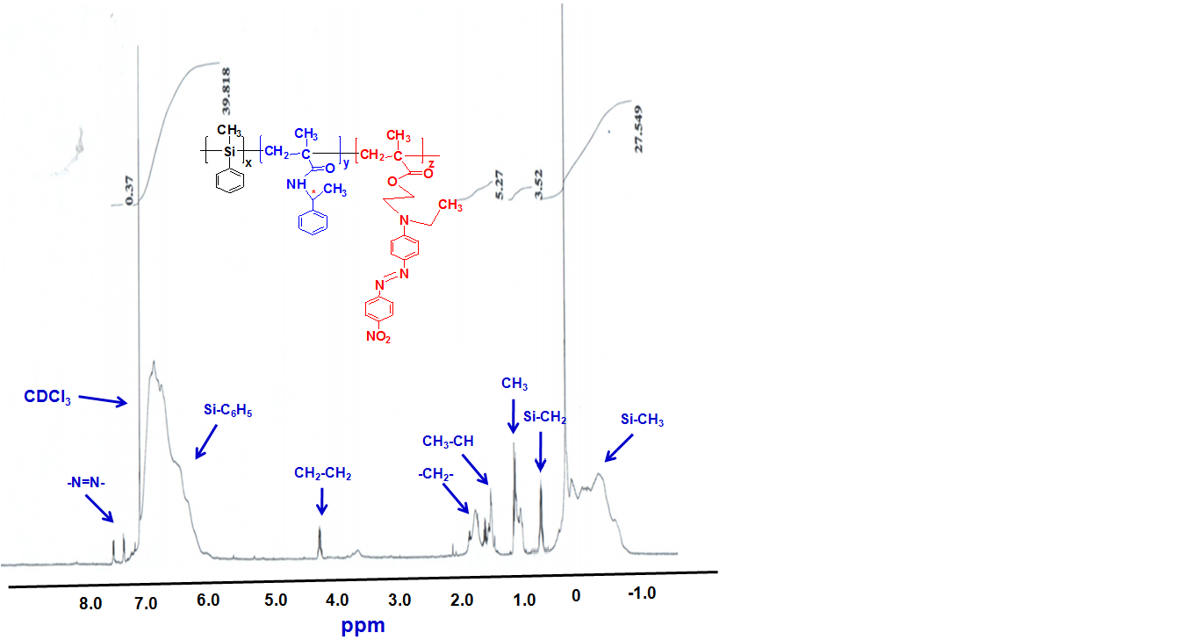
Figure 2: NMR analysis of multifunctional polysilane (SCDRDM-2B)
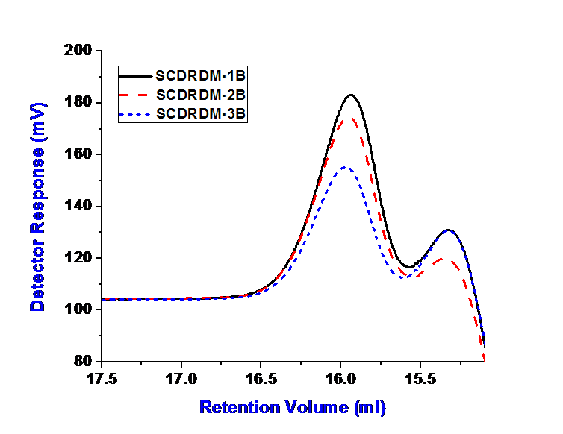

Figure S 3: Combined GPC chromatograms of SCDRDM copolymers

Figure 4: Temperature versus electronic absorbance

Figure S 5: Temperature versus electronic absorption (at 330 nm due to Si-Si bond)

Figure S 6: Temperature versus electronic absorption (at 475 nm due to –N=N- group)

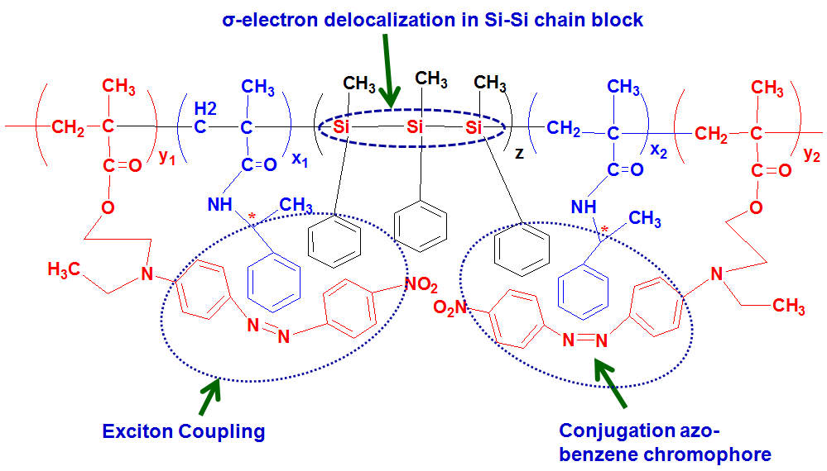
Scheme S 1: Plausible interaction of functional moieties in synthesized functional polysilanes (SCDRDM)

