Supporting Information

A series of Wells-Dawson and Keggin-based compounds with uncoordinated S donors as fluorescence sensors to Hg²⁺

JUN YING, YA-GUGANG CHEN and XIU-YAN WANG

Table S1. CAT% data of n-CPE (n = 1, 3, 4) for reduction of NO₂⁻, H₂O₂, BrO₃⁻ and AA.
CAT%  Substrate |  | 1−CPE | 3−CPE | 4−CPE
NO₂⁻ | 2 mM | 320 | 82 | 57
 | 4 mM | 489 | 117 | 143
 | 6 mM | 639 | 187 | 234
 | 8 mM | 770 | 251 | 433
 | 10 mM | 881 | 308 | 593
H₂O₂ | 2 mM | 11 | 168 | 19
 | 4 mM | 27 | 271 | 42
 | 6 mM | 35 | 362. | 67
 | 8 mM | 47 | 476. | 89
 | 10 mM | 56 | 573 | 108
BrO₃⁻ | 2 mM | 25 | 65 | 26
 | 4 mM | 59 | 217 | 64
 | 6 mM | 93 | 313 | 136
 | 8 mM | 127 | 374 | 204
 | 10 mM | 156 | 429 | 250
AA | 2 mM | 328 | 2130 | 37
 | 4 mM | 1410 | 3670 | 68
 | 6 mM | 2220 | 4730 | 93
 | 8 mM | 2990 | 6420 | 112
 | 10 mM | 3770 | 7830 | 138

Table S2. The analytical data for 1–, 3– and 4–CPE as amperometric sensors.
 | Response time (s) | Concentration range (mM) | Sensitivity  (μA mM^{–1}) | Correlation coefficient | Detection limit (M)
Potassium nitrite
1–CPE | 3.3 | 0.012–0.092 | 14.19 | 0.9730 | 2.6×10^{–5}
3–CPE | 2.3 | 0.016–0.092 | 26.54 | 0.9792 | 3.3×10^{–5}
4–CPE | 1.6 | 0.008–0.092 | 1.26 | 0.9937 | 2.2×10^{–5}

Table S3. Selected bond distances (Å) and angles (°) for 1-4.
Compound 1
Zn1-N6 | 2.185(14) | Zn1-N4 | 2.249(15)
Zn1-N3 | 2.147(13) | Zn1-N1 | 2.217(8)
Zn1-N5 | 2.247(15) | Zn1-N2 | 2.189(19)
Zn2-O1W | 2.017(12) | Zn2-N7 | 2.091(15)
Zn2-N10 | 2.210(12) | Zn2-N8 | 2.183(14)
Zn2-N9 | 2.066(13) | Zn3-N14 | 2.051(13)
Zn3-N11 | 2.130(14) | Zn3-N13 | 2.125(14)
Zn3-O2W | 2.039(12) | Zn3-N12 | 2.078(14)
N6-Zn1-N4 | 95.0(6) | N3-Zn1-N5 | 94.4(5)
O1W-Zn2-N7 | 126.0(6) | N10-Zn2-N8 | 171.9(5)
N11-Zn3-N13 | 169.5(5) | N11-Zn3-O2W | 89.3(5)
Compound 2
Cd1-O1W | 2.263(16) | Cd1-N4 | 2.30(2)
Cd1-N3 | 2.31(2) | Cd1-N2 | 2.37(3)
Cd1-O6 | 2.507(17) | N1-Cd1 | 2.33(2)
O2W-Cd2 | 2.248(17) | Cd2-N5 | 2.219(18)
Cd2-N7 | 2.25(2) | Cd2-N6 | 2.32(2)
Cd2-N8 | 2.38(2) | Cd3-N12 | 2.32(2)
Cd3-N10 | 2.34(2) | Cd3-N13 | 2.35(2)
Cd3-N14 | 2.39(3) | Cd3-N11 | 2.43(2)
Cd3-N9 | 2.45(2) | N4-Cd1-N1 | 176.3(8)
N3-Cd1-N1 | 103.8(7) | O1W-Cd1-N2 | 165.5(8)
N7-Cd2-O2W | 129.3(8) | N5-Cd2-N6 | 75.8(7)
N7-Cd2-N6 | 109.2(7) | N12-Cd3-N10 | 164.5(7)
N12-Cd3-N13 | 96.2(7) | N10-Cd3-N13 | 97.1(8)
Compound 3
Cd1-N4 | 2.258(13) | Cd1-N1 | 2.322(13)
Cd1-N2 | 2.355(12) | Cd1-N3 | 2.388(13)
Cd1-Cl1 | 2.504(5) | Cd1-O22 | 2.599(11)
Cd2-N5 | 2.292(12) | Cd2-N8 | 2.293(13)
Cd2-N7 | 2.310(12) | Cd2-N6 | 2.362(13)
Cl1-Cd2 | 2.542(5) | O40-Cd2 | 2.670(11)
N1-Cd1-N2 | 73.2(4) | N1-Cd1-N3 | 166.1(4)
N4-Cd1-Cl1 | 146.7(4) | Cl1-Cd1-O22 | 74.6(3)
N5-Cd2-N8 | 110.2(5) | N5-Cd2-N6 | 74.5(5)
N5-Cd2-Cl1 | 85.2(4) | N6-Cd2-Cl1 | 113.2(4)
Compound 4
O6-Cd1 | 2.30(2) | Cd1-N1 | 2.29(2)
Cd1-N2 | 2.30(2) | Cd1-N3 | 2.30(3)
Cd1-N4 | 2.41(3) | Cd1-O3 | 2.48(2)
N1-Cd1-N2 | 76.1(8) | N1-Cd1-O6 | 95.4(8)
N2-Cd1-O6 | 160.9(8) | N1-Cd1-N3 | 166.4(9)
N2-Cd1-N3 | 100.4(8) | O6-Cd1-N3 | 91.6(8)
N1-Cd1-N4 | 93.0(9) | N2-Cd1-N4 | 87.3(8)
O6-Cd1-N4 | 110.4(8) | N3-Cd1-N4 | 73.6(9)

Table S4. SHAPE² analysis of different coordinate geometries in 1-4.
Compound 1
Zn1
HP  (D6h) |  | PPY  (C5v) | OC  (Oh) |  |  | TPR  (D3h) | JPPY  (C5v)
24.960 |  | 26.598 | 1.415 |  |  | 14.873 | 29.228
Zn2
PP  (D5h) |  | vOC  (C4v) | TBPY  (D3h) |  |  | SPY  (C4v) | JTBPY  (D3h)
26.111 |  | 7.120 | 1.912 |  |  | 5.530 | 3.366
Zn3
PP  (D5h) |  | vOC  (C4v) | TBPY  (D3h) |  |  | SPY  (C4v) | JTBPY  (D3h)
25.666 |  | 2.069 | 4.467 |  |  | 1.920 | 6.429
Compound 2
Cd1
HP  (D6h) |  | PPY  (C5v) | OC  (Oh) |  |  | TPR  (D3h) | JPPY  (C5v)
26.570 |  | 24.541 | 2.317 |  |  | 14.168 | 27.169
Cd2
PP  (D5h) |  | vOC  (C4v) | TBPY  (D3h) |  |  | SPY  (C4v) | JTBPY  (D3h)
24.568 |  | 6.906 | 2.420 |  |  | 5.823 | 4.390
Cd3
HP  (D6h) | PPY  (C5v) |  |  | OC  (Oh) | TPR  (D3h) |  |  | JPPY  (C5v)
24.603 | 25.250 |  |  | 2.325 | 14.215 |  |  | 27.852
Compound 3
Cd1
PP  (D5h) |  | vOC  (C4v) | TBPY  (D3h) |  |  | SPY  (C4v) | JTBPY  (D3h)
25.797 |  | 5.047 | 3.245 |  |  | 5.537 | 5.963
Cd2
PP  (D5h) |  | vOC  (C4v) | TBPY  (D3h) |  |  | SPY  (C4v) | JTBPY  (D3h)
24.881 |  | 5.777 | 2.708 |  |  | 5.329 | 6.081
Compound 4
Cd1
HP  (D6h) |  | PPY  (C5v) | OC  (Oh) |  |  | TPR  (D3h) | JPPY  (C5v)
26.937 |  | 20.706 | 2.475 |  |  | 10.759 | 23.540
The smaller the shape measure, the closer the coordination polyhedron is to the ideal shape. Abbreviations: PP-Pentagon, VOC-Vacant octahedron, TBPY-Trigonal bipyramid, SPY-Spherical square pyramid, JTBPY-Johnson-trigonal bipyramid J12, HP-Hexagon, PPY-Pentagonal pyramid, OC- Octahedron, TPR-Trigonal prism, JPPY-Johnson pentagonal pyramid J2. The bold numbers indicate the best coincidence.

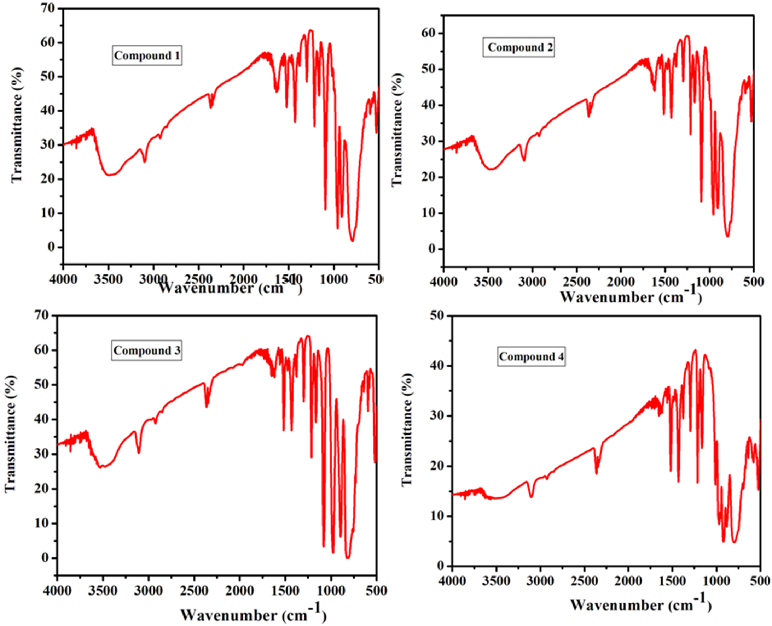
Figure S1. The IR spectra of 1-4.
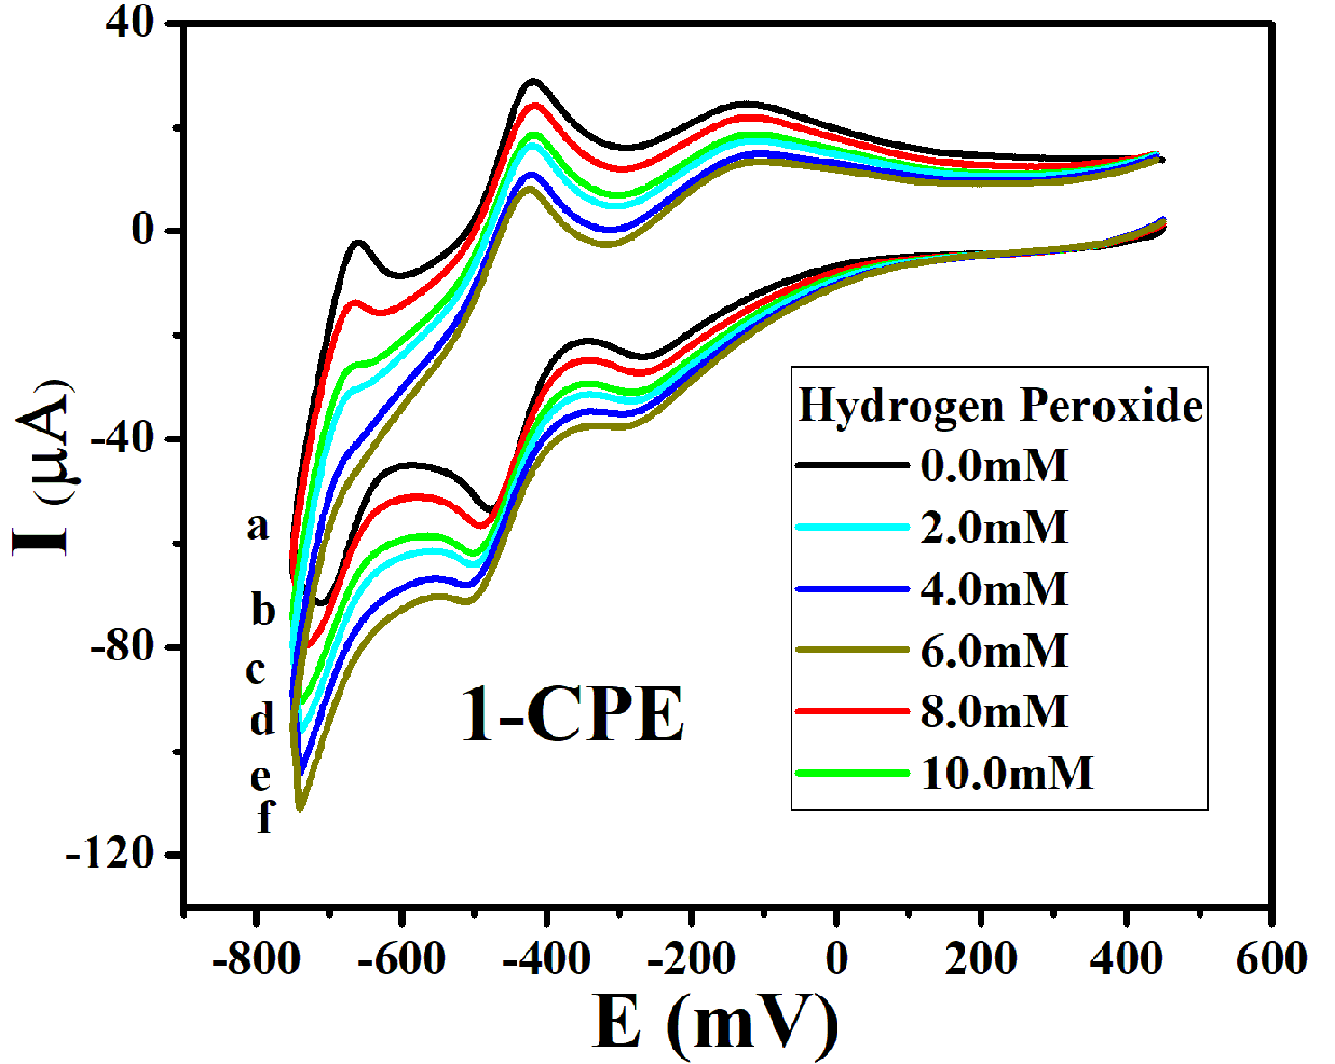
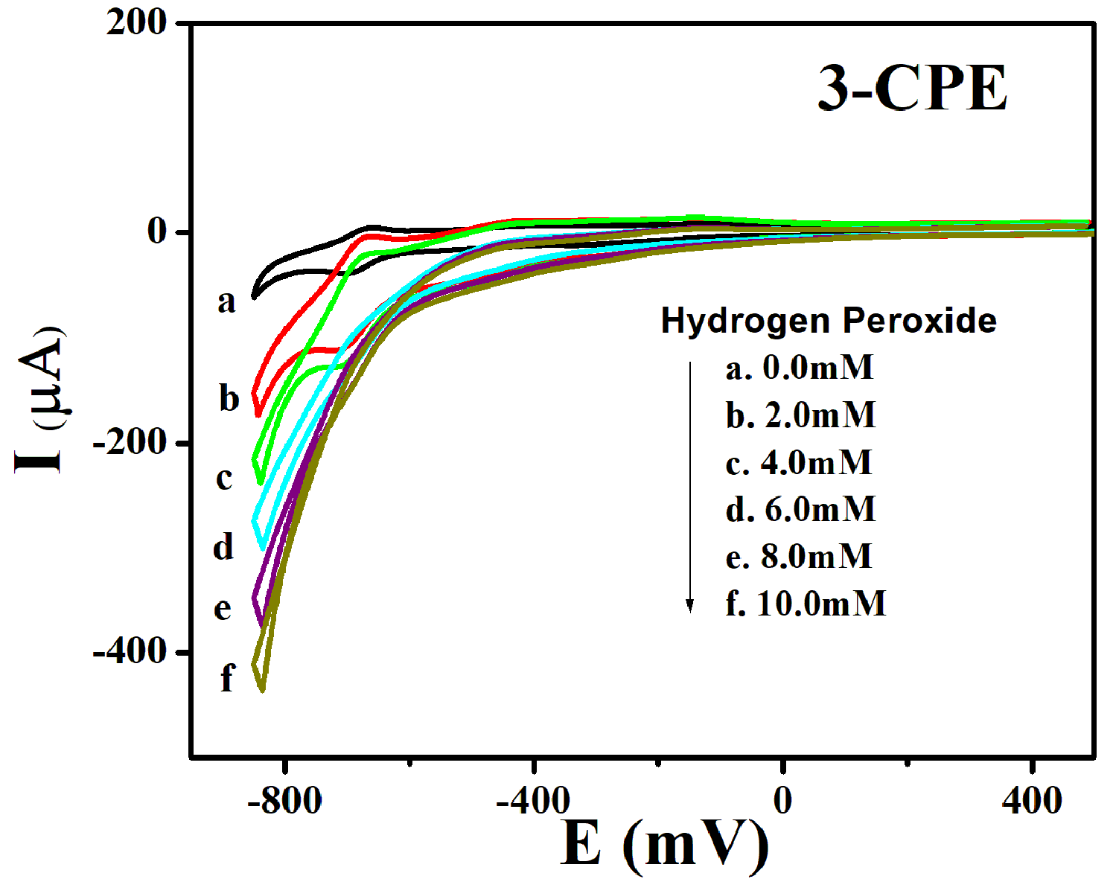
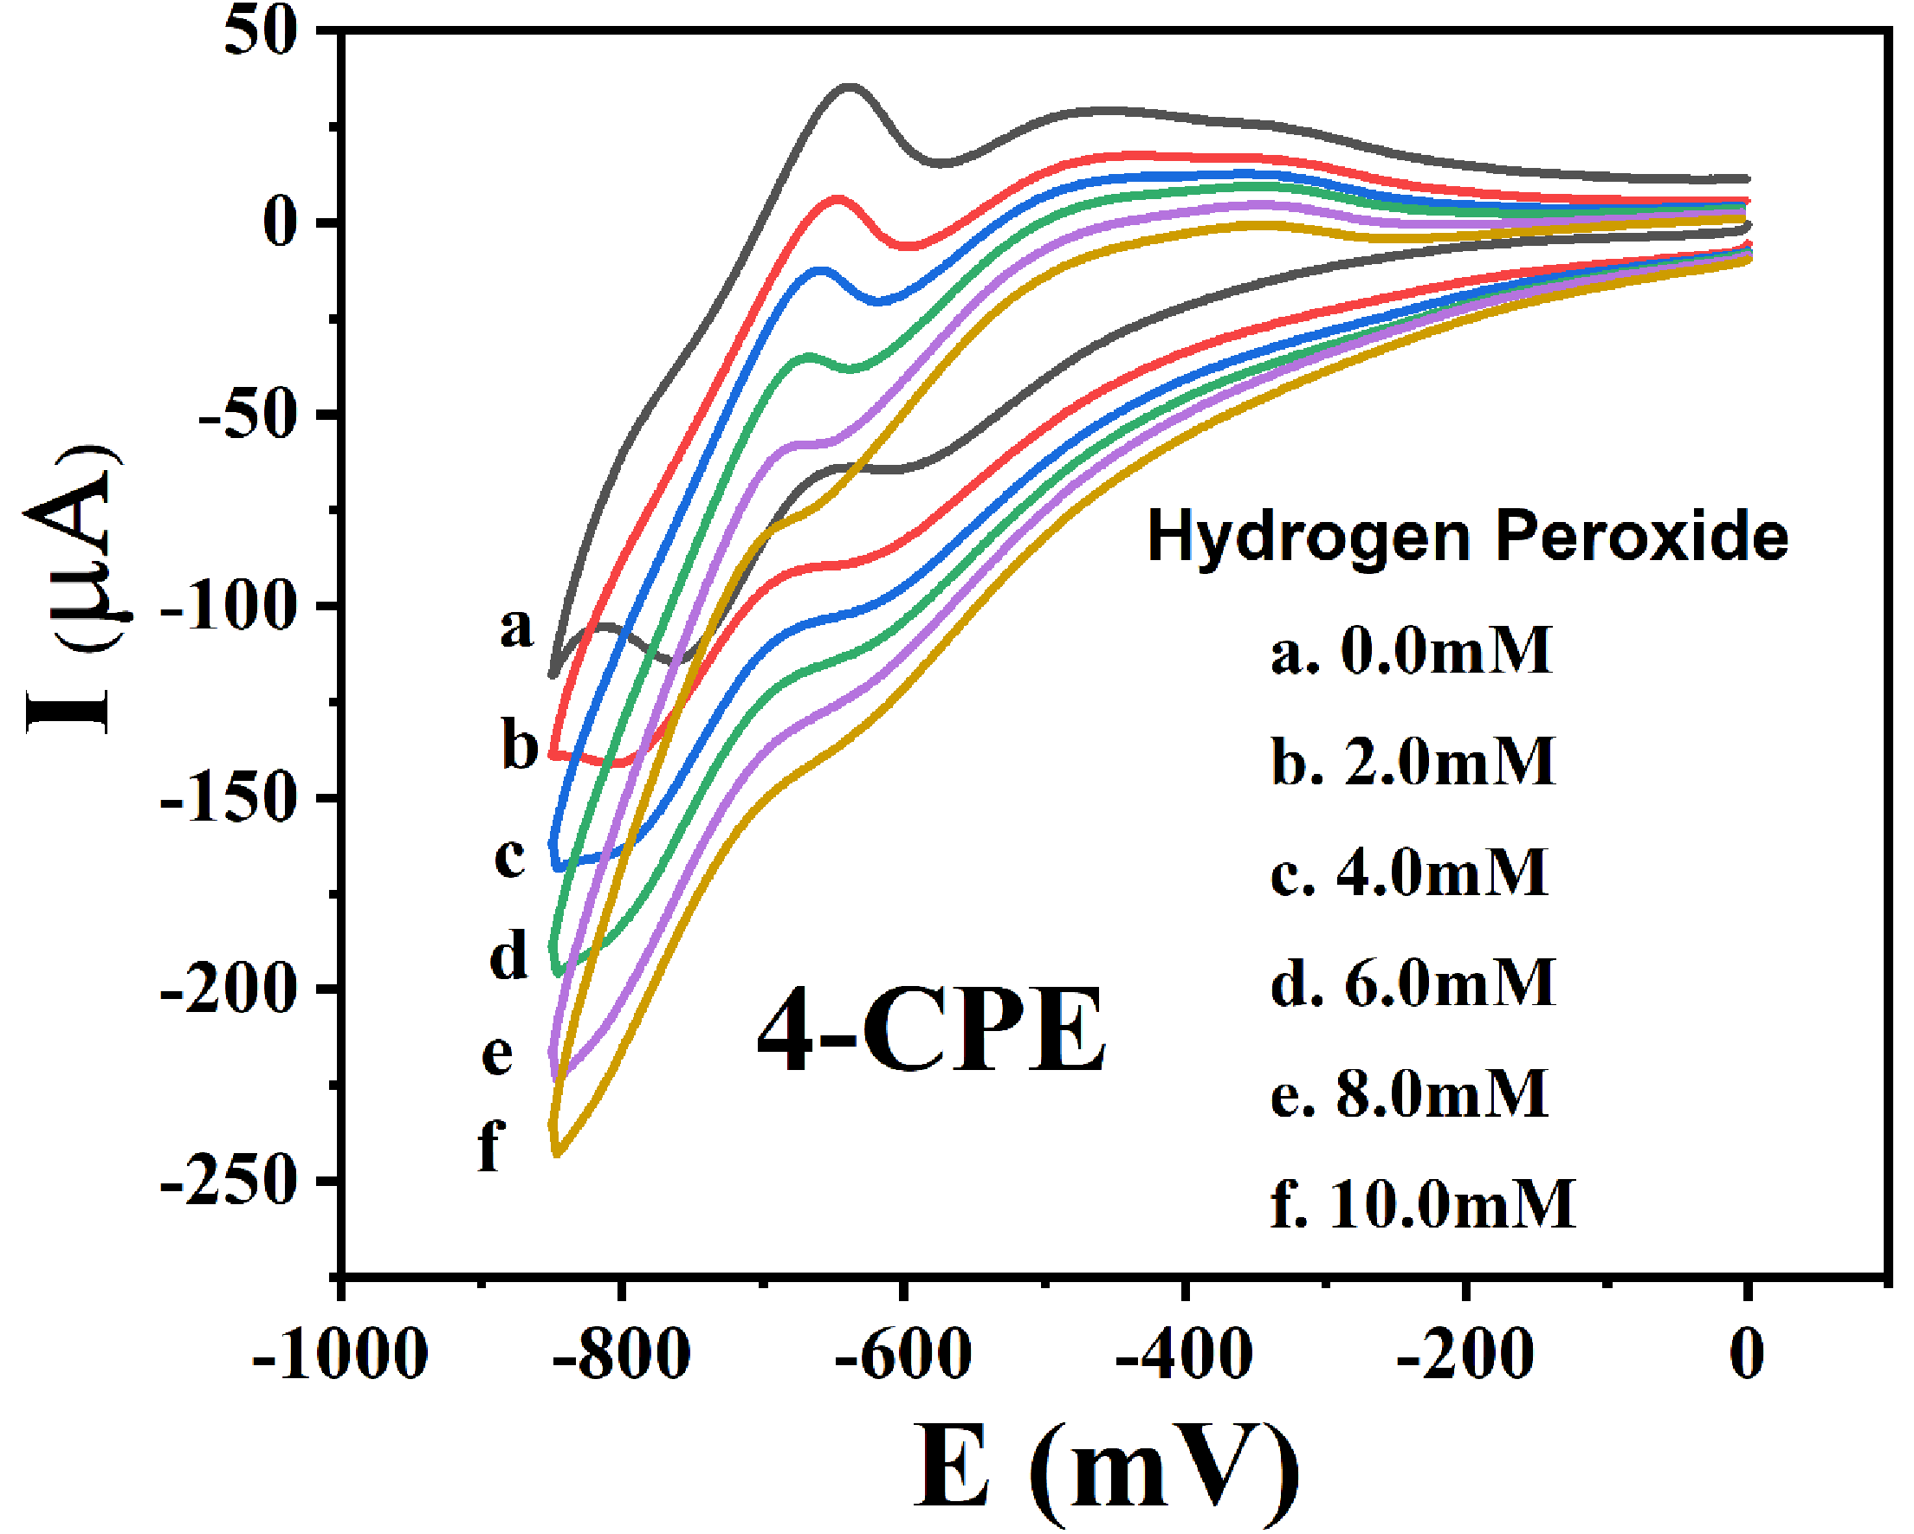
Figure S2. Cyclic voltammograms of 1–, 3– and 4–CPE in 0.1 M H₂SO₄ + 0.5 M Na₂SO₄ aqueous solution containing 0 (a); 2 (b); 4 (c); 6 (d); 8 (e) and 10 (f) mM H₂O₂. Scan rate: 200 mV·s⁻¹.
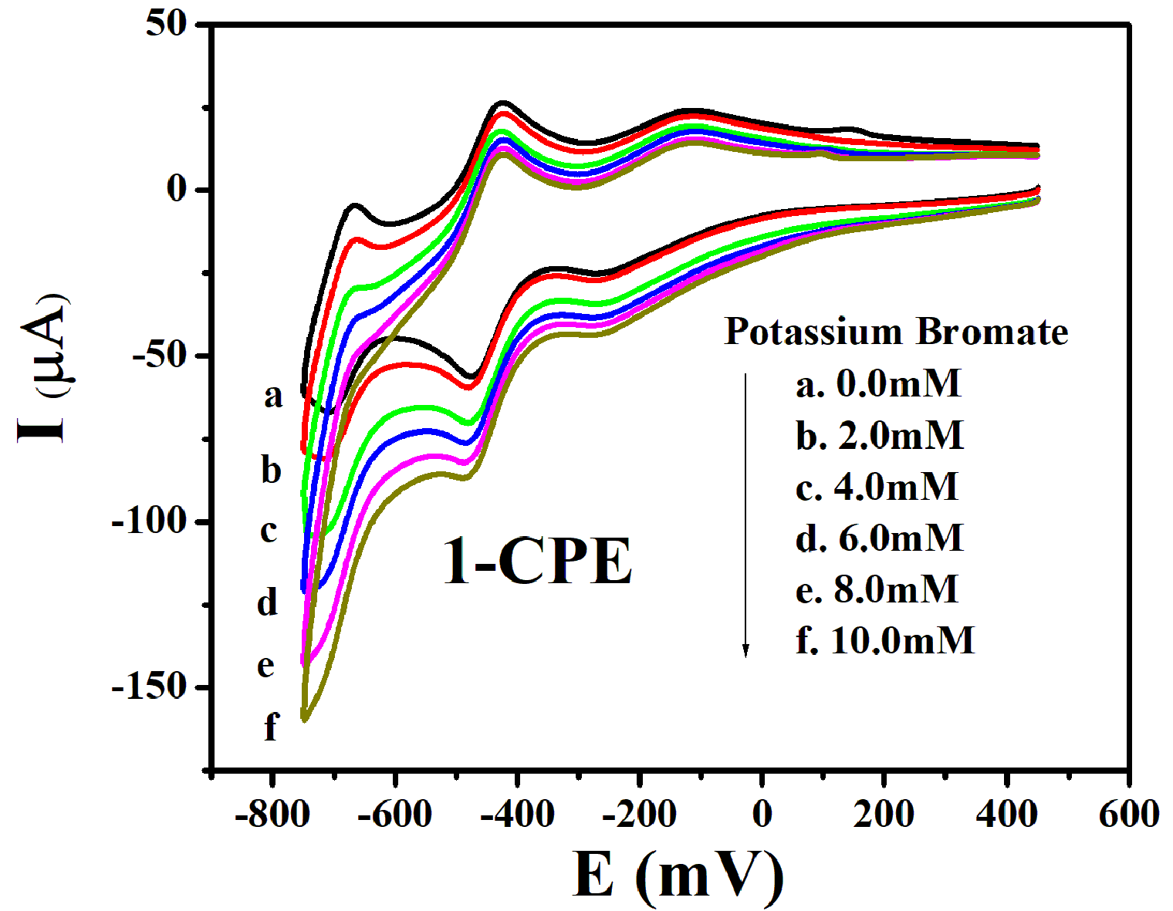
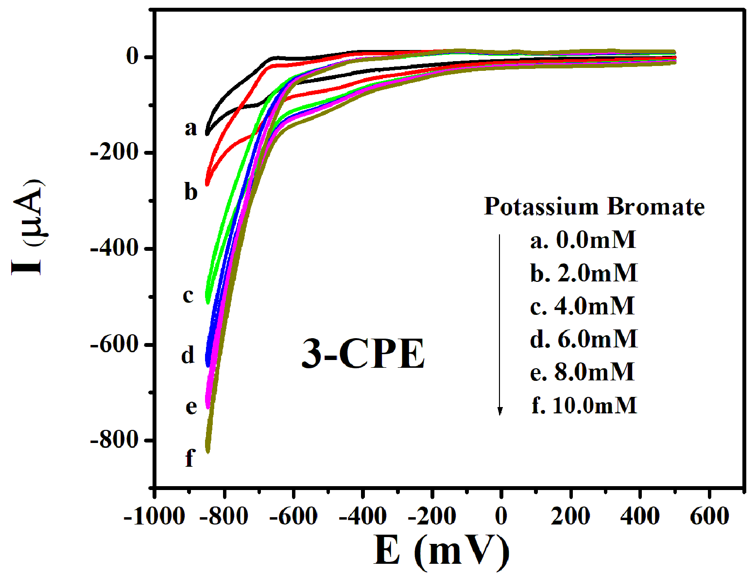
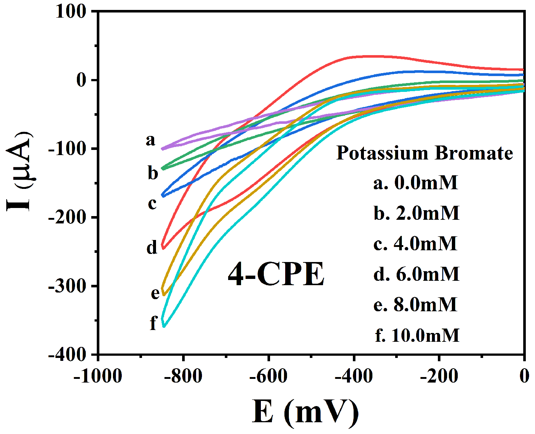
Figure S3. Cyclic voltammograms of 1–, 3– and 4–CPE in 0.1 M H₂SO₄ + 0.5 M Na₂SO₄ aqueous solution containing 0 (a); 2 (b); 4 (c); 6 (d); 8 (e) and 10 (f) mM BrO₃⁻. Scan rate: 200 mV·s⁻¹.

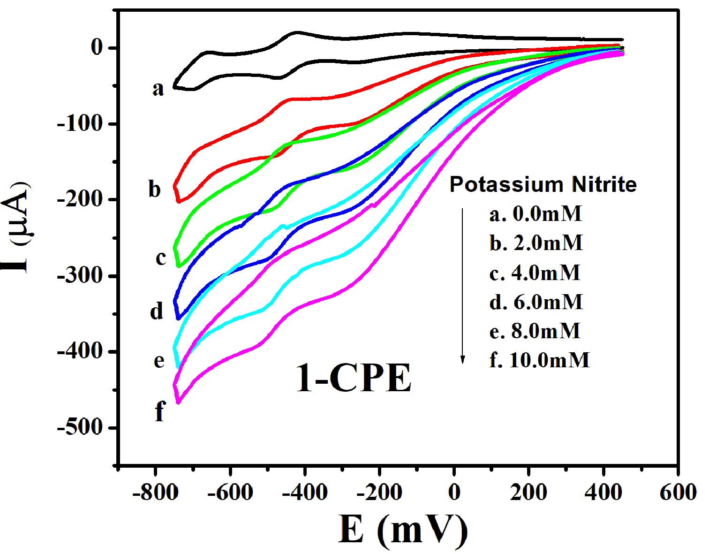
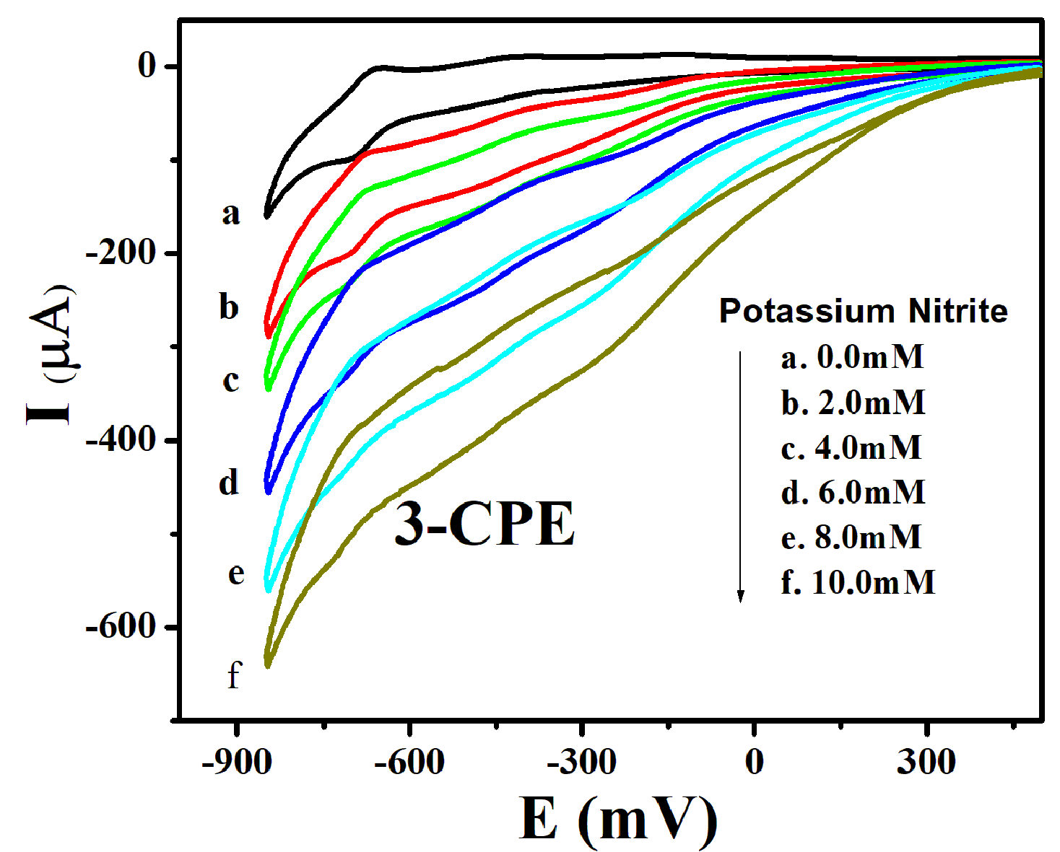
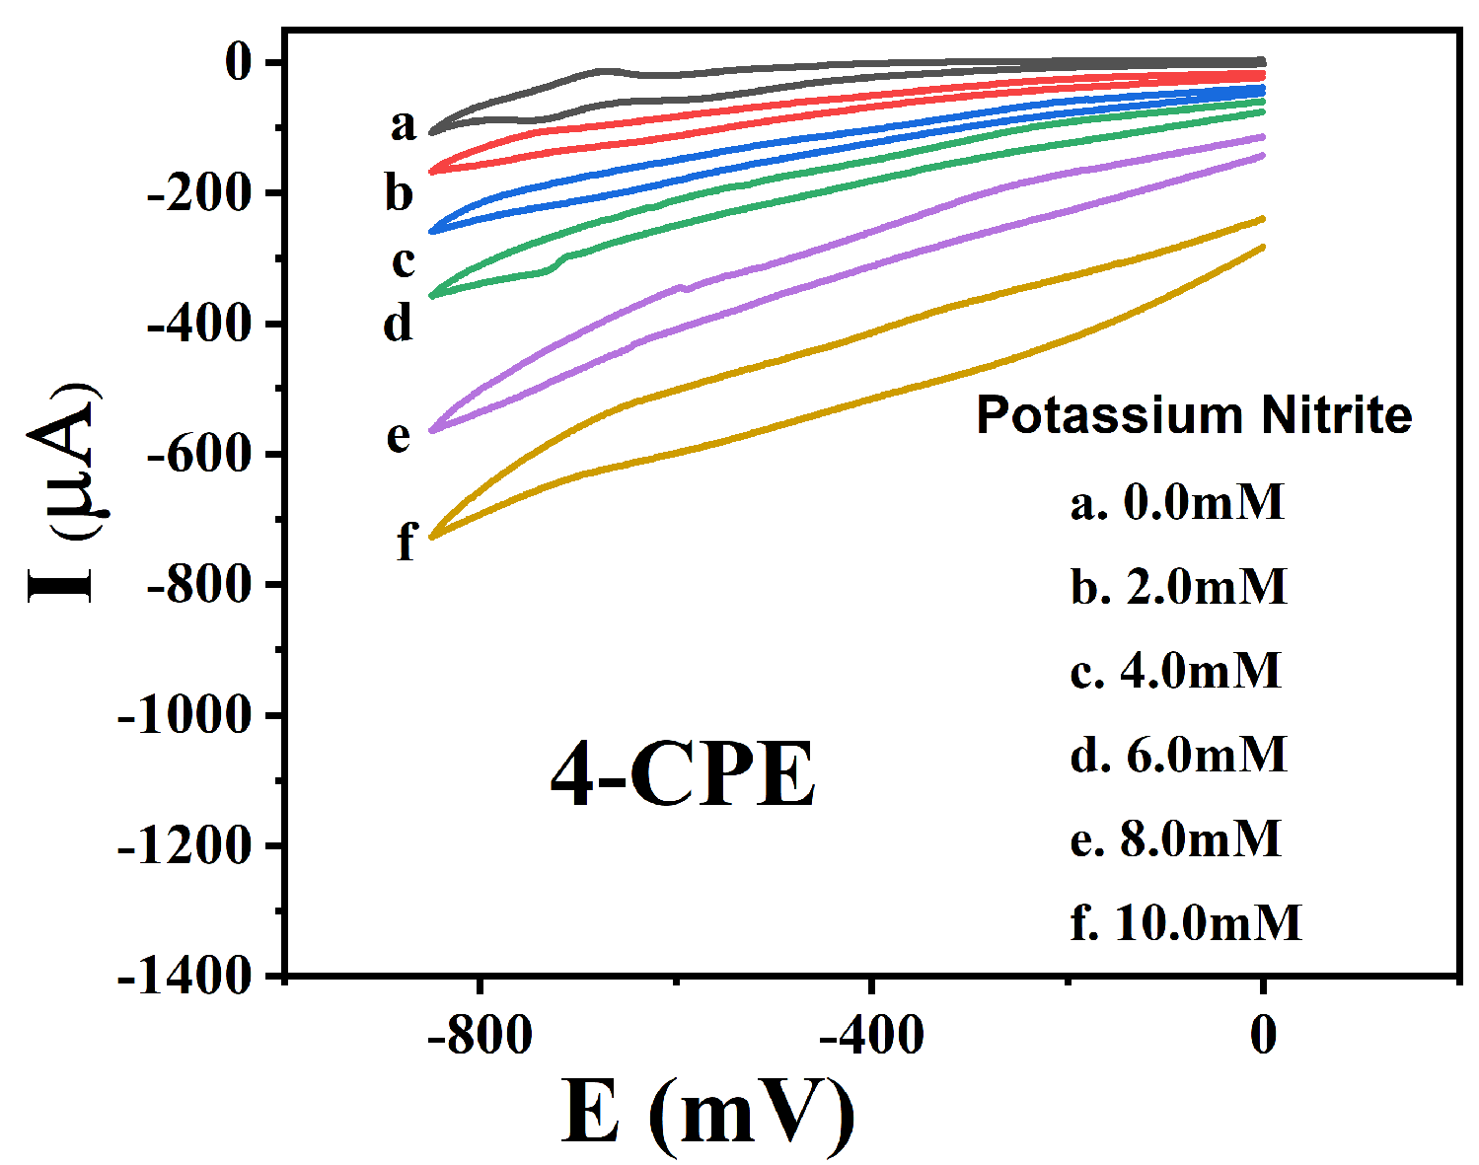
Figure S4. Cyclic voltammograms of 1–, 3– and 4–CPE in 0.1 M H₂SO₄ + 0.5 M Na₂SO₄ aqueous solution containing 0 (a); 2 (b); 4 (c); 6 (d); 8 (e) and 10 (f) mM NO₂⁻. Scan rate: 200 mV·s⁻¹.
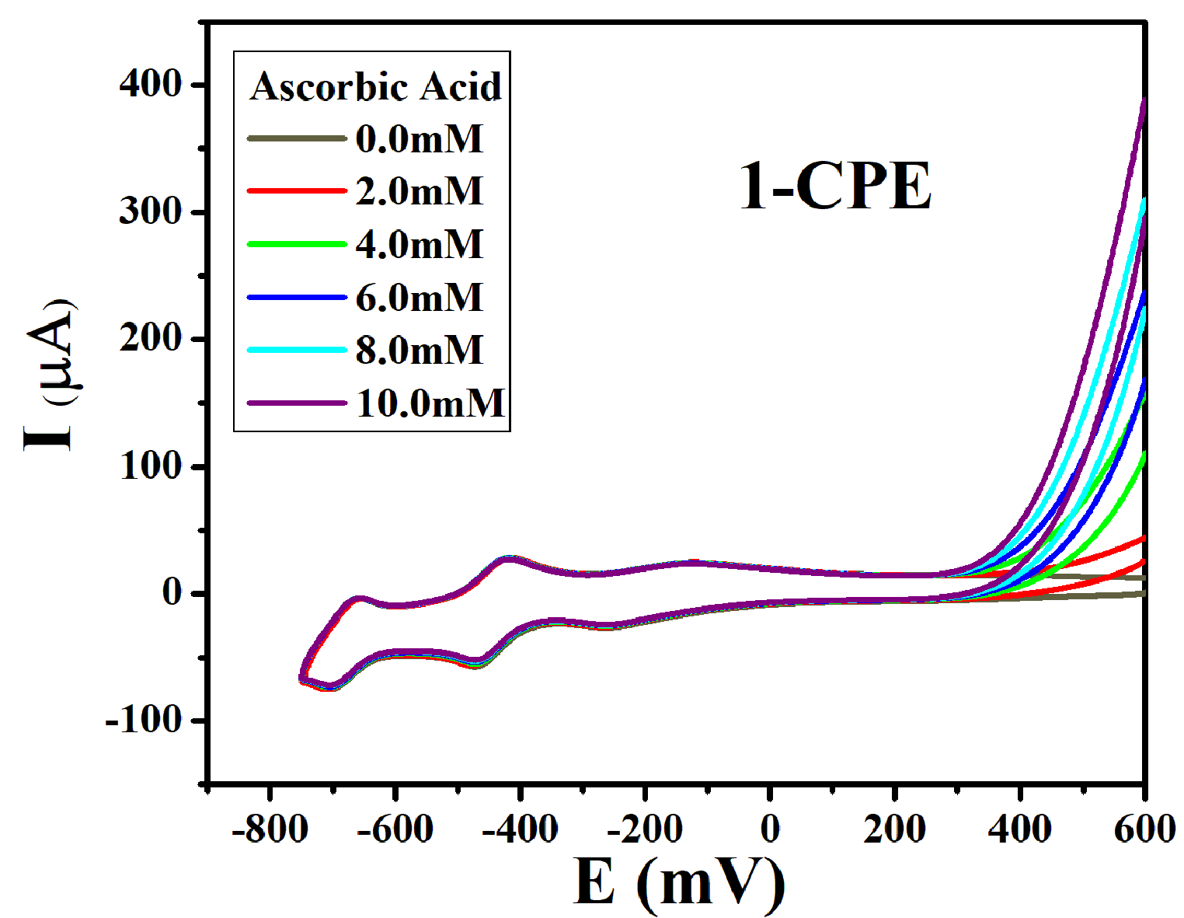
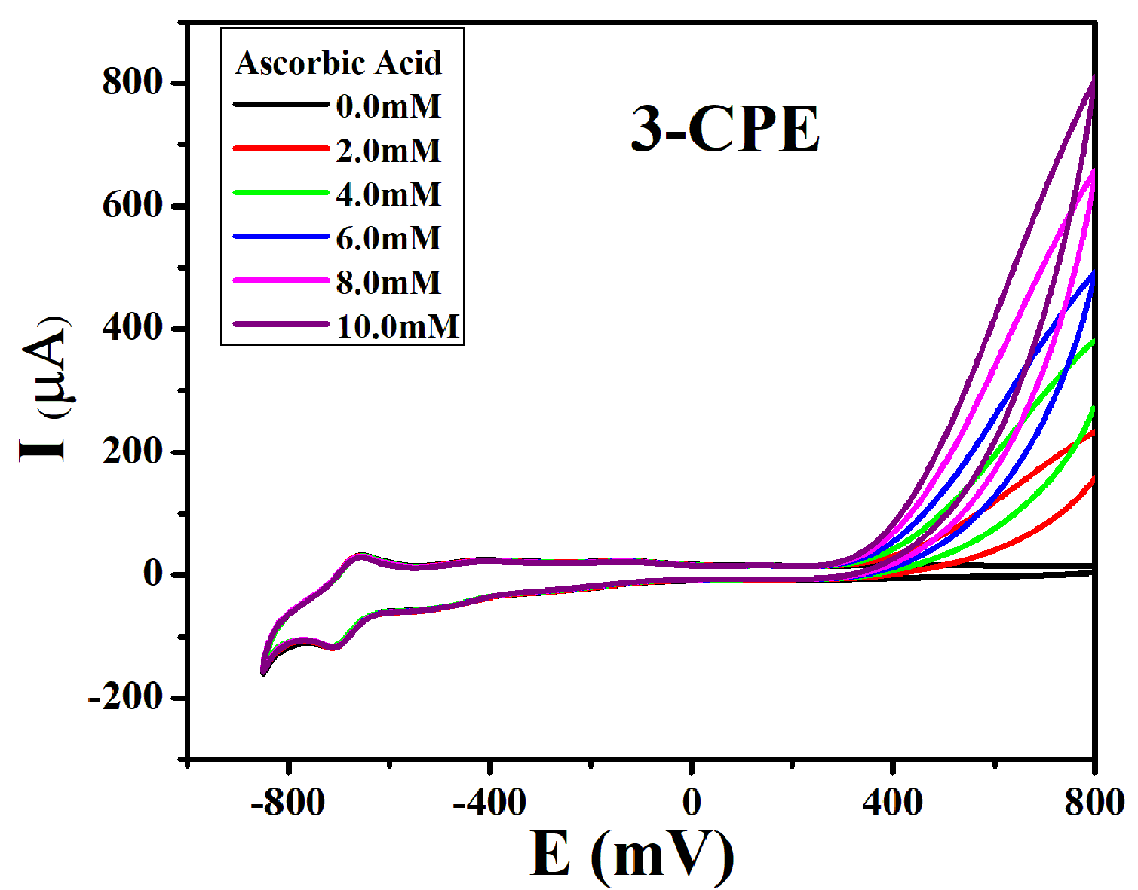
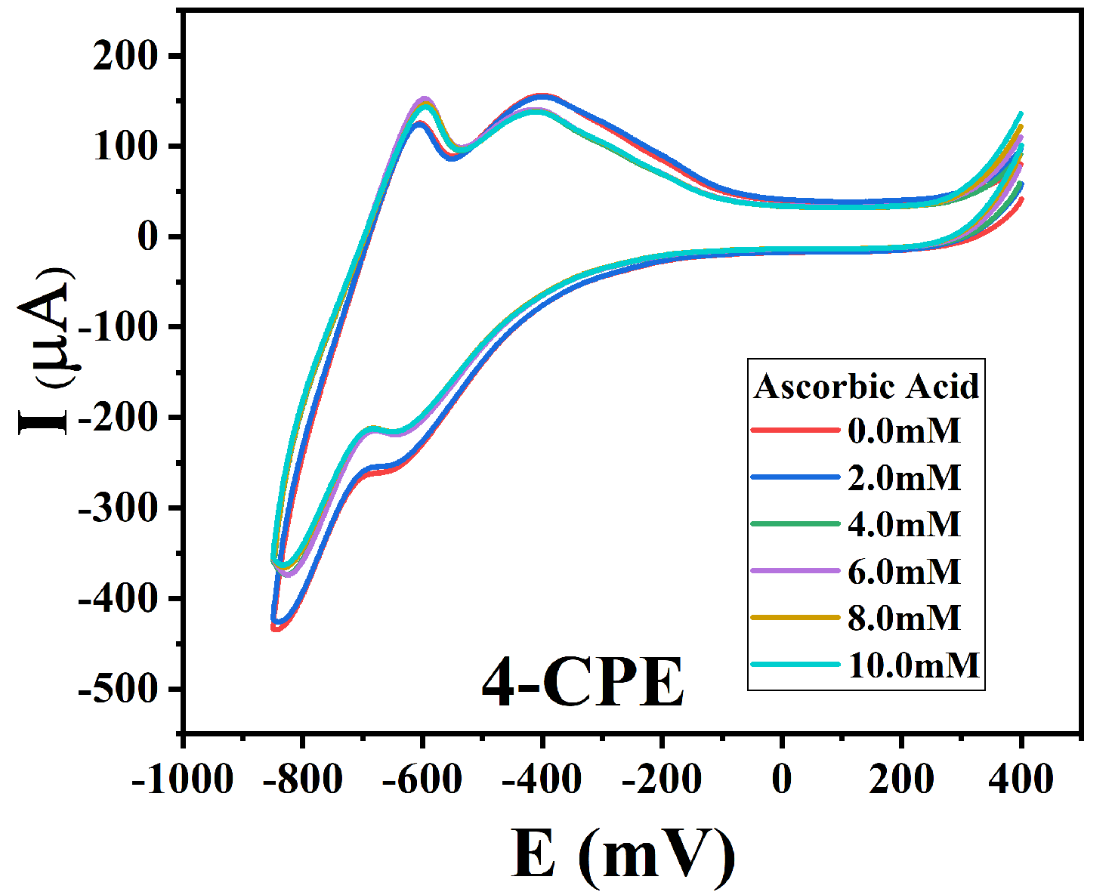
Figure S5. Cyclic voltammograms of 1–, 3– and 4–CPE in 0.1 M H₂SO₄ + 0.5 M Na₂SO₄ aqueous solution containing 0 (a); 2 (b); 4 (c); 6 (d); 8 (e) and 10 (f) mM AA. Scan rate: 200 mV·s⁻¹.
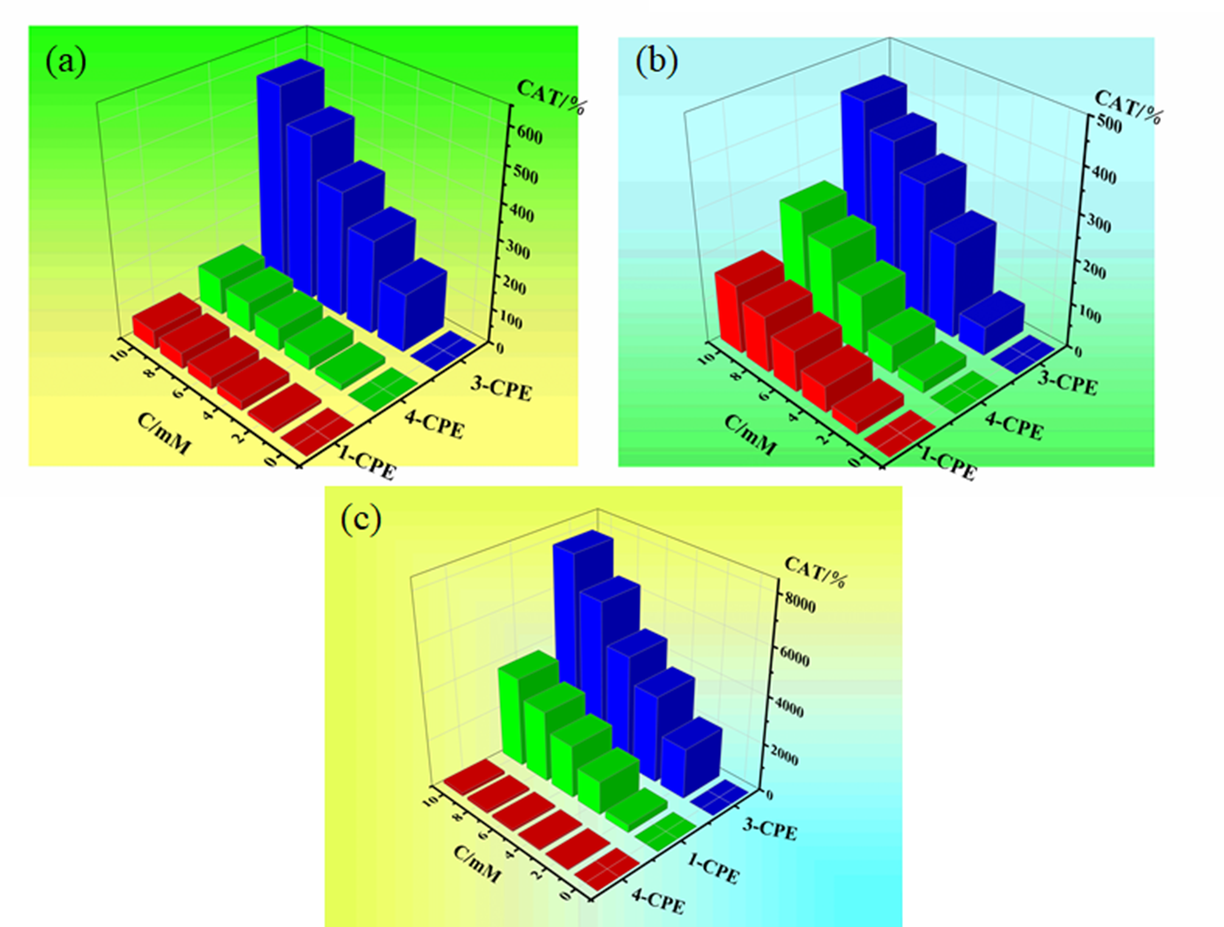
Figure S6. Chart of the CAT vs. concentration of H₂O₂ (a), BrO₃⁻ (b) and AA (c) for 1−, 3− and 4−CPEs (scan rate of 200 mV·s⁻¹).
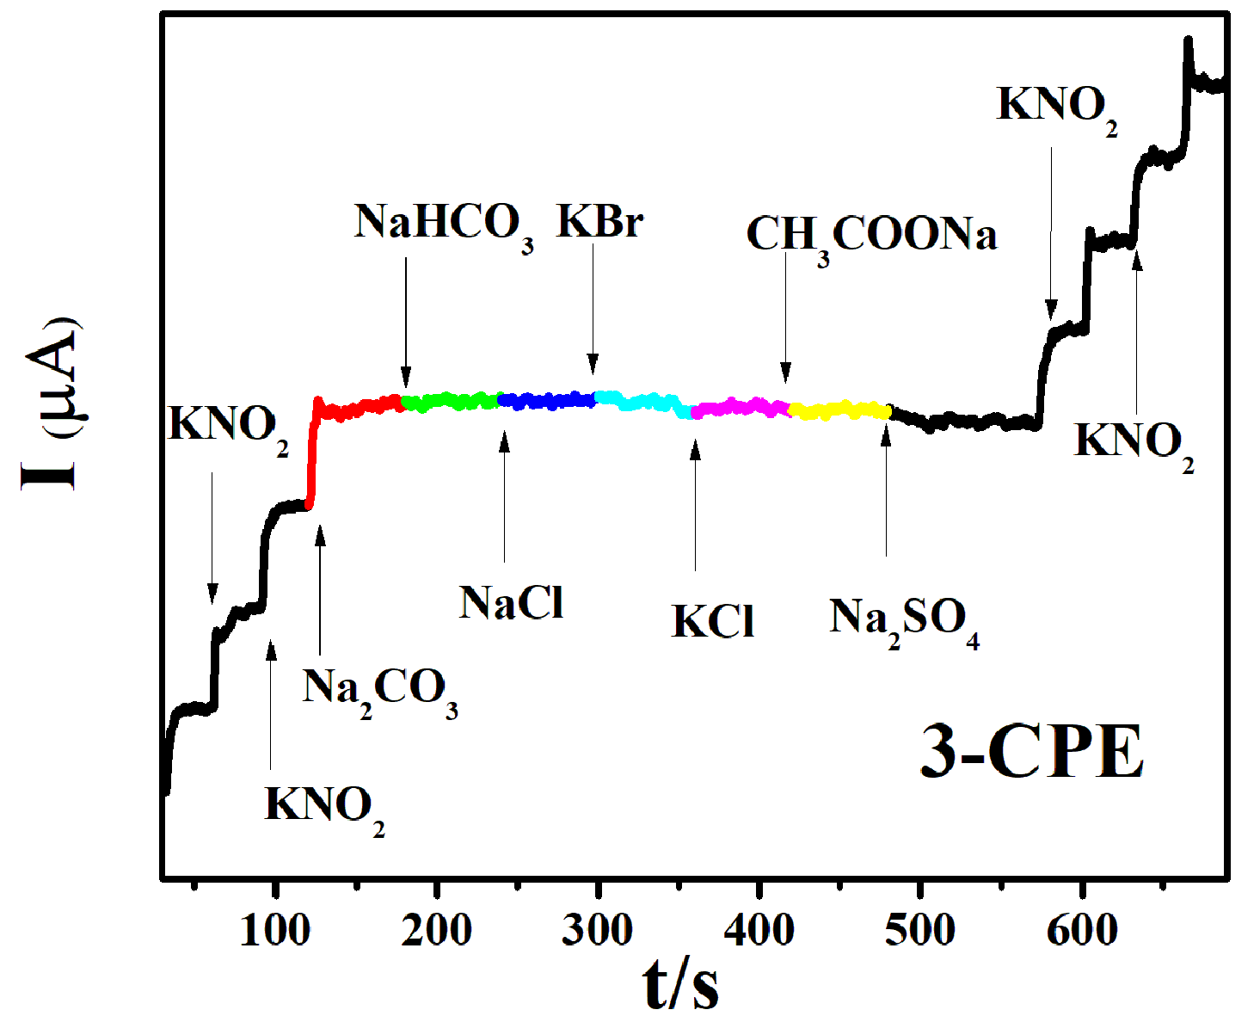
Figure S7. Amperometric current responses of 3−CPE in aqueous solution upon addition of various inorganic ions.

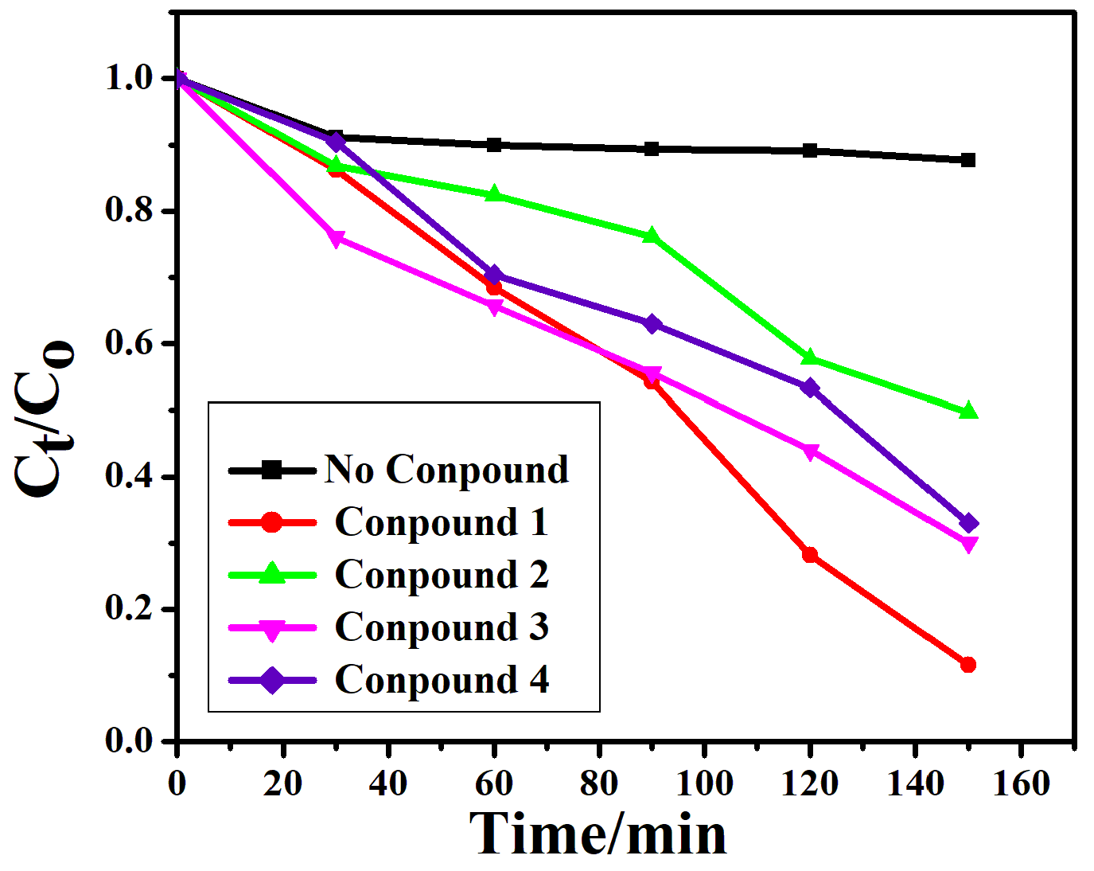
Figure S8. The conversions of MB with 1-4 as the catalysts.
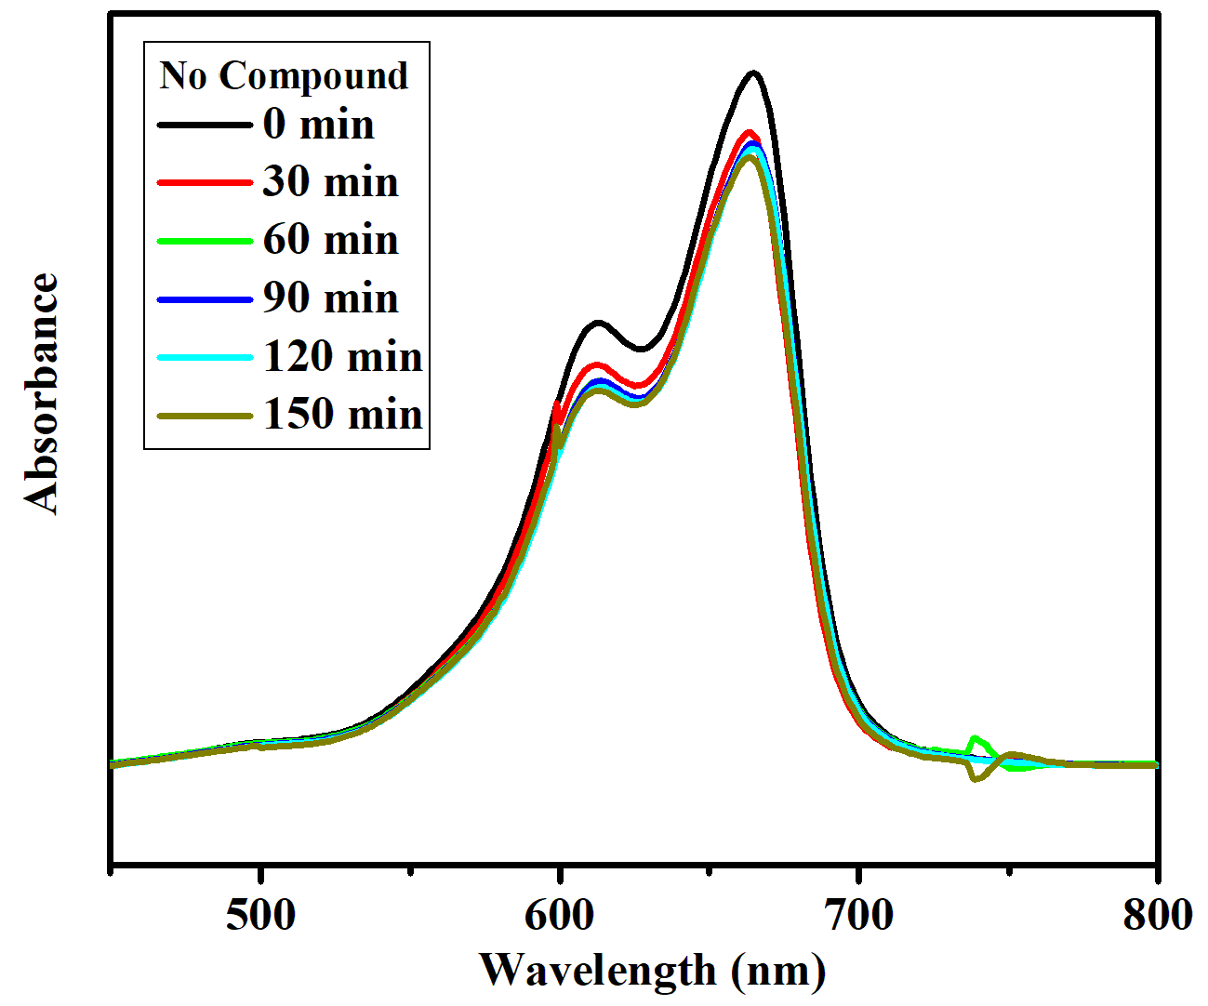
Figure S9. Absorption spectra of the MB solution during the decomposition reaction under UV irradiation without catalyst.

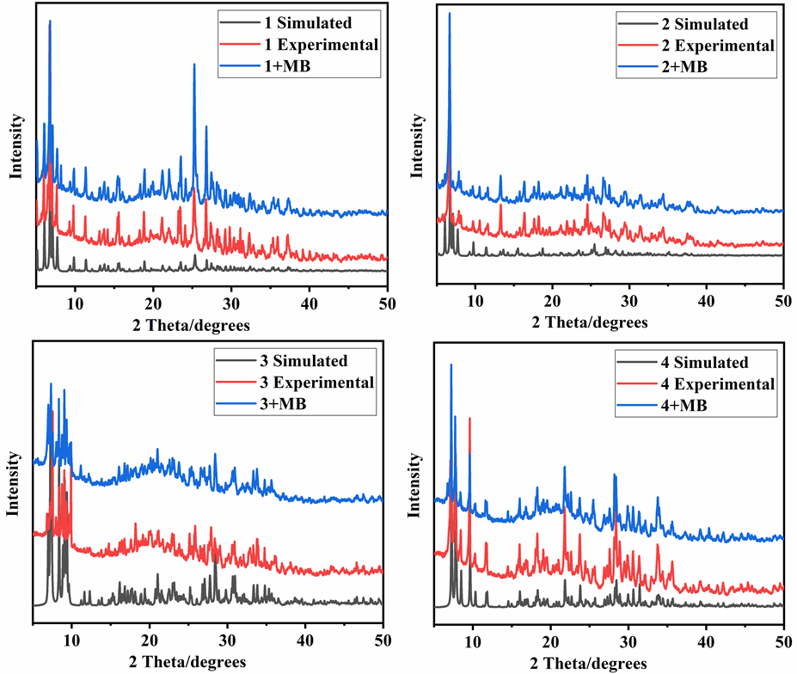
Figure S10. The simulative, experimental and recycled after photocatalysis powder X-ray diffraction patterns for compounds 1−4.
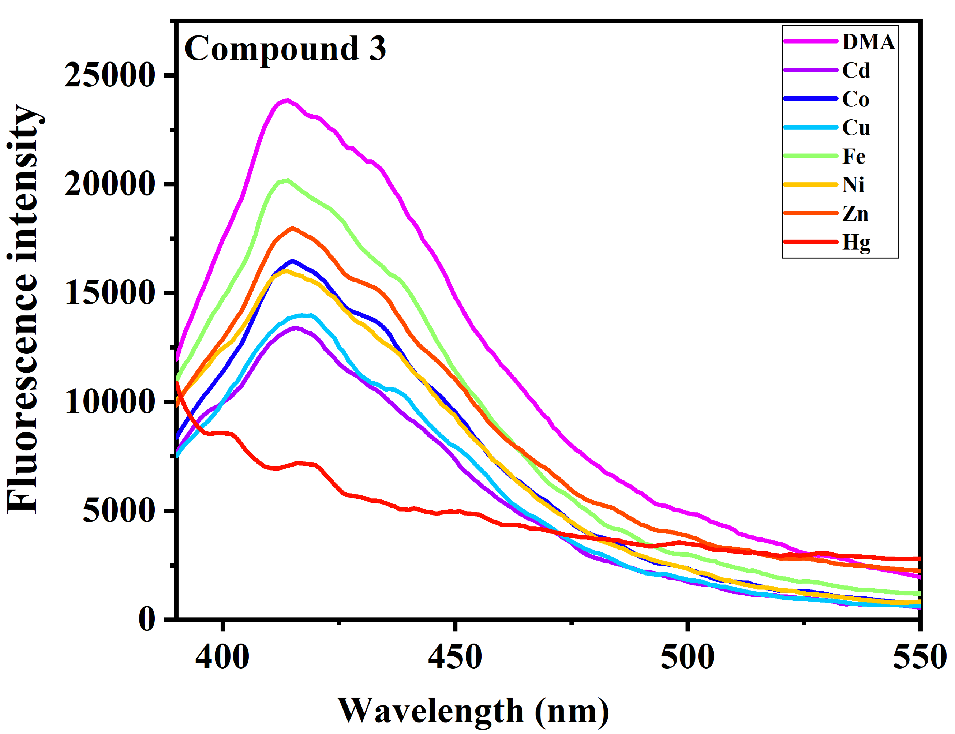
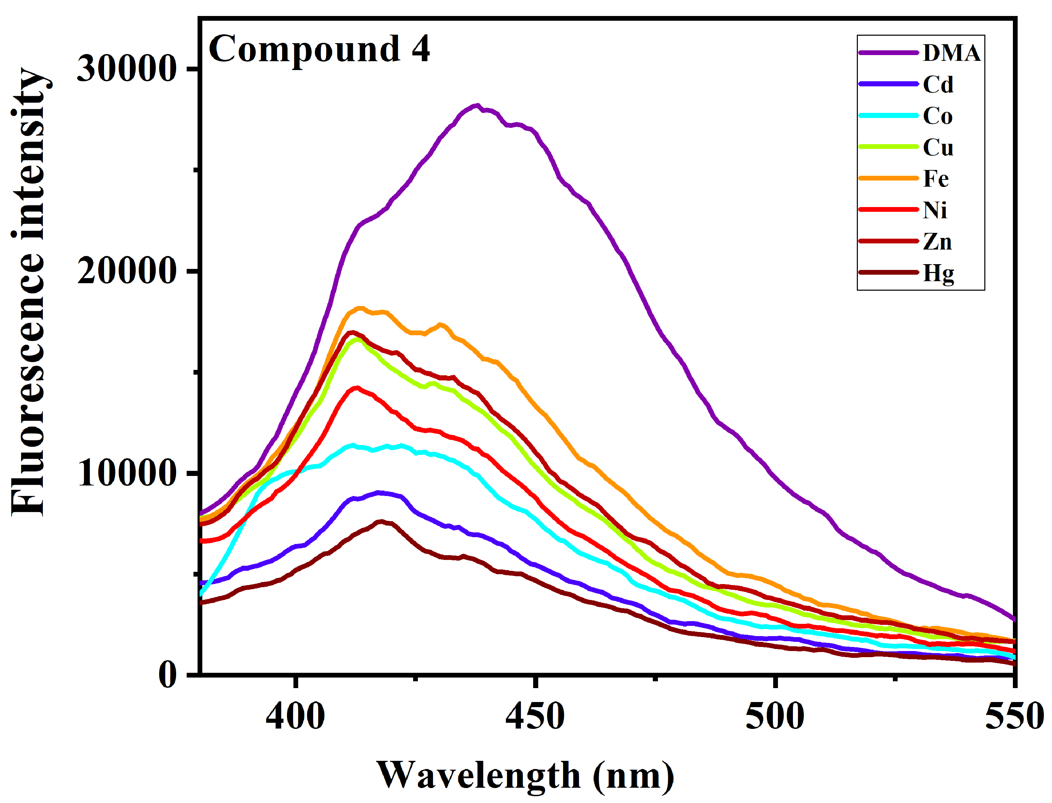
Figure S11. Fluorescence intensity of 1 and 2 suspension with the addition of different metal ions (excited at 380 nm).
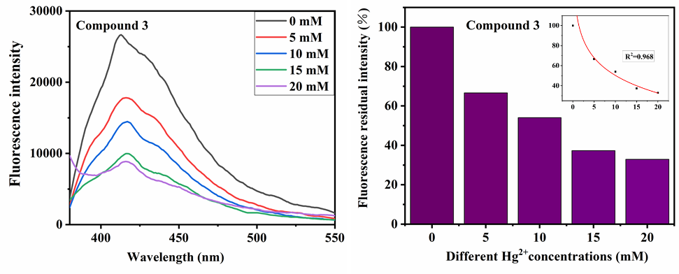
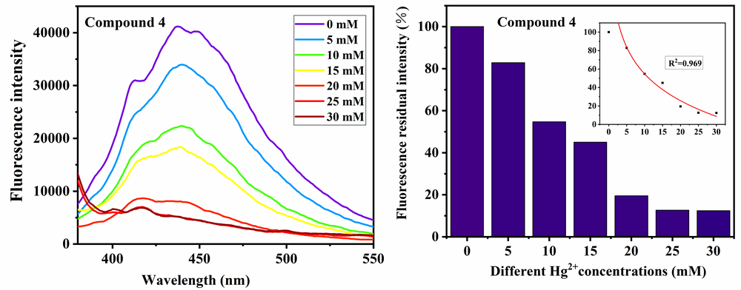
Figure S12. Fluorescence intensity of 3 and 4 with gradually increased Hg²⁺ (left), the right histogram reflects fluorescence residual intensity’s change (Inserted plot showing a fluorescence change after adding Hg²⁺).
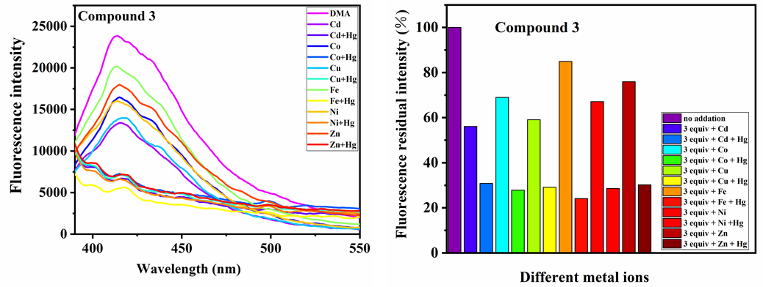
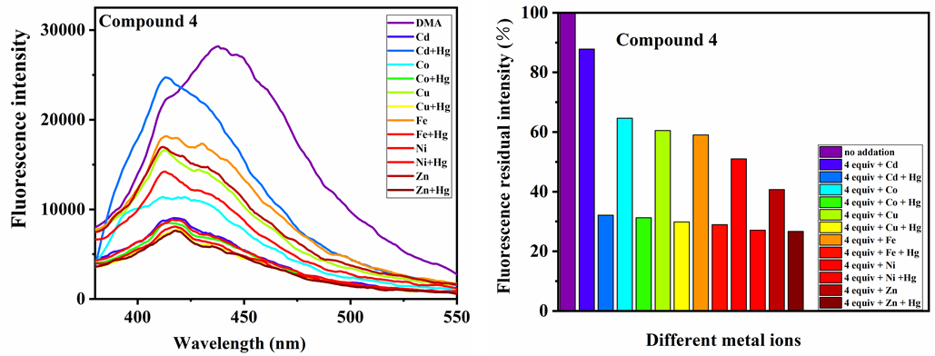
Figure S13. Fluorescence intensity of 3 and 4 at about 420 nm in suspension at room temperature upon the addition of Hg²⁺ or Hg²⁺ + M^{n+} ions (excited at 380 nm).
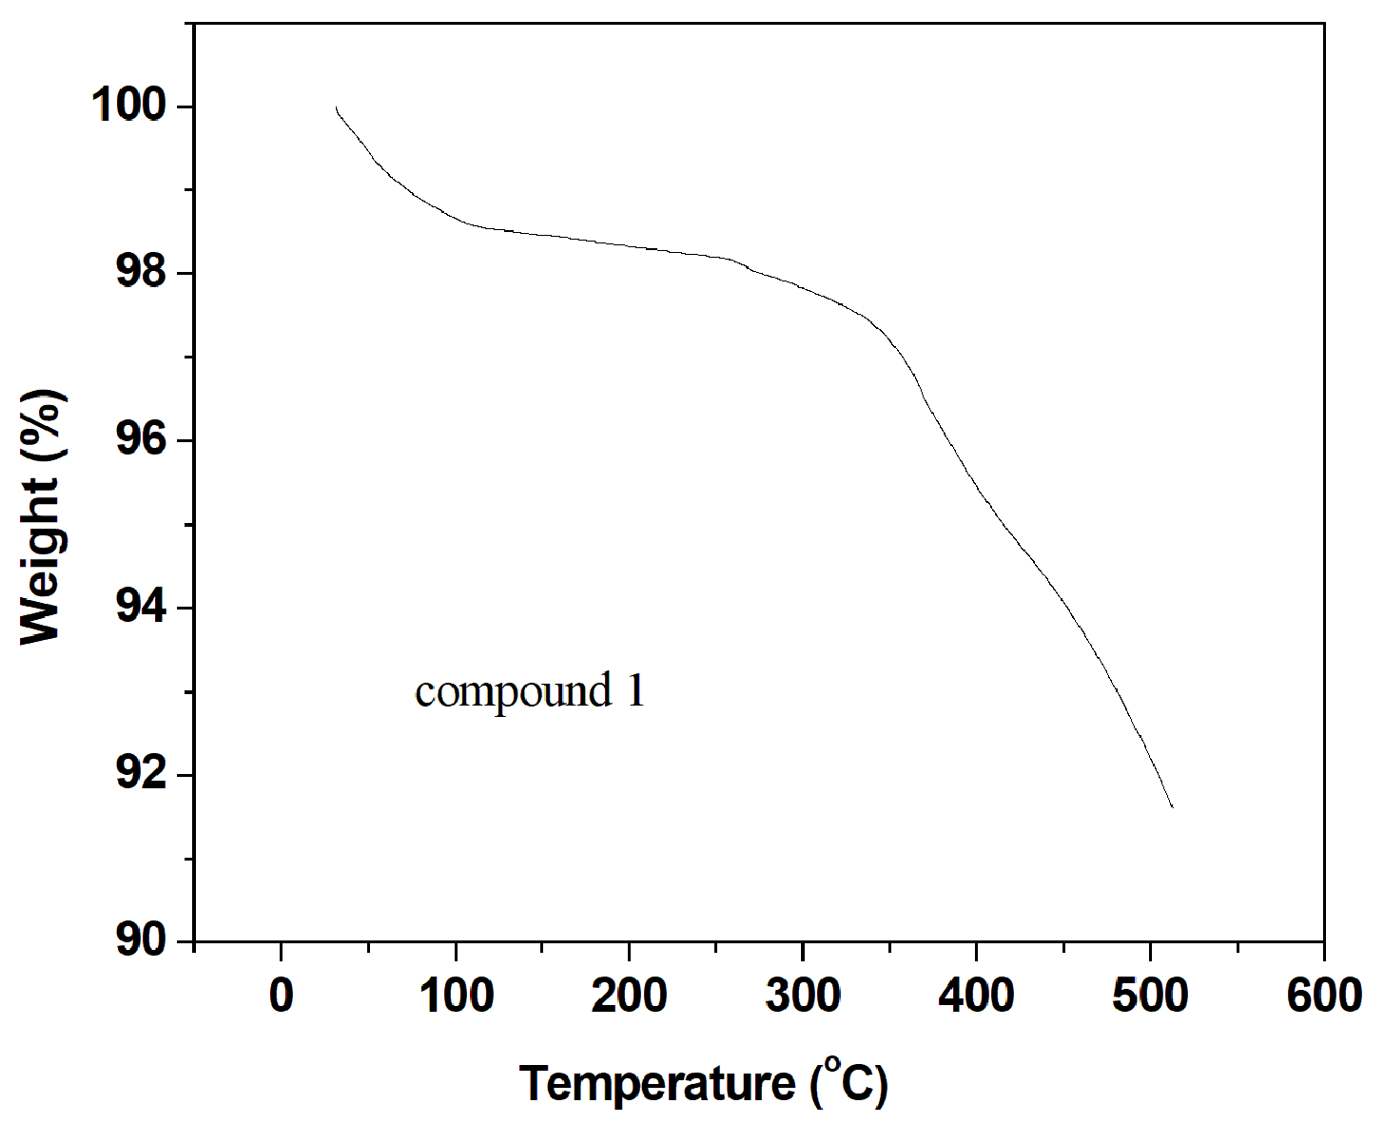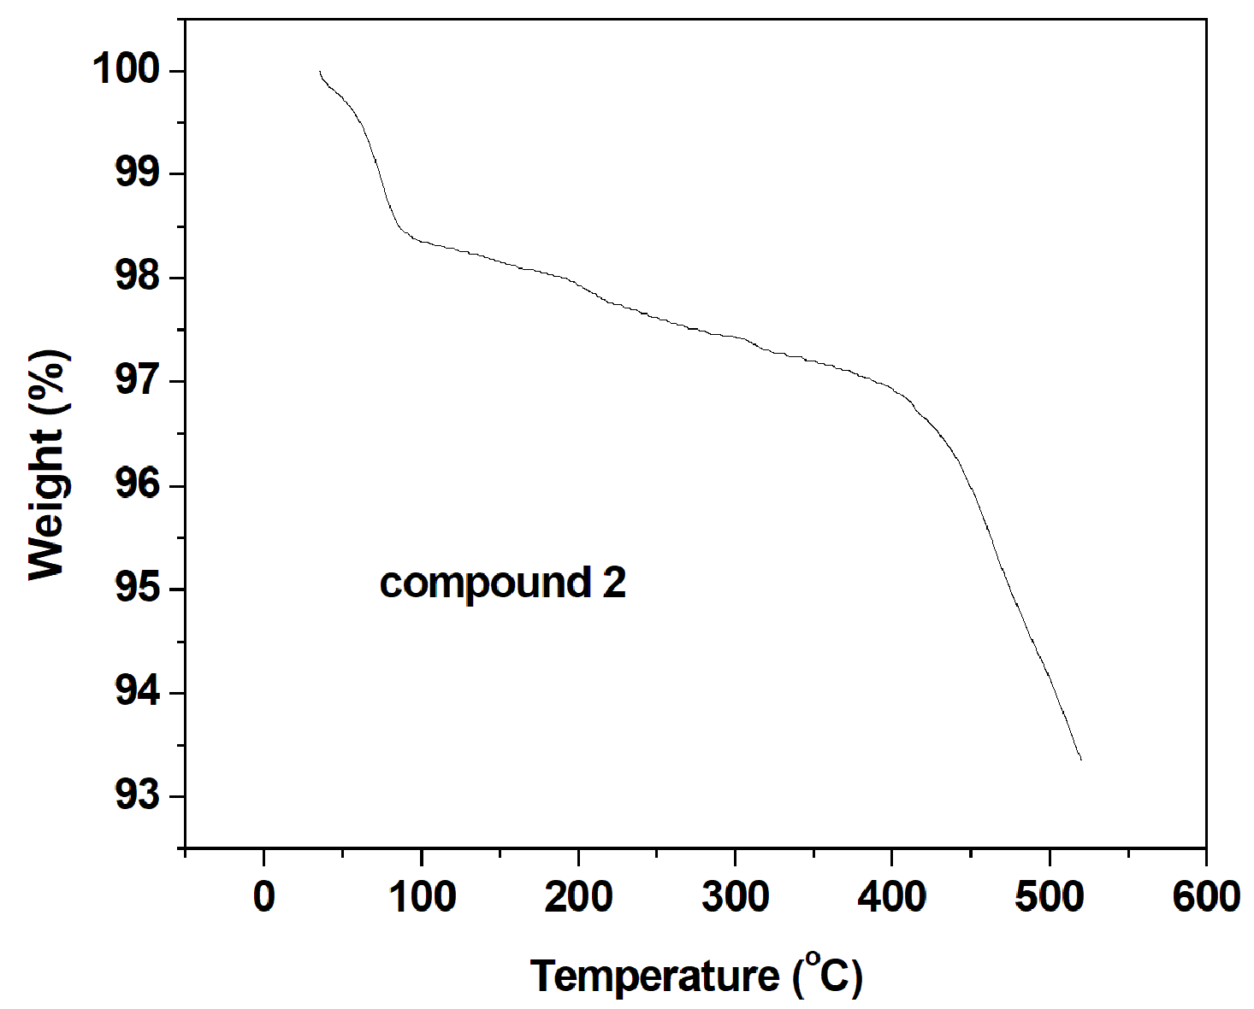
Figure S14. The TG curves of 1 and 2.

Thermalgravimetric analyses. The TGA experiments were performed under N₂ atmosphere with a heating rate of 10 °C⋅min⁻¹ in the temperature range of 40−500 °C for 1 and 2, shown in figure S1. In the TG curve for 1, the weight loss of 2.65% (calc. 2.74%) from 40 to 300 °C corresponds to the loss of crystal water molecules. The first weight loss step of TG curves of 2 below 300 °C (3.39%) correspond to the loss of water molecules (calc. 3.69%). In 1 and 2, the four and thirteen water molecules were highly disordered and could not be modeled properly, thus the SQUEEZE routine of PLATON was applied to remove the contributions to the scattering from the solvent molecules. The reported refinements are of the guest-free structures using the *.hkp files produced by using the SQUEEZE routine. The TG results further confirm the rationality of SQUEEZE routine.

