Supplementary Material
Comparison of simulations with different mesh resolution: 50$×$ 50 $×$48; 100$×$ 100 $×$96; and 200$×$ 200 $×$192 (Fig. S1). Velocity statistics of the mesh study is reported in the Table S1.

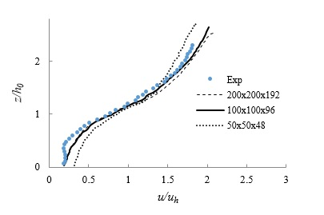
Figure S1. Comparison of measurements (circle symbols) and simulation for velocity-dependent C_{D}, P, and h, i.e. Case iii for 50$×$ 50 $×$48, 100$×$ 100 $×$96, and 200$×$ 200 $×$192. Vertical coordinate normalized by time-mean canopy height h₀. (a) streamwise velocity, u, normalized by u_{h} at the top of the canopy.

Table. S1. Mesh convergence evaluations for velocity statistics: RMSE Comparison with observations

Domain grid numbers | u/u* | −u′w′/u*² | σ_{u}/u* | σ_{w}/u* | Sk (u) | Sk (w)
50$×$ 50 $×$48 | 0.18 | 0.26 | 0.38 | 0.23 | 0.40 | 0.32
100$×$ 100 $×$96 | 0.08 | 0.10 | 0.16 | 0.07 | 0.19 | 0.17
200$×$ 200 $×$192 | 0.07 | 0.09 | 0.15 | 0.07 | 0.18 | 0.16

