Supporting Information
  - Figure 1S. Naphthalene concentration (µg/kg) adsorbed onto natural sediment having dominant mineral quartz and kaolinite along with laboratory grade quartz and kaolinite

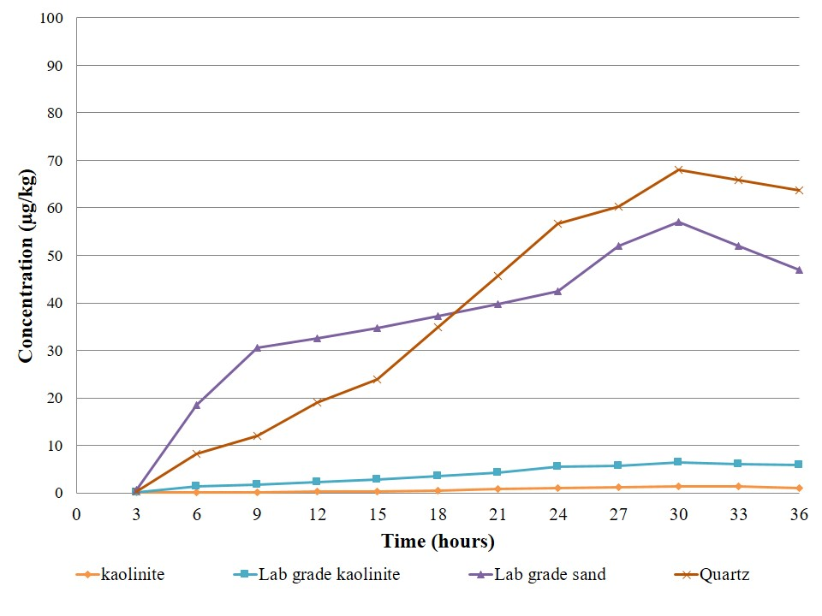
Fig.1S
  - Figure 2S Phenanthrene concentration (µg/kg) adsorbed onto natural sediment having dominant mineral quartz and kaolinite along with laboratory grade quartz and kaolinite
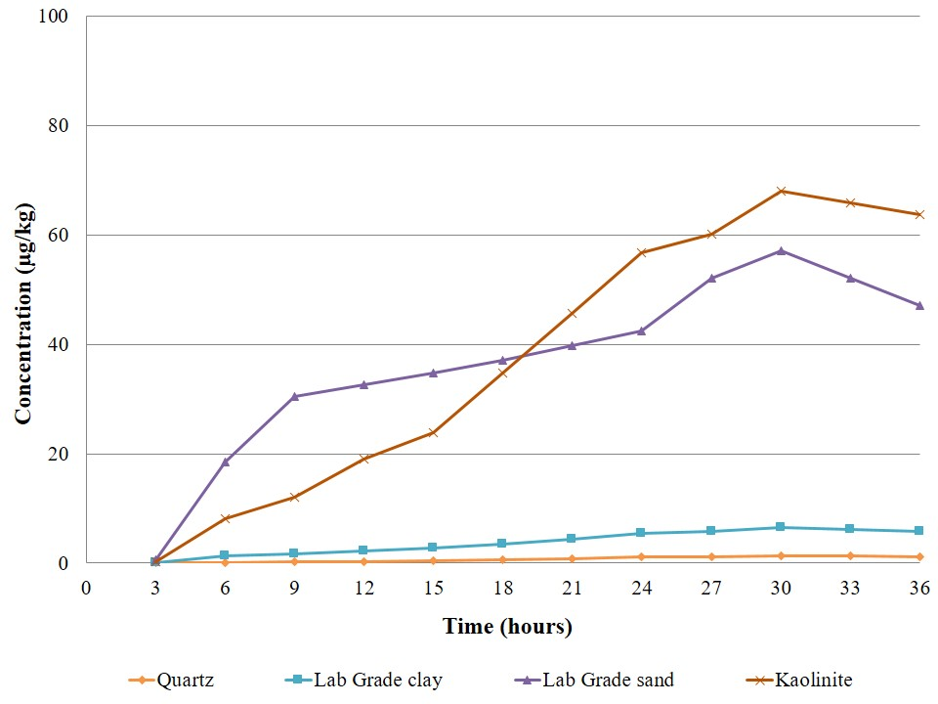
Fig.2S
  - Figure 3S. Fluoranthene concentration (µg/kg) adsorbed onto natural sediment having dominant mineral quartz and kaolinite along with laboratory grade quartz and kaolinite
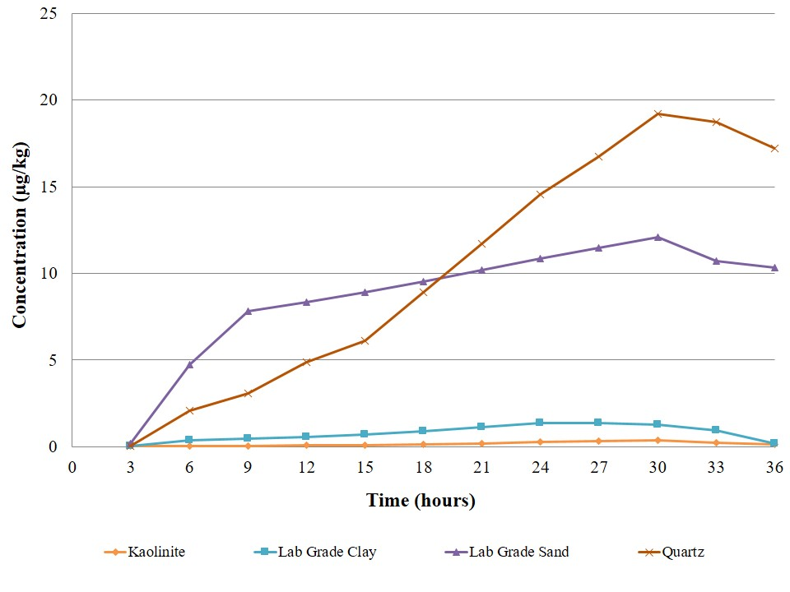
Fig.3S
  - Figure 4S. Hierarchical Cluster Analysis (HCA) for PAHs present in different land uses

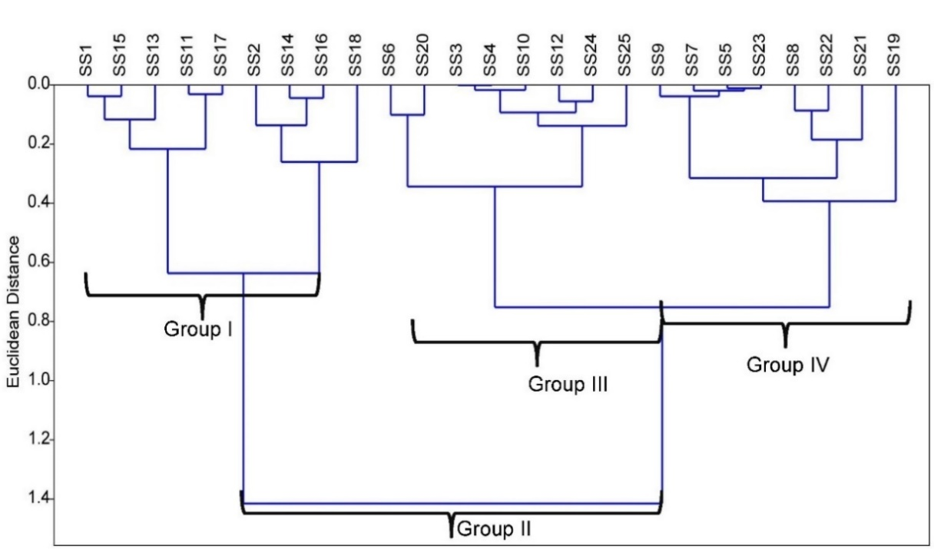

Fig.4S

Table 1S: Groundwater sampling locations across Western Bengal basin
Murshidabad |  |  | Nadia |  |  | North 24 Parganas |  |  |  | South 24 Parganas
Sample ID | Latitude | Longitude | Sample ID | Latitude | Longitude | Sample ID |  | Latitude | Longitude | Sample ID | Latitude | Longitude
S1 | 24.2598 | 88.6592 | S89 | 23.7639 | 88.3789 | S154 |  | 22.7219 | 88.4006 | S178 | 22.4867 | 88.3636
S2 | 24.2597 | 88.6590 | S90 | 24.0329 | 88.7140 | S155 |  | 22.774 | 88.3961 | S179 | 22.4878 | 88.3646
S3 | 23.9901 | 87.9140 | S91 | 24.0421 | 88.7105 | S156 |  | 22.8928 | 88.5535 | S180 | 22.4878 | 88.3646
S4 | 23.9912 | 87.9128 | S92 | 23.5507 | 88.3827 | S157 |  | 22.5735 | 88.5016 | S181 | 22.4879 | 88.3642
S5 | 24.1187 | 88.6566 | S93 | 23.5475 | 88.3887 | S158 |  | 23.1635 | 88.8907 | S182 | 22.4038 | 88.1504
S6 | 24.1131 | 88.6382 | S94 | 22.9932 | 88.5477 | S159 |  | 22.7361 | 88.535 | S183 | 22.1879 | 88.2254
S7 | 24.1150 | 88.6442 | S95 | 22.9931 | 88.5478 | S160 |  | 22.7382 | 88.403 | S184 | 22.1871 | 88.2245
S8 | 24.1167 | 88.6506 | S96 | 22.9595 | 88.5661 | S161 |  | 22.7342 | 88.4029 | S185 | 22.1879 | 88.2256
S9 | 24.1142 | 88.6458 | S97 | 22.9353 | 88.5415 | S162 |  | 22.5931 | 88.4895 | S186 | 22.1893 | 88.2266
S10 | 23.8511 | 88.2598 | S98 | 23.0277 | 88.5888 | S163 |  | 22.9253 | 88.7969 | S187 | 22.1843 | 88.2261
S11 | 23.8506 | 88.2562 | S99 | 23.0380 | 88.5144 | S164 |  | 22.9233 | 88.7891 | S188 | 22.1864 | 88.2280
S12 | 23.8545 | 88.2524 | S100 | 23.2906 | 88.3689 | S165 |  | 22.8083 | 88.5154 | S189 | 22.1832 | 88.2267
S13 | 23.8662 | 88.2485 | S101 | 23.2321 | 88.5233 | S166 |  | 22.8886 | 88.7404 | S190 | 22.1863 | 88.2272
S14 | 23.8227 | 88.2637 | S102 | 23.2868 | 88.3590 | S167 |  | 22.8897 | 88.7376 | S191 | 22.3947 | 88.2042
S15 | 24.1586 | 88.6473 | S103 | 23.6890 | 88.5292 | S168 |  | 22.8886 | 88.7404 | S192 | 22.3912 | 88.2139
S16 | 24.1534 | 88.6468 | S104 | 23.6902 | 88.5306 | S169 |  | 22.8897 | 88.7376 | S193 | 22.3953 | 88.2046
S17 | 24.1587 | 88.6438 | S105 | 23.6912 | 88.5306 | S170 |  | 23.0543 | 88.8071 | S194 | 22.3948 | 88.2042
S18 | 24.1548 | 88.6479 | S106 | 23.2327 | 88.4965 | S171 |  | 23.0572 | 88.7926 | S195 | 22.3949 | 88.2042
S19 | 23.9296 | 88.0470 | S107 | 23.2385 | 88.4590 | S172 |  | 22.8456 | 88.7442 | S196 | 22.4063 | 88.2186
S20 | 23.9282 | 88.0471 | S108 | 23.3936 | 88.6581 | S173 |  | 22.8471 | 88.7501 | S197 | 22.4062 | 88.2187
S21 | 23.9453 | 88.0405 | S109 | 23.3904 | 88.6524 | S174 |  | 22.8487 | 88.7493 | S198 | 22.4060 | 88.2188
S22 | 23.9441 | 88.0405 | S110 | 23.3415 | 88.4152 | S175 |  | 22.8369 | 88.6949 | S199 | 22.4060 | 88.2188
S23 | 24.1720 | 88.6056 | S111 | 23.3373 | 88.4190 | S176 |  | 22.8391 | 88.6964 | S200 | 22.4061 | 88.2193
S24 | 24.1723 | 88.6063 | S112 | 23.3542 | 88.4235 | S177 |  | 22.8376 | 88.6965 | S201 | 22.4064 | 88.2196
S25 | 23.9435 | 88.0229 | S113 | 23.3538 | 88.4247 |  |  |  |  | S202 | 22.4065 | 88.2195
S26 | 23.9433 | 88.0238 | S114 | 23.3552 | 88.4212 |  |  |  |  | S203 | 22.4068 | 88.2192
S27 | 23.9199 | 88.0533 | S115 | 23.0232 | 88.5990 |  |  |  |  | S204 | 22.4067 | 88.2193
S28 | 23.9193 | 88.0554 | S116 | 23.0233 | 88.6002 |  |  |  |  | S205 | 22.4068 | 88.2193
S29 | 23.9171 | 88.0611 | S117 | 23.0053 | 88.6023 |  |  |  |  | S206 | 22.4342 | 88.2916
S30 | 23.9299 | 88.0458 | S118 | 23.0092 | 88.6028 |  |  |  |  | S207 | 22.4307 | 88.2997
S31 | 23.8963 | 88.4624 | S119 | 23.0124 | 88.6051 |  |  |  |  | S208 | 22.4332 | 88.2994
S32 | 24.1078 | 88.6361 | S120 | 23.0133 | 88.6048 |  |  |  |  | S209 | 22.4358 | 88.3007
S33 | 24.1080 | 88.6367 | S121 | 23.3656 | 88.3382 |  |  |  |  | S210 | 22.4339 | 88.2979
S34 | 23.8988 | 87.9343 | S122 | 23.2503 | 88.5389 |  |  |  |  | S211 | 22.4349 | 88.2983
S35 | 23.8986 | 87.9342 | S123 | 23.2528 | 88.5396 |  |  |  |  | S212 | 22.3881 | 88.2467
S36 | 24.0495 | 88.6330 | S124 | 23.2549 | 88.5250 |  |  |  |  | S213 | 22.4270 | 88.3020
S37 | 24.0658 | 88.6049 | S125 | 23.2528 | 88.5225 |  |  |  |  | S214 | 22.4268 | 88.3068
S38 | 24.0712 | 88.6026 | S126 | 23.2525 | 88.5339 |  |  |  |  | S215 | 22.4336 | 88.2977
S39 | 23.9625 | 87.9275 | S127 | 22.9964 | 88.4909 |  |  |  |  | S216 | 22.3964 | 88.2081
S40 | 23.9614 | 87.9286 | S128 | 22.9826 | 88.4904 |  |  |  |  | S217 | 22.3995 | 88.2083
S41 | 23.9724 | 87.9281 | S129 | 23.7691 | 88.2672 |  |  |  |  | S218 | 22.3948 | 88.2042
S42 | 23.9192 | 88.3620 | S130 | 23.6210 | 88.3137 |  |  |  |  | S219 | 22.3948 | 88.2068
S43 | 24.0063 | 88.0241 | S131 | 23.7682 | 88.2666 |  |  |  |  | S220 | 22.4339 | 88.2979
S44 | 23.7708 | 88.2194 | S132 | 23.6202 | 88.3143 |  |  |  |  | S221 | 22.4336 | 88.2977
S45 | 24.0420 | 88.5520 | S133 | 23.7707 | 88.2611 |  |  |  |  | S222 | 22.3881 | 88.2467
S46 | 24.0428 | 88.5500 | S134 | 23.7696 | 88.2587 |  |  |  |  | S223 | 22.4270 | 88.3020
S47 | 24.0429 | 88.5488 | S135 | 23.6219 | 88.3129 |  |  |  |  | S224 | 22.4268 | 88.3068
S48 | 24.0420 | 88.5518 | S136 | 23.7671 | 88.2590 |  |  |  |  | S225 | 22.4357 | 88.2999
S49 | 24.0431 | 88.5523 | S137 | 23.6151 | 88.3265 |  |  |  |  | S226 | 22.4351 | 88.3004
S50 | 24.0097 | 88.5350 | S138 | 23.7699 | 88.2649 |  |  |  |  | S227 | 22.4349 | 88.2983
S51 | 24.0103 | 88.5327 | S139 | 23.6384 | 88.2657 |  |  |  |  | S228 | 22.4332 | 88.2994
S52 | 24.0089 | 88.5330 | S140 | 23.6184 | 88.3121 |  |  |  |  | S229 | 22.4339 | 88.2979
S53 | 23.9355 | 88.1099 | S141 | 23.7680 | 88.2583 |  |  |  |  | S230 | 22.4336 | 88.2977
S54 | 23.9321 | 88.1085 | S142 | 23.6315 | 88.2609 |  |  |  |  | S231 | 22.3881 | 88.2467
S55 | 23.9301 | 88.1063 | S143 | 23.7880 | 88.2505 |  |  |  |  | S232 | 22.4270 | 88.3020
S56 | 23.9277 | 88.1068 | S144 | 23.7877 | 88.2508 |  |  |  |  | S233 | 22.4307 | 88.2997
S57 | 23.9323 | 88.1069 | S145 | 23.5933 | 88.3415 |  |  |  |  | S234 | 22.4268 | 88.3068
S58 | 24.0312 | 87.8844 | S146 | 23.5871 | 88.3353 |  |  |  |  | S235 | 22.4336 | 88.2977
S59 | 24.0077 | 88.4952 | S147 | 23.5974 | 88.3474
S60 | 23.8967 | 87.9282 | S148 | 23.7580 | 88.3100
S61 | 23.8914 | 87.9151 | S149 | 23.7596 | 88.3102
S62 | 23.8913 | 87.9143 | S150 | 23.5325 | 88.4034
S63 | 24.0848 | 88.0711 | S151 | 23.5344 | 88.4013
S64 | 23.8636 | 88.4632 | S152 | 23.6892 | 88.3030
S65 | 23.8630 | 88.4633 | S153 | 23.6885 | 88.2997
S66 | 23.9530 | 88.0752
S67 | 23.9534 | 88.0722
S68 | 23.8214 | 88.4240
S69 | 24.0914 | 88.6283
S70 | 24.0907 | 88.6269
S71 | 24.0928 | 88.6226
S72 | 24.0931 | 88.6217
S73 | 23.8211 | 88.4244
S74 | 23.8211 | 88.4244
S75 | 24.0949 | 88.6217
S76 | 23.8183 | 88.4231
S77 | 23.8183 | 88.4231
S78 | 23.8195 | 88.4242
S79 | 23.8195 | 88.4242
S80 | 23.8216 | 88.4233
S81 | 23.8216 | 88.4233
S82 | 24.0926 | 88.6250
S83 | 24.0943 | 88.6227
S84 | 23.8184 | 88.4230
S85 | 23.8149 | 88.4214
S86 | 23.9531 | 88.2154
S87 | 23.9531 | 88.2151
S88 | 24.3408 | 88.3023

Table 2S: River water sampling locations across Western Bengal basin
Sample ID | Latitude | Longitude
WBB1 | 24.75 | 87.74
WBB2 | 24.63 | 87.97
WBB3 | 24.59 | 88.02
WBB4 | 24.53 | 88.06
WBB5 | 24.44 | 88.09
WBB6 | 24.31 | 88.18
WBB7 | 24.19 | 88.24
WBB8 | 24.10 | 88.23
WBB9 | 23.94 | 88.23
WBB10 | 23.84 | 88.23
WBB11 | 23.68 | 88.15
WBB12 | 23.56 | 88.33
WBB13 | 23.49 | 88.38
WBB14 | 23.43 | 88.32
WBB15 | 23.36 | 88.34
WBB16 | 23.29 | 88.36
WBB17 | 23.23 | 88.46
WBB18 | 23.17 | 88.46
WBB19 | 23.06 | 88.49
WBB20 | 23.01 | 88.45
WBB21 | 22.92 | 88.39
WBB22 | 22.85 | 88.37
WBB23 | 22.76 | 88.36
WBB24 | 22.67 | 88.36
WBB25 | 22.62 | 88.30
WBB26 | 22.57 | 88.24
WBB27 | 22.53 | 88.16
WBB28 | 22.47 | 88.12
WBB29 | 22.40 | 88.09
WBB30 | 22.32 | 88.09
WBB31 | 22.26 | 88.07
WBB32 | 22.20 | 88.17

Table 3S: Detailed information on mineralogical characteristics, pH and average organic carbon content (mg/kg) for 25 sediment samples
Sampling site | Mineral characterization | pH | Average organic carbon content
SS1 | Quartz, Silica | 8.1 | 0.92
SS2 | Quartz, Silica | 7.9 | 1.93
SS3 | Quartz, Feldspar | 8.0 | 2.18
SS4 | Quartz, Silica | 7.3 | 0.60
SS5 | Illite, Smectite | 7.5 | 3.21
SS6 | Calcite | 7.2 | 2.10
SS7 | Muscovite | 7.0 | 2.13
SS8 | Muscovite | 6.9 | 2.09
SS9 | Kaolinite, Kaolinite | 6.7 | 1.69
SS10 | Albite , Muscovite | 6.5 | 1.51
SS11 | Quartz, Silica | 7.3 | 1.19
SS12 | Muscovite, Illite | 8.1 | 0.93
SS13 | Orthoclase | 6.9 | 1.21
SS14 | Sanidine | 6.8 | 1.15
SS15 | Orthoclase, Berlinite | 6.8 | 1.75
SS16 | Anorthite | 6.7 | 1.69
SS17 | Calcite | 7.6 | 0.97
SS18 | Muscovite, Kaolinite | 7.6 | 0.91
SS19 | Quartz, Silica | 7.5 | 1.51
SS20 | Quartz, Feldspar | 6.4 | 2.11
SS21 | Kaolinite, Orthoclase | 7.3 | 2.05
SS22 | Muscovite, Illite | 7.3 | 0.67
SS23 | Albite, Muscovite | 7.2 | 0.61
SS24 | Anorthite, Illite | 7.1 | 1.21
SS25 | Muscovite, Illite, Kaolinite | 7.1 | 1.15

Table 4S: Minimum detection limit and extraction recoveries for the polycyclic aromatic Hydrocarbons (PAHs) in water samples
Compounds |  | Detection limit (µg/L) | Internal standard injected | Internal standard recovered | Recovery (%) |  |  | Internal standard injected | Internal standard recovered |  | Recovery (%)
Naphthalene |  | 0.3 | 0.5 | 0.32 | 64 |  |  | 1 | 0.89 |  | 66
Acenaphthylene |  | 0.5 | 0.5 | 0.39 | 78 |  |  | 1 | 0.91 |  | 77
Acenaphthene |  | 0.5 | 0.5 | 0.41 | 82 |  |  | 1 | 0.93 |  | 83
Fluorene |  | 0.5 | 0.5 | 0.46 | 92 |  |  | 1 | 0.98 |  | 96
Phenanthrene |  | 0.5 | 0.5 | 0.43 | 86 |  |  | 1 | 0.95 |  | 88
Anthracene |  | 0.3 | 0.5 | 0.32 | 64 |  |  | 1 | 0.84 |  | 50
Fluoranthene |  | 0.3 | 0.5 | 0.39 | 78 |  |  | 1 | 0.91 |  | 77
Pyrene |  | 0.2 | 0.5 | 0.33 | 66 |  |  | 1 | 0.85 |  | 55
Benz(a)anthracene |  | 0.2 | 0.5 | 0.42 | 84 |  |  | 1 | 0.82 |  | 82
Chrysene |  | 0.2 | 0.5 | 0.39 | 78 |  |  | 1 | 0.91 |  | 77
Benzo(b) fluoranthene |  | 0.2 | 0.5 | 0.41 | 82 |  |  | 1 | 0.93 |  | 83
Benzo(k) fluoranthene |  | 0.2 | 0.5 | 0.37 | 74 |  |  | 1 | 0.89 |  | 70
Benzo(a) pyrene |  | 0.1 | 0.5 | 0.32 | 64 |  |  | 1 | 0.84 |  | 50
d-Perylene (Istd)* |  | 0.1 | 0.5 | 0.42 | 84 |  |  | 1 | 0.94 |  | 86
Perylene |  | 1.0 | 0.5 | 0.4 | 80 |  |  | 1 | 0.92 |  | 80
Indeno(1,2,3)  pyrene |  | 0.2 | 0.5 | 0.29 | 58 |  |  | 1 | 0.81 |  | 34
Dibenzo(a,h)  anthracene |  | 0.9 | 0.5 | 0.39 | 78 |  |  | 1 | 0.91 |  | 77
Benzo(g,h,i)  perylene |  | 0.9 | 0.5 | 0.36 | 72 |  |  | 1 | 0.89 |  | 69
1,3-dimethyl naphthalene | 0.25 |  | 0.5 | 0.32 |  | 64 | 1 |  | 0.69 | 69
1-methyl naphthalene | 0.4 |  | 0.5 | 0.47 |  | 94 | 1 |  | 0.75 | 75
2-methyl naphthalene | 0.39 |  | 0.5 | 0.45 |  | 90 | 1 |  | 0.74 | 74
2,6-dimethyl naphthalene | 0.42 |  | 0.5 | 0.45 |  | 90 | 1 |  | 0.89 | 89

Table 5S: Minimum detection limit and extraction recoveries for the PAHs in sediment samples
Compounds | Detection limit (µg/kg) | Internal standard injected |  | Internal standard recovered |  | Recovery (%) | Internal standard injected |  |  | Internal standard recovered | Recovery (%)
Napthalene | 0.3 | 0.5 |  | 0.34 |  | 68 | 1 |  |  | 0.67 | 66
Acenaphthylene | 0.5 | 0.5 |  | 0.41 |  | 82 | 1 |  |  | 0.85 | 77
Acenaphthene | 0.5 | 0.5 |  | 0.43 |  | 86 | 1 |  |  | 0.87 | 83
Fluorene | 0.5 | 0.5 |  | 0.48 |  | 96 | 1 |  |  | 0.92 | 96
Phenanthrene | 0.5 | 0.5 |  | 0.45 |  | 90 | 1 |  |  | 0.89 | 88
Anthracene | 0.3 | 0.5 |  | 0.34 |  | 68 | 1 |  |  | 0.68 | 50
Fluoranthene | 0.3 | 0.5 |  | 0.41 |  | 82 | 1 |  |  | 0.85 | 77
Pyrene | 0.2 | 0.5 |  | 0.35 |  | 70 | 1 |  |  | 0.79 | 55
Benz(a)anthracene | 0.2 | 0.5 |  | 0.44 |  | 88 | 1 |  |  | 0.86 | 82
Chrysene | 0.2 | 0.5 |  | 0.41 |  | 82 | 1 |  |  | 0.85 | 77
Benzo(b)fluoranthene | 0.2 | 0.5 |  | 0.43 |  | 86 | 1 |  |  | 0.87 | 83
Benzo(k)fluoranthene | 0.2 | 0.5 |  | 0.39 |  | 78 | 1 |  |  | 0.76 | 70
Benzo(a)pyrene | 0.1 | 0.5 |  | 0.34 |  | 68 | 1 |  |  | 0.65 | 50
d-Perylene (Istd)* | 0.1 | 0.5 |  | 0.44 |  | 88 | 1 |  |  | 0.88 | 86
Perylene | 1.0 | 0.5 |  | 0.42 |  | 84 | 1 |  |  | 0.86 | 80
Indeno(1,2,3)pyrene | 0.2 | 0.5 |  | 0.31 |  | 62 | 1 |  |  | 0.65 | 34
Dibenzo(a,h)anthracene | 0.9 | 0.5 |  | 0.41 |  | 82 | 1 |  |  | 0.85 | 77
Benzo(g,h,i)perylene | 0.9 | 0.5 |  | 0.38 |  | 76 | 1 |  |  | 0.79 | 69
1,3-dimethyl naphthalene | 0.25 |  | 0.5 | 0.29 | 58 |  |  | 1 | 0.61 |  |  | 61
1-methyl naphthalene | 0.4 |  | 0.5 | 0.44 | 88 |  |  | 1 | 0.74 |  |  | 74
2-methyl naphthalene | 0.39 |  | 0.5 | 0.41 | 82 |  |  | 1 | 0.69 |  |  | 69
2,6-dimethyl naphthalene | 0.42 |  | 0.5 | 0.43 | 86 |  |  | 1 | 0.83 |  |  | 83

Table 6S: Polyaromatic Hydrocarbons (PAHs) concentration (µg/L) in river water samples for four districts of Western Bengal basin
Components | Murshidabad |  |  | Nadia |  |  | North 24 Parganas |  |  | South 24 Parganas
 | Med | Min | Max | Med | Min | Max | Med | Min | Max | Med | Min | Max
Naphthalene | 7.41 | 5.80 | 9.01 | 23.13 | 12.21 | 34.05 | 4.30 | 2.60 | 6.00 | 8.33 | 1.34 | 15.32
Phenanthrene | 5.83 | 4.90 | 6.76 | 4.84 | 1.54 | 8.14 | 5.71 | 3.86 | 7.57 | 5.67 | 2.99 | 8.35
Anthracene | 3.10 | 3.06 | 3.14 | 1.16 | 0.56 | 1.76 | 2.14 | 1.03 | 3.25 | 0.33 | 0.11 | 0.55
Fluoranthene | 3.65 | 3.57 | 3.74 | 3.90 | 2.91 | 4.90 | 7.22 | 5.38 | 9.07 | 1.70 | 1.16 | 2.24
Chrysene | 0.36 | 0.07 | 0.65 | 0.12 | 0.07 | 0.17 | 0.22 | 0.14 | 0.31 | 0.09 | 0.04 | 0.13
Pyrene | 0.20 | 0.09 | 0.30 | 0.10 | 0.10 | 0.10 | 0.01 | 0.00 | 0.01 | 0.16 | 0.10 | 0.21
1,3-dimethyl naphthalene | 4.60 | 3.58 | 3.70 | 4.96 | 3.16 | 6.75 | 2.18 | 1.86 | 2.50 | 1.59 | 1.02 | 2.16
1-methyl naphthalene | 4.60 | 4.56 | 4.63 | 1.20 | 0.93 | 1.48 | 2.23 | 1.71 | 2.74 | 1.44 | 1.22 | 1.66
2-methyl naphthalene | 3.50 | 3.43 | 3.57 | 3.80 | 2.61 | 5.00 | 5.04 | 0.83 | 9.24 | 0.89 | 0.44 | 1.33
2,6-dimethyl naphthalene | 3.87 | 3.63 | 4.11 | 2.49 | 1.31 | 3.66 | 4.61 | 2.43 | 6.78 | 0.71 | 0.53 | 0.90

Table 7S: Polyaromatic Hydrocarbons (PAHs) (µg/kg) concentration in sediment samples collected across the study area
Components | Murshidabad |  |  | Nadia |  |  | North 24 Parganas |  |  | South 24 Parganas
 | Mean | Min | Max | Mean | Min | Max | Mean | Min | Max | Mean | Min | Max
Naphthalene | 3.38 | 2.64 | 4.11 | 10.55 | 5.57 | 15.53 | 1.96 | 1.19 | 2.74 | 3.80 | 0.61 | 6.99
Phenanthrene | 2.66 | 2.24 | 3.08 | 2.21 | 0.70 | 3.71 | 2.61 | 1.76 | 3.45 | 2.59 | 1.36 | 3.81
Anthracene | 1.41 | 1.40 | 1.43 | 0.53 | 0.25 | 0.80 | 0.98 | 0.47 | 1.48 | 0.15 | 0.05 | 0.25
Fluoranthene | 1.67 | 1.63 | 1.70 | 1.78 | 1.33 | 2.24 | 3.29 | 2.45 | 4.14 | 0.78 | 0.53 | 1.02
Chrysene | 0.16 | 0.03 | 0.30 | 0.06 | 0.03 | 0.08 | 0.10 | 0.06 | 0.14 | 0.04 | 0.02 | 0.06
Benzo(a)anthracene | 1.86 | 1.69 | 2.03 | 2.82 | 2.63 | 3.01 | 1.51 | 1.09 | 1.92 | 3.18 | 3.09 | 3.26
Pyrene | 0.09 | 0.04 | 0.14 | 0.05 | 0.04 | 0.05 | 0.00 | 0.00 | 0.00 | 0.07 | 0.05 | 0.10
1,3-dimethyl naphthalene | 1.66 | 1.63 | 1.69 | 2.26 | 1.44 | 3.08 | 0.99 | 0.85 | 1.14 | 0.73 | 0.47 | 0.99
1-methyl naphthalene | 2.10 | 2.08 | 2.11 | 0.55 | 0.42 | 0.68 | 1.02 | 0.78 | 1.25 | 0.66 | 0.56 | 0.76
2-methyl naphthalene | 1.60 | 1.56 | 1.63 | 1.73 | 1.19 | 2.28 | 2.30 | 0.38 | 4.22 | 0.40 | 0.20 | 0.61
2,6-dimethyl naphthalene | 1.77 | 1.66 | 1.87 | 1.14 | 0.60 | 1.67 | 2.10 | 1.11 | 3.09 | 0.33 | 0.24 | 0.41

Table 8S: Isotherm parameters for Langmuir and Freundlich models for naphthalene
Isotherm Model  For naphthalene | Estimated isotherm parameters | Estimated isotherm parameters
 |  | Quartz | Kaolinite | Laboratory grade quartz | Laboratory grade kaolinite
Langmuir | q_{max} (mg/g) | 25.95 | 16.51 | 22.41 | 18.68
 | b | 0.39 | 0.00 | 0.05 | 0.01
 | R² | 0.93 | 0.91 | 0.98 | 0.98
Freundlich | n | 0.68 | 0.40 | 0.77 | 0.28
 | K_{f} | 9.67 | 2.43 | 8.60 | 11.53
 | R² | 0.91 | 0.89 | 0.98 | 0.97
Table 9S: Isotherm parameters for Langmuir and Freundlich models for fluoranthene
Isotherm Model for fluoranthene | Estimated isotherm parameters | Estimated isotherm parameters
 |  | Quartz | Kaolinite | Laboratory grade quartz | Laboratory grade kaolinite
Langmuir | q_{max} (mg/g) | 17.06 | 11.51 | 17.41 | 12.68
 | b | 1.63 | 0.02 | 0.21 | 0.02
 | R² | 0.95 | 0.94 | 0.96 | 0.97
Freundlich | n | 0.30 | 0.65 | 0.50 | 0.74
 | K_{f} | 8.54 | 81.30 | 14.47 | 10.40
 | R² | 0.91 | 0.89 | 0.92 | 0.93

Table 10S: Isotherm parameters for Langmuir and Freundlich models for phenanthrene
Isotherm Model for phenanthrene | Estimated isotherm parameters | Estimated isotherm parameters
 |  | Quartz | Kaolinite | Laboratory grade quartz | Laboratory grade kaolinite
Langmuir | q_{max} (mg/g) | 23.89 | 27.67 | 22.57 | 13.84
 | b | 0.80 | 0.008 | 0.10 | 0.02
 | R² | 0.99 | 0.95 | 0.99 | 0.98
Freundlich | n | 0.84 | 0.24 | 0.83 | 0.34
 | K_{f} | 9.10 | 81.86 | 15.04 | 10.96
 | R² | 0.91 | 0.87 | 0.97 | 0.96

Table 11S: Physical properties of collected groundwater samples across the Western Bengal basin
Sample Name | pH | TDS | Hardness | Sample Name | pH | TDS | Hardness | Sample Name | pH | TDS | Hardness | Sample Name | pH | TDS | Hardness
S1 | 7.15 | 405 | 107 | S26 | 8 | 722 | 112 | S51 | 8.38 | 1924 | 104 | S76 | 7.4 | 332 | 120
S2 | 7.9 | 586 | 120 | S27 | 8.2 | 794 | 116 | S52 | 7 | 593 | 108 | S77 | 7.8 | 317 | 120
S3 | 8.1 | 624 | 120 | S28 | 8 | 1532 | 120 | S53 | 8 | 587 | 100 | S78 | 6.9 | 294 | 120
S4 | 7.9 | 562 | 120 | S29 | 8.1 | 836 | 120 | S54 | 7 | 486 | 120 | S79 | 6.9 | 295 | 126
S5 | 7.9 | 592 | 116 | S30 | 8 | 624 | 116 | S55 | 7 | 575 | 108 | S80 | 8.3 | 405 | 120
S6 | 7.9 | 624 | 120 | S31 | 8 | 756 | 116 | S56 | 7 | 611 | 100 | S81 | 7.5 | 408 | 120
S7 | 7.8 | 654 | 116 | S32 | 8 | 892 | 120 | S57 | 7.5 | 632 | 104 | S82 | 8.3 | 627 | 120
S8 | 7.5 | 323 | 116 | S33 | 8.1 | 884 | 112 | S58 | 7.5 | 472 | 120 | S83 | 8.3 | 388 | 120
S9 | 7 | 427 | 100 | S34 | 8.1 | 698 | 112 | S59 | 8.5 | 561 | 120 | S84 | 6.8 | 299 | 120
S10 | 7.7 | 377 | 116 | S35 | 7.8 | 702 | 112 | S60 | 7.5 | 566 | 120 | S85 | 6.9 | 299 | 112
S11 | 7.9 | 390 | 120 | S36 | 8.1 | 712 | 112 | S61 | 7.5 | 664 | 120 | S86 | 7.2 | 299 | 112
S12 | 7.0 | 764 | 104 | S37 | 8.1 | 748 | 116 | S62 | 7.5 | 913 | 100 | S87 | 6.9 | 299 | 112
S13 | 7.5 | 611 | 112 | S38 | 8.2 | 740 | 120 | S63 | 8 | 838 | 120 | S88 | 8.1 | 594 | 112
S14 | 7.5 | 661 | 120 | S39 | 8.2 | 768 | 120 | S64 | 7 | 715 | 120 | S89 | 7.9 | 542 | 116
S15 | 8.3 | 650 | 116 | S40 | 8 | 714 | 108 | S65 | 7 | 560 | 104 | S90 | 8 | 598 | 112
S16 | 8 | 564 | 120 | S41 | 8.2 | 734 | 120 | S66 | 7.5 | 464 | 100 | S91 | 8 | 598 | 116
S17 | 6.6 | 47 | 12 | S42 | 8.1 | 728 | 120 | S67 | 7.5 | 464 | 100 | S92 | 8.08 | 500 | 100
S18 | 7.9 | 620 | 120 | S43 | 8.1 | 700 | 112 | S68 | 7.5 | 563 | 120 | S93 | 8.5 | 688 | 100
S19 | 7.9 | 832 | 116 | S44 | 8.1 | 700 | 112 | S69 | 7.5 | 480 | 108 | S94 | 7.74 | 383 | 100
S20 | 8.2 | 738 | 120 | S45 | 8.2 | 698 | 120 | S70 | 7.5 | 562 | 120 | S95 | 7.77 | 598 | 112
S21 | 7.8 | 740 | 120 | S46 | 8.1 | 694 | 112 | S71 | 7.8 | 286 | 108 | S96 | 7.5 | 689 | 116
S22 | 8.1 | 708 | 108 | S47 | 8 | 656 | 116 | S72 | 8 | 359 | 104 | S97 | 7.5 | 685 | 100
S23 | 8.2 | 732 | 120 | S48 | 8.1 | 654 | 108 | S73 | 7.4 | 299 | 112 | S98 | 7.88 | 624 | 116
S24 | 8.3 | 812 | 120 | S49 | 8.2 | 692 | 116 | S74 | 7.2 | 405 | 120 | S99 | 7.72 | 591 | 100
S25 | 8.2 | 800 | 116 | S50 | 8 | 694 | 116 | S75 | 7.2 | 405 | 120 | S100 | 8.62 | 598 | 112

Sample Name | pH | TDS | Hardness | Sample Name | pH | TDS | Hardness | Sample Name | pH | TDS | Hardness | Sample Name | pH | TDS | Hardness
S101 | 7.5 | 683 | 100 | S126 | 8.1 | 618 | 108 | S151 | 7.4 | 612 | 116 | S176 | 8.19 | 744 | 116
S102 | 7.5 | 411 | 100 | S127 | 7.9 | 656 | 120 | S152 | 8 | 660 | 120 | S177 | 8.16 | 716 | 120
S103 | 8.2 | 253 | 100 | S128 | 7.6 | 568 | 116 | S153 | 8.2 | 764 | 120 | S178 | 7.74 | 687 | 116
S104 | 8.0 | 253 | 100 | S129 | 7.9 | 568 | 116 | S154 | 8.2 | 756 | 112 | S179 | 8.13 | 764 | 116
S105 | 7.9 | 273 | 120 | S130 | 7.96 | 982 | 108 | S155 | 8.1 | 784 | 112 | S180 | 8.16 | 712 | 104
S106 | 8.0 | 247 | 100 | S131 | 7.83 | 998 | 110 | S156 | 7.8 | 600 | 104 | S181 | 8.16 | 714 | 104
S107 | 7.6 | 591 | 100 | S132 | 8 | 604 | 120 | S157 | 7.6 | 395 | 118 | S182 | 8.12 | 724 | 116
S108 | 7.7 | 591 | 100 | S133 | 7.7 | 582 | 120 | S158 | 7.4 | 386 | 116 | S183 | 7.86 | 736 | 116
S109 | 8 | 676 | 100 | S134 | 8 | 712 | 112 | S159 | 7.9 | 356 | 106 | S184 | 8.12 | 857 | 116
S110 | 7.5 | 570 | 100 | S135 | 7.5 | 586 | 108 | S160 | 7.9 | 568 | 108 | S185 | 7.93 | 812 | 108
S111 | 7.3 | 481 | 100 | S136 | 8.1 | 640 | 120 | S161 | 8.1 | 768 | 120 | S186 | 7.72 | 616 | 116
S112 | 7.4 | 507 | 104 | S137 | 8.1 | 648 | 112 | S162 | 8.2 | 1251 | 100 | S187 | 8.12 | 1026 | 108
S113 | 7 | 434 | 120 | S138 | 7.2 | 546 | 116 | S163 | 7.8 | 1173 | 110 | S188 | 7.96 | 1064 | 116
S114 | 7.5 | 493 | 100 | S139 | 8.1 | 684 | 116 | S164 | 7.8 | 1016 | 116 | S189 | 7.86 | 1076 | 116
S115 | 7.5 | 390 | 120 | S140 | 8 | 608 | 120 | S165 | 7.8 | 746 | 112 | S190 | 8.12 | 964 | 116
S116 | 7.5 | 387 | 100 | S141 | 7.9 | 572 | 120 | S166 | 8.1 | 664 | 116 | S191 | 7.78 | 1032 | 116
S117 | 7.5 | 520 | 120 | S142 | 8 | 632 | 116 | S167 | 8.1 | 716 | 120 | S192 | 8.24 | 808 | 116
S118 | 7.7 | 409 | 120 | S143 | 8 | 688 | 112 | S168 | 8.1 | 708 | 116 | S193 | 8.24 | 764 | 116
S119 | 7.5 | 397 | 120 | S144 | 8.2 | 658 | 112 | S169 | 8.2 | 640 | 108 | S194 | 8.14 | 856 | 116
S120 | 8 | 606 | 100 | S145 | 8 | 588 | 120 | S170 | 8.1 | 984 | 120 | S195 | 8.29 | 1230 | 120
S121 | 7.5 | 519 | 100 | S146 | 7.9 | 574 | 112 | S171 | 8.4 | 927 | 100 | S196 | 8.12 | 638 | 108
S122 | 8 | 538 | 120 | S147 | 8.2 | 726 | 112 | S172 | 7.8 | 974 | 116 | S197 | 7.96 | 732 | 104
S123 | 8.2 | 632 | 120 | S148 | 8 | 596 | 112 | S173 | 7.9 | 736 | 120 | S198 | 8.13 | 628 | 104
S124 | 8.2 | 812 | 116 | S149 | 7.6 | 756 | 112 | S174 | 7.9 | 824 | 116 | S199 | 7.92 | 649 | 112
S125 | 7.7 | 546 | 112 | S150 | 7.8 | 626 | 126 | S175 | 7.9 | 684 | 120 | S200 | 7.78 | 671 | 120

Sample Name | pH | TDS | Hardness | Sample Name | pH | TDS | Hardness
S201 | 7.84 | 652 | 104 | S226 | 6.9 | 273 | 108
S202 | 7.36 | 648 | 104 | S227 | 6.8 | 286 | 112
S203 | 7.98 | 862 | 104 | S228 | 6.9 | 312 | 120
S204 | 8.12 | 893 | 116 | S229 | 7.4 | 276 | 108
S205 | 7.86 | 748 | 116 | S230 | 7.2 | 550 | 104
S206 | 7.79 | 718 | 100 | S231 | 8.12 | 523 | 116
S207 | 7.5 | 501 | 120 | S232 | 8.03 | 313 | 108
S208 | 7.53 | 598 | 100 | S233 | 8.21 | 268 | 106
S209 | 7.5 | 512 | 120 | S234 | 7.79 | 309 | 110
S210 | 7.78 | 820 | 120 | S235 | 8.18 | 285 | 100
S211 | 7.16 | 741 | 120
S212 | 7.86 | 742 | 116
S213 | 7.84 | 720 | 116
S214 | 7.71 | 824 | 120
S215 | 7.96 | 724 | 116
S216 | 7.83 | 820 | 116
S217 | 8.1 | 840 | 120
S218 | 7.96 | 960 | 120
S219 | 7.51 | 960 | 120
S220 | 8.3 | 806 | 120
S221 | 8.01 | 720 | 110
S222 | 6.9 | 403 | 112
S223 | 6.9 | 312 | 116
S224 | 6.8 | 276 | 108
S225 | 6.9 | 270 | 108

Table 12S: Physical properties of collected river water samples across the Western Bengal basin
Sample Name | pH | TDS | Hardness
WBB1 | 7.72 | 424 | 120
WBB2 | 7.96 | 399 | 120
WBB3 | 7.84 | 373 | 116
WBB4 | 7.84 | 688 | 112
WBB5 | 8.39 | 435 | 110
WBB6 | 7.83 | 576 | 112
WBB7 | 7.99 | 545 | 108
WBB8 | 8.14 | 419 | 110
WBB9 | 7.92 | 456 | 120
WBB10 | 7.92 | 478 | 116
WBB11 | 7.86 | 496 | 108
WBB12 | 8.04 | 420 | 120
WBB13 | 7.93 | 471 | 120
WBB14 | 8.26 | 642 | 100
WBB15 | 7.96 | 685 | 120
WBB16 | 8.25 | 262 | 110
WBB17 | 8.21 | 408 | 100
WBB18 | 8.22 | 235 | 116
WBB19 | 7.71 | 651 | 120
WBB20 | 8.16 | 658 | 120
WBB21 | 8.18 | 436 | 116
WBB22 | 7.96 | 612 | 116
WBB23 | 8.12 | 367 | 108
WBB24 | 7.81 | 274 | 120
WBB25 | 8.25 | 344 | 110
WBB26 | 8.02 | 527 | 110
WBB27 | 7.8 | 262 | 120
WBB28 | 7.8 | 438 | 120
WBB29 | 8 | 404 | 100
WBB30 | 7.5 | 357 | 106
WBB31 | 8.1 | 469 | 120
WBB32 | 7.9 | 500 | 112

