**Supplementary Material**

**Table S1.** Characteristics of the 52 sampled urban stream sites.

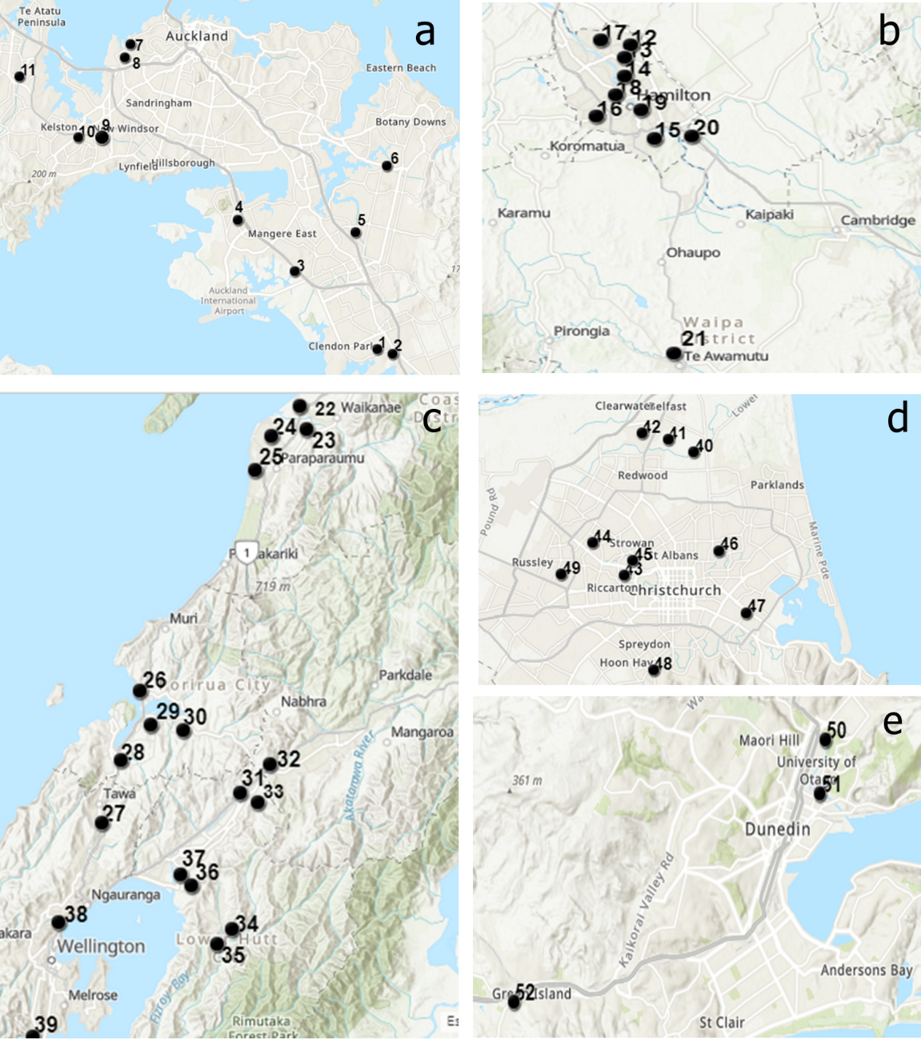**Figure S1**. Maps of the five urban regions, with the studied 52 stream sites identified by their site number; a: Auckland, b: Hamilton, c: Wellington, d: Christchurch, e: Dunedin

**Table S2.** Total microplastic items collected at each of the 52 stream sites (total items collected during 15 minutes and extrapolated to 24 hours using the flow velocity measured during sampling), plus numbers of microplastic items collected during 15 minutes in each size class and in each shape class.



**Table S3.** Total microplastic concentrations (per m3 of water and extrapolated to 1000 m3) at each of the 52 stream sites, plus microplastic concentrations per m3 in each size class and in each shape class.



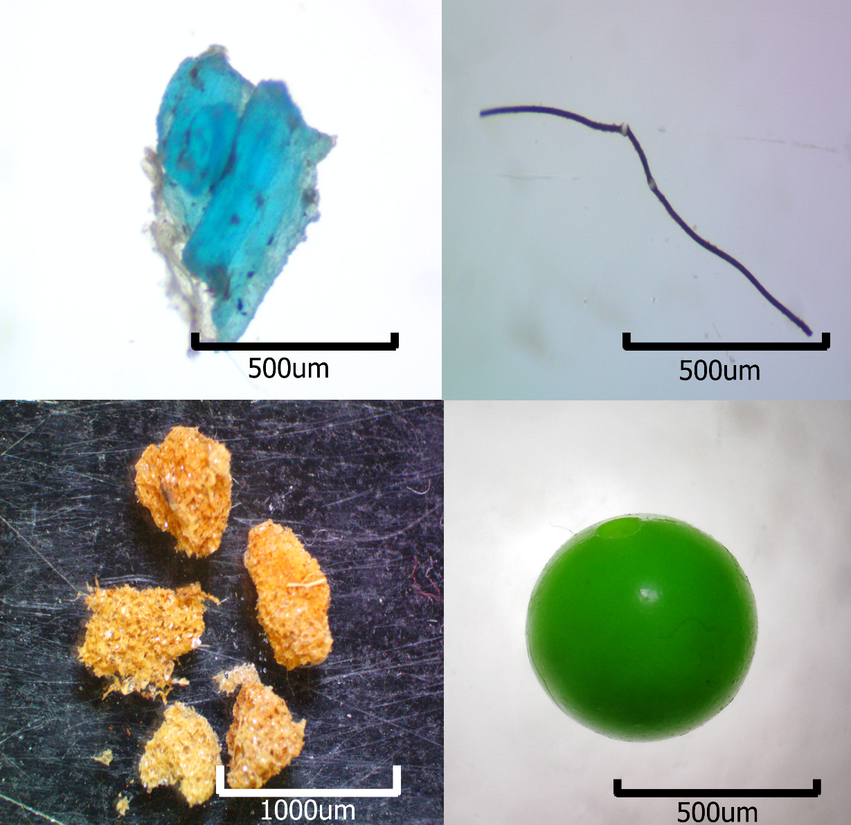

**Figure S2.** Microplastics found in the survey. Top left: fragment, top right: fibre, bottom left: polystyrene, bottom right: bead