Comparative study of antibiofilm, cytotoxic activities and chemical composition of Algerian propolis
Amina Daikhª, Narimane Segueniª*, Nazime Dogan^{b}, Sevki Arslan^{b}, Dogukan Mutlu^{b}, Ibrahim Kivrak^{c}, Salah Akkal^{d} and Salah Rhouatiª
ªLaboratory of natural product and organic synthesis. Department of Chemistry. University Constantine 1. Algeria
^{b}Department of Biology Science and Arts. Faculty Pamukkale University Denizli, Turkey.
^{c}Muğla Sıtkı Koçman University, Research Laboratory Center, Food Analysis Laboratory, 48000 Kotekli, Mugla, Turkey.
^{d}Valorization of Natural Resources, Bioactive Molecules and Biological Analysis Unit, Department of Chemistry, University of Mentouri Constantine1, 25000, Constantine, Algeria
*Corresponding author: E-Mail:segueninarimane@yahoo.fr.
Comparative study of antibiofilm, cytotoxic activities and chemical composition of Algerian propolis
Antimicrobial agents are one of the strategies for inhibition of biofilm formation. But, most antimicrobials aren’t often effective in controlling of biofilm formation. Therefore, finding of new materials that have biofilm inhibitory effects is so important. In this regards, we aimed to determine the antibiofilm and cytotoxic effect of five Algerian propolis extracts obtained by extraction in solvents of varying polarity. Propolis extracts were tested for their ability to inhibit biofilm formation and to reduce pre-formed biofilm of eight bacterial strains including reference strains of S. aureus (S. aureus ATCC29213 and S. aureus ATCC33862), three methicillin-resistant S. aureus (M10-1, M18-3 and M20-1), E. faecalis ATCC 19433, M. luteus NRRL-B1013 and Y. enterocolitica RSKK1501. Cytotoxic activities of propolis extracts were determined using MTT test. The chemical investigation was performed using ultra-performance liquid chromatography with electrospray ionization coupled to tandem mass spectrometry (UPLC-ESI-MS/MS). All tested extracts exhibited the highest eradicating capability for S. aureus reference strains and methicillin-resistant strains, especially MRSA18-3 and MRSA20-1. The reduction of biofilm formation was found to be significantly affected by the used solvent for maceration, the tested bacterial strains and the origin of tested propolis. In addition, biofilm reduction of Algerian propolis seemed to be dose-dependent. Moreover, all extracts showed high cytotoxic activity in colon adenocarcinoma cells. In addition, twenty-six phenolic compounds were detected. Difference between the amounts of detected compounds was found to be significant. Caffeic and ferulic acids were the main compounds in the tested extracts. These results suggest that those compounds might be responsible for the observed antibiofilm and cytotoxic activities of propolis extracts.
Keywords: Algerian propolis; antibiofilm activity; cytotoxic activity; MRSA; caffeic acid; ferulic acid

Figure S1. The total ion chromatograms (TIC) of major phenolic compounds found in Propolis PE1 (displayed as A1 in the TIC)

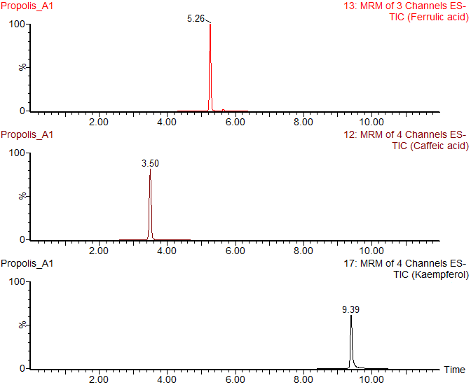

Figure S2. The total ion chromatograms (TIC) of major phenolic compounds found in PropolisEA5 (displayed as D2 in the TIC)
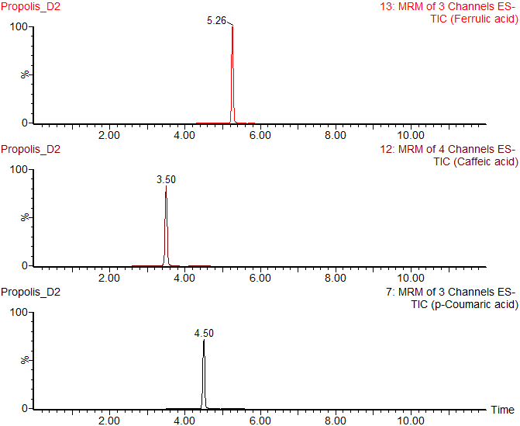

Figure S3. The total ion chromatograms (TIC) of major phenolic compounds found in PropolisME5 (displayed as D4 in the TIC)
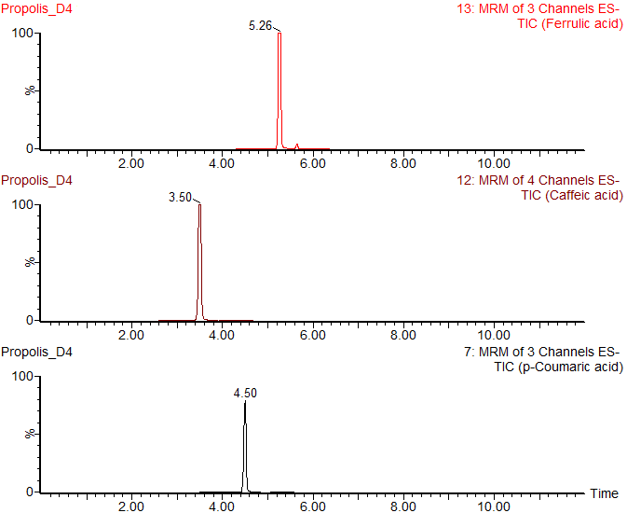

Figure S4. The total ion chromatograms (TIC) of major phenolic compounds found in Propolis Cl3 (displayed as E2 in the TIC)
