The other 8 theoretical model with corresponding population parameters of simulation one are placed as follows:

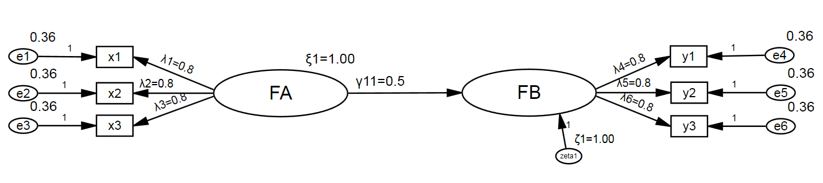
$Λ_{x}=\left[\begin{matrix}0.80 \\ 0.80 \\ 0.80\end{matrix}\right]$ $θ_{δ}=\left[\begin{matrix}0.36 & 0.00 & 0.00 \\ 0.00 & 0.36 & 0.00 \\ 0.00 & 0.00 & 0.36\end{matrix}\right]$
$Λ_{y}=\left[\begin{matrix}0.80 \\ 0.80 \\ 0.80\end{matrix}\right]$ $θ_{ε}=\left[\begin{matrix}0.36 & 0.00 & 0.00 \\ 0.00 & 0.36 & 0.00 \\ 0.00 & 0.00 & 0.36\end{matrix}\right]$
$Γ=\left[0.50\right]$ $ϕ=\left[1.00\right]$ $Β=\left[0.00\right]$ $Ψ=\left[1.00\right]$

Figure S1 | The SEM model with 2 factors and 3 indicators per factor, as well as the population parameters. FA is exogenous latent variable (factor); FB is endogenous latent variable (factor); x1-x3 and y1-y3 are the x and y indicators, respectively; e1-e6 are error terms of the indicators.

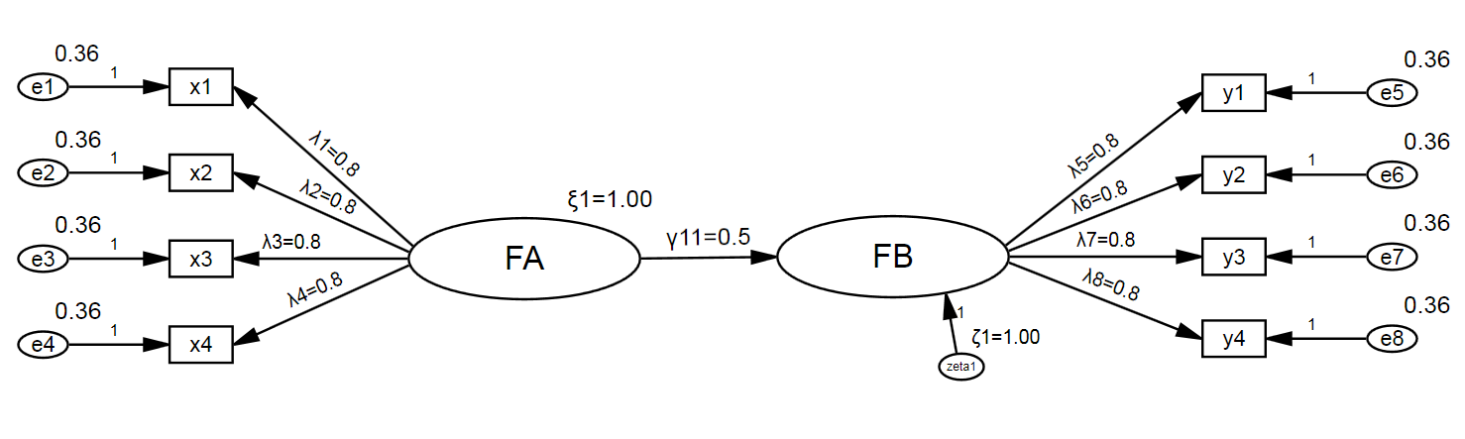
$Λ_{x}=\left[\begin{matrix}0.80 \\ 0.80 \\ \begin{matrix}0.80 \\ 0.80\end{matrix}\end{matrix}\right]$ $θ_{δ}=\left[\begin{matrix}\begin{matrix}0.36 \\ 0.00 \\ \begin{matrix}0.00 \\ 0.00\end{matrix}\end{matrix} & \begin{matrix}0.00 \\ \begin{matrix}0.36 \\ 0.00 \\ 0.00\end{matrix}\end{matrix} & \begin{matrix}\begin{matrix}0.00 \\ \begin{matrix}0.00 \\ 0.36 \\ 0.00\end{matrix}\end{matrix} & \begin{matrix}0.00 \\ \begin{matrix}0.00 \\ 0.00 \\ 0.36\end{matrix}\end{matrix}\end{matrix}\end{matrix}\right]$
$Λ_{y}=\left[\begin{matrix}0.80 \\ 0.80 \\ \begin{matrix}0.80 \\ 0.80\end{matrix}\end{matrix}\right]$ $θ_{ε}=\left[\begin{matrix}\begin{matrix}0.36 \\ 0.00 \\ \begin{matrix}0.00 \\ 0.00\end{matrix}\end{matrix} & \begin{matrix}0.00 \\ \begin{matrix}0.36 \\ 0.00 \\ 0.00\end{matrix}\end{matrix} & \begin{matrix}\begin{matrix}0.00 \\ \begin{matrix}0.00 \\ 0.36 \\ 0.00\end{matrix}\end{matrix} & \begin{matrix}0.00 \\ \begin{matrix}0.00 \\ 0.00 \\ 0.36\end{matrix}\end{matrix}\end{matrix}\end{matrix}\right]$
$Γ=\left[0.50\right]$ $ϕ=\left[1.00\right]$ $Β=\left[0.00\right]$ $Ψ=\left[1.00\right]$

Figure S2 | The SEM model with 2 factors and 4 indicators per factor, as well as the population parameters. FA is exogenous latent variable (factor); FB is endogenous latent variable (factor); x1-x4 and y1-y4 are the x and y indicators, respectively; e1-e8 are error terms of the indicators.
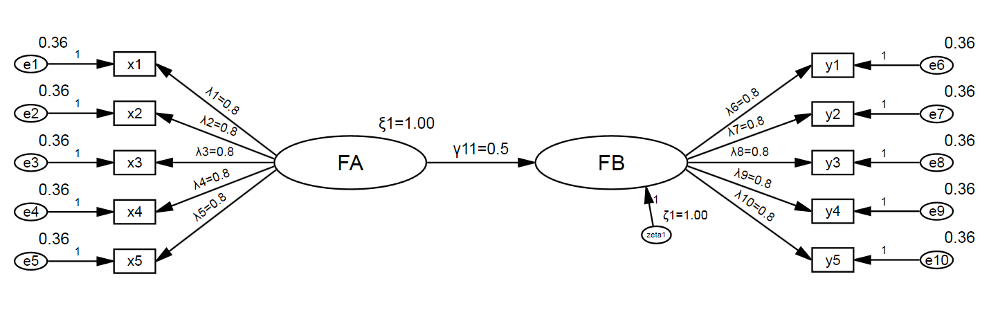
$Λ_{x}=\left[\begin{matrix}0.80 \\ 0.80 \\ \begin{matrix}0.80 \\ 0.80 \\ 0.80\end{matrix}\end{matrix}\right]$ $θ_{δ}=\left[\begin{matrix}\begin{matrix}0.36 & 0.00 & \begin{matrix}0.00 & 0.00 & 0.00\end{matrix}\end{matrix} \\ \begin{matrix}0.00 & \begin{matrix}0.36 & 0.00 & 0.00\end{matrix} & 0.00\end{matrix} \\ \begin{matrix}\begin{matrix}0.00 & \begin{matrix}0.00 & 0.36 & 0.00\end{matrix} & 0.00\end{matrix} \\ \begin{matrix}0.00 & \begin{matrix}0.00 & 0.00 & 0.36\end{matrix} & 0.00\end{matrix} \\ \begin{matrix}0.00 & \begin{matrix}0.00 & 0.00 & 0.00\end{matrix} & 0.36\end{matrix}\end{matrix}\end{matrix}\right]$
$Λ_{y}=\left[\begin{matrix}0.80 \\ 0.80 \\ \begin{matrix}0.80 \\ 0.80 \\ 0.80\end{matrix}\end{matrix}\right]$ $θ_{ε}=\left[\begin{matrix}\begin{matrix}0.36 & 0.00 & \begin{matrix}0.00 & 0.00 & 0.00\end{matrix}\end{matrix} \\ \begin{matrix}0.00 & \begin{matrix}0.36 & 0.00 & 0.00\end{matrix} & 0.00\end{matrix} \\ \begin{matrix}\begin{matrix}0.00 & \begin{matrix}0.00 & 0.36 & 0.00\end{matrix} & 0.00\end{matrix} \\ \begin{matrix}0.00 & \begin{matrix}0.00 & 0.00 & 0.36\end{matrix} & 0.00\end{matrix} \\ \begin{matrix}0.00 & \begin{matrix}0.00 & 0.00 & 0.00\end{matrix} & 0.36\end{matrix}\end{matrix}\end{matrix}\right]$
$Γ=\left[0.50\right]$ $ϕ=\left[1.00\right]$ $Β=\left[0.00\right]$ $Ψ=\left[1.00\right]$

Figure S3 | The SEM model with 2 factors and 5 indicators per factor, as well as the population parameters. FA is exogenous latent variable (factor); FB is endogenous latent variable (factor); x1-x5 and y1-y5 are the x and y indicators, respectively; e1-e10 are error terms of the indicators.

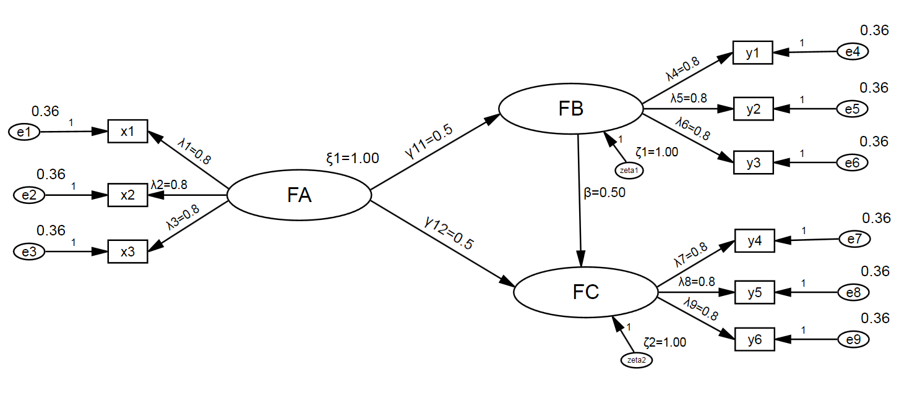
$Λ_{x}=\left[\begin{matrix}0.80 \\ 0.80 \\ 0.80\end{matrix}\right]$ $θ_{δ}=\left[\begin{matrix}0.36 & 0.00 & 0.00 \\ 0.00 & 0.36 & 0.00 \\ 0.00 & 0.00 & 0.36\end{matrix}\right]$
$Λ_{y}=\left[\begin{matrix}0.80 & 0.00 \\ \begin{matrix}0.80 \\ 0.80 \\ \begin{matrix}0.00 \\ 0.00 \\ 0.00\end{matrix}\end{matrix} & \begin{matrix}0.00 \\ 0.00 \\ \begin{matrix}0.80 \\ 0.80 \\ 0.80\end{matrix}\end{matrix}\end{matrix}\right]$ $θ_{ε}=\left[\begin{matrix}0.36 & 0.00 & \begin{matrix}0.00 & 0.00 & \begin{matrix}0.00 & 0.00\end{matrix}\end{matrix} \\ 0.00 & 0.36 & \begin{matrix}0.00 & 0.00 & \begin{matrix}0.00 & 0.00\end{matrix}\end{matrix} \\ \begin{matrix}0.00 \\ 0.00 \\ \begin{matrix}0.00 \\ 0.00\end{matrix}\end{matrix} & \begin{matrix}0.00 \\ 0.00 \\ \begin{matrix}0.00 \\ 0.00\end{matrix}\end{matrix} & \begin{matrix}\begin{matrix}0.36 & 0.00 & \begin{matrix}0.00 & 0.00\end{matrix}\end{matrix} \\ \begin{matrix}0.00 & 0.36 & \begin{matrix}0.00 & 0.00\end{matrix}\end{matrix} \\ \begin{matrix}\begin{matrix}0.00 & 0.00 & \begin{matrix}0.36 & 0.00\end{matrix}\end{matrix} \\ \begin{matrix}0.00 & 0.00 & \begin{matrix}0.00 & 0.36\end{matrix}\end{matrix}\end{matrix}\end{matrix}\end{matrix}\right]$
$Γ=\left[\begin{matrix}0.50 \\ 0.50\end{matrix}\right]$ $ϕ=\left[1.00\right]$ $Β=\left[\begin{matrix}0.00 & 0.00 \\ 0.50 & 0.00\end{matrix}\right]$ $Ψ=\left[\begin{matrix}1.00 & 0.00 \\ 0.00 & 1.00\end{matrix}\right]$

Figure S4 | The SEM model with 3 factors and 3 indicators per factor, as well as the population parameters. FA is exogenous latent variable (factor); FB and FC are endogenous latent variables (factors); x1-x3 and y1-y6 are the x and y indicators, respectively; e1-e9 are error terms of the indicators.

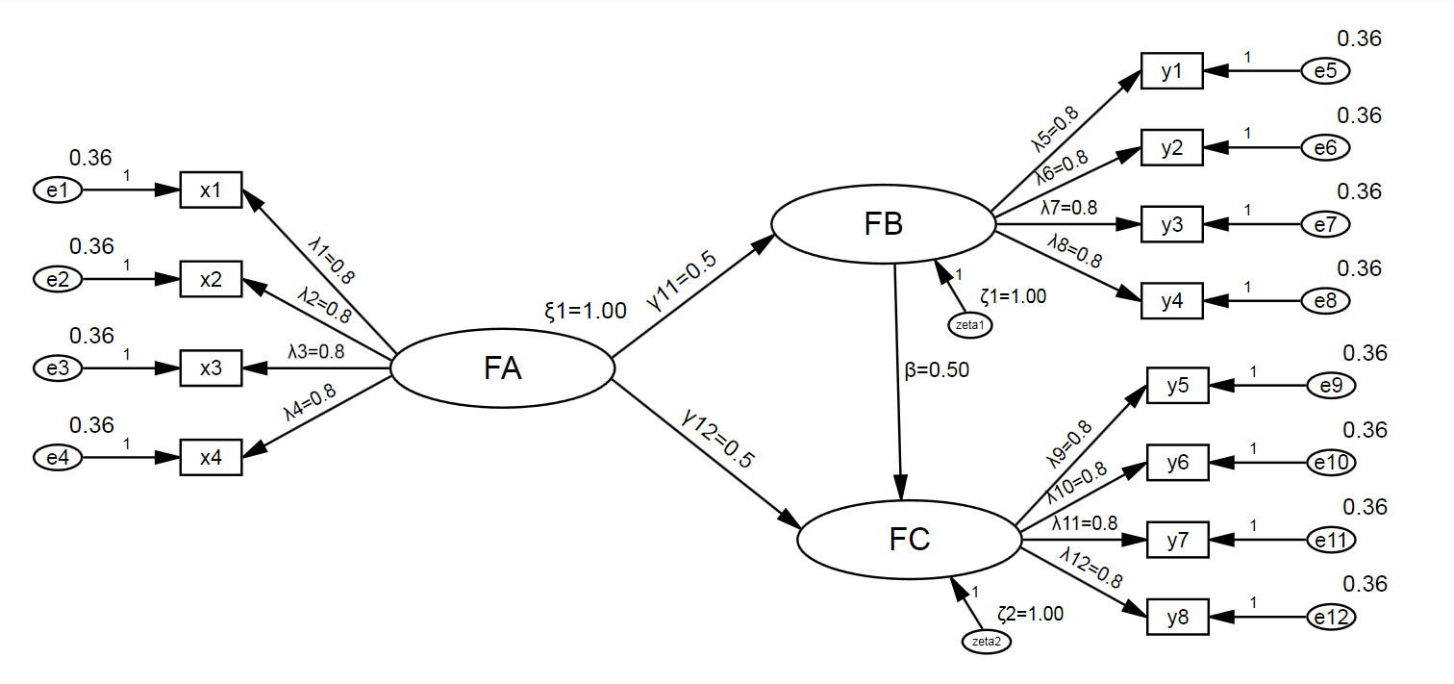
$Λ_{x}=\left[\begin{matrix}0.80 \\ 0.80 \\ \begin{matrix}0.80 \\ 0.80\end{matrix}\end{matrix}\right]$ $θ_{δ}=\left[\begin{matrix}\begin{matrix}0.36 \\ 0.00 \\ \begin{matrix}0.00 \\ 0.00\end{matrix}\end{matrix} & \begin{matrix}0.00 \\ \begin{matrix}0.36 \\ 0.00 \\ 0.00\end{matrix}\end{matrix} & \begin{matrix}\begin{matrix}0.00 \\ \begin{matrix}0.00 \\ 0.36 \\ 0.00\end{matrix}\end{matrix} & \begin{matrix}0.00 \\ \begin{matrix}0.00 \\ 0.00 \\ 0.36\end{matrix}\end{matrix}\end{matrix}\end{matrix}\right]$
$Λ_{y}=\left[\begin{matrix}0.80 & 0.00 \\ 0.80 & 0.00 \\ \begin{matrix}0.80 \\ \begin{matrix}0.80 \\ 0.00 \\ \begin{matrix}0.00 \\ 0.00 \\ 0.00\end{matrix}\end{matrix}\end{matrix} & \begin{matrix}0.00 \\ \begin{matrix}0.00 \\ 0.80 \\ \begin{matrix}0.80 \\ 0.80 \\ 0.80\end{matrix}\end{matrix}\end{matrix}\end{matrix}\right]$ $θ_{ε}=\left[\begin{matrix}0.36 & 0.00 & \begin{matrix}0.00 & 0.00 & \begin{matrix}0.00 & \begin{matrix}0.00 & 0.00 & 0.00\end{matrix}\end{matrix}\end{matrix} \\ 0.00 & 0.36 & \begin{matrix}0.00 & 0.00 & \begin{matrix}0.00 & \begin{matrix}0.00 & 0.00 & 0.00\end{matrix}\end{matrix}\end{matrix} \\ \begin{matrix}0.00 \\ 0.00 \\ \begin{matrix}0.00 \\ \begin{matrix}0.00 \\ \begin{matrix}0.00 \\ 0.00\end{matrix}\end{matrix}\end{matrix}\end{matrix} & \begin{matrix}0.00 \\ 0.00 \\ \begin{matrix}0.00 \\ \begin{matrix}0.00 \\ \begin{matrix}0.00 \\ 0.00\end{matrix}\end{matrix}\end{matrix}\end{matrix} & \begin{matrix}\begin{matrix}0.36 & 0.00 & \begin{matrix}0.00 & \begin{matrix}0.00 & 0.00 & 0.00\end{matrix}\end{matrix}\end{matrix} \\ \begin{matrix}0.00 & 0.36 & \begin{matrix}0.00 & \begin{matrix}0.00 & 0.00 & 0.00\end{matrix}\end{matrix}\end{matrix} \\ \begin{matrix}\begin{matrix}0.00 & 0.00 & \begin{matrix}0.36 & \begin{matrix}0.00 & 0.00 & 0.00\end{matrix}\end{matrix}\end{matrix} \\ \begin{matrix}\begin{matrix}0.00 & 0.00 & \begin{matrix}0.00 & \begin{matrix}0.36 & 0.00 & 0.00\end{matrix}\end{matrix}\end{matrix} \\ \begin{matrix}\begin{matrix}0.00 & 0.00 & \begin{matrix}0.00 & \begin{matrix}0.00 & 0.36 & 0.00\end{matrix}\end{matrix}\end{matrix} \\ \begin{matrix}0.00 & 0.00 & \begin{matrix}0.00 & \begin{matrix}0.00 & 0.00 & 0.36\end{matrix}\end{matrix}\end{matrix}\end{matrix}\end{matrix}\end{matrix}\end{matrix}\end{matrix}\right]$
$Γ=\left[\begin{matrix}0.50 \\ 0.50\end{matrix}\right]$ $ϕ=\left[1.00\right]$ $Β=\left[\begin{matrix}0.00 & 0.00 \\ 0.50 & 0.00\end{matrix}\right]$ $Ψ=\left[\begin{matrix}1.00 & 0.00 \\ 0.00 & 1.00\end{matrix}\right]$

Figure S5 | The SEM model with 3 factors and 4 indicators per factor, as well as the population parameters. FA is exogenous latent variable (factor); FB and FC are endogenous latent variables (factors); x1-x4 and y1-y8 are the x and y indicators, respectively; e1-e12 are error terms of the indicators.

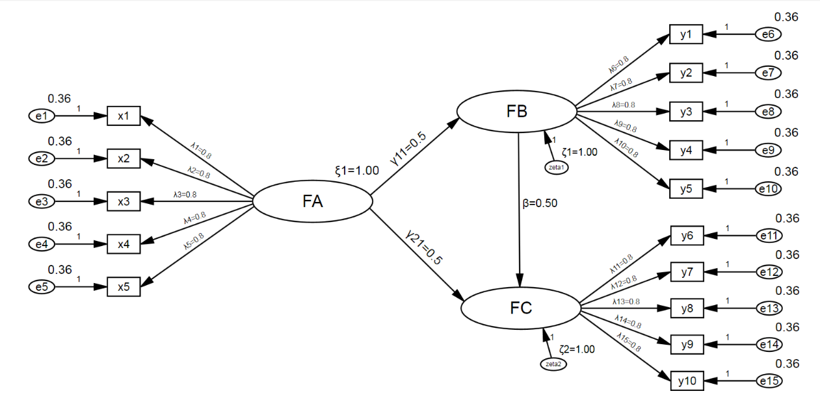
$Λ_{x}=\left[\begin{matrix}0.80 \\ \begin{matrix}0.80 \\ \begin{matrix}0.80 \\ \begin{matrix}0.80 \\ 0.80\end{matrix}\end{matrix}\end{matrix}\end{matrix}\right]$ $θ_{δ}=\left[\begin{matrix}\begin{matrix}0.36 & 0.00 & \begin{matrix}0.00 & 0.00 & 0.00\end{matrix}\end{matrix} \\ \begin{matrix}0.00 & \begin{matrix}0.36 & 0.00 & 0.00\end{matrix} & 0.00\end{matrix} \\ \begin{matrix}\begin{matrix}0.00 & \begin{matrix}0.00 & 0.36 & 0.00\end{matrix} & 0.00\end{matrix} \\ \begin{matrix}0.00 & \begin{matrix}0.00 & 0.00 & 0.36\end{matrix} & 0.00\end{matrix} \\ \begin{matrix}0.00 & \begin{matrix}0.00 & 0.00 & 0.00\end{matrix} & 0.36\end{matrix}\end{matrix}\end{matrix}\right]$
$Λ_{y}=\left[\begin{matrix}0.80 & 0.00 \\ 0.80 & 0.00 \\ \begin{matrix}0.80 \\ 0.80 \\ \begin{matrix}0.80 \\ 0.00 \\ \begin{matrix}0.00 \\ \begin{matrix}0.00 \\ 0.00 \\ 0.00\end{matrix}\end{matrix}\end{matrix}\end{matrix} & \begin{matrix}0.00 \\ 0.00 \\ \begin{matrix}0.00 \\ 0.80 \\ \begin{matrix}0.80 \\ \begin{matrix}0.80 \\ 0.80 \\ 0.80\end{matrix}\end{matrix}\end{matrix}\end{matrix}\end{matrix}\right]$ $θ_{ε}=\left[\begin{matrix}\begin{matrix}\begin{matrix}0.36 \\ 0.00 \\ \begin{matrix}0.00 \\ 0.00 \\ \begin{matrix}0.00 \\ 0.00 \\ \begin{matrix}0.00 \\ 0.00 \\ \begin{matrix}0.00 \\ 0.00\end{matrix}\end{matrix}\end{matrix}\end{matrix}\end{matrix} & \begin{matrix}0.00 \\ 0.36 \\ \begin{matrix}0.00 \\ 0.00 \\ \begin{matrix}0.00 \\ 0.00 \\ \begin{matrix}0.00 \\ 0.00 \\ \begin{matrix}0.00 \\ 0.00\end{matrix}\end{matrix}\end{matrix}\end{matrix}\end{matrix} & \begin{matrix}0.00 \\ 0.00 \\ \begin{matrix}0.36 \\ 0.00 \\ \begin{matrix}0.00 \\ 0.00 \\ \begin{matrix}0.00 \\ 0.00 \\ \begin{matrix}0.00 \\ 0.00\end{matrix}\end{matrix}\end{matrix}\end{matrix}\end{matrix}\end{matrix} & \begin{matrix}\begin{matrix}0.00 \\ 0.00 \\ \begin{matrix}0.00 \\ 0.36 \\ \begin{matrix}0.00 \\ 0.00 \\ \begin{matrix}0.00 \\ 0.00 \\ \begin{matrix}0.00 \\ 0.00\end{matrix}\end{matrix}\end{matrix}\end{matrix}\end{matrix} & \begin{matrix}0.00 \\ 0.00 \\ \begin{matrix}0.00 \\ 0.00 \\ \begin{matrix}0.36 \\ 0.00 \\ \begin{matrix}0.00 \\ 0.00 \\ \begin{matrix}0.00 \\ 0.00\end{matrix}\end{matrix}\end{matrix}\end{matrix}\end{matrix} & \begin{matrix}0.00 \\ 0.00 \\ \begin{matrix}0.00 \\ 0.00 \\ \begin{matrix}0.00 \\ 0.36 \\ \begin{matrix}0.00 \\ 0.00 \\ \begin{matrix}0.00 \\ 0.00\end{matrix}\end{matrix}\end{matrix}\end{matrix}\end{matrix}\end{matrix} & \begin{matrix}\begin{matrix}0.00 \\ 0.00 \\ \begin{matrix}0.00 \\ 0.00 \\ \begin{matrix}0.00 \\ 0.00 \\ \begin{matrix}0.36 \\ 0.00 \\ \begin{matrix}0.00 \\ 0.00\end{matrix}\end{matrix}\end{matrix}\end{matrix}\end{matrix} & \begin{matrix}0.00 \\ 0.00 \\ \begin{matrix}0.00 \\ 0.00 \\ \begin{matrix}0.00 \\ 0.00 \\ \begin{matrix}0.00 \\ 0.36 \\ \begin{matrix}0.00 \\ 0.00\end{matrix}\end{matrix}\end{matrix}\end{matrix}\end{matrix} & \begin{matrix}\begin{matrix}0.00 \\ 0.00 \\ \begin{matrix}0.00 \\ 0.00 \\ \begin{matrix}0.00 \\ 0.00 \\ \begin{matrix}0.00 \\ 0.00 \\ \begin{matrix}0.36 \\ 0.00\end{matrix}\end{matrix}\end{matrix}\end{matrix}\end{matrix} & \begin{matrix}0.00 \\ 0.00 \\ \begin{matrix}0.00 \\ 0.00 \\ \begin{matrix}0.00 \\ 0.00 \\ \begin{matrix}0.00 \\ 0.00 \\ \begin{matrix}0.00 \\ 0.36\end{matrix}\end{matrix}\end{matrix}\end{matrix}\end{matrix}\end{matrix}\end{matrix}\end{matrix}\right]$
$Γ=\left[\begin{matrix}0.50 \\ 0.50\end{matrix}\right]$ $ϕ=\left[1.00\right]$ $Β=\left[\begin{matrix}0.00 & 0.00 \\ 0.50 & 0.00\end{matrix}\right]$ $Ψ=\left[\begin{matrix}1.00 & 0.00 \\ 0.00 & 1.00\end{matrix}\right]$

Figure S6 | The SEM model with 3 factors and 5 indicators per factor, as well as the population parameters. FA is exogenous latent variable (factor); FB and FC are endogenous latent variables (factors); x1-x5 and y1-y10 are the x and y indicators, respectively; e1-e15 are error terms of the indicators.

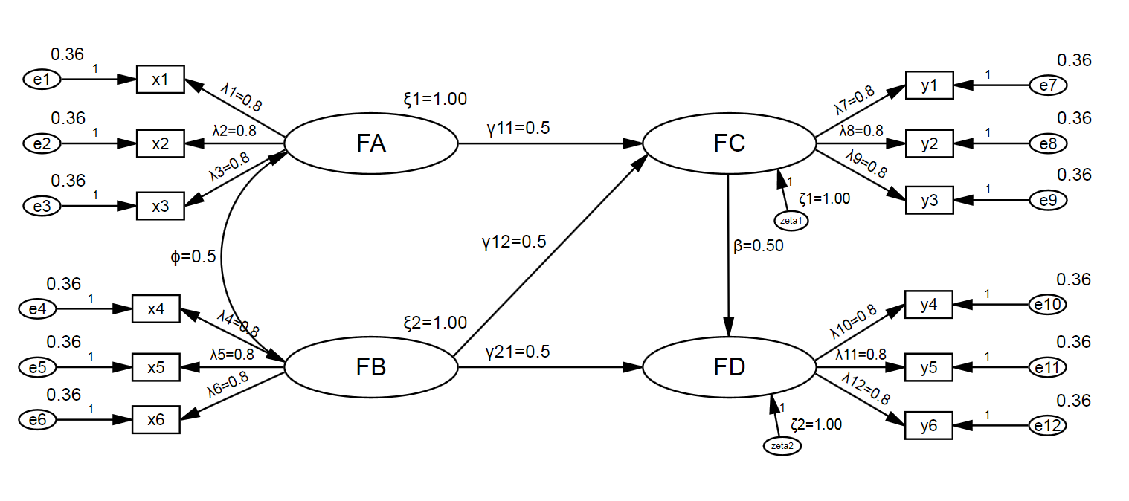
$Λ_{x}=\left[\begin{matrix}0.80 & 0.00 \\ 0.80 & 0.00 \\ \begin{matrix}0.80 \\ 0.00 \\ \begin{matrix}0.00 \\ 0.00\end{matrix}\end{matrix} & \begin{matrix}0.00 \\ 0.80 \\ \begin{matrix}0.80 \\ 0.80\end{matrix}\end{matrix}\end{matrix}\right]$ $θ_{δ}=\left[\begin{matrix}0.36 & 0.00 & \begin{matrix}0.00 & 0.00 & \begin{matrix}0.00 & 0.00\end{matrix}\end{matrix} \\ 0.00 & 0.36 & \begin{matrix}0.00 & 0.00 & \begin{matrix}0.00 & 0.00\end{matrix}\end{matrix} \\ \begin{matrix}0.00 \\ 0.00 \\ \begin{matrix}0.00 \\ 0.00\end{matrix}\end{matrix} & \begin{matrix}0.00 \\ 0.00 \\ \begin{matrix}0.00 \\ 0.00\end{matrix}\end{matrix} & \begin{matrix}\begin{matrix}0.36 & 0.00 & \begin{matrix}0.00 & 0.00\end{matrix}\end{matrix} \\ \begin{matrix}0.00 & 0.36 & \begin{matrix}0.00 & 0.00\end{matrix}\end{matrix} \\ \begin{matrix}\begin{matrix}0.00 & 0.00 & \begin{matrix}0.36 & 0.00\end{matrix}\end{matrix} \\ \begin{matrix}0.00 & 0.00 & \begin{matrix}0.00 & 0.36\end{matrix}\end{matrix}\end{matrix}\end{matrix}\end{matrix}\right]$
$Λ_{y}=\left[\begin{matrix}0.80 & 0.00 \\ 0.80 & 0.00 \\ \begin{matrix}0.80 \\ 0.00 \\ \begin{matrix}0.00 \\ 0.00\end{matrix}\end{matrix} & \begin{matrix}0.00 \\ 0.80 \\ \begin{matrix}0.80 \\ 0.80\end{matrix}\end{matrix}\end{matrix}\right]$ $θ_{ε}=\left[\begin{matrix}0.36 & 0.00 & \begin{matrix}0.00 & 0.00 & \begin{matrix}0.00 & 0.00\end{matrix}\end{matrix} \\ 0.00 & 0.36 & \begin{matrix}0.00 & 0.00 & \begin{matrix}0.00 & 0.00\end{matrix}\end{matrix} \\ \begin{matrix}0.00 \\ 0.00 \\ \begin{matrix}0.00 \\ 0.00\end{matrix}\end{matrix} & \begin{matrix}0.00 \\ 0.00 \\ \begin{matrix}0.00 \\ 0.00\end{matrix}\end{matrix} & \begin{matrix}\begin{matrix}0.36 & 0.00 & \begin{matrix}0.00 & 0.00\end{matrix}\end{matrix} \\ \begin{matrix}0.00 & 0.36 & \begin{matrix}0.00 & 0.00\end{matrix}\end{matrix} \\ \begin{matrix}\begin{matrix}0.00 & 0.00 & \begin{matrix}0.36 & 0.00\end{matrix}\end{matrix} \\ \begin{matrix}0.00 & 0.00 & \begin{matrix}0.00 & 0.36\end{matrix}\end{matrix}\end{matrix}\end{matrix}\end{matrix}\right]$
$Γ=\left[\begin{matrix}0.50 & 0.50 \\ 0.00 & 0.50\end{matrix}\right]$ $ϕ=\left[\begin{matrix}1.00 & 0.50 \\ 0.50 & 1.00\end{matrix}\right]$ $Β=\left[\begin{matrix}0.00 & 0.00 \\ 0.50 & 0.00\end{matrix}\right]$ $Ψ=\left[\begin{matrix}1.00 & 0.00 \\ 0.00 & 1.00\end{matrix}\right]$

Figure S7 | The SEM model with 4 factors and 3 indicators per factor, as well as the population parameters. FA and FB are exogenous latent variables (factors); FC and FD are endogenous latent variables (factors); x1-x6 and y1-y6 are the x and y indicators, respectively; e1-e12 are error terms of the indicators.

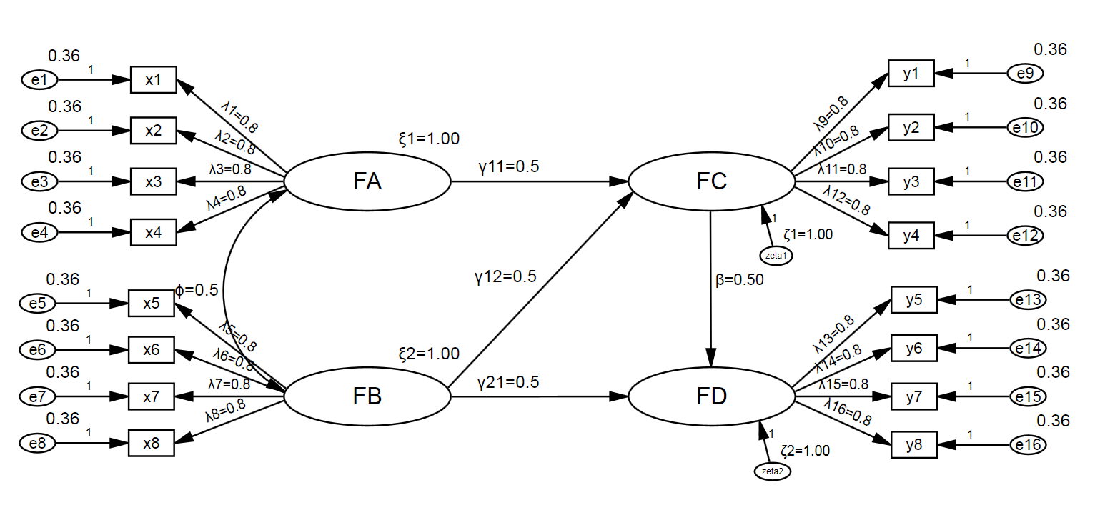
$Λ_{x}=\left[\begin{matrix}0.80 & 0.00 \\ 0.80 & 0.00 \\ \begin{matrix}0.80 \\ 0.80 \\ \begin{matrix}0.00 \\ \begin{matrix}0.00 \\ 0.00 \\ 0.00\end{matrix}\end{matrix}\end{matrix} & \begin{matrix}0.00 \\ 0.00 \\ \begin{matrix}0.80 \\ \begin{matrix}0.80 \\ 0.80 \\ 0.80\end{matrix}\end{matrix}\end{matrix}\end{matrix}\right]$ $θ_{δ}=\left[\begin{matrix}0.36 & 0.00 & \begin{matrix}0.00 & 0.00 & \begin{matrix}0.00 & \begin{matrix}0.00 & 0.00 & 0.00\end{matrix}\end{matrix}\end{matrix} \\ 0.00 & 0.36 & \begin{matrix}0.00 & 0.00 & \begin{matrix}0.00 & \begin{matrix}0.00 & 0.00 & 0.00\end{matrix}\end{matrix}\end{matrix} \\ \begin{matrix}0.00 \\ 0.00 \\ \begin{matrix}0.00 \\ \begin{matrix}0.00 \\ \begin{matrix}0.00 \\ 0.00\end{matrix}\end{matrix}\end{matrix}\end{matrix} & \begin{matrix}0.00 \\ 0.00 \\ \begin{matrix}0.00 \\ \begin{matrix}0.00 \\ \begin{matrix}0.00 \\ 0.00\end{matrix}\end{matrix}\end{matrix}\end{matrix} & \begin{matrix}\begin{matrix}0.36 & 0.00 & \begin{matrix}0.00 & \begin{matrix}0.00 & 0.00 & 0.00\end{matrix}\end{matrix}\end{matrix} \\ \begin{matrix}0.00 & 0.36 & \begin{matrix}0.00 & \begin{matrix}0.00 & 0.00 & 0.00\end{matrix}\end{matrix}\end{matrix} \\ \begin{matrix}\begin{matrix}0.00 & 0.00 & \begin{matrix}0.36 & \begin{matrix}0.00 & 0.00 & 0.00\end{matrix}\end{matrix}\end{matrix} \\ \begin{matrix}\begin{matrix}0.00 & 0.00 & \begin{matrix}0.00 & \begin{matrix}0.36 & 0.00 & 0.00\end{matrix}\end{matrix}\end{matrix} \\ \begin{matrix}\begin{matrix}0.00 & 0.00 & \begin{matrix}0.00 & \begin{matrix}0.00 & 0.36 & 0.00\end{matrix}\end{matrix}\end{matrix} \\ \begin{matrix}0.00 & 0.00 & \begin{matrix}0.00 & \begin{matrix}0.00 & 0.00 & 0.36\end{matrix}\end{matrix}\end{matrix}\end{matrix}\end{matrix}\end{matrix}\end{matrix}\end{matrix}\right]$
$Λ_{y}=\left[\begin{matrix}0.80 & 0.00 \\ 0.80 & 0.00 \\ \begin{matrix}0.80 \\ 0.80 \\ \begin{matrix}0.00 \\ \begin{matrix}0.00 \\ 0.00 \\ 0.00\end{matrix}\end{matrix}\end{matrix} & \begin{matrix}0.00 \\ 0.00 \\ \begin{matrix}0.80 \\ \begin{matrix}0.80 \\ 0.80 \\ 0.80\end{matrix}\end{matrix}\end{matrix}\end{matrix}\right]$ $θ_{ε}=\left[\begin{matrix}0.36 & 0.00 & \begin{matrix}0.00 & 0.00 & \begin{matrix}0.00 & \begin{matrix}0.00 & 0.00 & 0.00\end{matrix}\end{matrix}\end{matrix} \\ 0.00 & 0.36 & \begin{matrix}0.00 & 0.00 & \begin{matrix}0.00 & \begin{matrix}0.00 & 0.00 & 0.00\end{matrix}\end{matrix}\end{matrix} \\ \begin{matrix}0.00 \\ 0.00 \\ \begin{matrix}0.00 \\ \begin{matrix}0.00 \\ \begin{matrix}0.00 \\ 0.00\end{matrix}\end{matrix}\end{matrix}\end{matrix} & \begin{matrix}0.00 \\ 0.00 \\ \begin{matrix}0.00 \\ \begin{matrix}0.00 \\ \begin{matrix}0.00 \\ 0.00\end{matrix}\end{matrix}\end{matrix}\end{matrix} & \begin{matrix}\begin{matrix}0.36 & 0.00 & \begin{matrix}0.00 & \begin{matrix}0.00 & 0.00 & 0.00\end{matrix}\end{matrix}\end{matrix} \\ \begin{matrix}0.00 & 0.36 & \begin{matrix}0.00 & \begin{matrix}0.00 & 0.00 & 0.00\end{matrix}\end{matrix}\end{matrix} \\ \begin{matrix}\begin{matrix}0.00 & 0.00 & \begin{matrix}0.36 & \begin{matrix}0.00 & 0.00 & 0.00\end{matrix}\end{matrix}\end{matrix} \\ \begin{matrix}\begin{matrix}0.00 & 0.00 & \begin{matrix}0.00 & \begin{matrix}0.36 & 0.00 & 0.00\end{matrix}\end{matrix}\end{matrix} \\ \begin{matrix}\begin{matrix}0.00 & 0.00 & \begin{matrix}0.00 & \begin{matrix}0.00 & 0.36 & 0.00\end{matrix}\end{matrix}\end{matrix} \\ \begin{matrix}0.00 & 0.00 & \begin{matrix}0.00 & \begin{matrix}0.00 & 0.00 & 0.36\end{matrix}\end{matrix}\end{matrix}\end{matrix}\end{matrix}\end{matrix}\end{matrix}\end{matrix}\right]$
$Γ=\left[\begin{matrix}0.50 & 0.50 \\ 0.00 & 0.50\end{matrix}\right]$ $ϕ=\left[\begin{matrix}1.00 & 0.50 \\ 0.50 & 1.00\end{matrix}\right]$ $Β=\left[\begin{matrix}0.00 & 0.00 \\ 0.50 & 0.00\end{matrix}\right]$ $Ψ=\left[\begin{matrix}1.00 & 0.00 \\ 0.00 & 1.00\end{matrix}\right]$

Figure S8 | The SEM model with 4 factors and 4 indicators per factor, as well as the population parameters. FA and FB are exogenous latent variables (factors); FC and FD are endogenous latent variables (factors); x1-x8 and y1-y8 are the x and y indicators, respectively; e1-e16 are error terms of the indicators.

