Appendix 1. Action Primes along with Turkish labels.
- Chopping vegetables, “doğra”
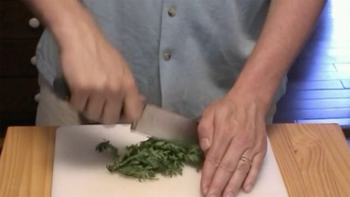
- Cutting paper, “kes”
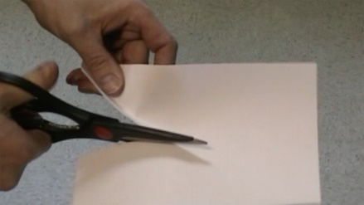
- Dialing a phone, “tuşla”
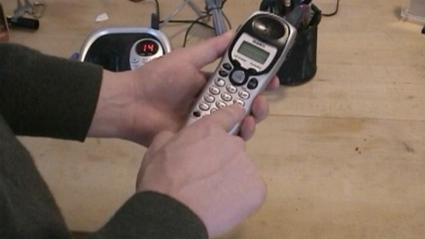
- Hammering a nail, “çak”
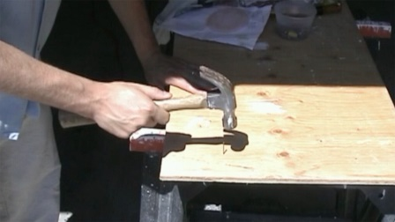
- Scrubbing a dish, “yıka”
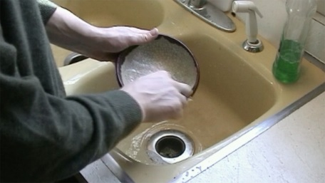

- Stirring soup, “karıştır”
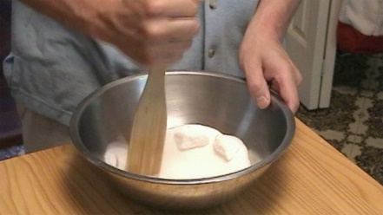
- Turning a key, “döndür”
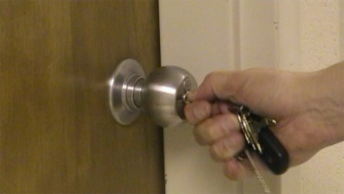
- Twisting the lid of a jar, “çevir”
- Typing, “yaz”
- Wiping the desk, “sil”

