Supplementary material
Synthesis, characterization and application of magnetic nanoparticles modified with Fe-Mn binary oxide for the effective removal of As(III) and As(V) from water
Jasmina Nikićª, Malcolm A. Watson*ª, Marijana Kragulj Isakovskiª, Aleksandra Tubićª,
Marko Šolićª, Branko Kordićª, Jasmina Agbabaª

ªUniversity of Novi Sad Faculty of Sciences, Department of Chemistry, Biochemistry and Environmental Protection, Trg Dositeja Obradovića 3, 21000 Novi Sad, Republic of Serbia
*Corresponding author: Malcolm Watson, email: malcolm.watson@dh.uns.ac.rs

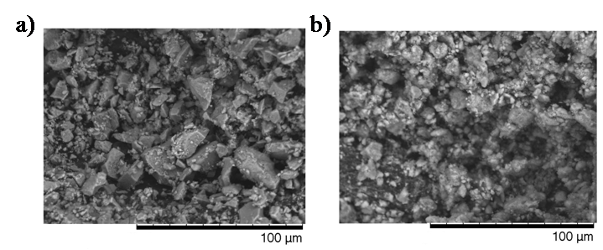
Figure S1. SEM images of a) MNp b) MNp-FeMn

Figure S2. XRD patterns of a) MNp b) MNp-FeMn

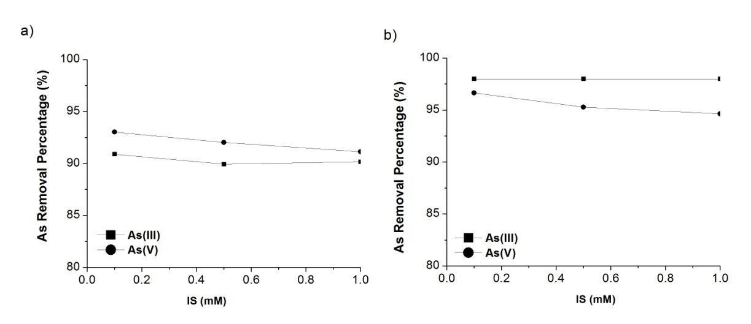
Figure S3. Effect of ionic strength on As(III) and As(V) removal by a) MNp b) MNp-FeMn
Initial As concentration 0.2 mg/l; sorbent dose 0.5 g/l

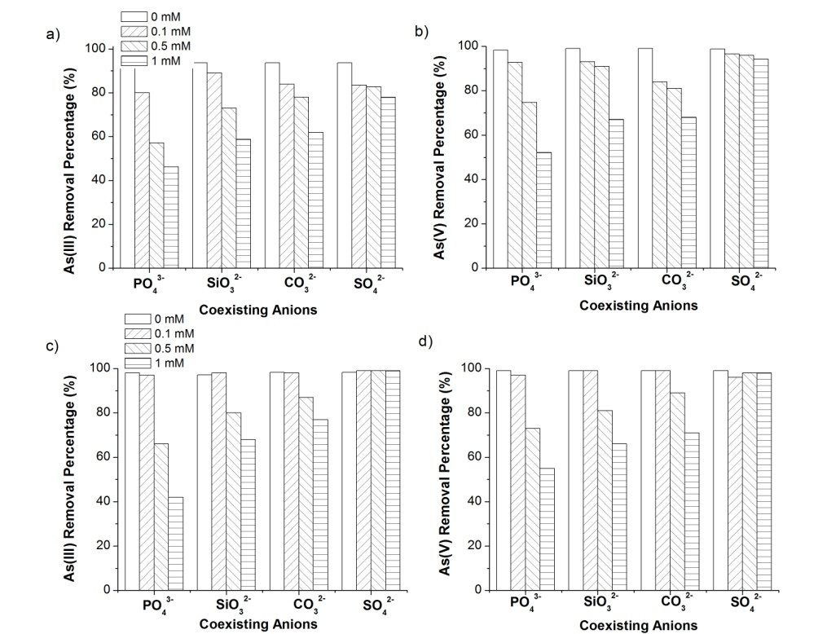
Figure S4. Effect of coexisting anions on As(III) and As(V) removal by a-b) MNp and c-d) MNp -FeMn
Initial As concentration 0.2 mg/l. adsorbent dose 0.5 g/l. initial solution pH 7.0 ± 0.2.

Table S1. EDS analysis of MNp and MNp-FeMn
Adsorbents | Element (%)
 | C | O | Fe | Mn
MNp | 15.2 | 43.2 | 41.7 | -
MNp-FeMn | 8.75 | 47.4 | 35.0 | 8.84

Table S2. Absorption bands of the FTIR spectra of MNp and MNp-FeMN before and after As(III) and As(V) adsorption
Wavenumber (cm⁻¹) | MNp | MNp-FeMn | MNp +As(III) | MNp  +As(V) | MNp-FeMn  +As(III) | MNp-FeMn +As(V) | Functional group | Reference
3420 | + | + | + | + | + | + | -OH stretching vibration of OH group  (from H₂O) | [20]
1630 | + | + | + | + | + | + | -OH bending vibration of OH group  (from H₂O)
1384 | - | - | + | - | - | - | -OH bending vibration of OH
1050 | - | + | - | - | - | - | -OH bending vibration of OH group (Fe-OH) | [47,48]
1120 | + | - | - | - | - | -
825 | - | - | - | + | + | + | As–O stretching vibration  (As–O–Fe) | [20,47,48]
694 | + | - | + | + | - | - | Fe–O-Fe stretching vibration of the γ-Fe₂O₃ | [31]
636 | + | + | + | + | + | +
560 | + | + | + | + | + | +

