Supplementary Material

1 Supplementary Tables
Supplementary Table S1 Identification of significantly different metabolites (SDMs) during pre-fermentation
Metabolites | R. T. (min) | Similarity | Mass | VIP | p-value
Alanine | 7.94 | 957 | 116 | 1.229 | <0.001
2-Deoxyerythritol | 10.61 | 916 | 117 | 1.59 | 0.002
Proline | 10.75 | 952 | 142 | 3.962 | <0.001
Succinic acid | 10.97 | 924 | 247 | 2.188 | <0.001
Tartronic acid | 11.96 | 606 | 131 | 2.403 | <0.001
L-Malic acid | 13.19 | 900 | 233 | 1.006 | <0.001
5-Oxoproline | 13.67 | 935 | 156 | 2.068 | 0.049
4-Aminobutyric acid | 13.73 | 893 | 174 | 1.582 | 0.001
4-Hydroxyphenylethanol | 14.28 | 846 | 179 | 1.336 | <0.001
3-Phenyllactic acid | 14.39 | 869 | 193 | 1.189 | <0.001
Xylose | 15.22 | 933 | 103 | 1.119 | <0.001
Ribose | 15.39 | 871 | 103 | 1.095 | <0.001
Glucose-1-phosphate | 16.42 | 916 | 217 | 2.064 | <0.001
2-Deoxy-D-glucose | 16.51 | 619 | 103 | 1.108 | <0.001
3,4-Dihydroxybenzoic acid | 17.03 | 938 | 193 | 2.163 | <0.001
Fructose | 17.48 | 859 | 103 | 7.242 | <0.001
Dl-p-Hydroxyphenyl lactic acid | 17.88 | 856 | 179 | 2.202 | <0.001
D-galacturonic acid | 18.25 | 844 | 333 | 1.44 | <0.001
Gluconic acid | 18.77 | 870 | 333 | 1.197 | 0.001
Palmitic acid | 19.35 | 950 | 132 | 3.351 | 0.024
Myo-inositol | 19.65 | 943 | 305 | 1.122 | 0.012
Glucoheptonic acid | 20.09 | 622 | 204 | 3.421 | <0.001
Oleic acid | 20.88 | 917 | 337 | 1.958 | 0.005
6-Phosphogluconic acid | 22.44 | 679 | 318 | 1.307 | <0.001
Sucrose | 24.17 | 835 | 361 | 1.955 | 0.010
Trehalose | 25.03 | 818 | 191 | 3.247 | 0.020
Sophorose | 25.29 | 894 | 319 | 1.403 | <0.001
Maltotriitol | 32.76 | 832 | 361 | 1.483 | <0.001

Supplementary Table S2 Results from metabolomics pathway analyses
Pathway Name | Total | Hits | Raw p | -ln(p) | Impact
Starch and sucrose metabolism | 18 | 4 | 0.001 | 6.793 | 0.138
Pentose phosphate pathway | 18 | 3 | 0.012 | 4.423 | 0.125
Alanine, aspartate and glutamate metabolism | 20 | 3 | 0.016 | 4.126 | 0.157
Pentose and glucuronate interconversions | 12 | 2 | 0.042 | 3.172 | 0.000
Butanoate metabolism | 17 | 2 | 0.079 | 2.535 | 0.286
Galactose metabolism | 17 | 2 | 0.079 | 2.535 | 0.359
Amino sugar and nucleotide sugar metabolism | 24 | 2 | 0.143 | 1.945 | 0.138
Arginine and proline metabolism | 37 | 2 | 0.278 | 1.280 | 0.000
Glyoxylate and dicarboxylate metabolism | 14 | 1 | 0.331 | 1.107 | 0.000
Propanoate metabolism | 14 | 1 | 0.331 | 1.107 | 0.000
Biosynthesis of unsaturated fatty acids | 42 | 2 | 0.331 | 1.104 | 0.000
Tyrosine metabolism | 19 | 1 | 0.421 | 0.866 | 0.000
Inositol phosphate metabolism | 19 | 1 | 0.421 | 0.866 | 0.164
Citrate cycle (TCA cycle) | 20 | 1 | 0.437 | 0.827 | 0.024
Glycolysis or Gluconeogenesis | 24 | 1 | 0.499 | 0.694 | 0.000
Fatty acid metabolism | 28 | 1 | 0.555 | 0.589 | 0.000
Aminoacyl-tRNA biosynthesis | 67 | 2 | 0.574 | 0.555 | 0.000
Fatty acid biosynthesis | 37 | 1 | 0.659 | 0.417 | 0.000

2 Supplementary Figure
Supplementary Figure S1 Fragments of significantly different metabolites (SDMs)
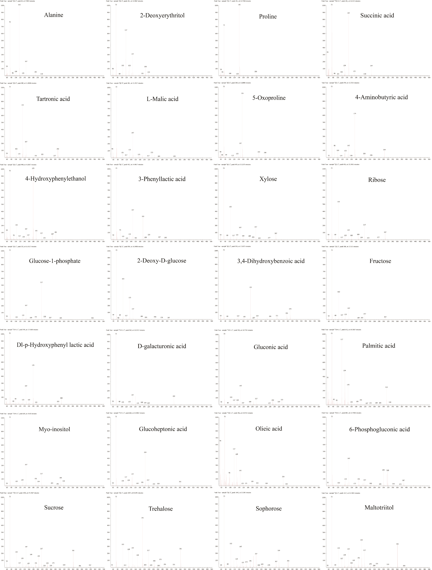

Supplementary Figure S2 Results from metabolomics pathway analyses
