Fig. S1: Standard (integral) XRD data-curve corresponding to the differential data depicted in Fig. 1.
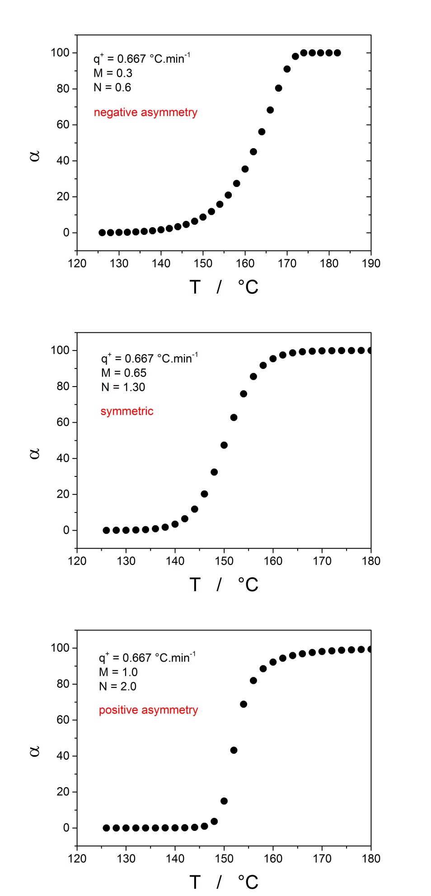
Fig. S2: Differential (dα/dt) data-curves corresponding to the integral data depicted in Fig. 4.
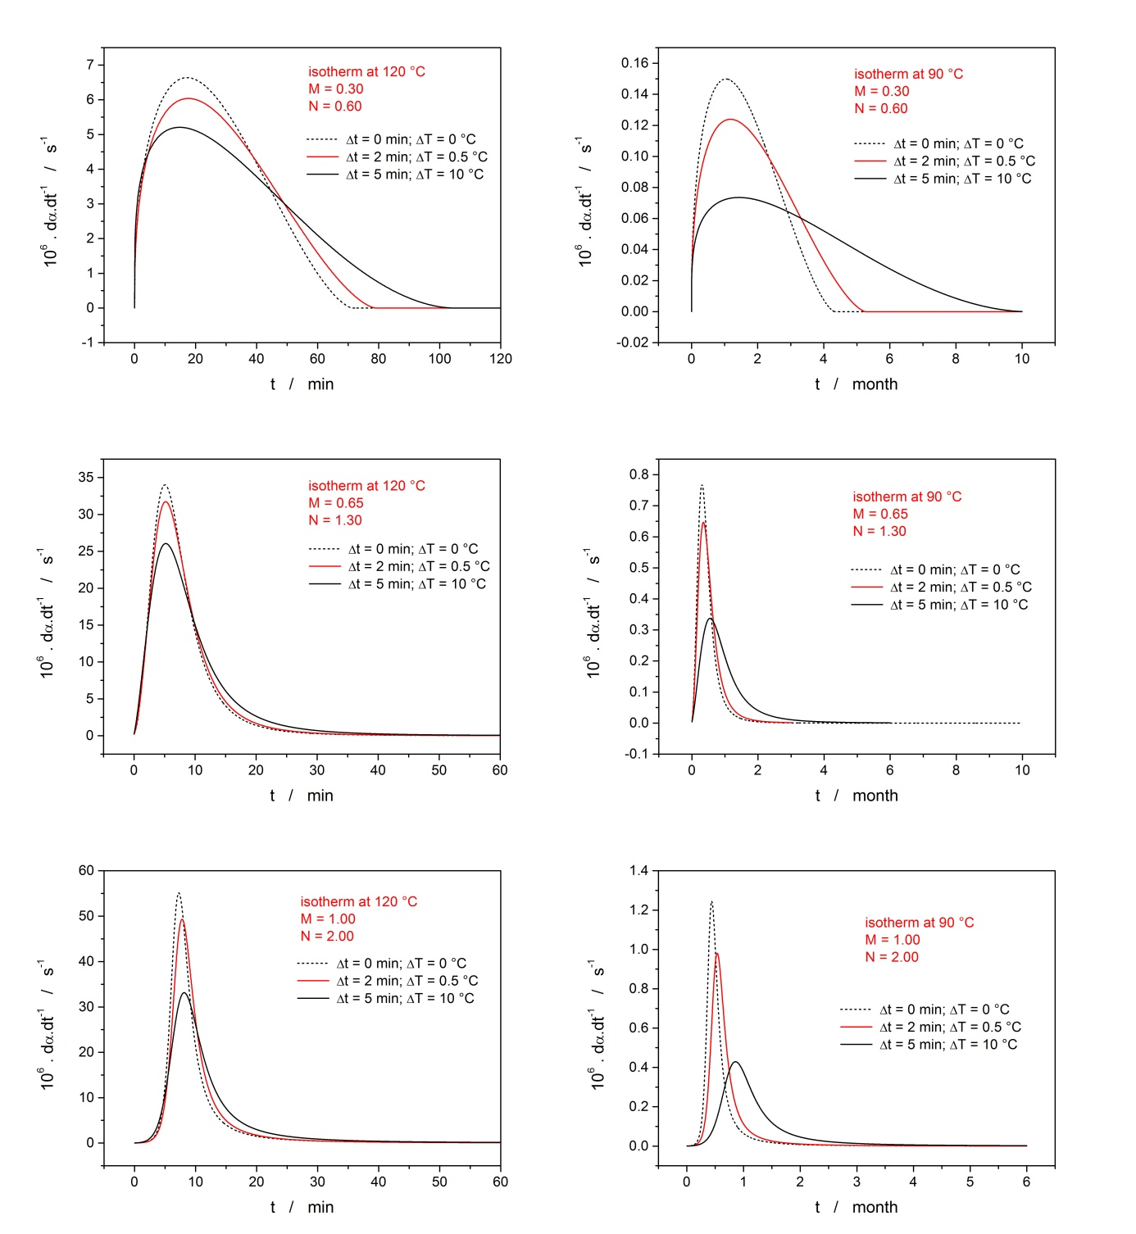

Fig. S3: Comparison of the standard (integral) XRD data-curves from Fig. 5 (points) and signals simulated for the similar q⁺_{eff} at simple heating scan (lines).
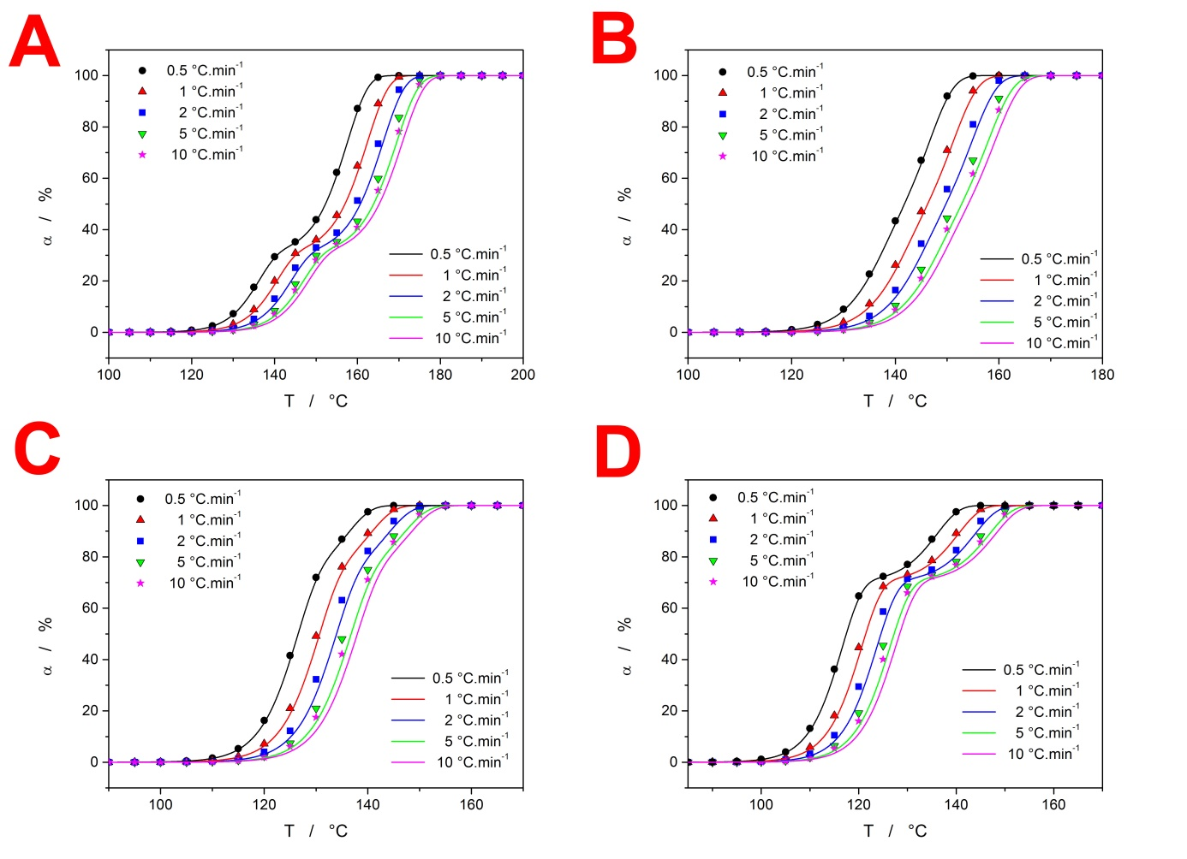

Fig. S4: Comparison of the standard (integral) XRD data-curves from Fig. 6 (points) and signals simulated for the similar q⁺_{eff} at simple heating scan (lines).
