Figure S1. Change in HbA1c by OAD class and visit

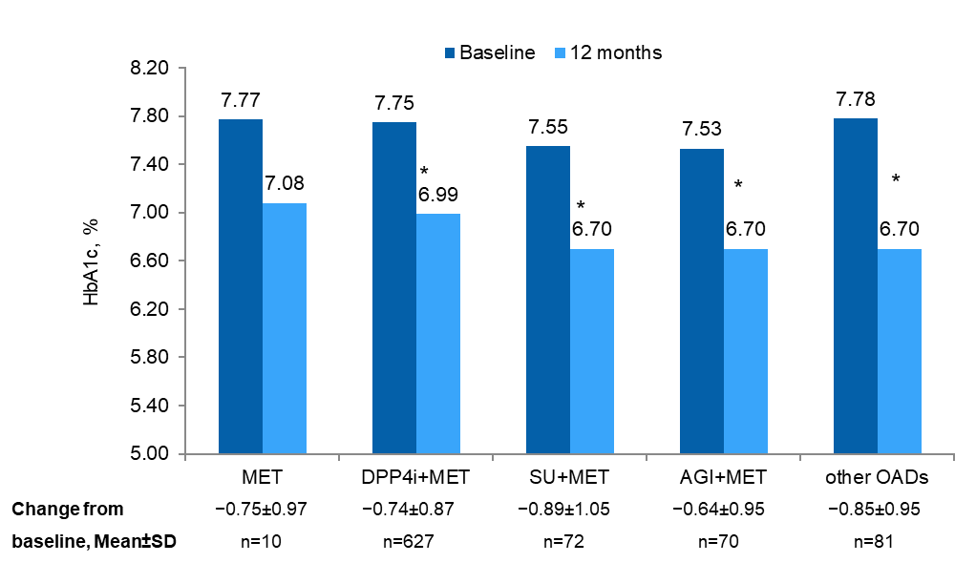

*p<0.0001 versus baseline
AGI, alpha-glucosidase inhibitor; DPP-4i, dipeptidyl peptidase-4 inhibitor; HbA1c, glycated hemoglobin; MET, metformin; OAD, oral anti-diabetes drug; SD, standard deviation; SU, sulfonylurea

Table S1. Summary statistics of patient characteristics by visit (eligible patients)
 | Baseline | Month 12 | Month 24
HbA1c, % | 7.72±0.54 | 6.95±0.82 | N/A
Body weight, kg | 78.70±13.60 | 79.26±13.80 | 78.63±13.64
BMI, kg/m² | 29.78±4.66 | 29.98±4.79 | 29.84±4.77
Vital signs
Pulse rate, bpm | 75.64±6.97 | 75.35±6.43 | 74.83±6.21
Systolic blood pressure, mm Hg | 134.11±15.33 | 132.73±14.41 | 130.84±14.43
Diastolic blood pressure, mm Hg | 77.74±7.39 | 76.62±6.95 | 76.07±7.29

BMI, body mass index; bpm, beats per minute; HbA1c, glycated hemoglobin; N/A, not applicable

Table S2. DSC-R domains: summary statistics by visit and OAD class
Score | Visit | All OADs  (N=860) | p-value* | MET  (n=10) | DPP-4i+MET  (n=627) | SU+MET  (n=72) | AGI+MET  (n=70) | Other  OADs (n=81)
Psychological fatigue score | Baseline | 1.0±1.00 | - | 1.4±1.46 | 1.0±0.98 | 1.0±0.95 | 1.2±1.14 | 0.9±1.02
 | Month 12 | 0.9±0.93 | 0.0011 | 1.0±1.73 | 0.9±0.95 | 0.8±0.77 | 1.0±0.88 | 0.7±0.97
 | Month 24 | 0.9±0.92 | 0.0173 | 1.0±1.73 | 0.8±0.92 | 0.9±0.94 | 0.8±0.77 | 0.8±0.95
Psychological cognitive function score | Baseline | 0.7±0.85 | - | 1.1±1.33 | 0.7±0.84 | 0.7±0.74 | 0.9±0.93 | 0.6±0.87
 | Month 212 | 0.6±0.77 | 0.1494 | 0.8±1.44 | 0.6±0.79 | 0.8±0.75 | 0.7±0.76 | 0.6±0.66
 | Month 24 | 0.6±0.74 | 0.0157 | 0.8±1.44 | 0.6±0.77 | 0.8±0.70 | 0.5±0.67 | 0.4±0.55
Neuropathic pain score | Baseline | 0.6±0.83 | - | 0.6±1.31 | 0.6±0.81 | 0.6±0.76 | 0.9±1.04 | 0.6±0.80
 | Month 12 | 0.5±0.71 | 0.3936 | 0.6±0.63 | 0.5±0.69 | 0.7±0.68 | 0.8±0.89 | 0.5±0.73
 | Month 24 | 0.5±0.69 | 0.3037 | 0.6±0.96 | 0.5±0.67 | 0.7±0.74 | 0.7±0.75 | 0.5±0.73
Neuropathic sensory function score | Baseline | 0.7±0.86 | - | 0.8±1.08 | 0.7±0.82 | 0.7±0.82 | 1.1±1.07 | 0.6±0.87
 | Month 12 | 0.7±0.74 | 0.1510 | 0.3±0.35 | 0.6±0.72 | 0.8±0.73 | 0.9±0.88 | 0.7±0.76
 | Month 24 | 0.6±0.72 | 0.1667 | 0.6±0.88 | 0.6±0.69 | 0.8±0.75 | 0.9±0.75 | 0.7±0.82
Cardiovascular symptoms score | Baseline | 0.6±0.74 | - | 0.6±0.59 | 0.6±0.69 | 0.6±0.81 | 1.0±0.91 | 0.6±0.77
 | Month 12 | 0.6±0.65 | 0.1487 | 0.4±0.72 | 0.6±0.62 | 0.7±0.78 | 0.8±0.69 | 0.5±0.66
 | Month 24 | 0.6±0.64 | 0.0955 | 0.4±0.72 | 0.6±0.60 | 0.8±0.82 | 0.6±0.71 | 0.6±0.69
Ophthalmological function score | Baseline | 0.6±0.80 | - | 1.0±1.52 | 0.5±0.74 | 0.6±0.82 | 1.0±0.99 | 0.6±0.89
 | Month 12 | 0.5±0.71 | 0.0560 | 0.5±0.92 | 0.5±0.70 | 0.7±0.63 | 0.9±0.83 | 0.4±0.65
 | Month 24 | 0.5±0.66 | 0.0191 | 0.0±0.00 | 0.5±0.68 | 0.7±0.61 | 0.6±0.63 | 0.4±0.57
Hypoglycemia score | Baseline | 0.7±0.92 | - | 1.0±1.25 | 0.7±0.90 | 0.8±0.80 | 1.1±0.95 | 0.7±1.01
 | Month 12 | 0.6±0.76 | 0.0010 | 0.9±1.54 | 0.6±0.76 | 0.7±0.68 | 0.7±0.77 | 0.5±0.73
 | Month 24 | 0.6±0.75 | 0.0022 | 0.9±1.54 | 0.6±0.76 | 0.8±0.75 | 0.5±0.60 | 0.4±0.70
Hyperglycemia score | Baseline | 1.0±0.89 | - | 0.9±0.92 | 0.9±0.89 | 0.9±0.86 | 1.5±0.85 | 1.0±0.90
 | Month 12 | 0.7±0.75 | <0.0001 | 0.3±0.43 | 0.6±0.75 | 0.8±0.70 | 1.0±0.77 | 0.7±0.73
 | Month 24 | 0.6±0.69 | <0.0001 | 0.3±0.43 | 0.6±0.68 | 0.8±0.66 | 0.8±0.74 | 0.7±0.68
Total DSC-R score | Baseline | 0.7±0.68 | - | 0.9±1.05 | 0.7±0.63 | 0.7±0.69 | 1.1±0.86 | 0.7±0.70
 | Month 12 | 0.6±0.59 | <0.0001 | 0.6±0.91 | 0.6±0.57 | 0.8±0.64 | 0.9±0.68 | 0.6±0.57
 | Month 24 | 0.6±0.56 | <0.0001 | 0.5±0.91 | 0.6±0.54 | 0.8±0.69 | 0.7±0.57 | 0.6±0.54
Data are expressed as mean±SD
*Changes versus baseline
AGI, alpha-glucosidase inhibitor; DPP-4i, dipeptidyl peptidase-4 inhibitor; DSC-R, Diabetes Symptom Checklist-Revised; MET, metformin; OAD, oral anti-diabetes drug; SU, sulfonylurea

Table S3. EQ-5D dimensions: summary statistics by visit and OAD class

 |  | Baseline |  |  |  |  |  | Month 12
 |  | MET  (n=10) | DPP-4i+MET (n=627) | SU+MET (n=72) | AGI+MET (n=70) | Other OADs  (n=81) | All OADs (N=860) | MET  (n=4) | DPP-4i+MET (n=551) | SU+MET (n=63) | AGI+MET (n=64) | Other OADs  (n=81) | All OADs (N=756)
Mobility | None | 5 | 407 | 42 | 37 | 49 | 540 (63.7) | 1 | 352 | 43 | 41 | 47 | 484 (66.9)
 | Some | 4 | 210 | 30 | 32 | 32 | 308 (36.3) | 2 | 172 | 16 | 22 | 26 | 238 (32.9)
 | Extreme | - | - | - | - | - | - | 0 | 2 | 0 | 0 | 0 | 2 (0.3)
Self-care | None | 8 | 551 | 63 | 56 | 72 | 750 (88.4) | 2 | 462 | 54 | 56 | 63 | 637 (88.1)
 | Some | 1 | 64 | 9 | 13 | 8 | 95 (11.2) | 1 | 59 | 5 | 7 | 10 | 82 (11.3)
 | Extreme | 0 | 2 | 0 | 0 | 1 | 3 (0.4) | 0 | 4 | 0 | 0 | 0 | 4 (0.6)
Usual activities | None | 8 | 516 | 58 | 57 | 69 | 708 (83.6) | 2 | 432 | 54 | 54 | 61 | 603 (83.4)
 | Some | 1 | 92 | 14 | 11 | 10 | 128 (15.1) | 1 | 84 | 5 | 9 | 11 | 110 (15.2)
 | Extreme | 0 | 9 | 0 | 1 | 1 | 11 (1.3) | 0 | 9 | 0 | 0 | 1 | 10 (1.4)
Pain/discomfort | None | 4 | 340 | 42 | 29 | 39 | 454 (53.5) | 1 | 317 | 46 | 30 | 38 | 432 (59.8)
 | Some | 5 | 262 | 29 | 35 | 40 | 371 (43.8) | 2 | 199 | 12 | 33 | 35 | 281 (38.9)
 | Extreme | 0 | 15 | 1 | 5 | 2 | 23 (2.7) | 0 | 9 | 1 | 0 | 0 | 10 (1.4)
Anxiety/depression | None | 4 | 399 | 48 | 36 | 41 | 528 (62.3) | 1 | 366 | 48 | 29 | 47 | 491 (67.8)
 | Some | 5 | 194 | 21 | 28 | 36 | 284 (33.5) | 2 | 143 | 10 | 27 | 22 | 204 (28.2)
 | Extreme | 0 | 23 | 3 | 5 | 4 | 35 (4.1) | 0 | 17 | 1 | 7 | 4 | 29 (4.0)
Data are expressed as n or n (%)
AGI, alpha-glucosidase inhibitor; DPP-4i, dipeptidyl peptidase-4 inhibitor; EQ-5D, EuroQol 5 dimensions; MET, metformin; OAD, oral anti-diabetes drug; SU, sulfonylurea

Table S4. TSQM-9: summary statistics by visit and OAD class (eligible patients)

 |  | Baseline  (N=860) | Month 12  (N=756) |  | Month 24  (N=664)
 |  | Score | Score | p-value* | Score | p-value*
MET | Effectiveness | 62.4±12.04 | 72.2±25.46 | 0.4226 | 77.8±19.25 | 0.5000
 | Convenience | 69.8±12.76 | 61.1±9.62 | 1.0000 | 68.5±3.21 | 0.5000
 | Global satisfaction | 56.5±15.61 | 58.3±16.02 | 1.0000 | 71.3±19.51 | 0.5063
DPP-4i+MET | Effectiveness | 67.7±16.07 | 74.8±18.06 | <0.0001 | 77.8±17.83 | <0.0001
 | Convenience | 75.1±15.77 | 79.2±14.52 | <0.0001 | 80.4±13.80 | <0.0001
 | Global satisfaction | 62.6±17.63 | 72.3±18.17 | <0.0001 | 74.6±18.49 | <0.0001
SU+MET | Effectiveness | 63.5±15.81 | 71.5±12.28 | <0.0001 | 78.2±16.32 | <0.0001
 | Convenience | 69.7±14.11 | 75.2±12.45 | 0.0020 | 78.7±14.63 | 0.0197
 | Global satisfaction | 56.0±13.75 | 66.9±12.99 | <0.0001 | 73.4±18.93 | <0.0001
AGI+MET | Effectiveness | 62.6±15.03 | 63.9±13.56 | 0.1587 | 66.1±10.34 | 0.0126
 | Convenience | 68.3±11.56 | 70.0±9.70 | 0.2104 | 68.7±9.86 | 0.7534
 | Global satisfaction | 52.1±16.78 | 60.1±13.58 | 0.0004 | 61.8±12.81 | <0.0001
Other OADs | Effectiveness | 60.4±14.01 | 67.0±14.10 | 0.0011 | 68.1±12.42 | 0.0001
 | Convenience | 70.0±13.71 | 69.6±13.00 | 0.6897 | 71.9±11.01 | 0.5779
 | Global satisfaction | 54.7±16.35 | 60.9±16.60 | 0.0005 | 64.0±15.49 | <0.0001
Data are expressed as mean±SD
*Change versus baseline
AGI, alpha-glucosidase inhibitor; DPP-4i, dipeptidyl peptidase-4 inhibitor; MET, metformin; OAD, oral anti-diabetes drug; SU, sulfonylurea; TSQM-9, Treatment Satisfaction Questionnaire of Medication-9

Table S5. Number of patients with adverse reaction by SOC

 | N=860
At least one adverse drug reaction | 24 (2.79)
Gastrointestinal disorders | 14 (1.63)
Investigations | 4 (0.47)
Skin and subcutaneous tissue disorders | 3 (0.35)
Ear and labyrinth disorders | 1 (0.12)
Immune system disorders | 1 (0.12)
Musculoskeletal and connective tissue disorders | 1 (0.12)
Nervous system disorders | 1 (0.12)
Respiratory, thoracic and mediastinal disorders | 1 (0.12)

Data are expressed as n (%) of eligible patients with at least one adverse reaction
SOC, system organ class

