The Lissajous figures, and current and voltage waveforms in manuscript are shown as follows.

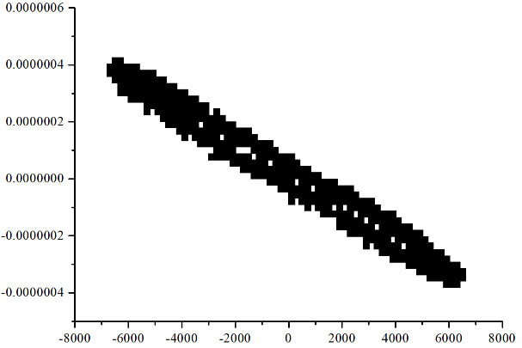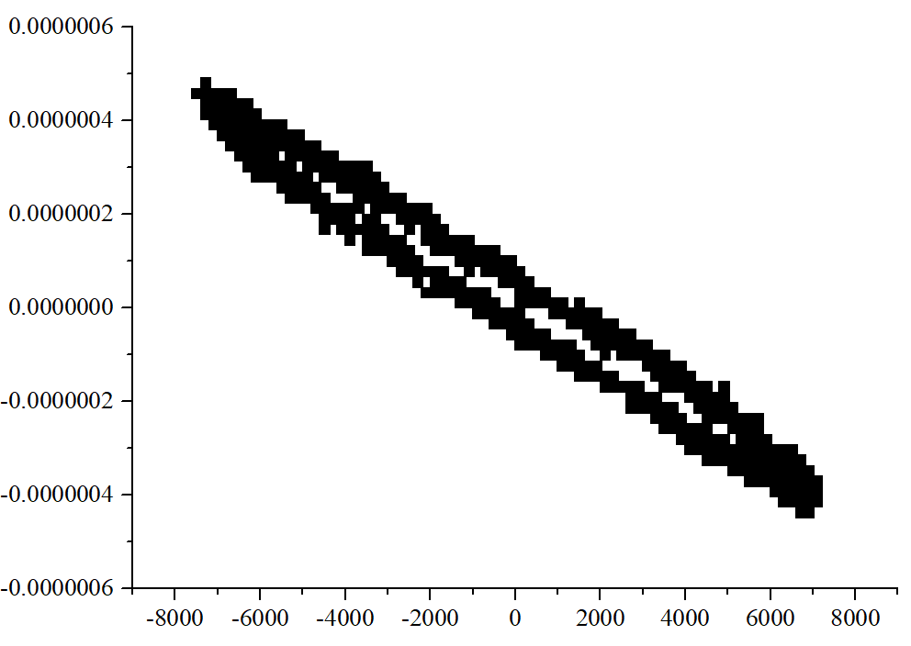
(b)
(a)
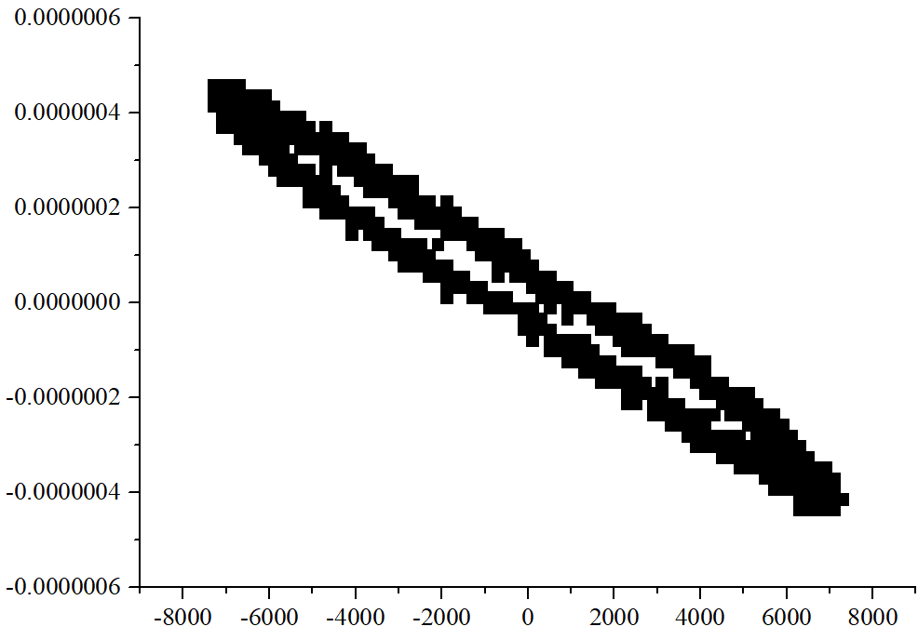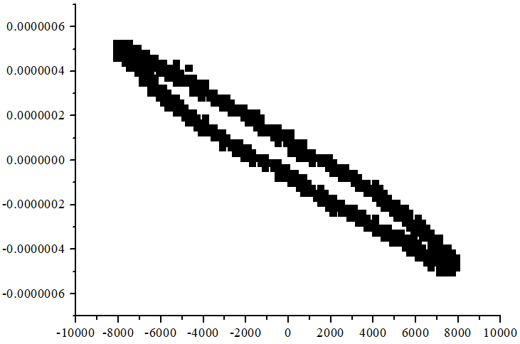
(d)
(c)
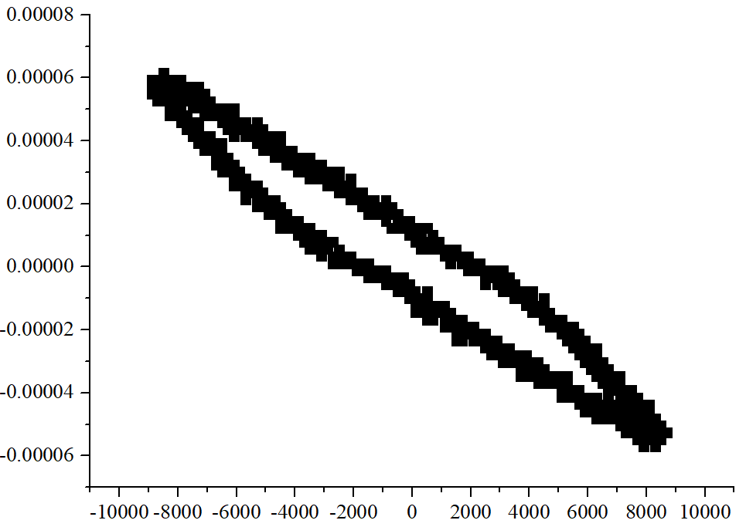
(e)

*(a) the Lissajous figure with 270 J/L, (b) the Lissajous figure with 320 J/L, (c) the Lissajous figure with 389 J/L, (d) the Lissajous figure with 435 J/L, (e) the Lissajous figure with 504 J/L.

