Supplementary Scheme 1

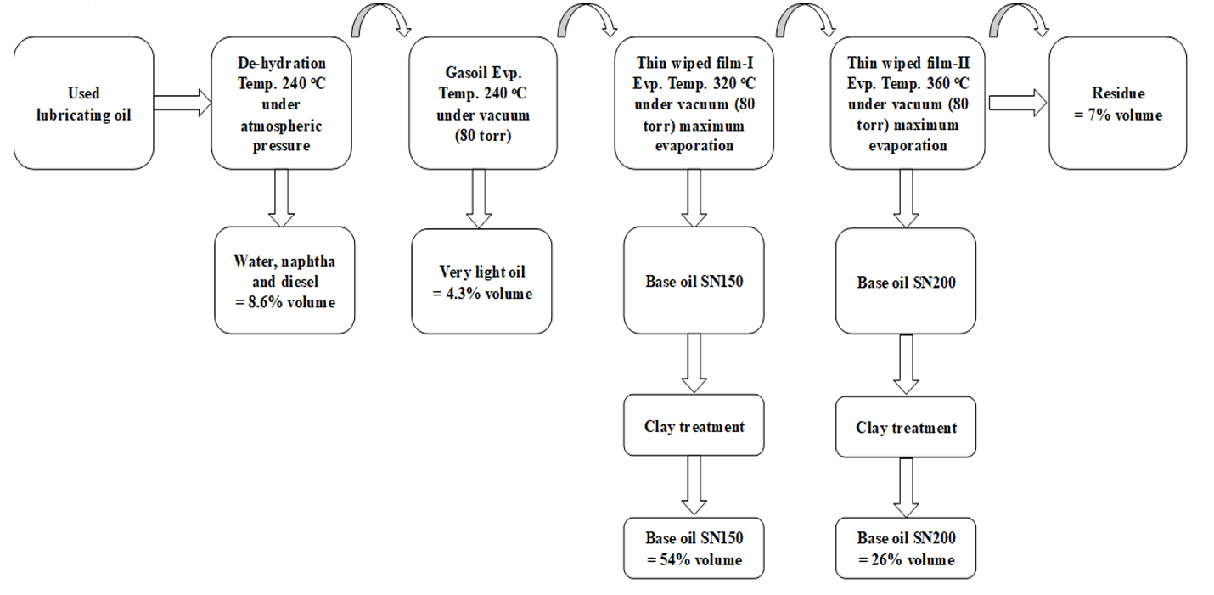

Supplementary Scheme 1. The whole process of vacuum distillation thin wiped film evaporation technique.

