SUPPLEMENTARY MATERIAL

Impact of agricultural land use on the physicochemical properties of soils developed on sedimentary rocks in Malaysia

Mum-Keng Wong, Paramananthan Selliah, Tham-Fatt Ng, Meor Hakif Amir Hassan, Eric Van Ranst & Kazuyuki Inubushi

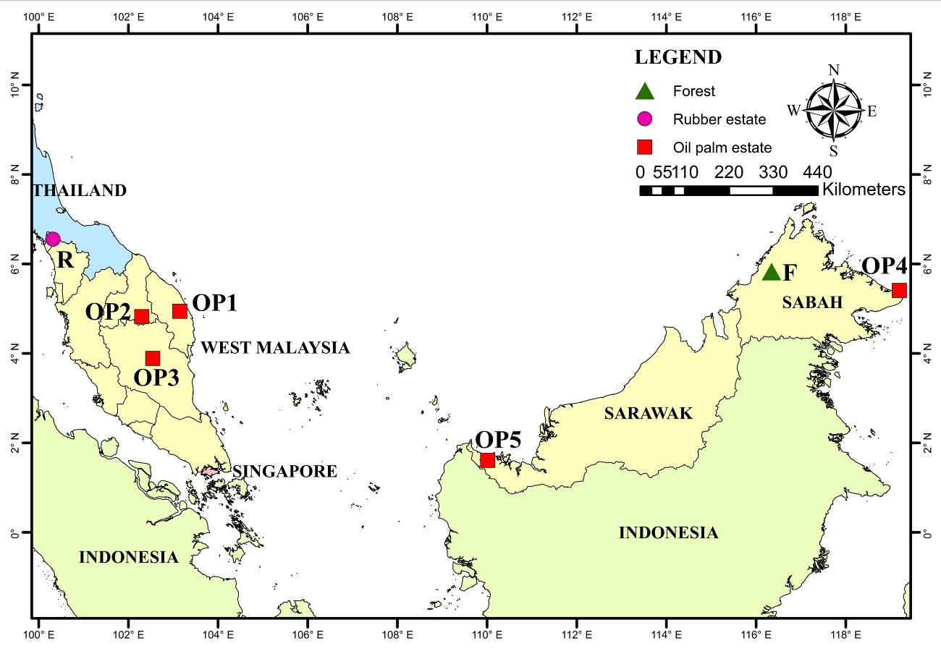
Figure S1. Location of study sites in Malaysia showing forest, rubber and oil palm plantation.

Table S1. List of soil sample numbers for Figure 1.

Soil profile | Soil sample numbers
 | A(p/h)/Om | B(t1) | B(t2)/C
P1 | 1 | 2 | 3
P2 | 4 | 5 | 6
P3 | 7 | 8 | 9
P4 | 10 | 11 | 12
P5 | 13 | 14 | 15
P6 | 16 | 17 | 18
P7 | 19 | 20 | 21
P8 | 22 | 23 | 24
P9 | 25 | 26 | 27
P10 | 28 | 29 | 30
P11 | 31 | 32 | 33
P12 | 34 | 35 | 36
P13 | 37 | 38 | 39
P14 | 40 | 41 | 42
P15 | 43 | 44 | 45
P16 | 46 | 47 | 48
P17 | 49 | 50 | 51
P18 | 52 | 53 | 54
P19 | 55 | 56 | 57
P20 | 58 | 59 | 60
P21 | 61 | 62 | 63
P22 | 64 | 65 | 66
P23 | 67 | 68 | 69
P24 | 70 | 71 | 72
P25 | 73 | 74 | 75

