Supplementary Information
DNA and RNA binding studies on a novel bromo-bridged dimeric copper(II) complex stabilized from a Schiff base ligand

NABA KR MANDAL, BHARGAB GUHATHAKURTA, PRITHA BASU, ANKUR BIKASH PRADHAN, CHANDRA SHEKHAR PUROHIT, SHUBHAMOY CHOWDHURY and JNAN PRAKASH NASKAR*

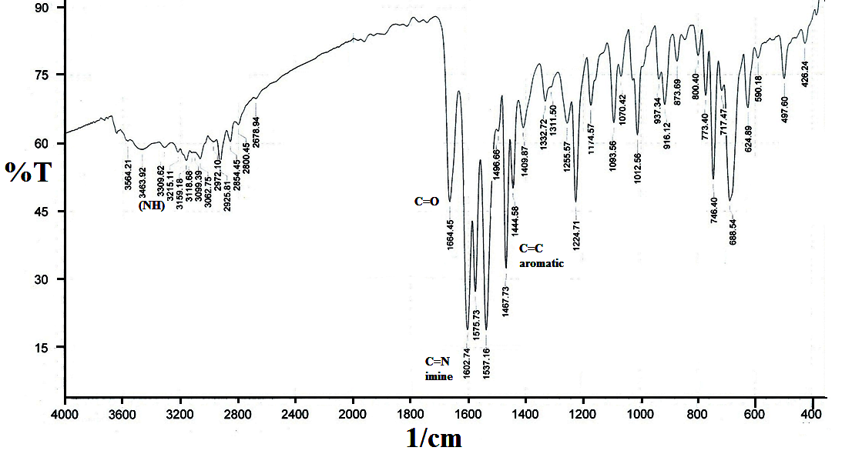
Figure S1. FT-IR spectrum of LH.
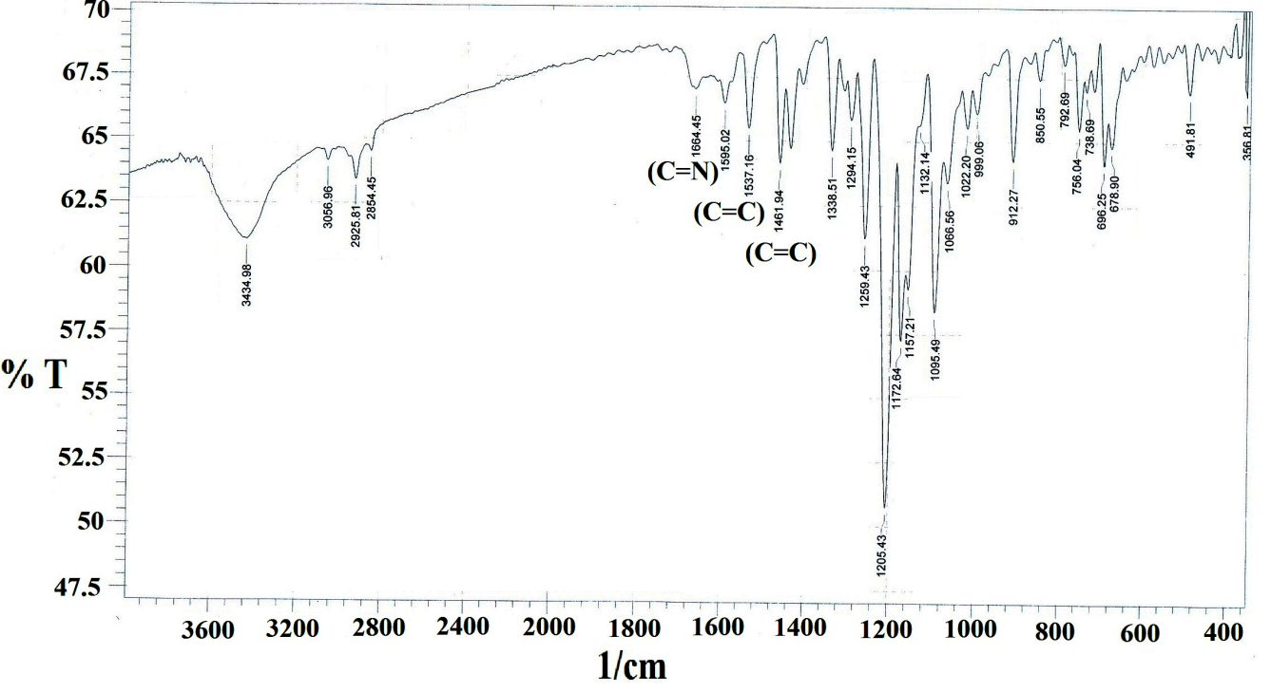
Figure S2. FT-IR spectrum of 1.

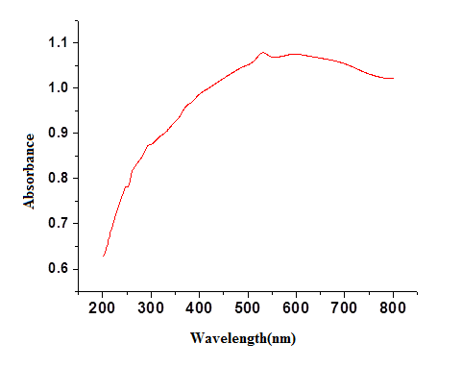
Figure S3. Solid state UV-Vis spectrum of 1.
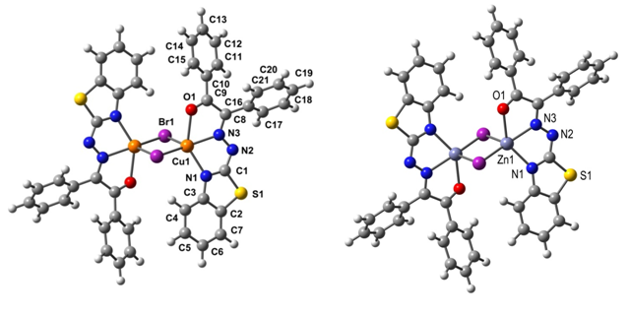
Figyre S4. Geometry optimized structure of 1 (left) and [ZnLBr]₂ (right).
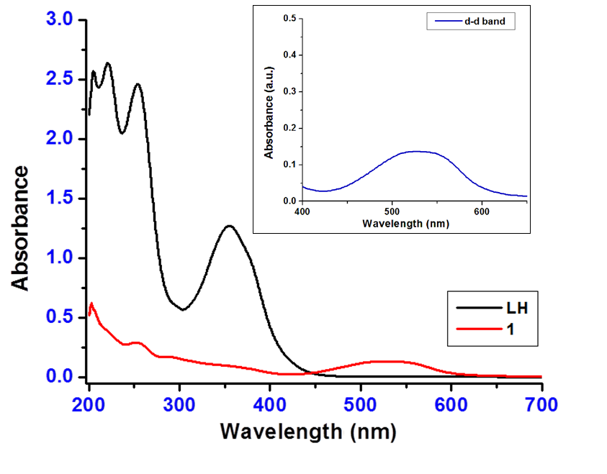
Figure S5. UV-Vis spectra of LH and 1 in methanol. The conc. of LH and 1 were 5.25×10⁻⁵ and 2.25×10⁻⁵ M, respectively.

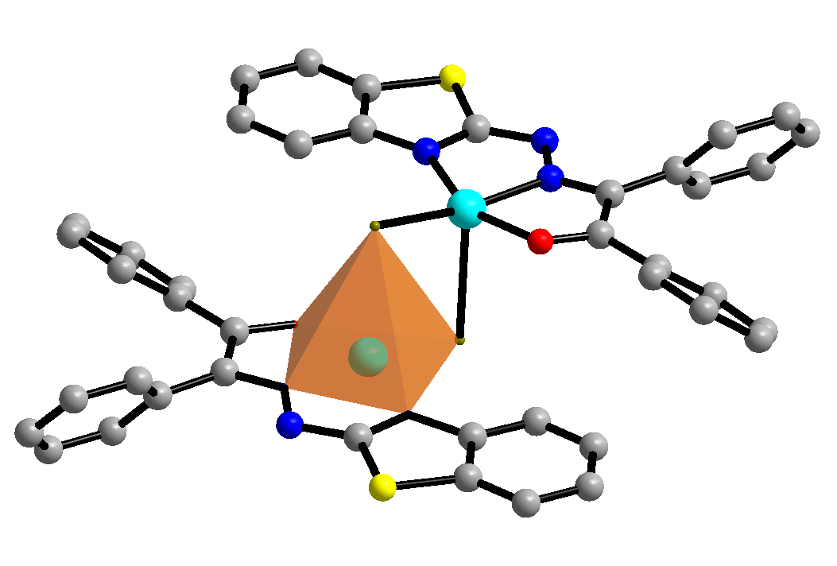
Figure S6. Penta coordination around each copper center (color code: blue = nitrogen, red = oxygen, cyan = copper).
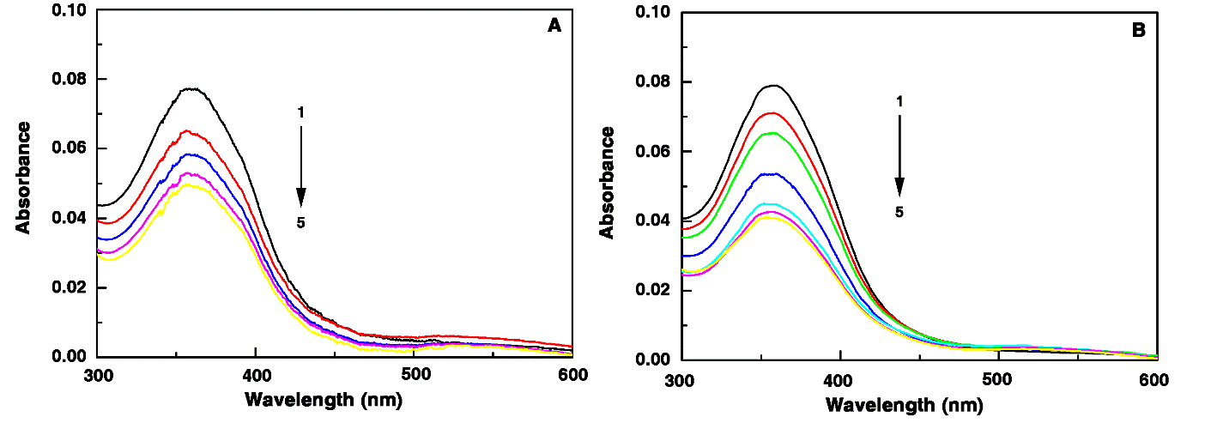
Figure S7. Change of absorption spectra of ligand (curve 1) on increasing concentration of
(A) CT DNA and (B) Poly(A) (curves 2-5).
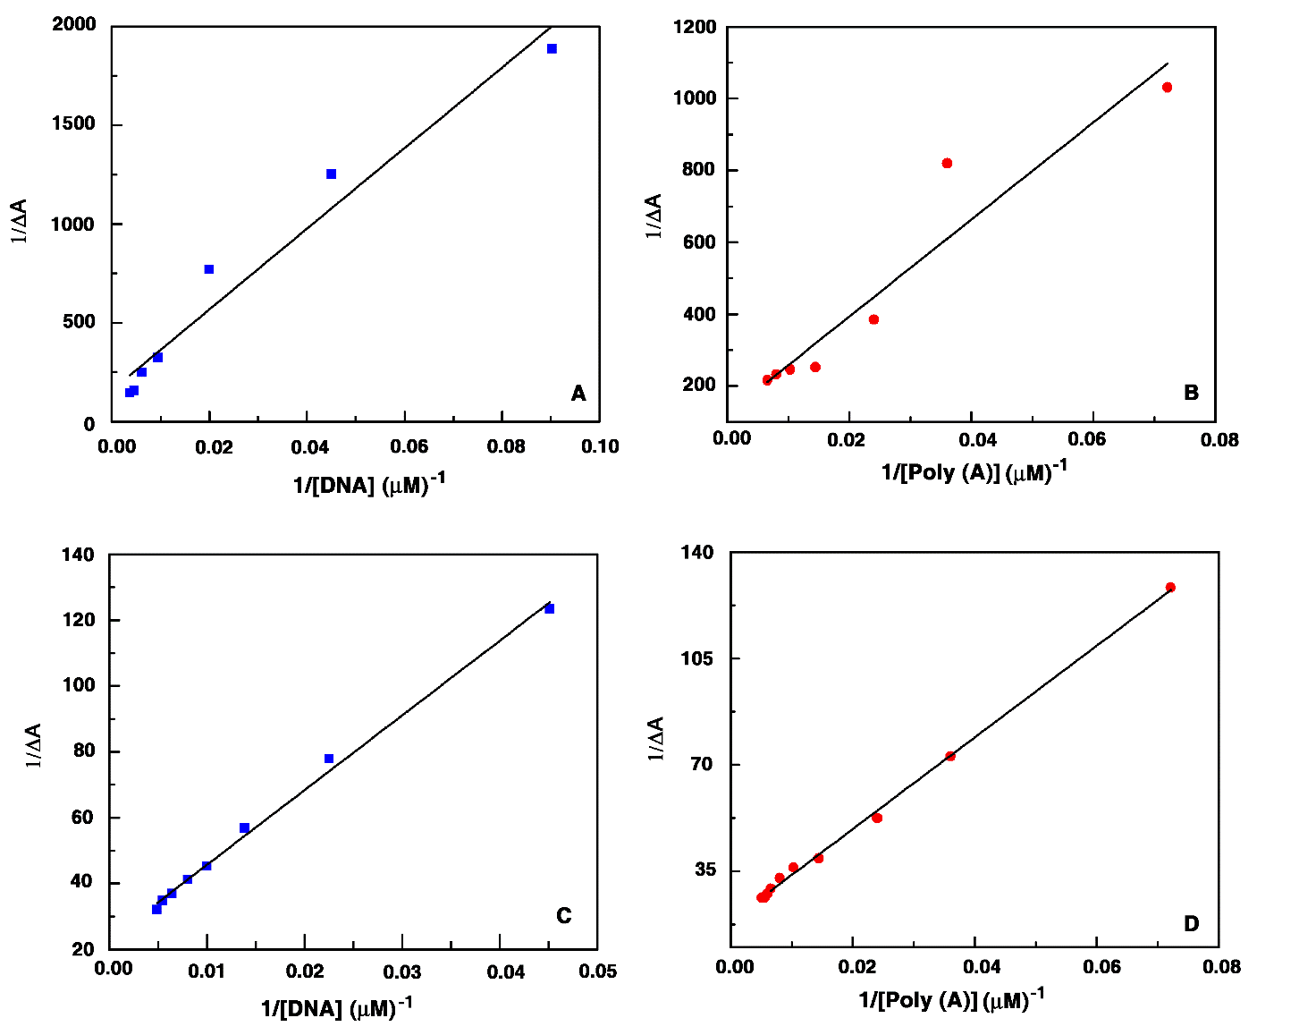
Figure S8. B-H plot for (A) complex with CT DNA, (B) complex with Poly(A), (C) ligand with CT DNA and (D) ligand with Poly(A) as obtained from absorption titrimetric data.
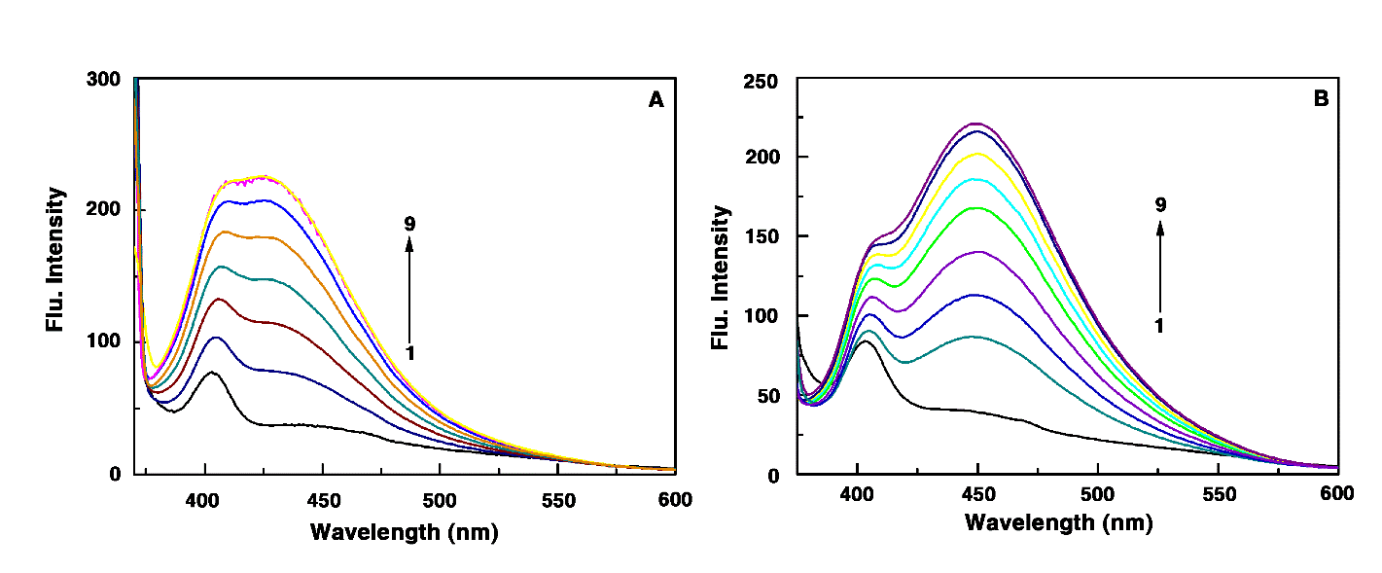
Figure S9. Fluorescence titration of ligand (curve 1) with increasing concentration of (A) CT DNA (curves 2-9) and (B) Poly(A) (curves 2-9).
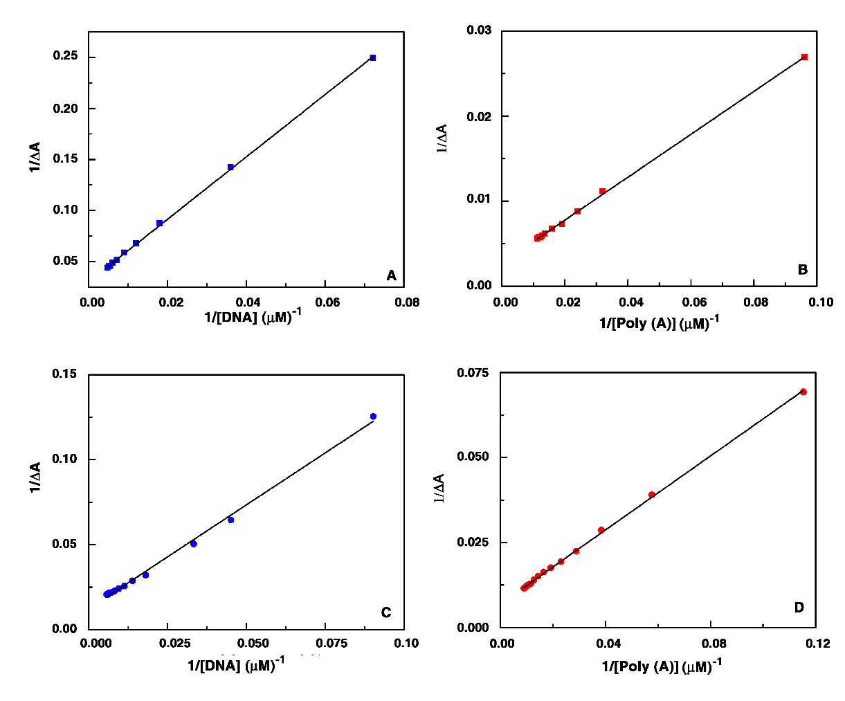
Figure S10. B-H plot for (A) complex with CT DNA, (B) complex with Poly(A), (C) ligand with CT DNA and (D) ligand with Poly(A) as obtained from the fluorescence titrimetric data.
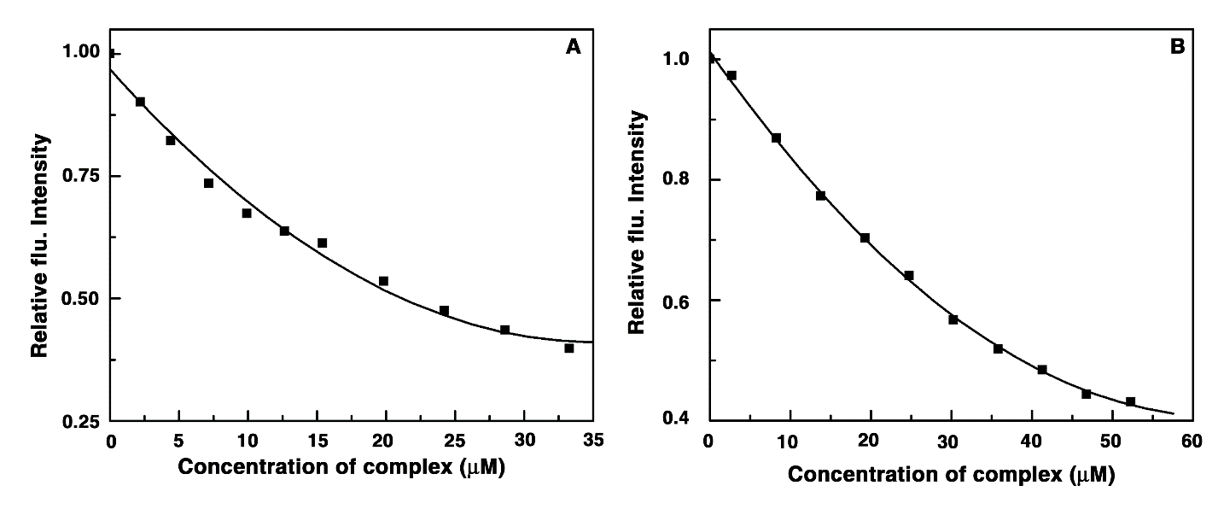
Figure S11. Relative fluorescence intensity decrement of (A) EB (7 μM)-CT DNA (50 μM) and (B) EB (7 μM)-Poly(A) (50 μM); (■) complex induced by the binding of complex.
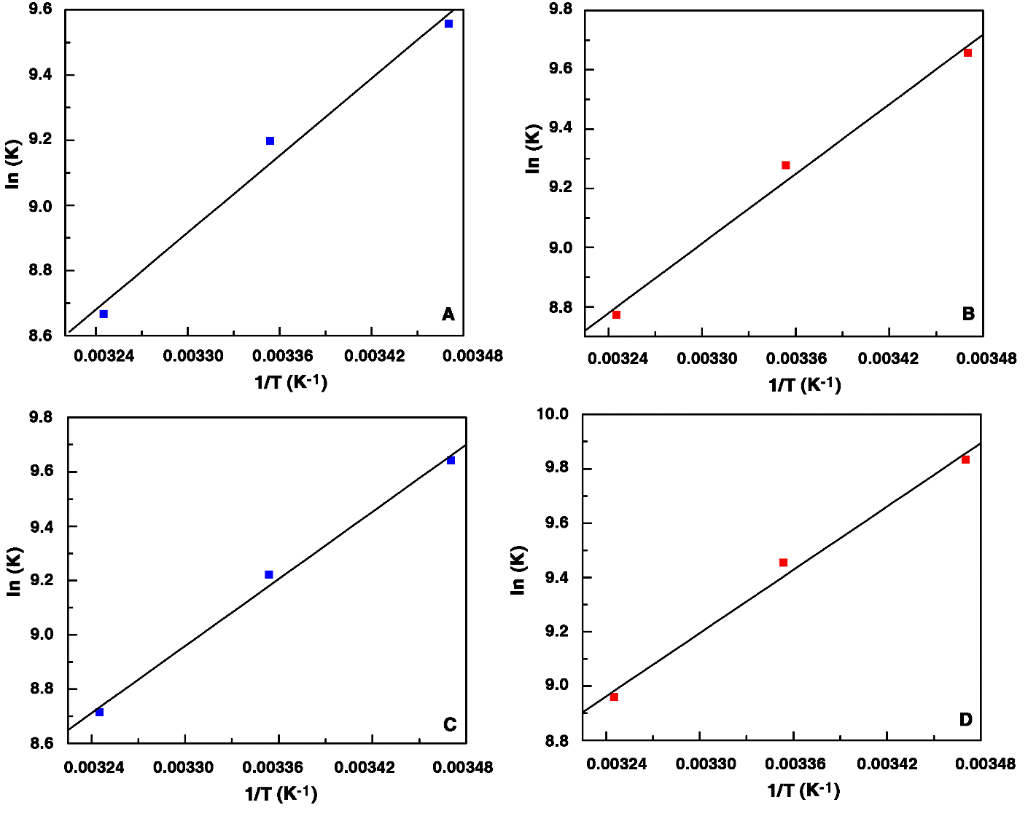
Figure S12. van’t Hoff plot for binding of (A) complex with CT DNA, (B) complex with Poly(A), (C) ligand with CT DNA and (D) ligand with Poly(A).

