Pathogenic Vibrio parahaemolyticus isolated from biofouling on commercial vessels and harbor structures

Valeria J. Revilla-Castellanosª, Abraham Guerreroª, Bruno Gomez-Gil^{b} , Erick Navarro-Barrón^{b}, Marcial L. Lizárraga-Partida^{a*}

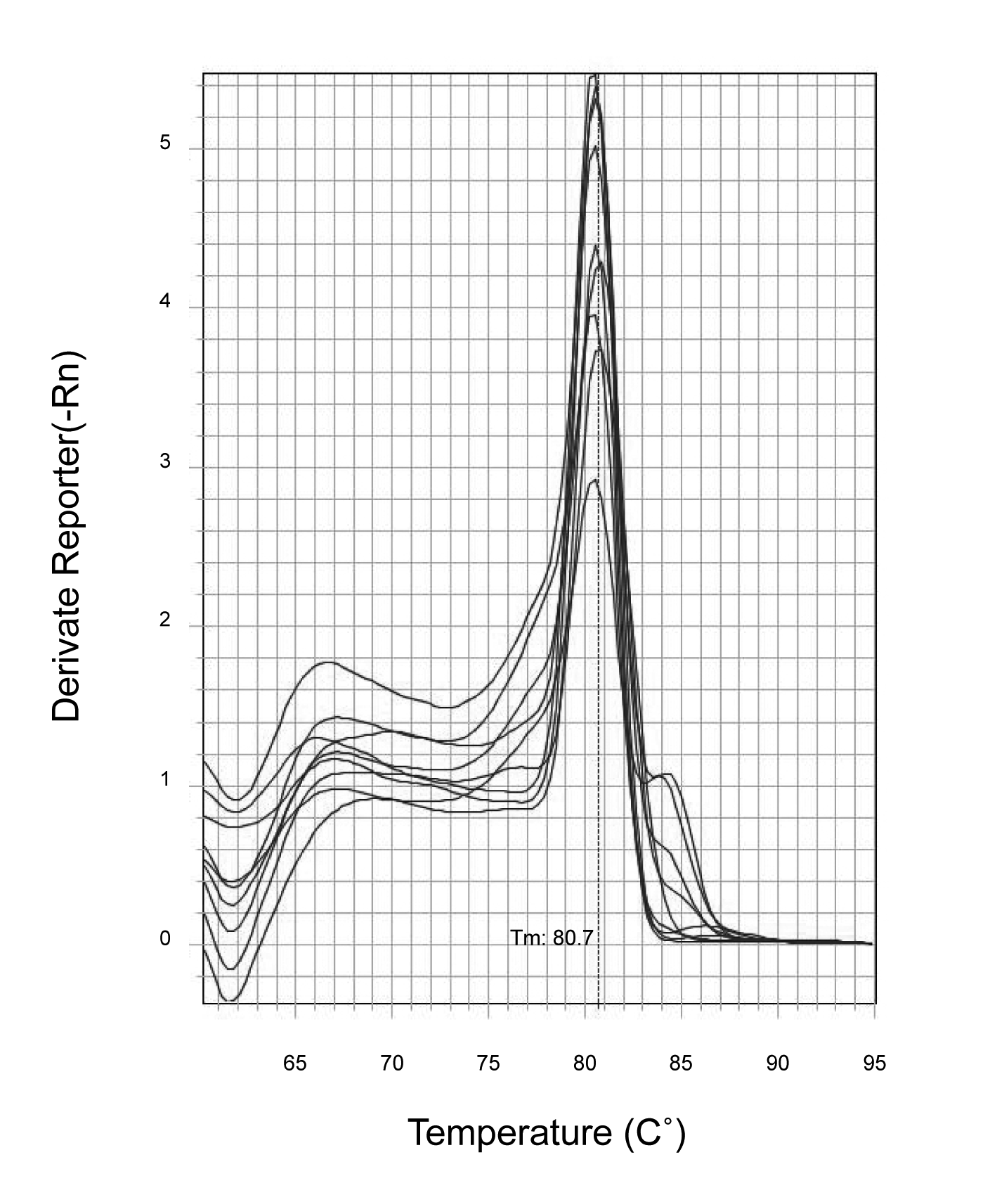

Figure S-1. Melt curve with tlh primers

Sample | Code | C_{T} | DNA ng/µl | Genome copies
Ship 1 Yokohama, Japan | B1 | 33.49 | 0.008 | 1.43 X 10³
Dock at the arrival ship 1 | EIT-B1 | 25.15 | 0.5 | 8.96 X 10⁴
Ship 2 Busan, South Korea | B2 | 35.58 | 0.004 | 7.17 X 10²
Dock at the arrival ship 2 | EIT-B2 | 34.69 | 0.005 | 8.96 X 10²
Ship 3 Fukuyama, Japan | B3 | 28.9 | 0.07 | 1.25 X 10⁴
Dock at the arrival ship 3 | EIT-B3 | 30.12 | 0.04 | 7.17 X 10³
Local tours port | LTP | 39.57 | 0.0008 | 1.43 X 10²
Ensenada cruise port | ECP | 34.12 | 0.007 | 1.25 X 10³

Table S-1. DNA concentration (ng/µL) based on cycle times (C_{T}) in V. parahaemolyticus samples using tdh primers and calculated number of genome copies.

