Tunable electrochemical synthesis of pyrrole based adsorbents
Avinash Kumar Pandey^{1,2*}, Abhishek Kumar Mishra ^{1,3}
¹Chemistry Department, DDU Gorakhpur University, Gorakhpur- 273009, India
Present Address: ²Chandigarh University, Gharuan, Mohali-140413, India
³Sardar Patel Institute of Science and Technology Mahavidyalaya, Gorakhpur- 273001, India
Supplementary file
Electrochemical synthesis of pyrrole based adsorbents
Pyrrole based adsorbents were obtained by electropolymerization of pyrrole from its aqueous solution containing (i) potassium bromide, (ii) potassium bromide and an anionic surfactant sodium dodecyl sulphate (NaDS) in different ratios and (iii) potassium bromide, NaDS and Prussian blue (PB) different experimental conditions, using an experimental setup as shown in Figure S1. The experimental setup consisting of a circular platinum cathode of radius 2.5 cm and a vertical platinum anode. The vertical anode was put at the center of the circular cathode such that it touched the surface of the solution taken in the Petri dish. These electrodes were attached to a potentiostat (Scientific India). When a constant potential of 6 V (field intensity = 2.4 V/cm) was applied across the electrodes, polymerization started at the tip of vertical anode electrode. Electropolymerization was carried out at moderate potential to prevent the oxidative decomposition of the solvent, electrolyte and the polymer.
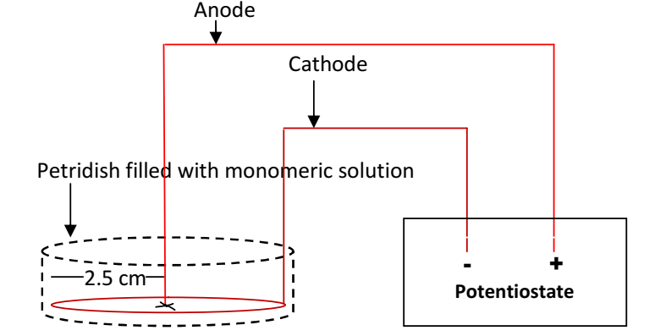
Fig. S1: Schematic representation of experimental setup of electropolymerization
Adsorption experiments
Different amounts of the electrochemically synthesized polymers were added to 10 mL of aqueous solution of MB in a small conical flask fitted with a stopper stirred vigorously on a magnetic stirrer for 60 minutes to perform the adsorption experiments. The adsorbent was then separated from the solution by centrifuging the solution. The absorbance of the supernatant liquid was measured at 664 nm using a microprocessor UV-vis. double beam spectrophotometer [model LI-2802]. An optimum adsorbent dosage was determined by using adsorption capacity (Q_{e}) vs adsorbent dosage plot. MB solutions of different concentrations (5 x 10⁻⁴ - 3 x 10⁻³ M) were prepared for experiments. The absorbance of MB solutions was measured at 664 nm. A calibration curve was obtained by plotting absorbance as a function of MB concentration. Optimum adsorbent dosage of polymers was added to 10 mL of MB solution of each concentration in a small conical flask fitted with a stopper. The flask was stirred vigorously for 60 minutes. The adsorbent was separated from the solution. The absorbance of the supernatant liquids was measured. The experiment was also performed at different contact times. The effect of pH on Q_{e} was studied at [MB] = 1.5 x 10⁻³ M at room temperature and in pH range 2-10. pH was measured with a digital pH meter (Remi). The experiments were carried out at different temperatures viz. 30, 40, 50, and 60 ºC in an incubator to study the effect of temperature on adsorption. The adsorption capacity was measured with 1.5 gL⁻¹ of adsorbent in 1.5 x 10⁻³ M MB solution at each temperature. The contact time was 60 minutes in each case.
A desorption study was carried out with 1.5 gL⁻¹ of adsorbent added to10 mL of aqueous solution of MB. The mixture was shaken for 1 h. The initial dye concentration was 5 x 10⁻⁴ M. The MB-adsorbed polymer was separated and added into 10 mL of methanol and stirred for 30 min, separated again, and added into 10 mL of methanol. The process was repeated for 5 times. The adsorbent was collected by centrifugation technique and reused for adsorption. The supernatant solutions were analyzed by UV-vis spectrophotometer. Adsorption and desorption were successively carried out three times for adsorbent used in this study.

Table S1: Kinetic models and equations used

Kinetic model | Equation | Equation number | Reference
Pseudo- first- order | log (Q_{e}-Q_{t}) = log Q_{e} - $\frac{k_{1}t}{2.303}$ | 1 |  | 1,2
Pseudo-second-order | $$\frac{t}{Q_{t}}= \frac{1}{k_{2}Q_{e}^{2}}+ \frac{1}{Q_{e}} t$$ | 2 |  | 1,2
Elovich equation | Q_{t}=$\frac{1}{β}\ln{t + \frac{1}{β}}\ln{(αβ)}$ | 3 |  | 3
where Q_{t} and Q_{e} (mgg⁻¹) are the amount of MB adsorbed at any time and at equilibrium, respectively, k₁ (min⁻¹) represents the pseudo-first-order model rate constant, k₂ (g mg⁻¹ min⁻¹) is the pseudo-second-order rate constant, α is the initial adsorption rate (mgg⁻¹min⁻¹) and β is the adsorption constant (gmg⁻¹).

Table S2: Equations used for the calculation of isotherm parameters (equations 5- 6) and thermodynamic parameters (equations 7-9).

Equation | Equation number | Reference
$$\frac{C_{e}}{Q_{e}}= \frac{1}{K_{L}Q_{max}}+ \frac{C_{e}}{Q_{max}}$$ | 5 |  | 1, 3, 4
$$\log{Q_{e}= }\log{K_{F}+}\frac{1}{n}\log{C_{e}}$$ | 6 |  | 1, 3, 4
$$∆G^{o}= -RT lnK_{c}$$ | 7 |  | 1, 5
$$K_{c} = Q_{e}/ C_{e}$$ | 8 |  | 1, 5
$$lnK_{c}= -∆H^{o}/RT+ ∆S^{o}/R$$ | 9 |  | 1, 5
where K_{L} (Lmg⁻¹) is the Langmuir constant, which is related to adsorption. Q_{max}(mgg⁻¹) is maximum adsorption capacity corresponding to complete monolayer coverage. K_{F} (mg^{1-1/n}L^{1/n}g⁻¹) is related to the adsorption capacity of the adsorbent and 1/n is a constant that is related to the adsorption intensity, R is gas constant and T (K) is temperature.

References
- Bai, L.; Li, Z.; Zhang, Y.; Wang, T.; Lu, R.; Zhou, W.; Gao, H.; Zhang, S. (2015) Synthesis of water-dispersible graphene-modified magnetic polypyrrole nanocomposite and its ability to efficiently adsorb methylene blue from aqueous solution. Chem. Eng. J. 279: 757.
- Wang, L.; Zhang, J.; Wang, A. (2011) Fast removal of methylene blue from aqueous solution by adsorption onto chitosan-g-poly (acrylic acid)/attapulgite composite. Desalination 266: 33.
- Peng, X.; Zhang, W.; Gai, L.; Jiang, H.; Wang, Y.; Zhao, L. (2015) Dedoped Fe₃O₄/ PPy nanocomposite with high anti-interfering ability for effective separation of Ag (I) from mixed metal-ion solution. Chem. Eng. J. 280: 197.
- Shanehsaz, M.; Seidi, S.; Ghorbani, Y.; Shoja, S. M. R.; Rouhani, S. (2015) Polypyrrole-coated magnetic nanoparticles as an efficient adsorbent for RB19 synthetic textile dye: Removal and kinetic study. Spectrochimica Acta Part A: Molecular and Biomolecular Spectroscopy 149: 481.
- Bhatt, A. S.; Sakaria, P. L.; Vasudevan, M.; Pawar, R. R.; Sudheesh, N.; Bajaj, H. C.; Mody, H. M. (2012) Adsorption of an anionic dye from aqueous medium by organoclays: equilibrium modeling, kinetic and thermodynamic exploration. RSC Adv. 2: 8663.

