Copper catalyzed aryl amidation between N^{α}-Fmoc-protected amino acid azides and aryl boronic acids
Roopesh Kumar^{[a]}, Vishwanatha Thimmalapura ^{[a]}, Veladi Panduranga^{[a]}, Mandipogula Mahesh^{[b]}, P. Venkata Ramana^{[b]} and Vommina. V. Sureshbabu^{[a]}*
^{[a]} #109, Peptide Research Laboratory, Department of Studies in Chemistry, Central College Campus, Dr. B. R. AmbedkarVeedhi, Bangalore University, Bangalore-560001, India.
E-mail: sureshbabuvommina@rediffmail.com, hariccb@gmail.com.
^{[b]} Department of Chemistry, Sri Krishnadevaraya University, Ananthapuramu-515 003, Andhra Pradesh, India
Experimental procedures
General information
All chemicals were used as obtained from Sigma Aldrich Company, USA. All the solvents were dried and purified using recommended procedures in the literature whenever necessary. ESI mass spectra were recorded on a Micromass Q-TOF micromass spectrometer. ¹H NMR and ¹³C NMR spectra were recorded on Bruker AV NMR 400 MHz and 100 MHz spectrometers, respectively, at the Indian Institute of Science, Bangalore. The RP-HPLC analysis of isomers was carried out by using an Agilent instrument at λ = 254 nm; flow rate: 0.5 mL/min; column: Phenomenex Lux Amylose-2, pore size-5 μm, diameter × length = 4.6 × 250 mm; method: gradient 0.1% TFA water-acetonitrile; Flow rate: 0.5 mL/min in 20 min. TLC experiments were performed using MERCK TLC aluminum sheets (silica gel 60 F254) and chromatograms were visualized by exposing in an iodine chamber or to a UV-lamp. Column chromatography was performed on silica gel (100–200 mesh) using ethyl acetate and hexane as the eluent.

General procedure for the amidation reaction
To a solution of N^{α}-Fmoc amino acid azide (1.0 mmol) in MeOH (10 ml), was added CuBr·S(Me)₂ (5 mol %) and aryl boronic acid (1.5 mmol). The mixture was stirred at r.t. until the reaction was complete (TLC). The solution was filtered through a pad of Celite and washed with EtOAc (10 mL). The filterate was diluted with H₂O (10 mL) and the mixture was extracted with EtOAc (3 × 10 mL). The combined organic layers were washed thrice with 10% Na₂CO₃ (3 × 10 mL), 1N HCl (3 × 10 mL) and H₂O (3 × 10 mL) and dried over anhydrous Na₂SO₄. Evaporation of the solvent under vacuo followed by column chromatography on silica gel (mesh 100-200) using ethyl acetate and hexane as the eluents [Ethyl acetate : Hexane = 3:7], gave the product in good yields.

Characterization data for compounds
1. Fmoc-Ala-[CONH]-C₆H₅ [3a]: ^{[1]}
White solid, yield (92 %, 0.355g), m.p. = 190-192 °C (Lit. 191-193 °C). ¹H NMR (400 MHz, CDCl₃): δ 9.20 (s, 1H), 7.60-7.00 (m, 13H), 6.28 (d, J = 5.2 Hz, 1H), 4.95-4.82 (m, 1H), 4.35 (d, J = 5.2 Hz, 2H), 4.07 (t, J = 5.2 Hz, 1H), 1.3 (d, J = 5.6 Hz, 3H). ¹³C NMR (100 MHz, CDCl₃): δ 171.0, 155.8, 143.5, 140.9, 138.1, 130.8, 128.5, 127.4, 126.8, 124.9, 123.7, 119.6, 66.4, 50.9, 46.8, 18.7. HRMS: m/z Calculated for C₂₄H₂₃N₂O₃ [M + H]⁺ 387.1709; found: 387.1706. Chromatography eluent [Ethyl acetate/Hexane = 2.5:7.5]

2. Fmoc-Gly-[CONH]-4-ClC₆H₄ [3b]:
White solid, yield (86 %, 0.349g), m.p. = 176-178 °C. ¹H NMR (400 MHz, CDCl₃): δ 9.34 (s, 1H), 7.75-7.03 (m, 12H), 6.35 (s, 1H), 4.33 (d, J = 6.0 Hz, 2H), 4.13 (t, J = 6.2 Hz, 1H), 3.91 (s, 2H). ¹³C NMR (100 MHz, CDCl₃): δ 170.5, 156.3, 143.8, 140.8, 138.3, 135.5, 130.0, 127.7, 127.1, 125.1, 123.0, 120.0, 67.2, 46.9, 42.6. HRMS: m/z Calculated for C₂₃H₂₀ClN₂O₃ [M + H]⁺ 407.1162; found: 407.1182. Chromatography eluent [Ethyl acetate/Hexane = 2.5:7.5]

3. Fmoc-Ala-[CONH]-4-ClC₆H₄ [3c]:
White solid, yield (89 %, 0.374g), m.p. = 184-186 °C. ¹H NMR (400 MHz, CDCl₃): δ 9.44 (s, 1H), 7.63-7.00 (m, 12H), 6.28 (d, J = 6.0 Hz, 1H), 4.97-4.88 (m, 1H), 4.41 (d, J = 6.2 Hz, 2H), 4.11 (t, J = 6.0 Hz, 1H), 1.27 (d, J = 6.4 Hz, 3H). ¹³C NMR (100 MHz, CDCl₃): δ 171.3, 155.8, 143.5, 140.9, 139.4, 133.8, 129.5, 127.4, 126.8, 124.8, 123.4, 119.6, 66.3, 50.9, 46.8, 18.6. HRMS: m/z Calculated for C₂₄H₂₁ClN₂NaO₃ [M + Na]⁺ 443.1138; found: 443.1133. Chromatography eluent [Ethyl acetate/Hexane = 2.5:7.5]

4. Fmoc-Pro-[CONH]-4-ClC₆H₄ [3d]:
White solid, yield (79 %, 0.353g), m.p. = 193-195 °C. ¹H NMR (400 MHz, CDCl₃): δ 9.11 (s, 1H), 7.82-7.00 (m, 12H), 4.75 (t, J = 6.0 Hz, 1H), 4.41 (d, J = 5.8 Hz, 2H), 4.21 (t, J = 5.4 Hz, 1H), 3.29 (t, J = 6.0 Hz, 2H), 2.05 (q, J = 6.0 Hz, 2H), 1.70-1.55 (m, 2H).¹³C NMR (100 MHz, CDCl₃): δ 169.5, 156.6, 143.4, 141.1, 139.1, 134.2, 129.5, 127.7, 127.0, 124.8, 123.7, 119.9, 67.8, 60.8, 49.2, 47.0, 27.5, 24.5. HRMS: m/z Calculated for C₂₆H₂₄ClN₂O₃ [M + H]⁺ 447.1475; found: 447.1480. Chromatography eluent [Ethyl acetate/Hexane = 2.5:7.5]

5. Fmoc-Ile-[CONH]-4-BrC₆H₄ [3e]:
White solid, yield (83 %, 0.421g), m.p. = 156-158 °C. ¹H NMR (400 MHz, CDCl₃): δ 9.34 (s, 1H), 7.81-7.15 (m, 12H), 6.10 (s, 1H), 4.95 (t, J = 6.2 Hz, 1H), 4.71 (d, J = 6.0 Hz, 2H), 4.35 (t, J = 5.4 Hz, 1H), 2.11-1.96 (m, 1H), 1.62-1.53 (m, 2H), 1.26 (d, J = 5.4 Hz, 3H), 0.91 (t, J = 6.2 Hz, 3H). ¹³C NMR (100 MHz, CDCl₃): δ 169.9, 155.6, 143.8, 141.3, 133.4, 131.3, 130.3, 127.7, 127.0, 125.0, 121.2, 120.0, 66.7, 64.3, 47.3, 37.9, 25.6, 14.1, 11.0. HRMS: m/z Calculated for C₂₇H₂₈BrN₂O₃ [M + H]⁺ 507.1283; found: 507.1282. Chromatography eluent [Ethyl acetate/Hexane = 2.5:7.5]

6. Fmoc-Val-[CONH]-4-OCH₃C₆H₄ [3f]:
White solid, yield (84 %, 0.373g), m.p. = 206-208 °C. ¹H NMR (400 MHz, CDCl₃): δ 9.41 (s, 1H), 7.86-7.09 (m, 12H), 6.52 (s, 1H), 4.85 (t, J = 7.2 Hz, 1H), 4.50 (d, J = 6.8 Hz, 2H), 4.24 (t, J = 7.2 Hz, 1H), 3.66 (s, 3H), 2.77-2.68 (m, 1H), 0.97 (d, J = 7.2 Hz, 6H). ¹³C NMR (100 MHz, CDCl₃): δ 170.0, 156.6, 153.2, 143.6, 141.1, 131.4, 129.1, 128.5, 127.5, 126.9, 124.8, 119.8, 66.7, 61.1, 53.0, 46.9, 30.2, 21.2. HRMS: m/z Calculated for C₂₇H₂₈N₂NaO₄ [M +Na]⁺ 467.1947; found: 467.1942. Chromatography eluent [Ethyl acetate/Hexane = 2.5:7.5]

7. Fmoc-Lys(Boc)-[CONH]-4-CH₃C₆H₄ [3g]: ^{[2]}
White solid, yield (81 %, 0.428g), m.p. = 137-139 °C (Lit. 136-139 °C). ¹H NMR (400 MHz, CDCl₃): δ 9.31 (s, 1H), 7.92-7.28 (m, 12H), 6.74 (s, 1H), 6.53 (s, 1H), 4.93 (t, J = 6.0 Hz, 1H), 4.35-4.12 (m, 3H), 3.21 (q, J = 5.2 Hz, 2H), 2.32 (s, 3H), 1.91 (q, J = 4.8 Hz, 2H), 1.63-1.50 (m, 2H), 1.36 (s, 9H), 1.29-1.12 (m, 2H). ¹³C NMR (100 MHz, CDCl₃): δ 171.5, 155.7, 155.3, 143.8, 142.6, 136.8, 135.4, 129.5, 127.3, 126.0, 124.6, 121.6, 120.2, 79.8, 67.3, 58.2, 47.3, 41.6, 31.9, 29.9, 28.5, 23.1, 21.9. HRMS: m/z Calculated for C₃₃H₃₉N₃NaO₅ [M + Na]⁺ 580.2787; found: 580.2783. Chromatography eluent [Ethyl acetate/Hexane = 3.5:6.5]

8. Fmoc-Tyr(OtBu)-[CONH]-3-CHOC₆H₄ [3h]:
White gummy solid, yield (77 %, 0.433g). ¹H NMR (400 MHz, CDCl₃): δ 9.51 (s, 1H), 9.30 (s, 1H), 7.81-6.89 (m, 16H), 6.41 (br s, 1H), 5.41-5.29 (m, 1H), 4.43 (d, J = 6.0 Hz, 2H), 4.22 (t, J = 6.2 Hz, 1H), 2.39-2.24 (m, 2H), 1.32 (s, 9H). ¹³C NMR (100 MHz, CDCl₃): δ 194.5, 173.8, 155.7, 154.7, 143.8, 142.2, 140.8, 138.1, 133.4, 129.5, 128.0, 127.3, 126.6, 126.0, 125.3, 124.6, 123.9, 120.9, 119.6, 86.2, 67.6, 58.8, 47.3, 37.6, 27.8. HRMS: m/z Calculated for C₃₅H₃₄N₂NaO₅ [M + Na]⁺ 585.2365; found: 585.2369. Chromatography eluent [Ethyl acetate/Hexane = 3.5:6.5]

9. Fmoc-Glu(COOtBu)-[CONH]-C₆H₅ [3i]:
White solid, yield (78 %, 0.390g), m.p. = 142-144 °C. ¹H NMR (400 MHz, CDCl₃): δ 9.32 (s, 1H), 7.82-7.21 (m, 13H), 6.49 (s, 1H), 5.41-5.27 (m, 1H), 4.45 (d, J = 5.4 Hz, 2H), 4.22 (t, J = 5.8 Hz, 1H), 2.31 (t, J = 5.8 Hz, 2H), 2.10-1.98 (m, 2H), 1.43 (s, 9H). ¹³C NMR (100 MHz, CDCl₃): δ 173.3, 172.2, 156.3, 143.8, 141.3, 138.5, 129.3, 128.6, 127.1, 126.3, 125.1, 122.0, 120.0, 82.4, 67.2, 58.5, 47.1, 31.2, 28.8, 27.1. HRMS: m/z Calculated for C₃₀H₃₃N₂O₅ [M + H]⁺ 501.2389; found: 501.2380. Chromatography eluent [Ethyl acetate/Hexane = 3.5:6.5]

10. Fmoc-Leu-[CONH]-Gly-[CONH]-4-CH₃C₆H₄ [6a]:
Colourless gummy solid, yield (73 %, 0.364g). ¹H NMR (400 MHz, CDCl₃): δ 9.35 (s, 1H), 9.12 (s, 1H), 7.81-7.23 (m, 12H), 6.47 (br d, J = 6.4 Hz, 1H), 5.50-5.39 (m, 1H), 4.41 (d, J = 6.0 Hz, 2H), 4.21 (t, J = 6.0 Hz, 1H), 4.02 (s, 2H), 2.40 (s, 3H), 1.78 (q, J = 5.4 Hz, 2H), 1.44-1.36 (m, 1H), 0.94 (d, J = 5.4 Hz, 6H). ¹³C NMR (100 MHz, CDCl₃): δ 172.5, 170.8, 155.9, 143.7, 141.4, 136.0, 135.3, 129.6, 128.6, 127.7, 125.0, 122.2, 120.1, 67.1, 56.7, 47.2, 44.2, 42.3, 24.0, 22.3, 20.9. HRMS: m/z Calculated for C₃₀H₃₄N₃O₄ [M + H]⁺ 500.2549; found: 500.2544. Chromatography eluent [Ethyl acetate/Hexane = 4:6]

11. Fmoc-Gly-[CONH]-Ala-[CONH]-C₆H₅ [6b]:
Colourless gummy solid, yield (75 %, 0.332g). ¹H NMR (400 MHz, CDCl₃): δ 9.32 (s, 1H), 9.11 (s, 1H), 7.81-7.23 (m, 13H), 6.73 (s, 1H), 5.53-5.41 (m, 1H), 4.43 (d, J = 6.4 Hz, 2H), 4.22 (t, J = 6.4 Hz, 1H), 3.93 (s, 2H), 1.52 (d, J = 6.0 Hz, 3H). ¹³C NMR (100 MHz, CDCl₃): δ 173.3, 171.6, 156.4, 143.9, 142.5, 138.5, 129.2, 128.3, 126.7, 126.0, 125.7, 121.6, 120.6, 67.6, 53.1, 47.4, 44.3, 18.0. HRMS: m/z Calculated for C₂₆H₂₆N₃O₄ [M + H]⁺ 444.1923; found: 444.1927. Chromatography eluent [Ethyl acetate/Hexane = 4:6]

12. Fmoc-Leu-[CONH]-Gly-CON₃ [5a]:
Gummy solid. ¹H NMR (400 MHz, CDCl₃): δ 9.49 (s, 1H), 7.82-7.21 (m, 8H), 6.75 (s, 1H), 4.73 (d, J = 4.8 Hz, 2H), 4.59 (t, J = 6.0 Hz, 1H), 4.46 (t, J = 6.0 Hz, 1H), 4.30 (s, 2H), 1.81 (t, J = 6.0 Hz, 2H), 1.59-1.38 (m, 1H), 0.94 (d, J = 6.0 Hz, 6H). ¹³C NMR (100 MHz, CDCl₃): δ 178.7, 172.8, 156.1, 143.6, 141.3, 127.1, 126.3, 125.5, 120.0, 67.3, 57.1, 47.1, 45.4, 42.3, 25.0, 23.4. HRMS: m/z Calculated for C₂₃H₂₅N₅NaO₄ [M + Na]⁺ 458.1804; found: 458.1808. Chromatography eluent [Ethyl acetate/Hexane = 2:8]

13. Fmoc-Gly-[CONH]-Ala-CON₃ [5b]:
Gummy solid. ¹H NMR (400 MHz, CDCl₃): δ 9.50 (s, 1H), 7.83-7.20 (m, 8H), 6.74 (s, 1H), 4.80-4.59 (m, 3H), 4.33 (t, J = 7.2 Hz, 1H), 3.88 (s, 2H), 1.46 (s, 3H). ¹³C NMR (100 MHz, CDCl₃): δ 179.1, 172.6, 156.4, 143.7, 141.3, 127.1, 126.2, 125.1, 120.0, 67.1, 56.8, 47.1, 45.3, 18.1. HRMS: m/z Calculated for C₂₀H₁₉N₅NaO₄ [M + Na]⁺ 416.1335; found: 416.1336. Chromatography eluent [Ethyl acetate/Hexane = 2:8]

References for reported compounds:
[1] Chilakapati, M.; Vishwanatha, T. M.; Sureshbabu, V. V. Synthesis 2013, 45, 19, 2727-2736.
[2] Zhang, Z.; Zheng, D.; Wan, Y.; Zhang, G.; Bi, J.; Liu, Q.; Liu, T.; Shi. L. J. Org. Chem. 2018, 83, 3, 1369 - 1376.

References for acid azide:
[1] Sureshbabu, V. V.; Ananda, K.; Vasanthakumar, G-R. J. Chem. Soc., Perkin Trans. 2000, 1, 4328 - 4331
[2] Patil, B. S.; Vasanthakumar, G-R.; Sureshbabu, V. V. J. Org. Chem. 2003, 68, 7274-7280.

SPECTRAL DATA
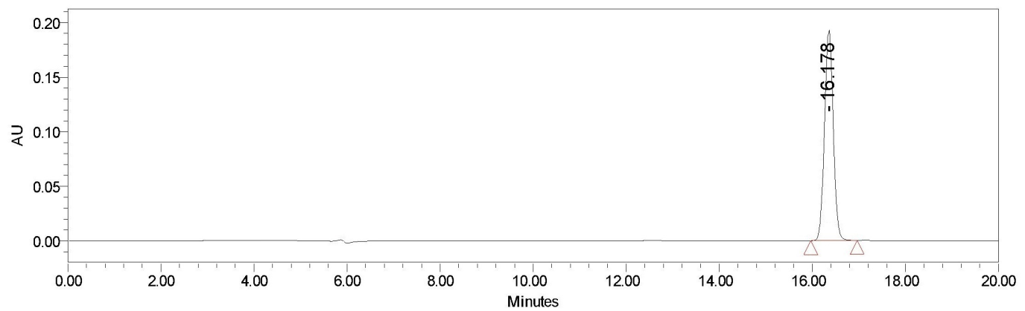
Racemization study of compound 3a [L-isomer]
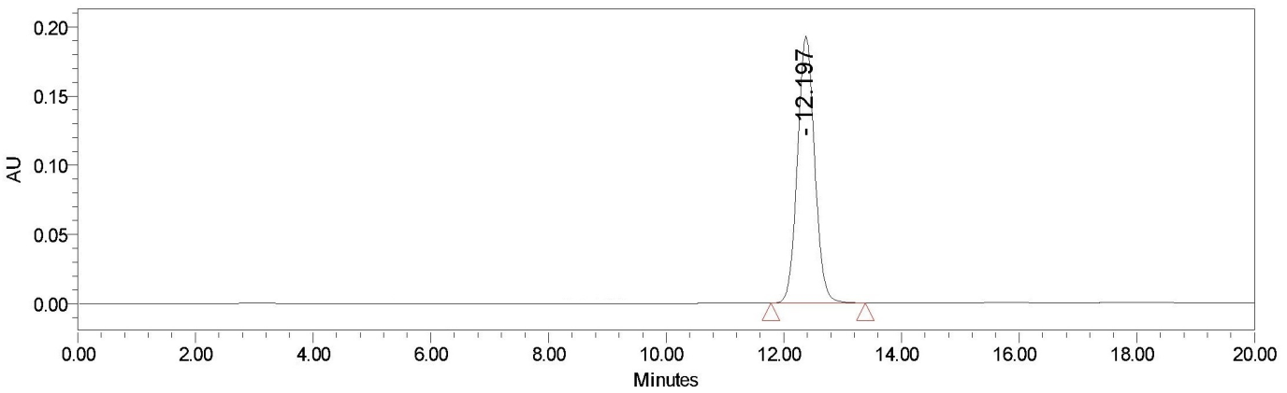
Racemization study of compound 3a* [D-isomer]
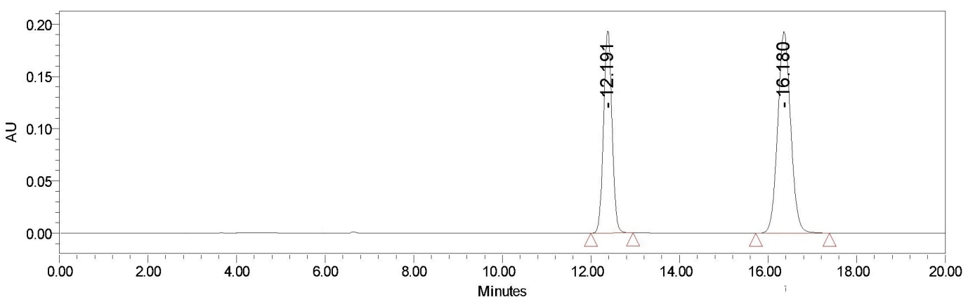
Racemization study of mixture of compound 3a & 3a* [L- & D-isomer]

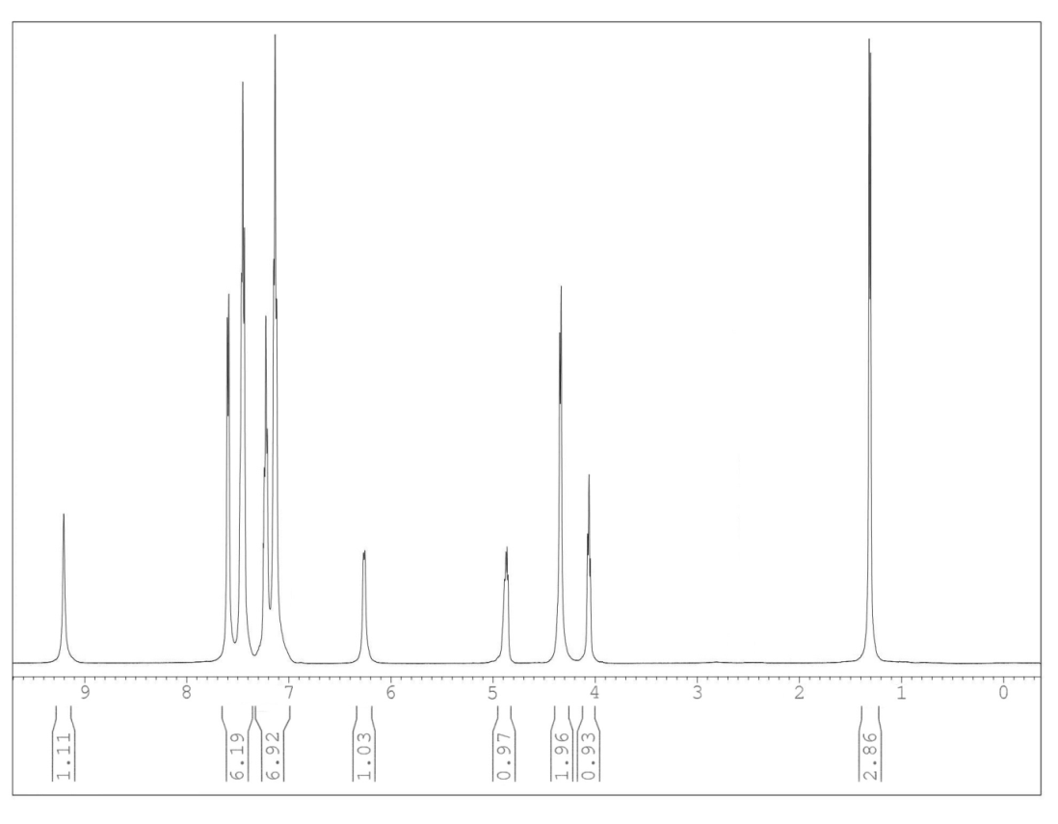
¹H NMR Spectrum of Compound 3a

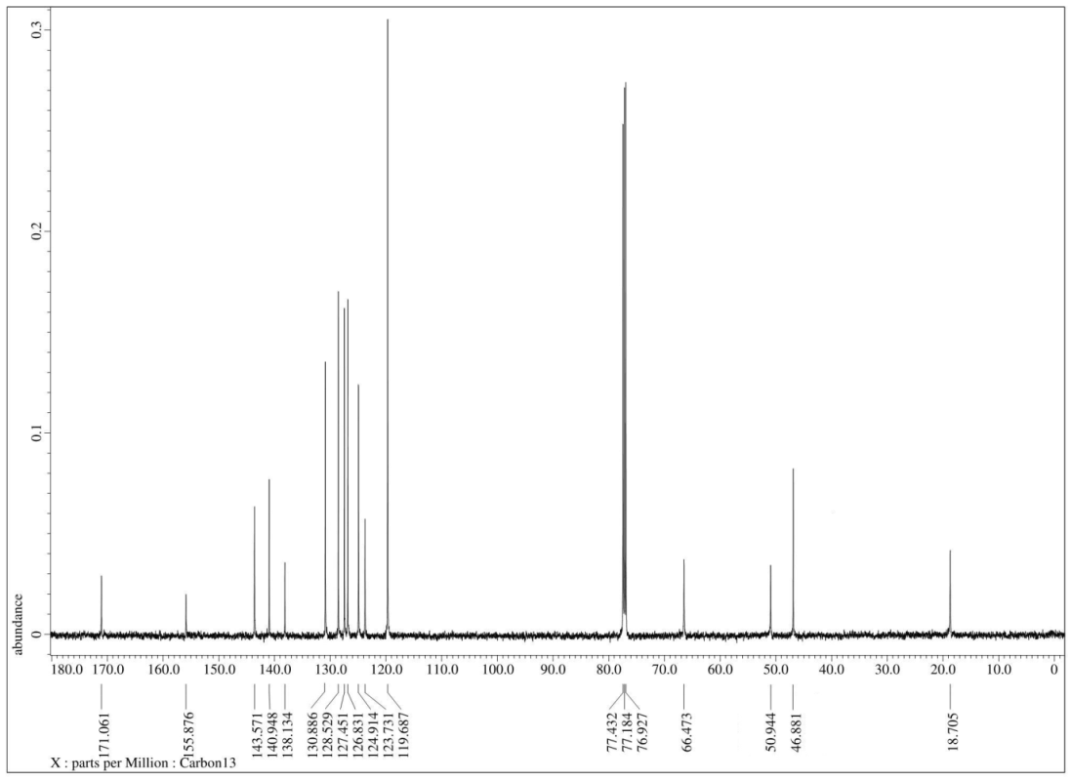
¹³C NMR Spectrum of Compound 3a

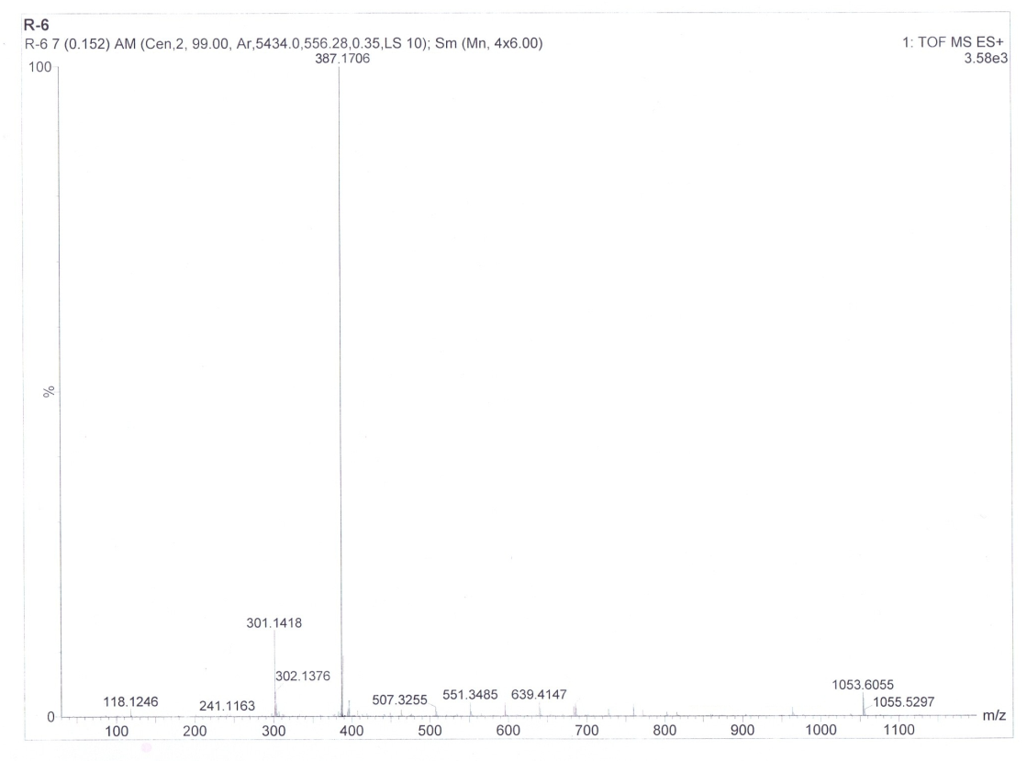
HRMS of Compound 3a

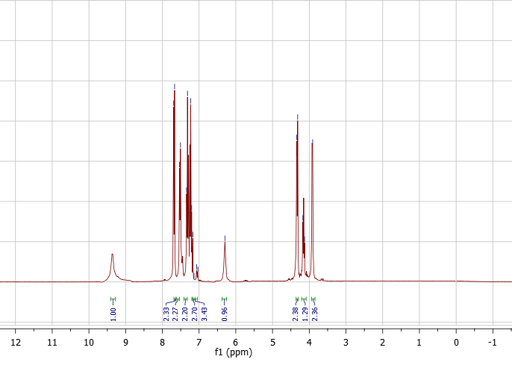
¹H NMR Spectrum of Compound 3b

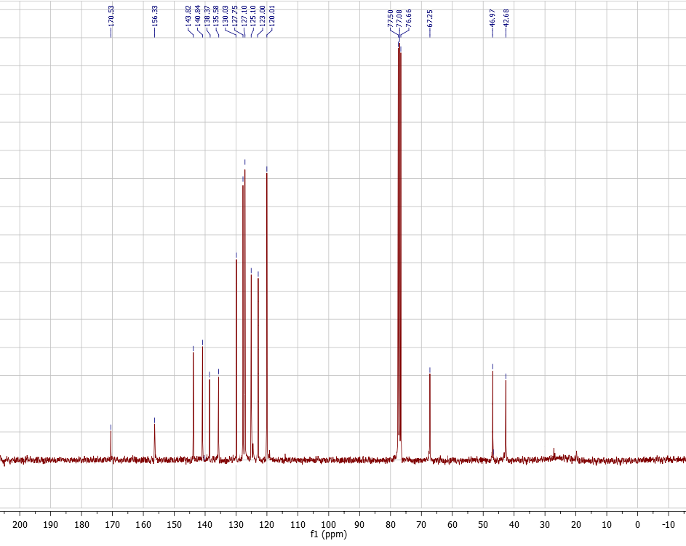
¹³C NMR Spectrum of Compound 3b

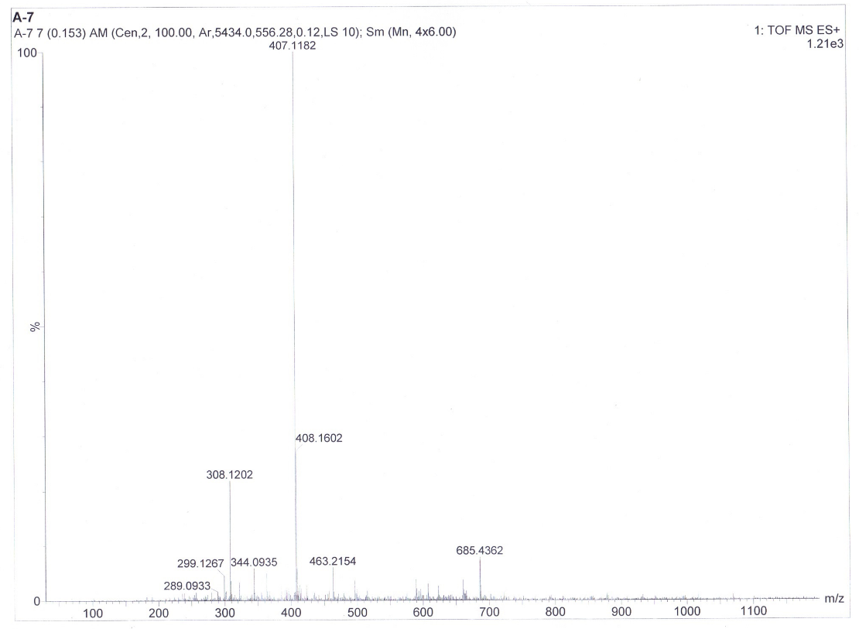
HRMS of compound 3b

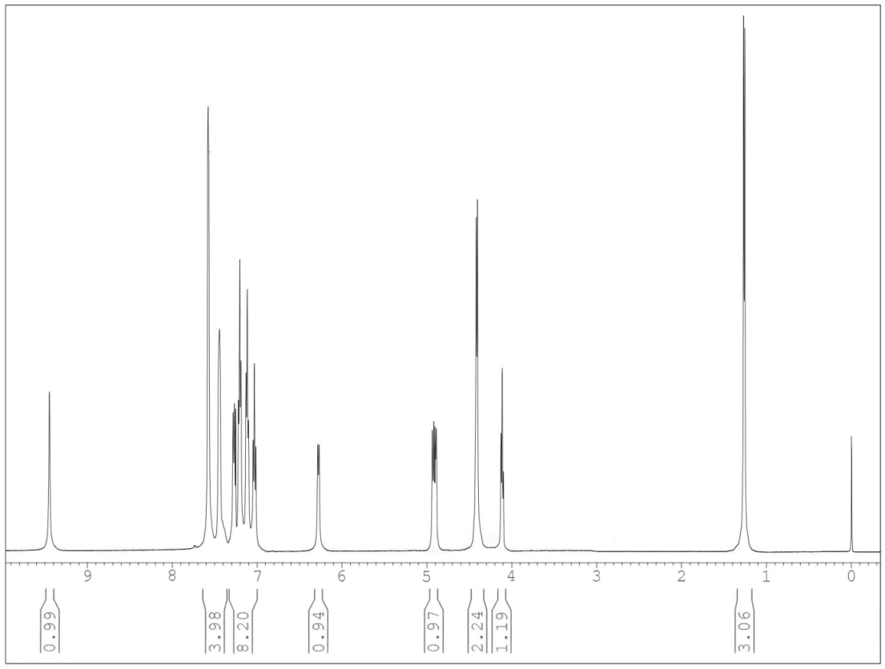
¹H NMR Spectrum of Compound 3c

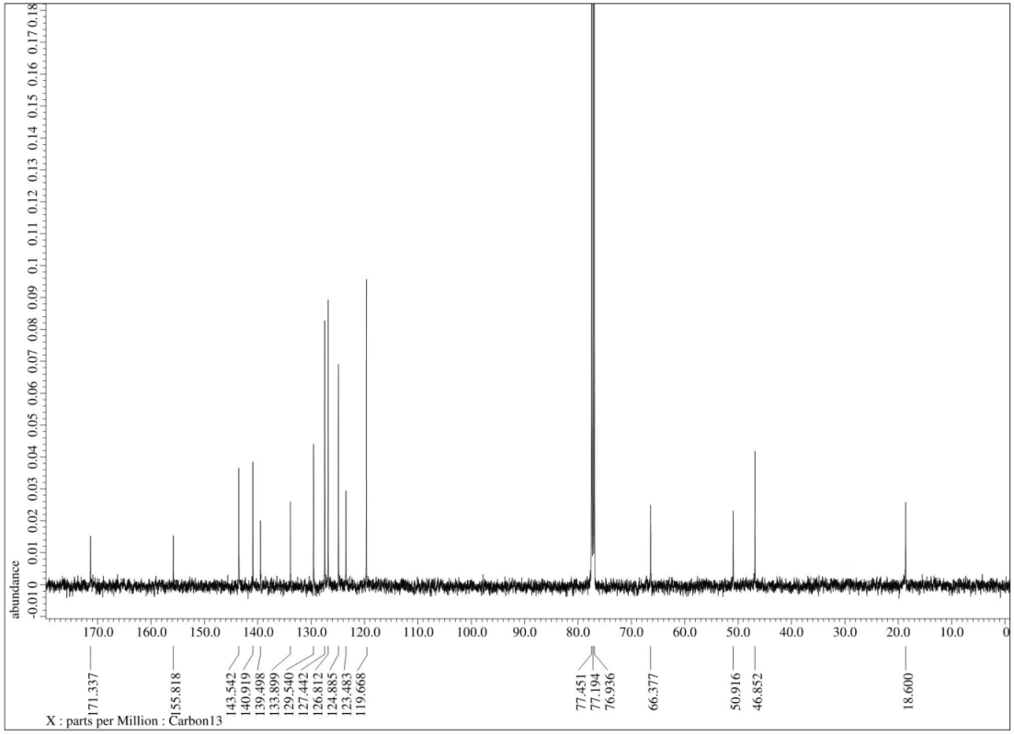
¹³C NMR Spectrum of Compound 3c

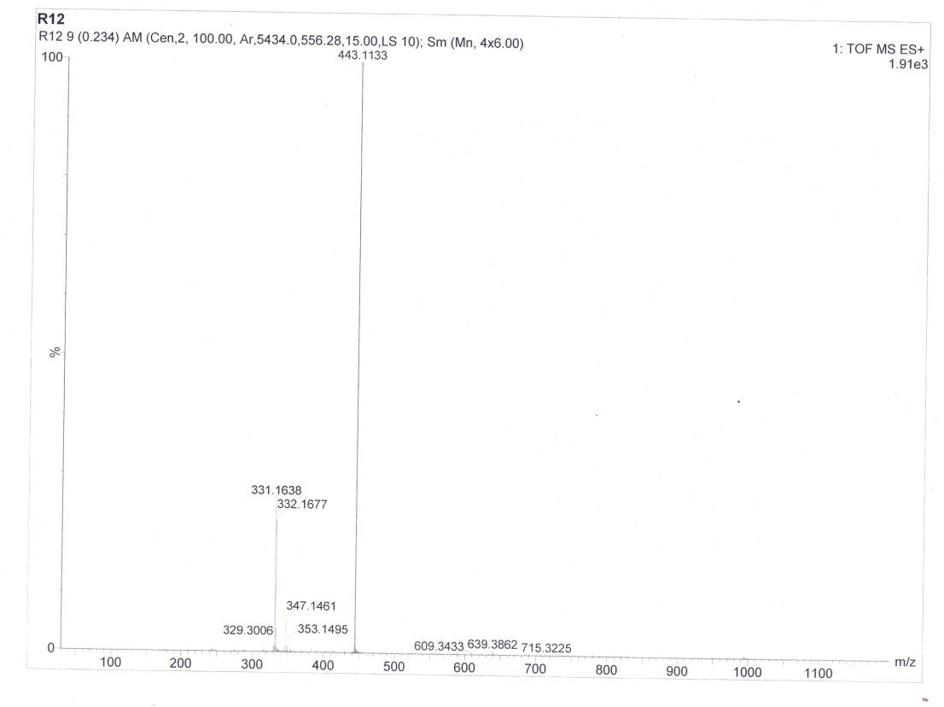
HRMS of compound 3c

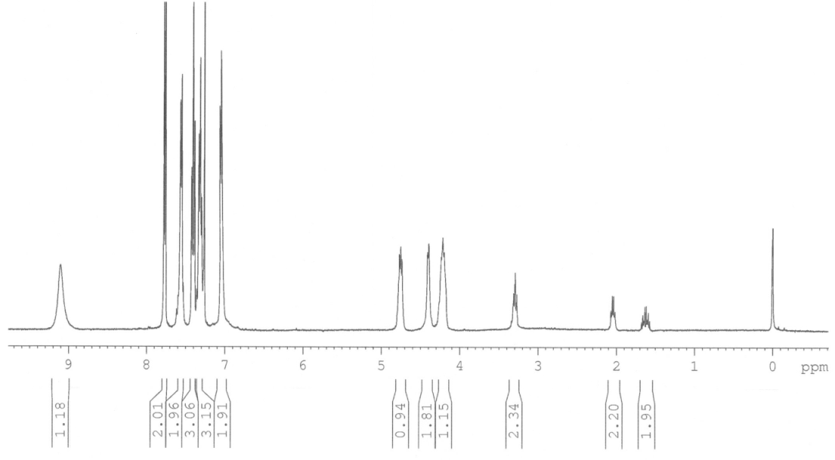
¹H NMR Spectrum of Compound 3d

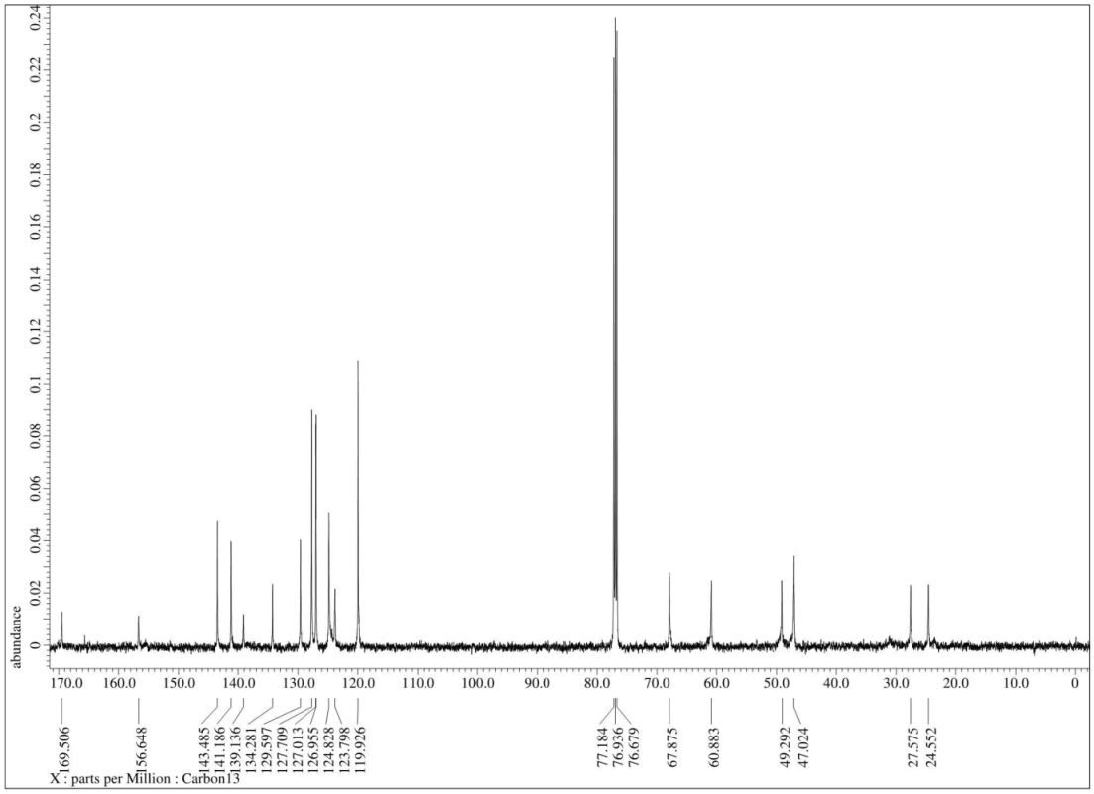
¹³C NMR Spectrum of Compound 3d

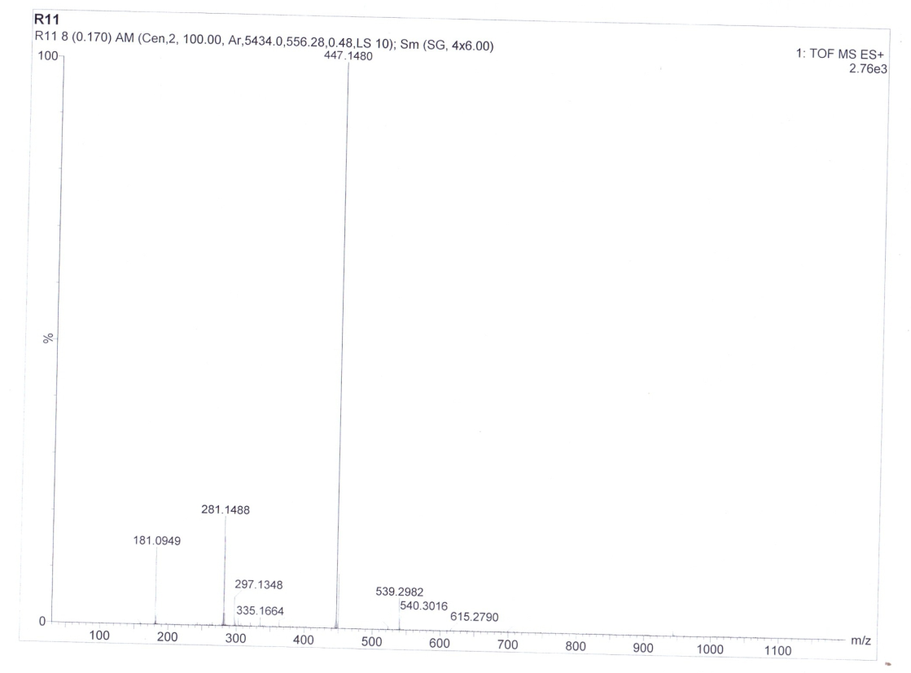
HRMS of Compound 3d

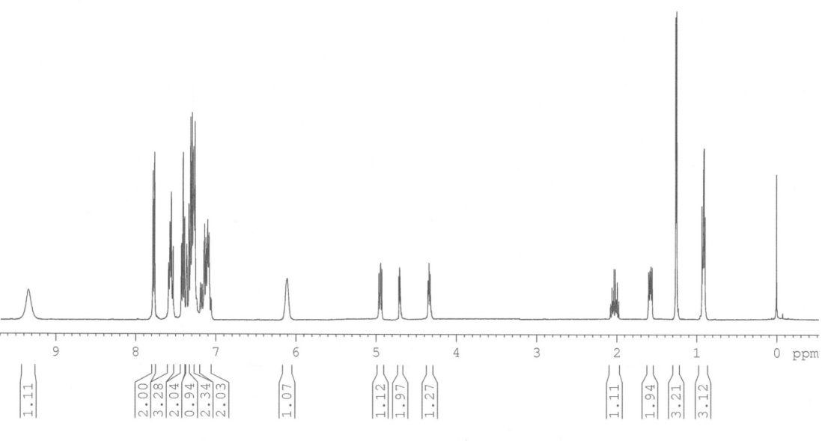
¹H NMR Spectrum of Compound 3e

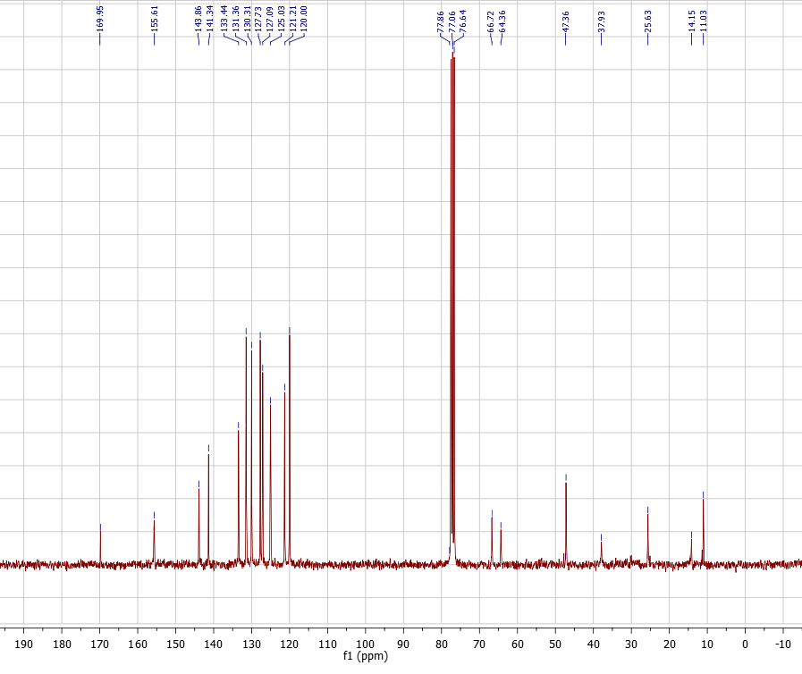
¹³C NMR Spectrum of Compound 3e

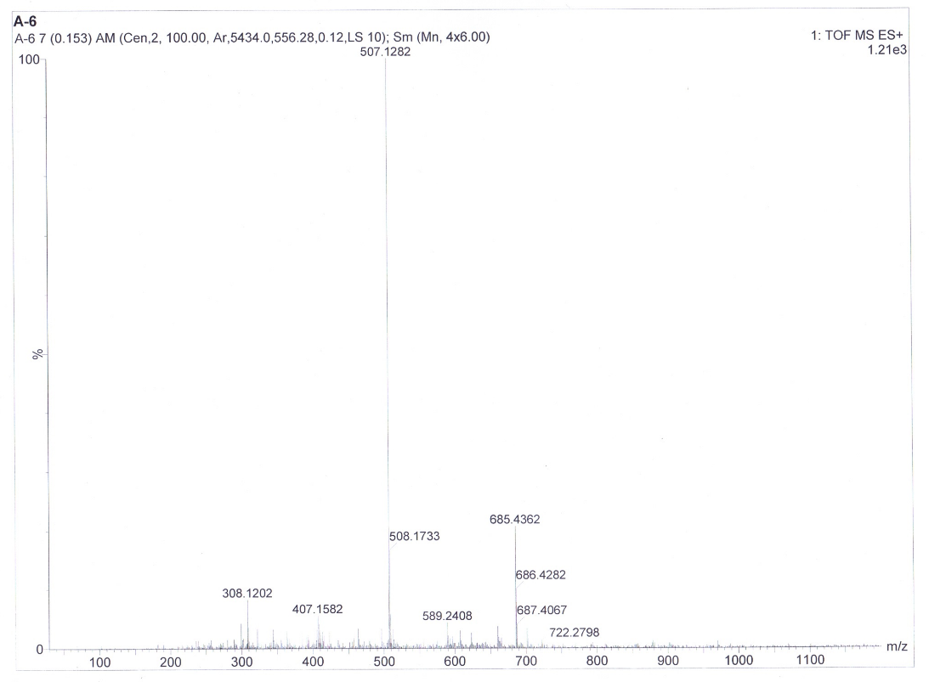
HRMS of compound 3e

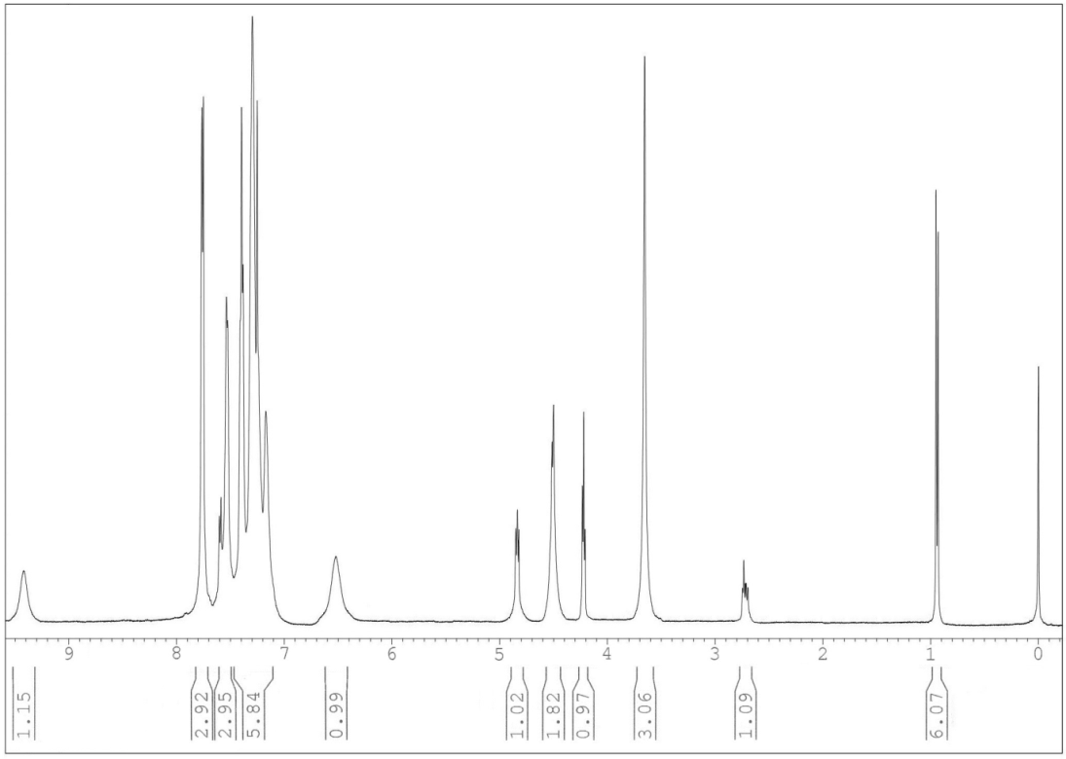
¹H NMR Spectrum of Compound 3f

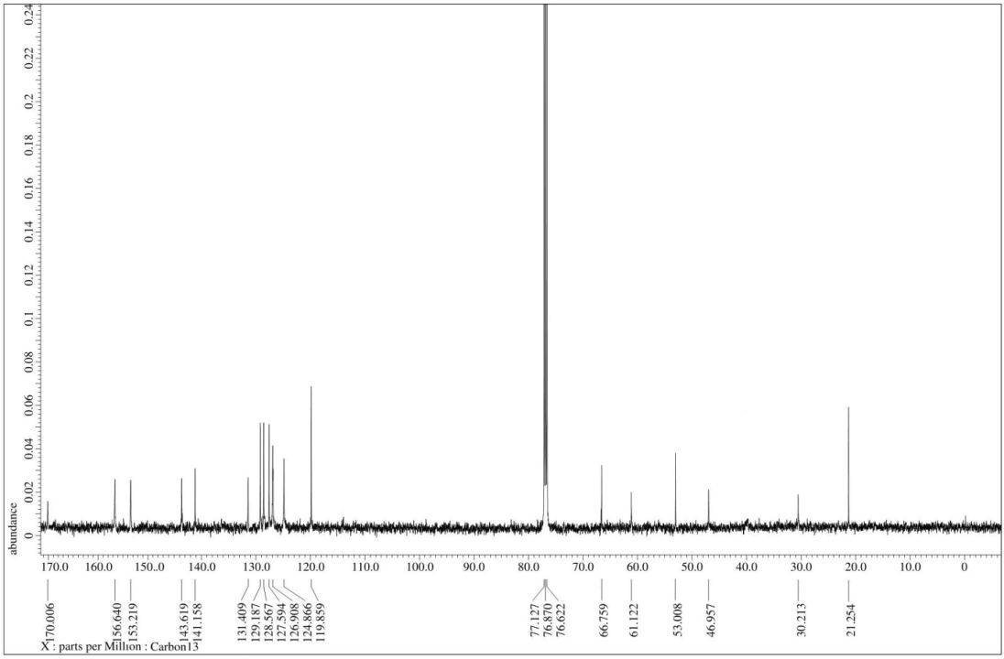
¹³C NMR Spectrum of Compound 3f

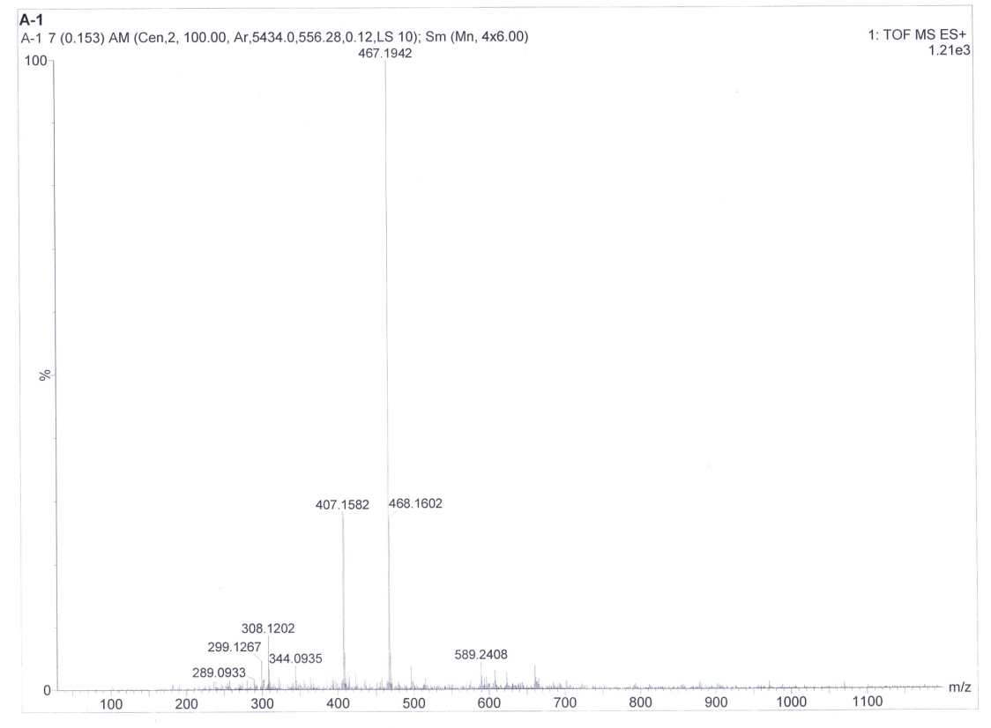
HRMS of compound 3f

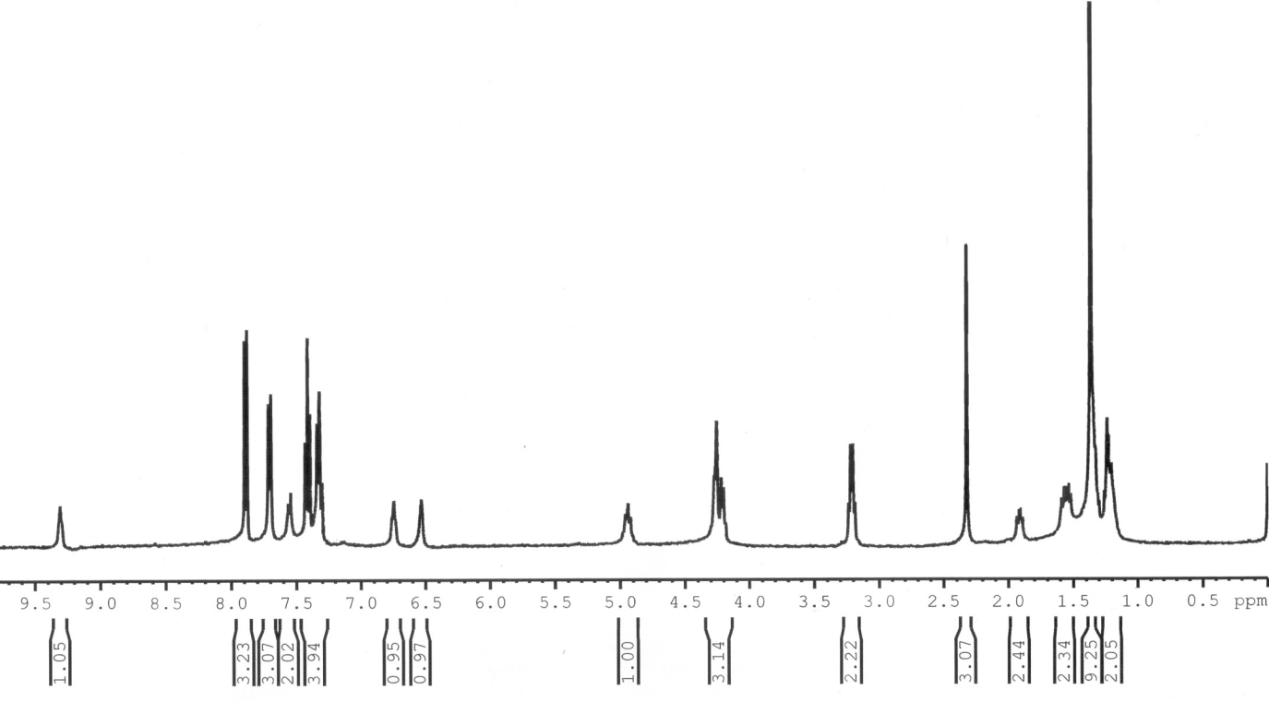
¹H NMR Spectrum of Compound 3g

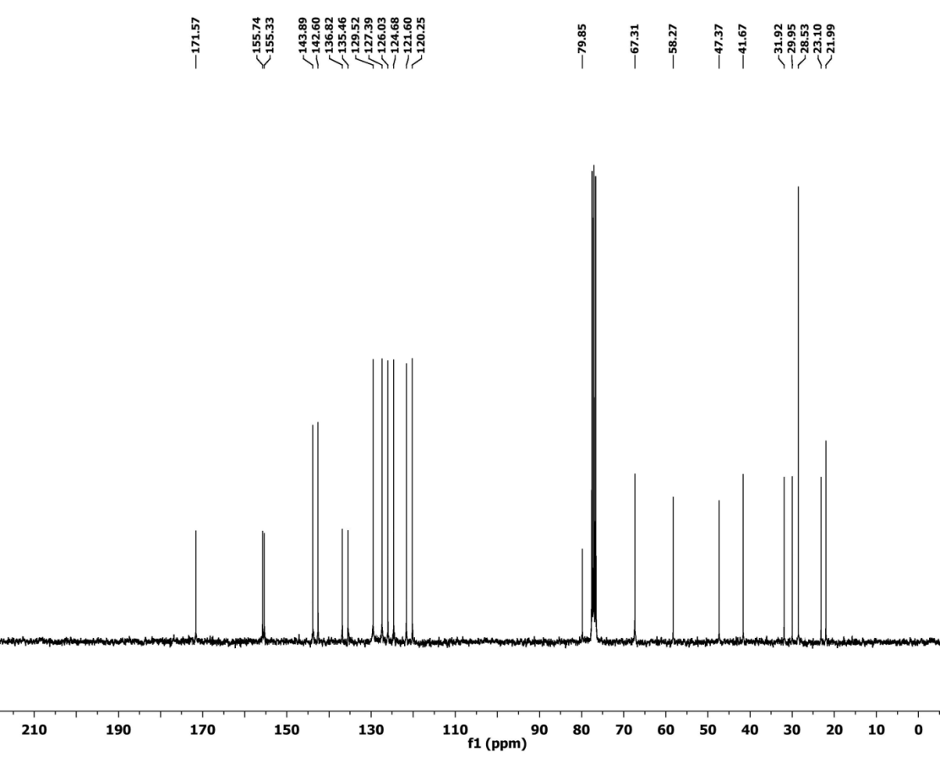
¹³C NMR Spectrum of Compound 3g

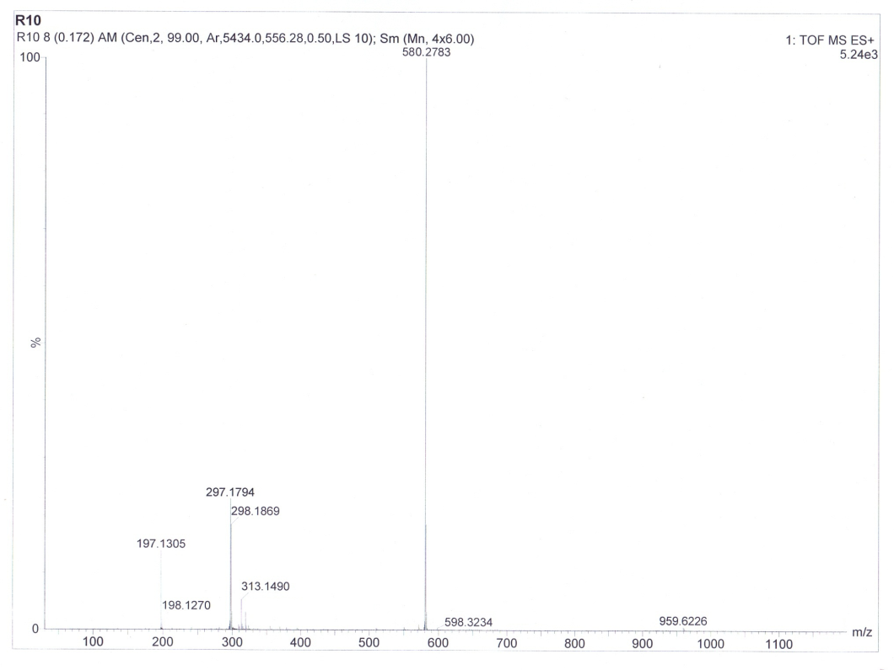
HRMS of compound 3g

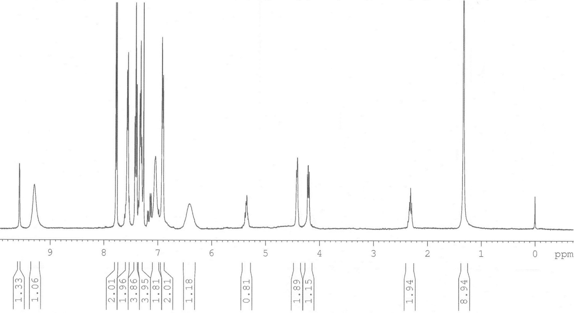
¹H NMR Spectrum of Compound 3h

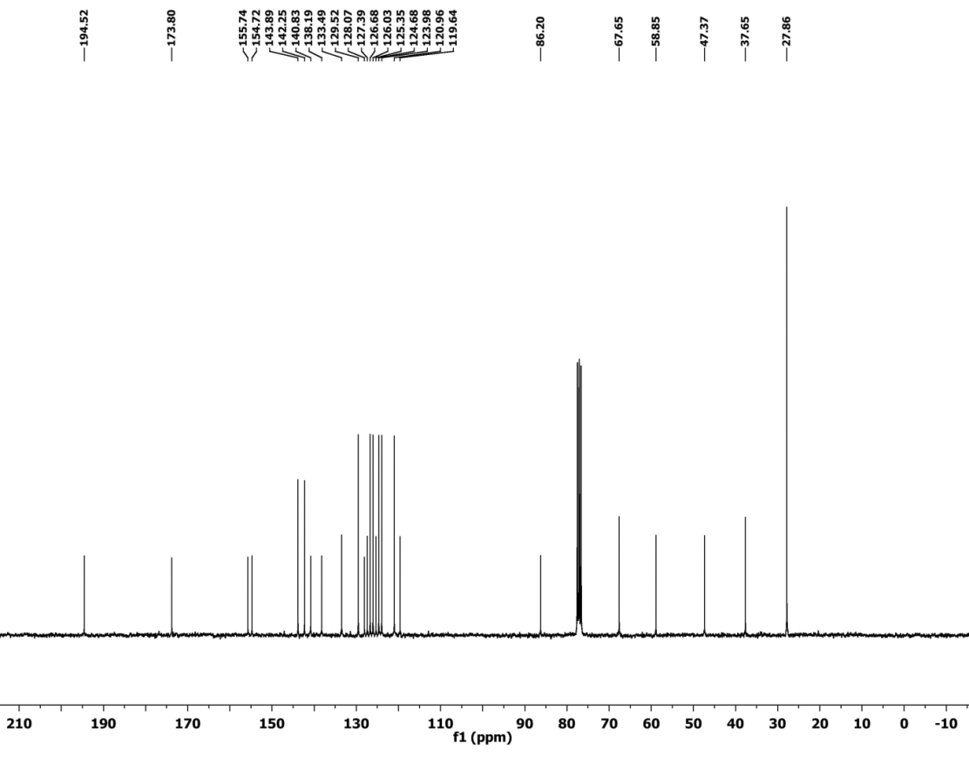
¹³C NMR Spectrum of Compound 3h

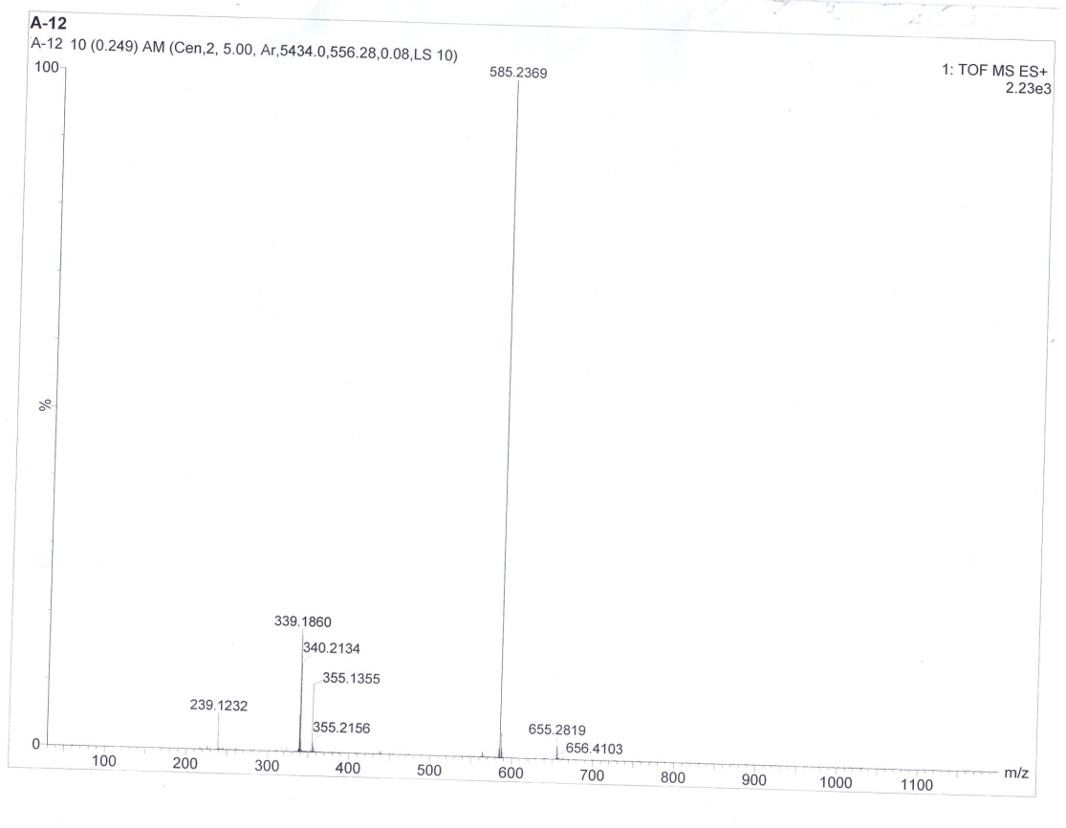
HRMS of compound 3h

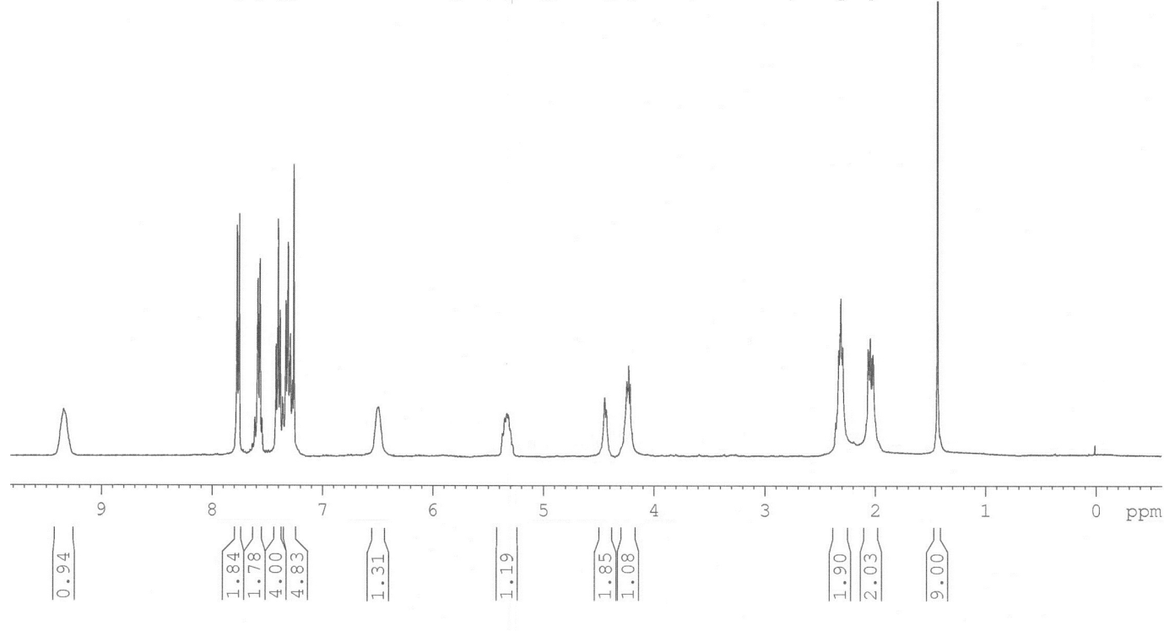
¹H NMR Spectrum of Compound 3i

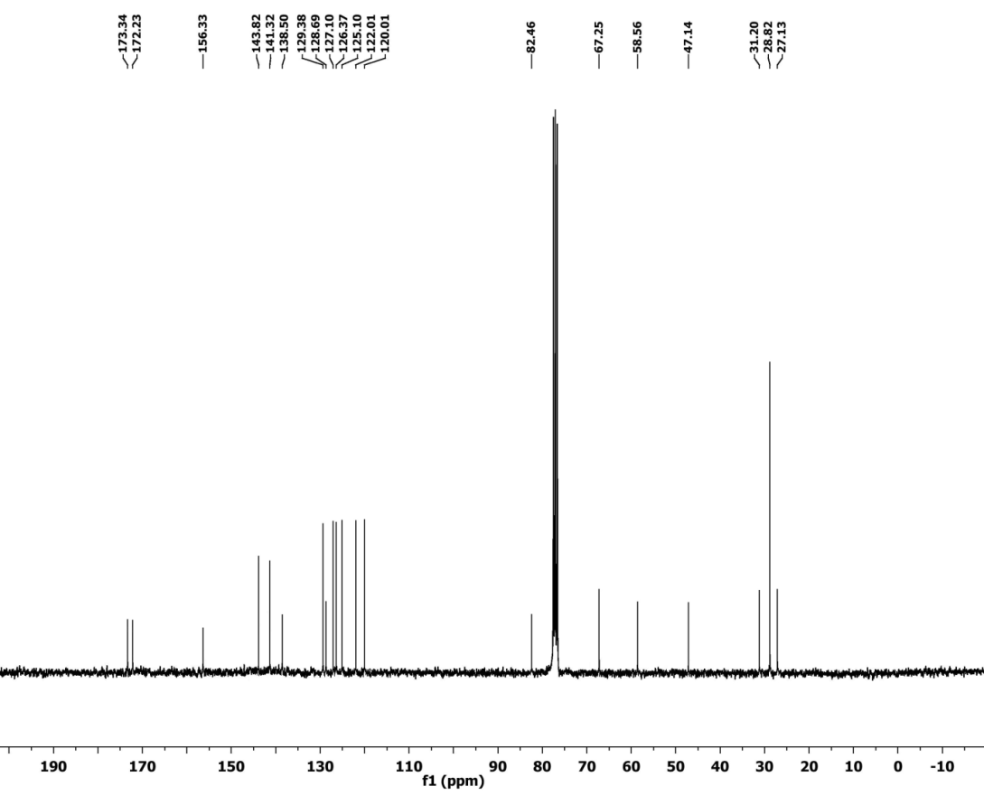
¹³C NMR Spectrum of Compound 3i

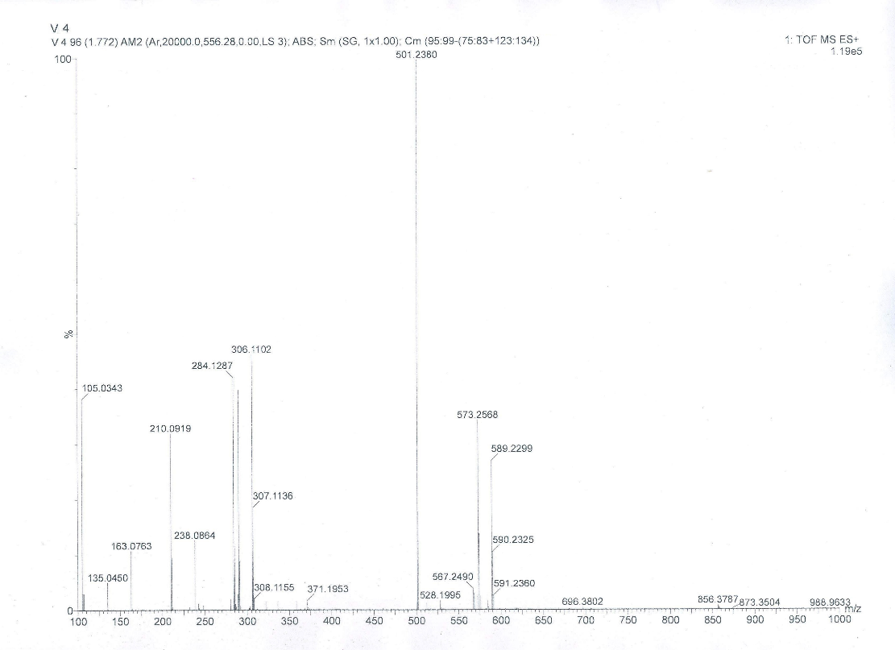
HRMS of compound 3i

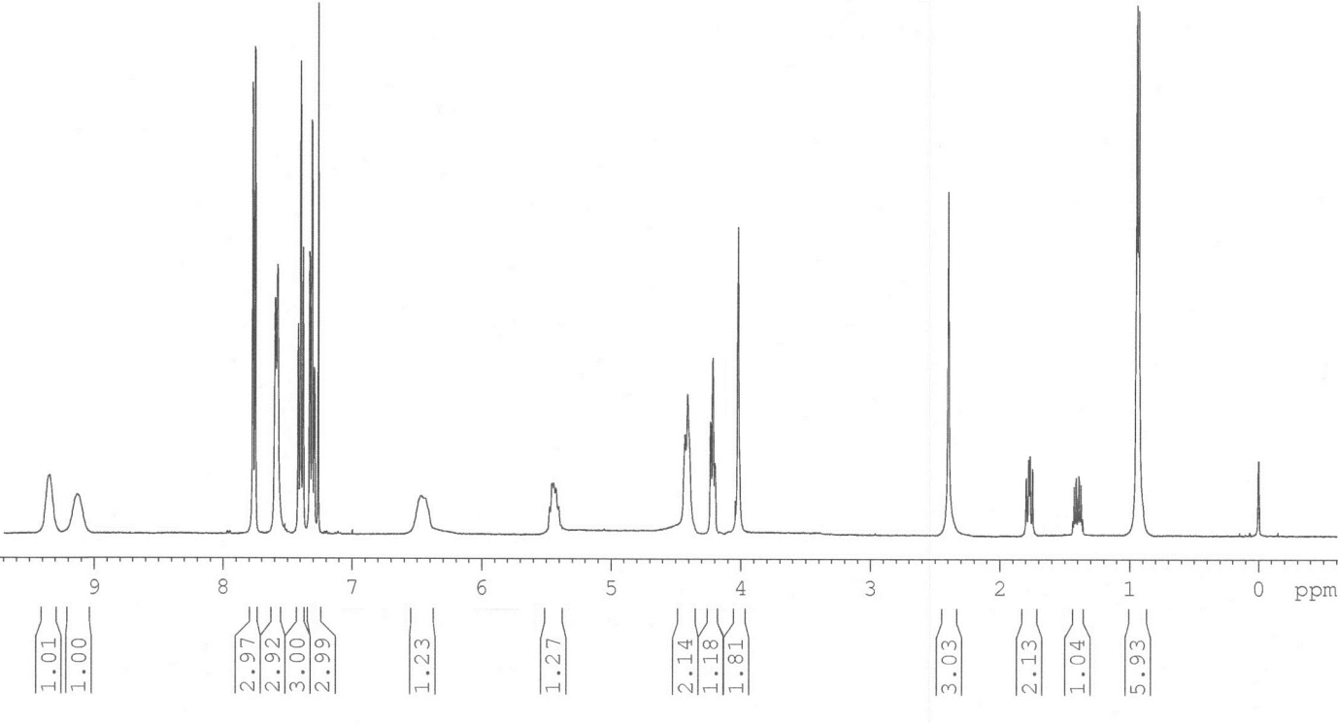
¹H NMR Spectrum of Compound 6a

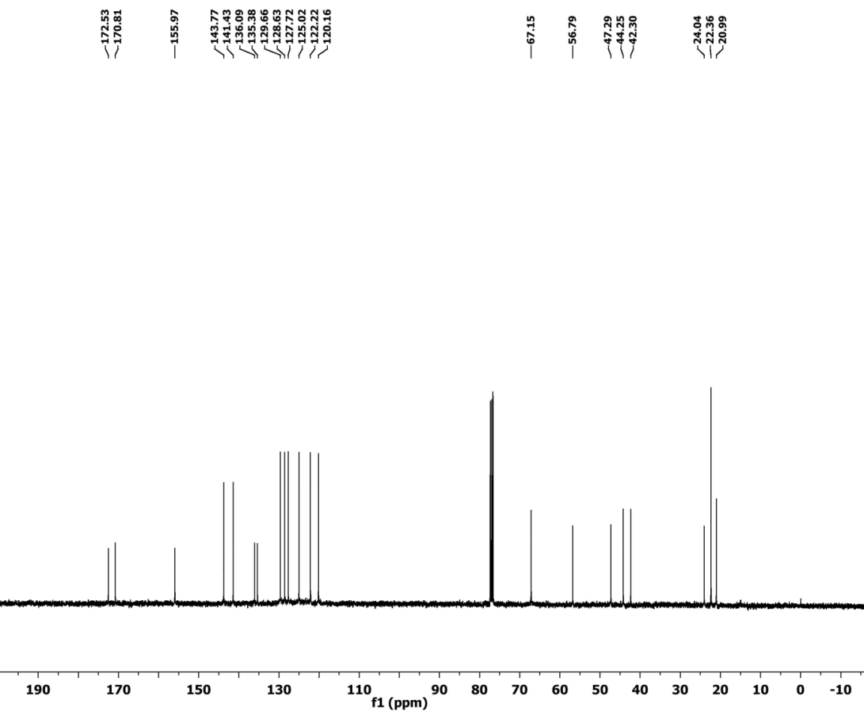
¹³C NMR Spectrum of Compound 6a

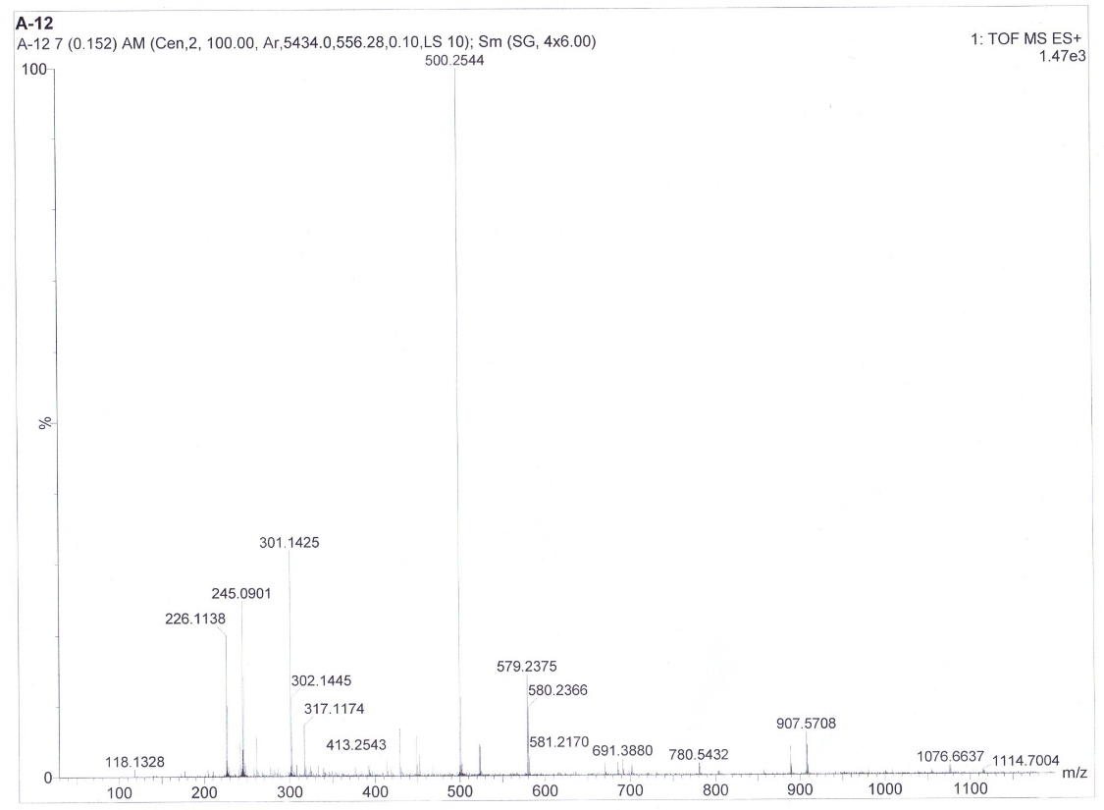
HRMS of compound 6a

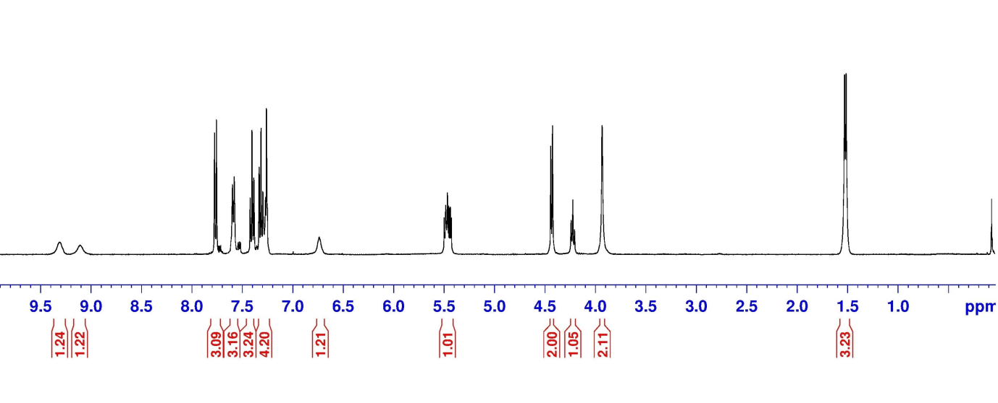
¹H NMR Spectrum of Compound 6b

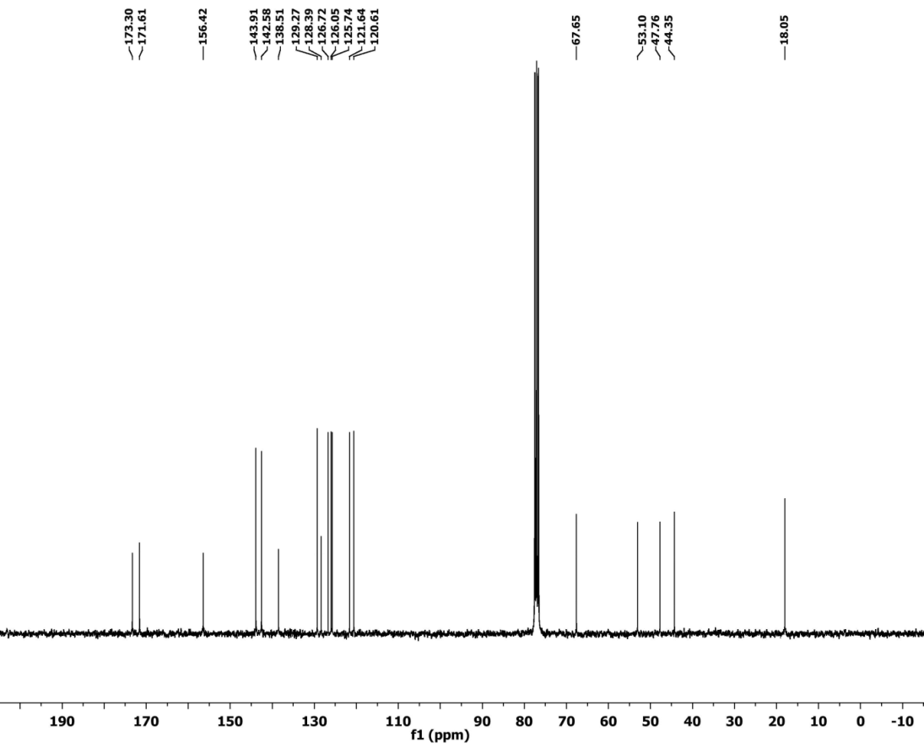
¹³C NMR Spectrum of Compound 6b

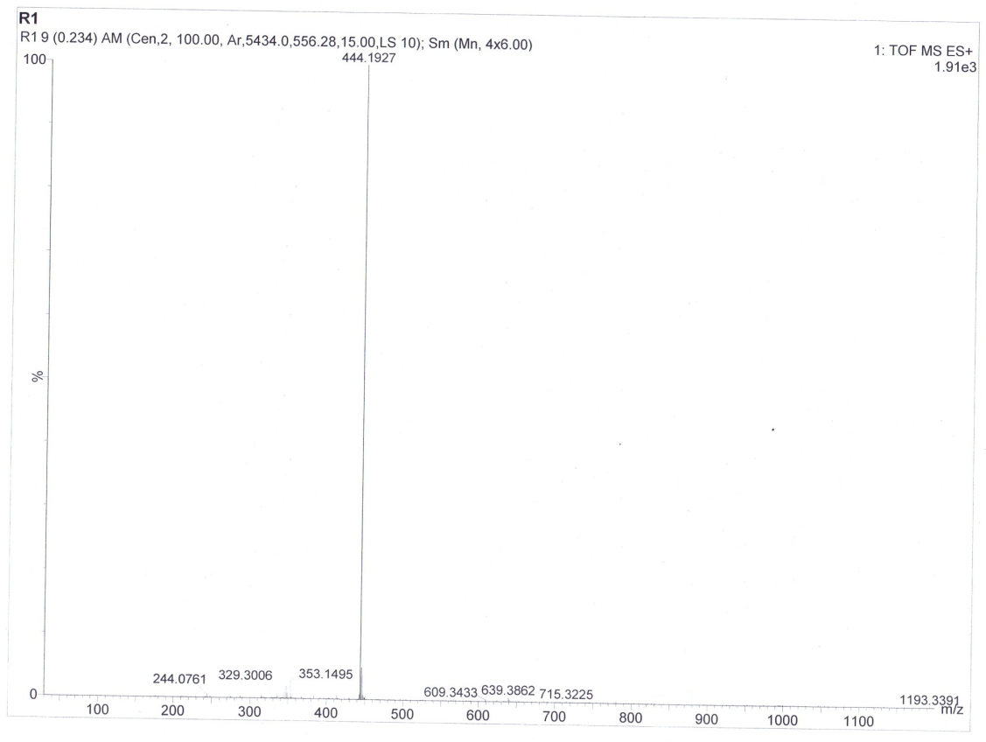
HRMS of compound 6b
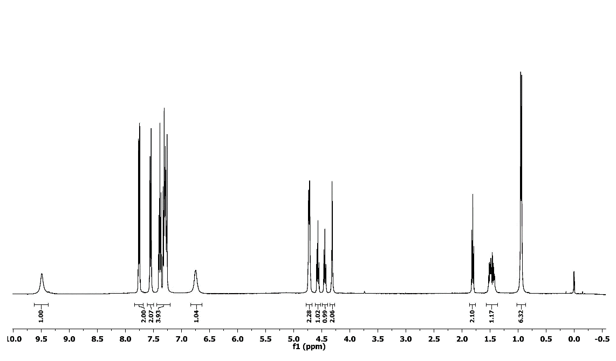
¹H NMR Spectrum of Compound 5a

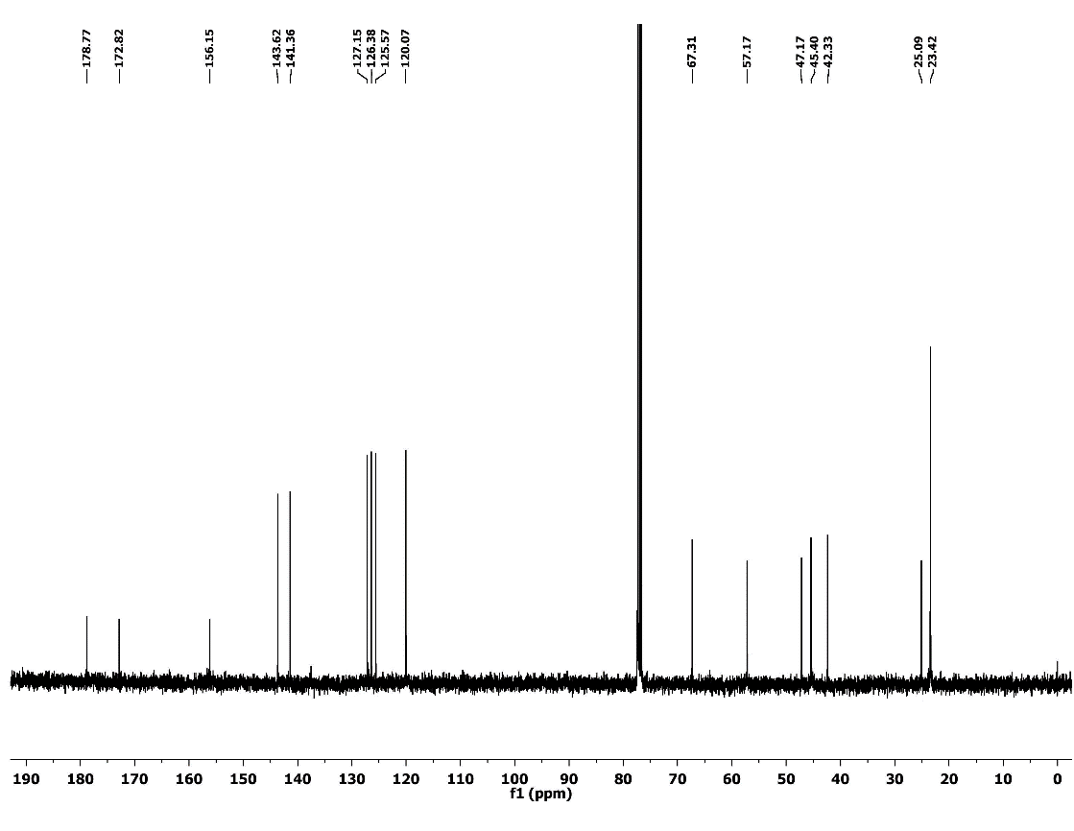
¹³C NMR Spectrum of Compound 5a

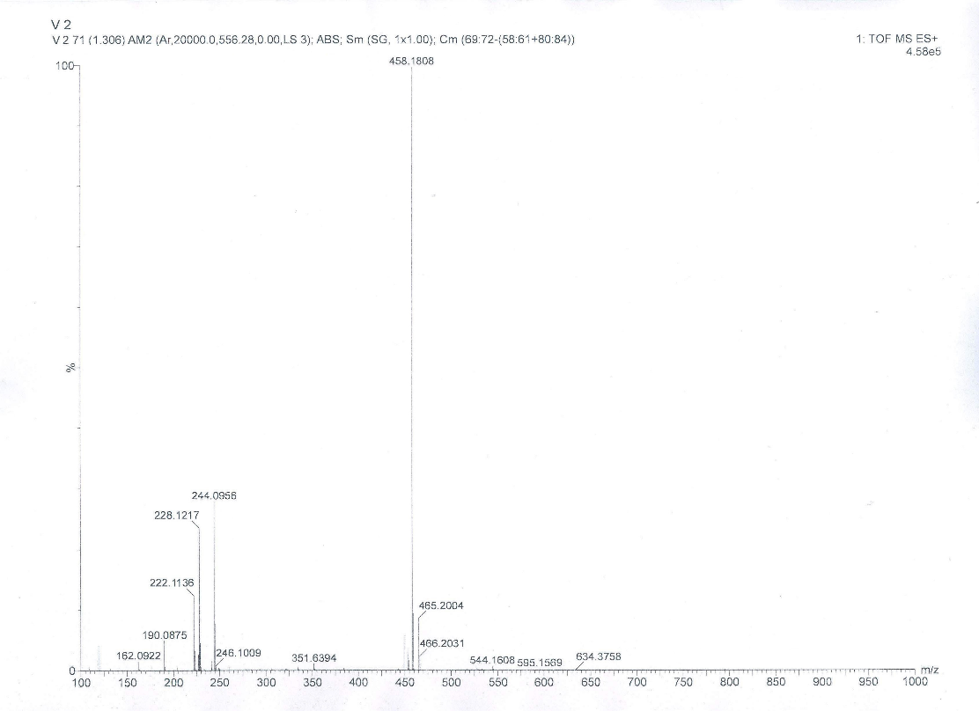
HRMS of compound 5a

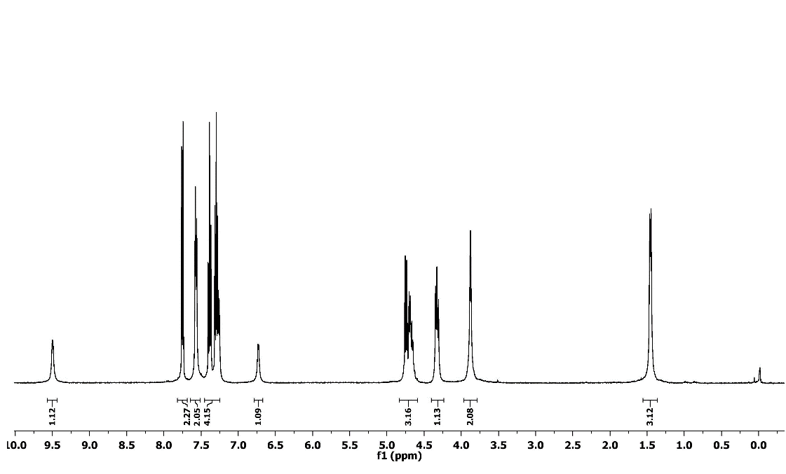
¹H NMR Spectrum of Compound 5b

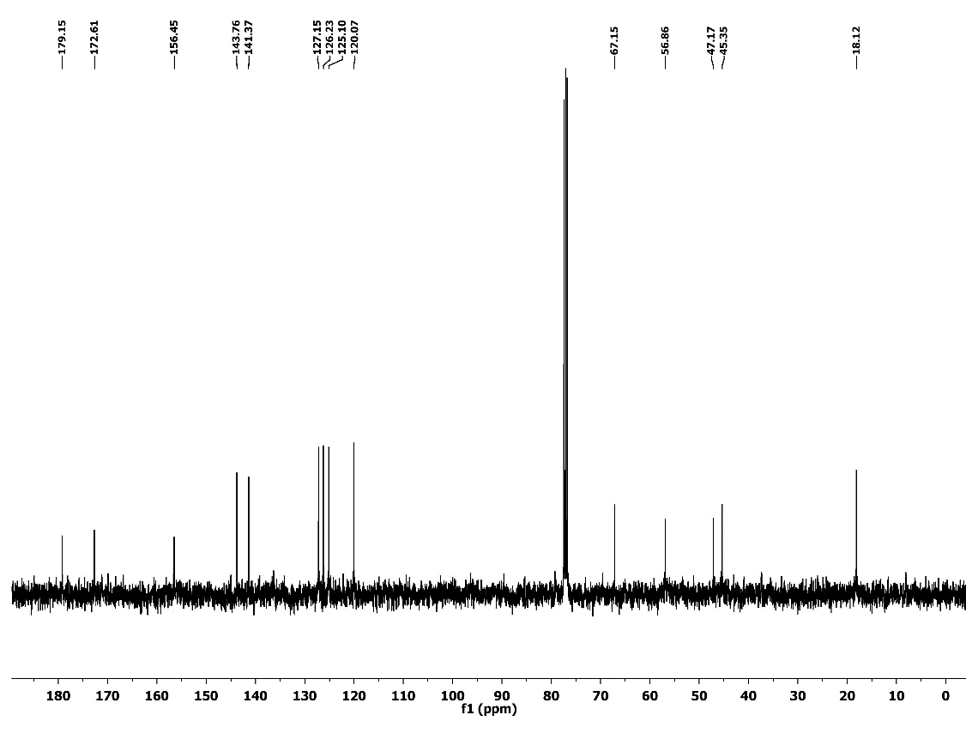
¹³C NMR Spectrum of Compound 5b

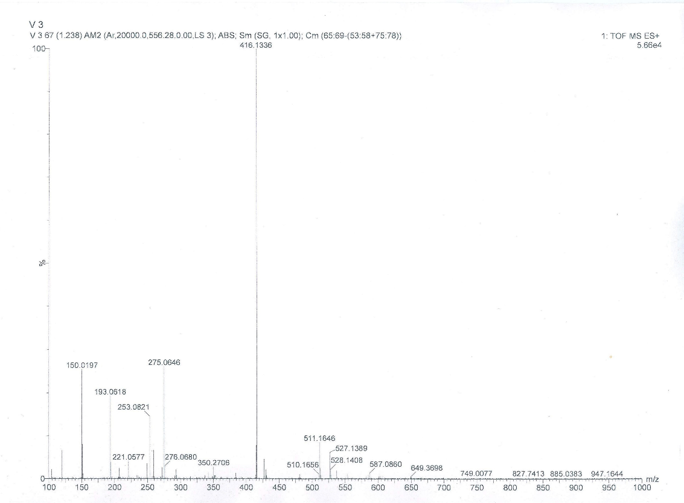
HRMS of compound 5b

