Supporting Information
Vibrational energy redistribution and vibrational dynamics of methanol mixed with Rhodamine101 dye
Xiaosong Liu¹, Wei Zhang², Weilong Liu³, Yunfei Song³, Zhuo Wang¹, Wenjing Zhang^{*1}
¹ International Collaborative Laboratory of 2D Materials for Optoelectronics Science and Technology of Ministry of Education, Institute of Microscale Optoelectronics, Shenzhen University - 3688 Nanhai Avenue, Nanshan District, Shenzhen,518060, China
² Tianjin Institute of Power Sources -No. 6, 7th Haitai Huake Road, Xiqing district, Tianjin, 300384, China
³ Department of Physics, Harbin Institute of Technology - 92 Xidazhi Street, Nangang District, Harbin, 150001, China

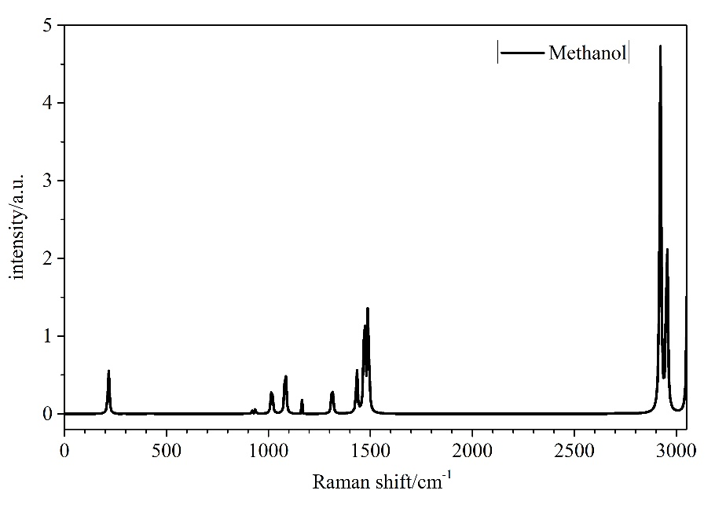
Figure 1. Raman spectrum of methanol

Symmetry (C_{s}) |  | Vibrational modes/cm⁻¹ | Assignment
Aˊ  Aˊ  Aˊ  Aˊ  Aˊ  Aˊ  Aˊ  Aˊ  Aˊˊ  Aˊˊ  Aˊˊ  Aˊˊ | 3628  2993  2834  1464  1107  1033  2940  1464  1165  246 |  | OH str  CH₃ d-str  CH₃ s-str  CH₃ d-deform (OV)  CH₃ rock  CO str  CH₃ str  CH₃ deform (OV)  CH₃ rock  torsion
Table 1. Vibrational assignment of methanol in the liquid phase
OV represents vibrational bands overlapping

