Supporting Information
A trinuclear Cu(II) precursor for solvatochromically distinguishing CH₃OH from C₂H₅OH

XUE-MEI GAO, WEN MA, GANG JIN, JING-ZHE LI, XUE-WEN WEI and KUAN-GUAN LIU*

S1. Synthesis
Other experimental conditions have been done for getting compound 1. The detailed description of the attempted synthesis in those reaction conditions and the resulting products are attached as follows. For reaction 1, the process is same to the synthesis of compound 1. PhC≡CCOOH (abbreviated as PPA, 3.0×10⁻⁴ mol) was dissolved in CH₃OH (3.0 mL) of Cu(CH₃CN)₄BF₄ (3.0×10⁻⁴ mol) under ultrasonication, giving a clear yellow solution, then bpy (6.0×10⁻⁴ mol) was added and the solution change to red-brown. Then the solution was sealed and heated to 70 °C for 20 h. After cooling to room temperature, the black-brown solution was filtered. Slow evaporation of the filtrate at 5 °C afforded the product of compound 1 as blue crystals after one day. For reaction 2, the process is same to reaction 1, except that before ultrasonication treatment N2 was pumped to the methanol mixture for 30 min. For reactions 3-7, the process is same to reaction 1, except that 0.3 mmol of other carbonate sources like NaHCO₃ (3), Na₂CO₃ (4), NH₄HCO₃ (5) and (NH₄)₂CO₃ (6) were used instead of PPA and without PPA (7) for comparison. For reaction 8, Cu₂(OH)₂CO₃ (3.0×10⁻⁴ mol) was added CH₃OH (3.0 mL); after 15 min ultrasonication treatment, bpy (6.0×10⁻⁴ mol) was added under 30 min ultrasonication treatment. Then the mushy mixture was sealed and heated to 70 °C for 20 h. After cooling to room temperature, many pale green precipitate were obtained.

Table S1. Serial experiment results for preparing compound 1.
Reactions | Copper salts | Carbonate source | Controlled atmosphere | Results
1 | Cu(CH₃CN)₄BF₄ | PPA | air | Compound 1
2 | Cu(CH₃CN)₄BF₄ | PPA | N₂ | Compound 1
3 | Cu(CH₃CN)₄BF₄ | NaHCO₃ | air | Precipitate
4 | Cu(CH₃CN)₄BF₄ | Na₂CO₃ | air | Precipitate
5 | Cu(CH₃CN)₄BF₄ | NH₄HCO₃ | air | Precipitate
6 | Cu(CH₃CN)₄BF₄ | (NH₄)₂CO₃ | air | Precipitate
7 | Cu(CH₃CN)₄BF₄ | --- | air | Blue powder
8 | Cu₂(OH)₂CO₃ | --- | air | Precipitate

S2. Characterization
Figure S1. The XRD pattern of result blue powder compared with the simulated data of compound 1.

Figure S2. The IR spectrum of compound 1.

Figure S3. The UV-visible spectrum for compound 1 in CH₃CN with different concentrations.

(b)
(a)
Figure S4. The solid powder (a) and the solution (b) EPR spectra of compound 1.

(b)
(a)
Figure S5. The TGA curve (a) of compound 1 and the XRD (b) of compound 1 and after 250 °C burning.

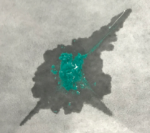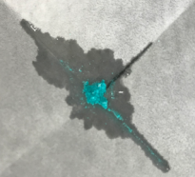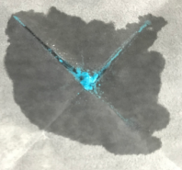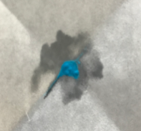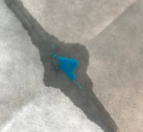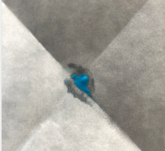
(f)
(c)
(b)
(a)
(a)
(b)
(c)
(d)
(e)
(f)
(e)
(d)
Figure S6. The sensitivity tests with various ratios of methanol/ethanol mixtures. (a) CH₃OH:C₂H₅OH = 1:10000, (b) CH₃OH:C₂H₅OH = 1:5000, (c) CH₃OH:C₂H₅OH = 1:1000, (d) CH₃OH:C₂H₅OH = 1:100, (e) CH₃OH:C₂H₅OH = 1:50, (f) CH₃OH:C₂H₅OH = 1:1.

Figure S7. The PXRD pattern of compound 1 during solvatochromism behavior.

(b)
(a)
Figure S8. The diffuse reflectance spectra of the blue powder sample before (a) and after (b) its solvatochromism behaviors.

Table S2. Crystal data and structure refinement for 1.
Chemical formula | C₆₄H₅₆B₄Cu₃F₁₆N₁₂O₈
Formula weight | 1659.06
Crystal system | Triclinic
Space group | P-1
a, Ǻ | 11.4543(6)
b, Ǻ | 13.2135(6)
c, Ǻ | 25.1120(12)
α, deg | 76.0660(10)
β, deg | 88.807(2)
γ, deg | 76.3350(10)
V, Ǻ³ | 3581.9(3)
Z | 2
ρ_{calc}, g/cm³ | 1.538
µ, mm⁻¹ | 0.986
Reflections collected | 47460
Independent reflections | 13691
R_{int} | 0.0347
Reflections I > 2σ(I) | 13691
Parameters | 996
GOF on F² | 1.041
R₁ª /wR₂^{b} (I > 2σ(I)) | 0.0533 / 0.1351
R₁ª /wR₂^{b} (all) | 0.0737 / 0.1471
ª R₁ = [Σ abs(abs(Fo) - abs(Fc))]/ [Σ abs(Fo)]. ^{b} wR2 = [Σ(w(Fo² - Fc²)²)/ Σ[w(Fo²)²]^{0.5}.

