Supplementary Material
Table A1: Parameter values
Parameter Description |  |  | Assigned value  (alternate values)
Economic parameters
T | Length of the planning horizon |  | 200 years
Δt | Time step |  | 10 years
R | Monetary discount rate |  | 0.025
β | Discount factor |  | 1/(1+r)=0.80
r_{c} | Carbon discount rate |  | 0.01
c_{h} | Cost of logging trees/m³ |  | $22.20
p_{L} | Price of lumber/m³ |  | $160
P_{Eng} | Price of HWP/m³ |  | $200
P_{Pulp} | Price of chips in pulp/m³ |  | $145
P_{Fuel} | Price of fuel/m³ |  | $155
c_{hau} | Hauling cost/m³ |  | $6.77
c_{harv} | Cost of logging trees/m³ |  | $22.20
Km | Average round-trip distance |  | 150 km
Sp | Speed of trucks including loading |  | 50 km/hr
Mill | Sawmilling cost/m³ |  | $72
Emill | Extra cost for HWP/m³ |  | $50
ppr_{eng} | Proportion of residuals for HWP |  | 0.151
ppr_{pulp} | Proportion of residuals for pulp |  | 0.697
ppr_{fuel} | Proportion of residuals for fuel |  | 0.152
Environmental parameters
η | Conversion of CO₂ to carbon |  | 3.67
δ | Decay rate of organic matter |  | 0.0718
δ_{lum} | Decay rate of softwood |  | 0.0082
δ_{pulp} | Decay rate of pulpwood |  | 0.0234
δ_{fuel} | Decay rate of biomass for fuel |  | 0.700
δ_{eng} | Decay rate of HWP |  | 0.008
e_{saw} | Carbon in raw material in sawnwood (tCO₂/m³) |  | 0.0293
e_{eng} | Carbon in raw material in HWP (tCO₂/m³) |  | 0.066
e_{pulp} | Carbon in raw material in pulp (tCO₂/m³) |  | 0.100
e_{fuel} | Carbon in raw material in fuel (tCO₂/m³) |  | 0.000
e_{harv} | Emissions from harvesting (tCO₂/m³) |  | 0.01173
e_{truck} | Trucking emissions (tCO₂/m³ per km) |  | 0.000078
save_{sub} | Emissions saved by product substitution |  | 0 (1)
save_{fuel} | Emissions saved by fuel substitution |  | 0 (1.365)
γ | =1 if carbon outside ecosystem is counted, =0 otherwise |  | 0 (1)
Programming parameters
itermax | Upper bound for iterations |  |  | 30,000
Tol | Convergence tolerance | 1e-5
Source: van Kooten, Bogle, and de Vries (2015); van Kooten (2018)

Table A2: Functional forms
Variable | Description | Functional form
Economic variables
lum | Lumber as a proportion of volume (m³) | 0.00008+0.4658x̅
res | Residues from commercial bole (m³) | 3.25115+0.5212x̅–0.000329x̅₂
val | Commercial value ($) | 0.001(p_{lum}-mill)×lum+ 0.001[(p_{eng} –e_{mill})×ppr_{eng}+p_{pulp}×ppr_{pulp}+p_{fuel}×ppr_{fuel} ]×res]
Logcost (x̅<250) |  | 2.04 – 0.05x̅
Logcost (x̅≥250) |  | 0.79 – 0.0001x̅
cost |  | 0.001[((c_{hau}×km/sp)+c_{harv} )x̅+logcost]
NetRev | Net revenue ($) | Val – cost
Environmental variables
c_{live} | Carbon in living biomass (m³) | 1.93536+0.41905x̅ – 0.0001739x̅₂
c_{dead} | Carbon in dead biomass (m³) | 0.0055x̅
c_{dis} | Discounted carbon (tCO₂) | 0.32η r_{c}/(r_{c}+δ_{lum})×lum+[ppr_{eng}×r_{c}/(r_{c}+δ_{eng} ) +ppr_{pulp}×r_{c}/(r_{c}+δ_{pulp})+pprf_{uel}×r_{c}/(r_{c}+δ_{fuel} )]×res
e_{prod} | Production emissions (tCO₂) | e_{saw}×lum+(e_{eng}×ppr_{eng}+e_{pulp}×ppr_{pulp}+e_{fuel}×  ppr_{fuel} )×res
e | Total emissions (tCO₂) | (e_{harv}+e_{truck}×km)x̅+e_{prod}
save_{harv} | Carbon stored in products, product & fuel substitution (tCO₂) | cd_{is}+save_{sub}×(lum+ppr_{eng}×res)+save_{fuel}×ppr_{fuel}×res
c_{noneco} | Carbon stored outside of the ecosystem (tCO₂) | 0.001×p_{c}×save_{harv}×(1–γ)
Source: van Kooten et al. (2015); van Kooten (2018)

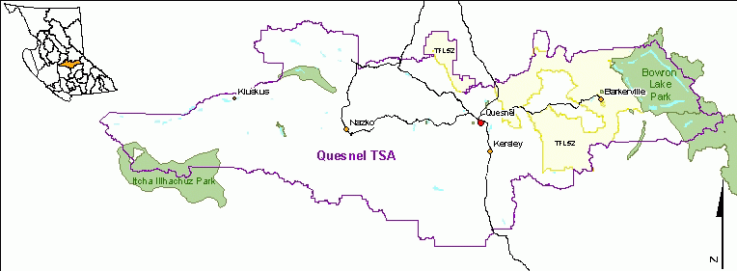
Figure S1: Map of Quesnel Timber Supply Area (TSA), British Columbia, Canada.
Source: Government of British Columbia. 2017. Retrieved from: https://www2.gov.bc.ca/gov/content/industry/forestry/managing-our-forest-resources/timber-supply-review-and-allowable-annual-cut/allowable-annual-cut-timber-supply-areas/quesnel-tsa.

